POD

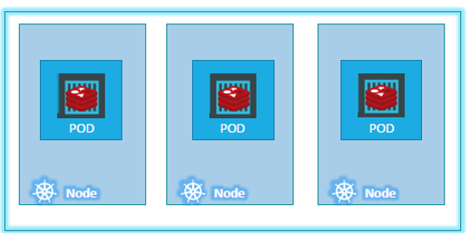

**🔹 What is a Kubernetes Pod?**

A **Pod** is the **smallest deployable unit** in Kubernetes. It represents a **single instance of a running process** in a cluster.

A Pod:

* Wraps one or more **containers**
* Shares the same **network**, **storage**, and **lifecycle**

Think of a Pod as a **wrapper** around one or more containers (usually Docker containers), providing an environment for them to run together.

🔹 Key Characteristics of a Pod

| **Feature** | **Description** |
| --- | --- |
| **Containers** | One or more containers can run in a Pod (most commonly, only one) |
| **Shared Network** | All containers in the same Pod share the **same IP address**, **hostname**, and **network namespace** |
| **Shared Storage** | Volumes can be mounted into containers within the Pod |
| **Tightly Coupled** | Containers in a Pod can communicate via localhost, as they run on the same node |
| **Ephemeral (Immutable)** | Pods are **not durable** by default—if a Pod dies, a new one is created, but it's a different instance |

🔹 Why Multiple Containers in a Pod?

You can run multiple containers in a Pod when they are **tightly coupled** and need to share resources.

This is called a **multi-container Pod**.

**🔹 Pod Lifecycle**

1. **Pending** – The Pod is accepted but not yet scheduled to a node.
2. **Running** – The Pod has been bound to a node and all containers are started.
3. **Succeeded** – All containers terminated successfully.
4. **Failed** – One or more containers failed.
5. **Unknown** – Status couldn't be obtained, usually due to communication error.

**🔹 How Pods are Created**

Pods are rarely created directly by users. Instead, they are managed by higher-level Kubernetes objects like:

* **Deployments**
* **ReplicaSets**
* **StatefulSets**
* **DaemonSets**

These controllers ensure the desired state of the application is maintained and will recreate Pods as needed.

🔹 Pod YAML Example

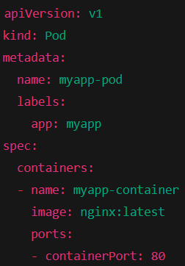

You can create it with:



**🔹 Accessing Pods**

* Each Pod gets an **IP address**, but you typically don't access Pods directly.
* Instead, you use **Services** in Kubernetes to expose Pods.
* Services provide stable IPs and DNS names and load-balance traffic to Pods.

**🔹 Volumes in Pods**

Pods can use Kubernetes **Volumes** to persist and share data among containers. Volumes are declared in the Pod spec and mounted in containers.

Example:

**🔹 Limitations of Pods**

* Pods are **ephemeral**; they don't persist after failure (unless managed by a controller).
* Pods cannot span across multiple nodes.
* Scaling Pods manually is not efficient—use Deployments or StatefulSets.

**Types PODs**

**🔶 Single-Container Pods**

**🔶 Multi-Container Pods**

A **multi-container Pod** is a Pod that contains **more than one container**, which are tightly coupled and need to **cooperate** to function as a single unit.

**🧠 Why use Multi-Container Pods?**

Use multi-container Pods when:

* Containers need to **share a local filesystem** (using volumes).
* They must communicate **via localhost**.
* They are **part of the same logical application**.

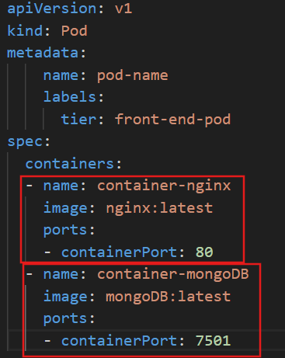

**Q.) How application is deployed in the Kubernetes cluster?**

**

Q.) What if the number of users accessing our application increase?

We need to add additional instances of our application to share the load.

Q.) Do we bring up a new container instance within the same POD?   
  
No! We create a new POD altogether with a new instance of the same application in same Kubernetes system or node.

Q.) What if the user base further increases and our current node has no sufficient capacity?

* Then we can always deploy additional PODs on a new node in the Kubernetes cluster.
* PODs usually have a one-to-one relationship with containers
  + To scale UP we create new PODs and to scale down we delete PODs
  + We do not add additional containers to an existing POD to scale our application.