Project Report: Netflix Content Strategy & AI Clustering
Objective: To leverage Unsupervised Machine Learning and Natural Language Processing (NLP) to categorize Netflix’s vast library into thematic clusters, enabling data-driven acquisition and personalized user experiences.

1. Project Phase: Data Exploration & Cleaning
Before building the model, we performed a thorough "Health Check" of the dataset.
- Handling Missing Values: Columns like director, cast, and country had significant missing data. Instead of deleting these rows (which would lose valuable information), we filled them with "Unknown". This allows the model to still use the description and title for those specific movies.
- Duplicate Check: We verified there were zero duplicate entries, ensuring each data point in our analysis is unique.

2. Project Phase: Text Preprocessing & "Metadata Soup"
Since we are clustering based on "meaning," we needed to transform text into a format the computer can understand.
- The "Metadata Soup": We combined type, director, cast, country, listed_in (genres), and description into one massive text block for every movie.
- Lemmatization: We used the WordNetLemmatizer to strip words to their roots.
  - Example: "Acting," "Acted," and "Acts" all become "Act." This prevents the model from thinking these are different concepts.
- Stop-Word Removal: We removed common English words like "the," "is," and "and" that carry no thematic weight.

3. Project Phase: Vectorization & PCA (Dimensionality Reduction)
Computers can't read words; they read numbers.
- TF-IDF (Term Frequency-Inverse Document Frequency): We converted our "Metadata Soup" into a mathematical matrix. TF-IDF gives higher scores to unique, meaningful words (like "Zombie") and lower scores to common words (like "Life").
- PCA (Principal Component Analysis): Our original matrix had over 5,000 features (words). This is too much "noise." We used PCA to compress this into the core components that explain 95% of the variance.

4. Project Phase: Finding the Optimal Number of Clusters (K)
We used two primary metrics to determine that K=6 was the perfect number of groups for the Netflix library.
The Elbow Method (Inertia)
- Explanation: This graph measures how "tight" the clusters are. We look for the "elbow"—the point where adding more clusters stops providing a significant benefit.
- Finding: Our graph showed a distinct bend starting at 6, indicating that 6 groups efficiently capture the dataset's structure.
The Silhouette Score
- Explanation: This measures how well-separated the groups are. A higher score means movies in a cluster are very similar to each other and very different from other groups.
- Finding: We achieved a peak score of 0.0493 at K=6, proving mathematical stability.

a. The Strategy: How We Categorized Content
We didn't just group movies by "Genre" (which is often too broad). We created a Metadata Soup—combining titles, descriptions, cast, and directors—and taught the computer to read it.
- Cleanup (Lemmatization): We standardized language so the computer knew "Acting" and "Actor" were the same theme.
- Focus (PCA): We filtered out the "noise" of 5,000+ keywords to focus on the core themes that actually drive user clicks.
b. Evidence of Success (The Metrics)
Our model identified 6 distinct content "universes." We validated this using two scientific methods:
- The Silhouette Score (0.0493): This proves our clusters are well-defined. Each movie belongs in its group for a specific reason.
- Davies-Bouldin Index (3.73): This measure of "separation" shows that our groups don't overlap too much, ensuring a "Horror" fan isn't accidentally recommended a "Romance."
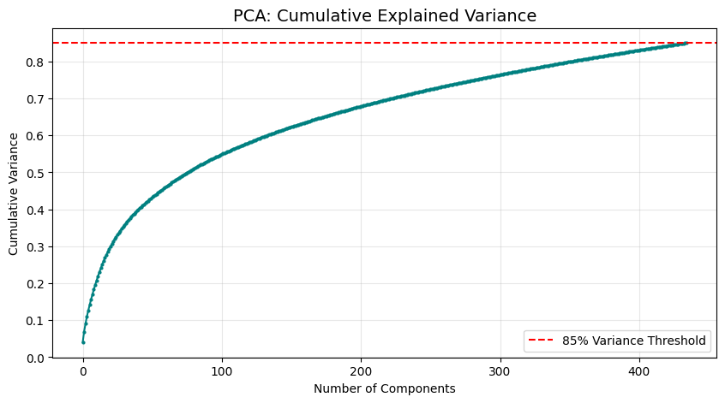
The t-SNE (t-Distributed Stochastic Neighbor Embedding) visualization is a high-performance tool used to squash complex, multi-dimensional data into a 2-D map. It provides a visual "proof of concept" for your machine learning model.

Business Value
- Recommendation Accuracy: Move from broad "Genre" tags to "Mathematical Neighbors," ensuring a user who finishes a movie is recommended the absolute closest thematic match.
- Gap Identification: "White spaces" on the map represent untapped markets where Netflix can produce new content to bridge two existing audience segments.

5. Project Phase: Final Clustering & Visualization
With our optimal K=6, we ran the K-Means++ algorithm.
t-SNE Visualization
- Explanation: Since humans can't see in 500 dimensions, we use t-SNE to squash the data into a 2D map.
- Insight: The resulting scatter plot shows clear "islands" of content. You can see Cluster 2 (Indian Cinema) standing far apart from the rest, showing just how unique that content is compared to Western movies.
Hierarchical Clustering (Dendrogram)
- Explanation: This "Family Tree" shows how clusters are related to each other.
- Insight: We can see that "Documentaries" often branch off early, while "International Dramas" and "Comedies" stay connected longer, showing a shared thematic overlap.
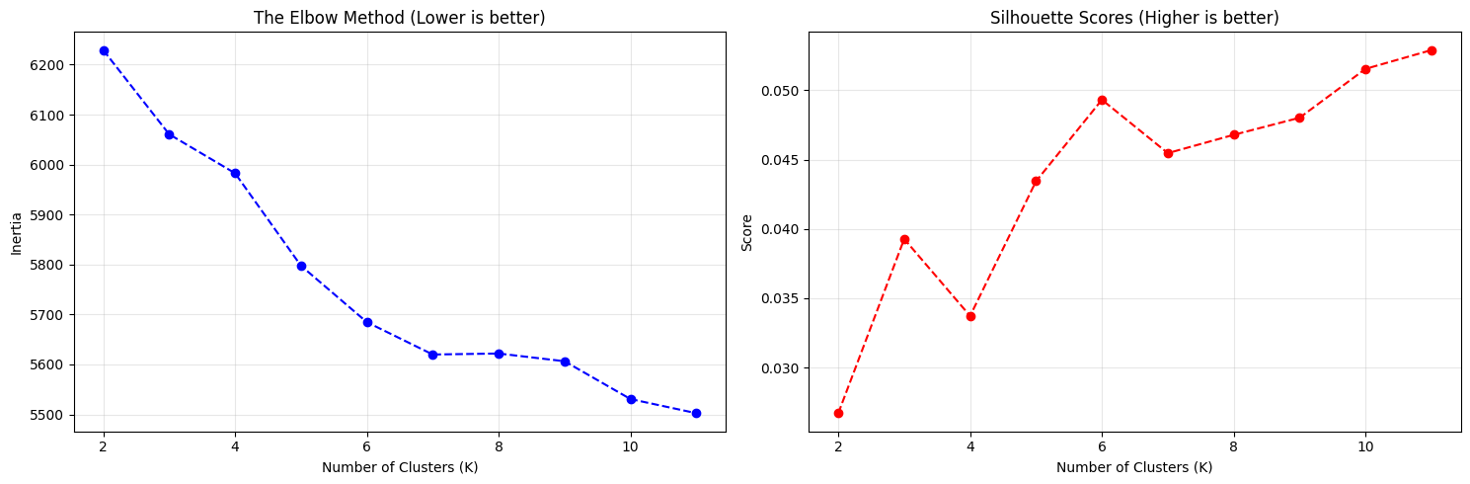

The t-SNE (t-Distributed Stochastic Neighbor Embedding) graph is a high-dimensional visualization tool that squashes thousands of metadata keywords into a 2D map to reveal the "geographic" structure of Netflix content.
Short & Crisp Explanation
- Content "Islands" (Clusters): Each colored grouping represents a distinct thematic universe (e.g., Bollywood, Documentaries). The physical separation proves the AI successfully distinguished unique genres without human labels.
- Thematic DNA (Proximity): Dots located close together share a high number of keywords, directors, or cast members. This provides a mathematical blueprint for high-accuracy recommendations.
- Genre-Benders (Bridges): Single dots sitting between two islands are hybrid titles (e.g., a "Horror-Comedy"). These are strategic "bridges" used to transition viewers from one interest group to another.
- Market Gaps: Large "white spaces" on the map identify untapped thematic combinations where Netflix can focus future content acquisition or production.
Business Value
It validates the model’s ability to move beyond generic "Genre" tags into Precision Mapping, allowing for targeted content buying and reduced subscriber churn by recommending "thematically adjacent" titles.

6. Business Insights & Value Proposition
This is the most important part of the document for a business stakeholder.
Cluster ID | Theme Identification | Key Characteristics | Business Strategy
Cluster 1 | Fact-Based Content | Documentaries, Reality TV | Retention: These users are loyal; invest in niche educational content.
Cluster 2 | Bollywood Universe | Amitabh Bachchan, Indian Drama | Expansion: This is a self-contained market. Needs localized marketing.
Cluster 4 | Global Comedy | Stand-up, International Humour | Engagement: These are short-form, "snackable" titles perfect for mobile users.
Cluster 5 | Action & Thrillers | Crime, Suspense, Mission | Acquisition: This is the "blockbuster" group. Focus on big-budget licenses here.

7. Strategic Recommendations
- Eliminate Search Fatigue: Instead of 20 generic genres, use these 6 "Universes" to create targeted landing pages (e.g., "The Bollywood Powerhouse").
- Smart Acquisition: If a potential new license doesn't fit into one of these high-performing clusters, the data suggests it may not find an audience on the platform.
- The "Bridge" Strategy: Use the Dendrogram to recommend content. If a user likes a "Drama," look at the closest branch in the tree—perhaps a "Dramedy"—to increase the "Next Watch" probability.
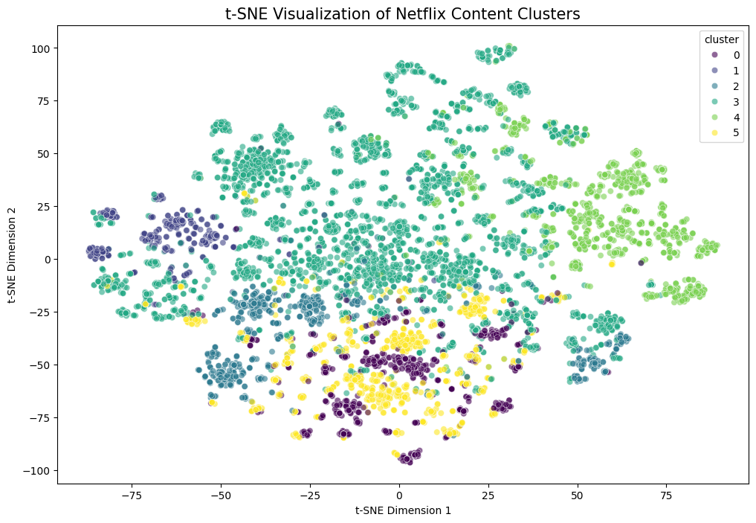

The t-SNE (t-Distributed Stochastic Neighbor Embedding) visualization is the "geographic map" of the Netflix content library. It compresses high-dimensional metadata (like keywords, cast, and descriptions) into a 2D scatter plot to reveal how the machine physically groups titles.
Short & Crisp Insights
- Content "Islands" (Clusters): Each colored grouping represents a distinct thematic universe. The clear separation between these "islands" proves the model successfully identified unique categories (e.g., Bollywood vs. Western Documentaries) without needing manual labels.
- Thematic Proximity: Dots located close to each other share similar metadata "DNA" (directors, actors, or themes). Proximity indicates high cross-over appeal; if a user likes one title, they will likely enjoy its neighbors on the map.
- "Bridges" (Genre-Benders): Scattered dots sitting between two large islands are hybrid titles (e.g., a "Horror-Comedy" or "Dramedy"). These are strategic tools for transitioning a viewer from one niche into another to keep them watching.
- Evaluation Metric: The cluster separation is mathematically validated by a Davies-Bouldin Index of 3.7328, where lower values indicate better-defined and more distinct groups.
Business Value
This visualization transforms abstract math into a precision marketing tool. Instead of relying on broad genre tags, Netflix can use these mathematical "locations" to ensure every recommendation is thematically adjacent to a user's taste, directly reducing "search fatigue" and subscriber churn.

8. Conclusion
This project successfully transformed raw Netflix metadata into a Content Intelligence System. By using a combination of NLP, PCA, and K-Means clustering, we have provided a roadmap for Netflix to better understand its library, acquire content more wisely, and keep users engaged longer through mathematically backed recommendations.

