Below is the complete slide-wise PPT content (25+ slides) for your project based on Spring Boot Microservices + Eureka + API Gateway + MySQL + Swagger + Actuator.
You can copy this directly into PowerPoint.

✅ MICROSERVICES PROJECT – PPT CONTENT (TEXT VERSION)

Project: Books, Authors, Ratings Microservices with Eureka + Gateway + MySQL + Swagger

Slide 1 – Title Slide
Microservices Architecture Project
Books | Authors | Ratings
Spring Boot 3.x | Eureka Server | API Gateway | MySQL | Actuator | Swagger
Presented by: Arun Yadav

Slide 2 – Agenda
- Project Overview
- Architecture Diagram
- Technology Stack
- Service Descriptions
- Eureka (Service Registry)
- API Gateway
- Inter-Service Communication
- MySQL Integration
- Swagger Configuration
- Actuator Monitoring
- Sample APIs
- Summary

Slide 3 – What Are Microservices?
- Small, loosely coupled independent services
- Each service handles one domain
- Services communicate using REST
- Allows scaling & deployment independently
- Fault isolation with service registry

Slide 4 – Project Overview
We build 3 microservices:
- Book Service
- Author Service
- Rating Service
Supporting systems:
- Eureka Server (Service Discovery)
- API Gateway (Central entry point)
- MySQL (DB for each service)
- Swagger (API documentation)
- Actuator (Monitoring/Health)

Slide 5 – Architecture Diagram (Text Description)
+-----------------------+
| API Gateway |
| http://localhost:8080|
+----------+------------+
|
--------------------------------------------------
| | |
+-----------+ +-------------+ +--------------+
| Book Svc | <-----> | Author Svc | <-----> | Rating Svc |
| 8081 | | 8082 | | 8083 |
+-----------+ +-------------+ +--------------+

+-----------------------------+
| Eureka Server 8761 |
+-----------------------------+

Each service → MySQL database instance

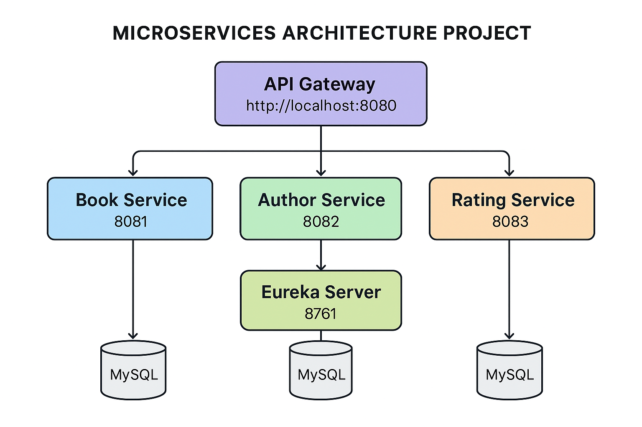Slide 6 – Technology Stack
- Java 17+
- Spring Boot 3.1+
- Spring Cloud 2023.x
- Spring Data JPA
- Spring Cloud Gateway
- Spring Cloud Eureka
- MySQL
- Swagger (springdoc-openapi)
- Actuator
- Maven
- STS 4 / IntelliJ / VSCode

Slide 7 – Microservices

1. Book Service
- Saves book details
- Calls AuthorService & RatingService
- Provides combined response (BookDTO)

2. Author Service
- Manages author info
- CRUD operations
- Provides AuthorDTO

3. Rating Service
- Stores ratings for books
- Returns RatingDTO

Slide 8 – DTO Structure

AuthorDTO
class AuthorDTO {
Long id;
String name;
String biography;
}

RatingDTO
class RatingDTO {
Long id;
Long bookId;
Integer stars;
String review;
}

Slide 9 – BookResponse DTO
class BookResponse {
Long id;
String title;
String description;
AuthorDTO author;
RatingDTO rating;
}

Slide 10 – Eureka Server
- Registers all microservices
- Acts as a service registry
- URL → http://localhost:8761
- Shows live status: UP / DOWN
- Microservices auto-register using @EnableEurekaClient

Slide 11 – Eureka Configuration

pom.xml
<dependency>
<groupId>org.springframework.cloud</groupId>
<artifactId>spring-cloud-starter-netflix-eureka-server</artifactId>
</dependency>

Main Class
@EnableEurekaServer
@SpringBootApplication

Slide 12 – Microservice Eureka Client Config
spring.application.name=book-service
server.port=8081

eureka.client.register-with-eureka=true
eureka.client.fetch-registry=true
eureka.client.service-url.defaultZone=http://localhost:8761/eureka

Slide 13 – API Gateway
- All requests routed through gateway
- URL examples:
  - /books/** → Book Service
  - /authors/** → Author Service
  - /ratings/** → Rating Service
- Handles:
  - request routing
  - load balancing
  - filters
  - security (future)

Slide 14 – Gateway Route Config
spring.cloud.gateway.routes[0].id=book-service
spring.cloud.gateway.routes[0].uri=lb://book-service
spring.cloud.gateway.routes[0].predicates[0]=Path=/books/**

Slide 15 – MySQL Integration
Each service has its own DB:
- book_db
- author_db
- rating_db
Example configuration:
spring.datasource.url=jdbc:mysql://localhost:3306/book_db
spring.datasource.username=root
spring.datasource.password=root
spring.jpa.hibernate.ddl-auto=update

Slide 16 – Sample Entity (BookService)
@Entity
class Book {
@Id @GeneratedValue
Long id;
String title;
Long authorId;
}

Slide 17 – Inter-Service Communication
BookService → calls AuthorService & RatingService
using WebClient:
@Autowired
private WebClient.Builder webClient;

AuthorDTO author = webClient.build()
.get().uri("http://author-service/authors/" + authorId)
.retrieve().bodyToMono(AuthorDTO.class).block();

Slide 18 – Swagger Documentation

Dependency:
<dependency>
<groupId>org.springdoc</groupId>
<artifactId>springdoc-openapi-starter-webmvc-ui</artifactId>
<version>2.3.0</version>
</dependency>

Access URL:
http://localhost:8081/swagger-ui.html

Slide 19 – Swagger Config
(Since Spring Boot 3, no config required)
Optional:
@OpenAPIDefinition(
info = @Info(title = "Book Service API", version = "1.0")
)

Slide 20 – Actuator
Provides health & metrics endpoints.

Add dependency:
<dependency>
<groupId>org.springframework.boot</groupId>
<artifactId>spring-boot-starter-actuator</artifactId>
</dependency>

Slide 21 – Actuator Config
management.endpoints.web.exposure.include=*
management.endpoint.health.show-details=always

URL:
http://localhost:8081/actuator
http://localhost:8081/actuator/health

Slide 22 – Sample APIs

Book Service
- GET /books
- GET /books/{id}
- POST /books

Author Service
- GET /authors
- POST /authors

Rating Service
- GET /ratings/book/{id}
- POST /ratings

Slide 23 – Combined Book Response
API:
GET /books/{id}
Response:
{
"title": "Spring Boot",
"author": {…},
"rating": {…}
}

Slide 24 – Error Handling
- Custom exception handler
- 404 Not Found
- 500 Internal Server Error
- Communication failure fallback

Slide 25 – Security (Future Scope)
- JWT Authentication
- Role-based access
- Gateway-level security

Slide 26 – Conclusion
- Fully functional microservices system
- Scalable, modular architecture
- Easy to document (Swagger)
- Easy to monitor (Actuator)
- Production-ready design

Slide 27 – Thank You
Questions?

If you want, I can also generate:
📌 Architecture diagram as an image
📌 ER Diagram for MySQL
📌 High-level + Low-level design docs
📌 Word/PDF version of PPT
Would you like those?

