

“E-Waste Segregation System”

Submitted to the
Savitribai Phule Pune University
In partial fulfillment for the award of the Degree of
Bachelor of Engineering
in
Information Technology
by

Yash Gawandare
(4064 SEIT)

Kedar Mahamuni
(4025 SEIT)

Harshad Bhalsing
(4070 SEIT)

Atharva Kamble
(4024 SEIT)

Under the guidance of

Prof. MrsKshama Balbudhe

Department of Information Technology
PVGCOET & GKPIM, Pune
Pune, Maharashtra 411009

2024-25


CERTIFICATE

This is to certify that the project-based learning report entitled “E-Waste Segregation System” being submitted by Mr.Yash Gawandare (4064 SEIT) is a record of bonafide work carried out by him/her under the supervision and guidance of Prof. Mrs.Kshama Balbudhe in partial fulfillment of the requirement for SE (Information Technology) 2019 course of Savitribai Phule Pune University, Pune in the academic year 2024-25.

Date:

Place: Pune

Guide Head of the Department

Prof.Mrs Kshama Balbudhe Prof. S.A.Mahajan

CERTIFICATE

This is to certify that the project-based learning report entitled “E-Waste Segregation System” being submitted by Mr.Kedar Mahamuni (4025 SEIT) is a record of bonafide work carried out by him/her under the supervision and guidance of Prof. Kshama Balbudhe in partial fulfillment of the requirement for SE (Information Technology) 2019 course of Savitribai Phule Pune University, Pune in the academic year 202.

Date:

Place: Pune

Guide Head of the Department

Prof.Mrs Kshama Balbudhe Prof. S.A.Mahajan

CERTIFICATE

This is to certify that the project-based learning report entitled “E-Waste Segregation System” being submitted by Mr.Harshad Bhalsing (4070 SEIT) is a record of bonafide work carried out by him/her under the supervision and guidance of Prof. Kshama Balbudhe in partial fulfillment of the requirement for SE (Information Technology) 2019 course of Savitribai Phule Pune University, Pune in the academic year 2022-23.

Date:

Place: Pune

Guide Head of the Department

Prof.Mrs Kshama Balbudhe Prof. S.A.Mahajan

CERTIFICATE

This is to certify that the project-based learning report entitled “E-Waste Segregation System” being submitted by Mr.Atharva Kamble (4024 SEIT) is a record of bonafide work carried out by him/her under the supervision and guidance of Prof. Kshama Balbudhe in partial fulfillment of the requirement for SE (Information Technology) 2019 course of Savitribai Phule Pune University, Pune in the academic year 2022-23.

Date:

Place: Pune

Guide Head of the Department

Prof.Mrs Kshama Balbudhe Prof. S.A.Mahajan

ACKNOWLEDGEMENT

I would like to express my sincere gratitude to all those who have contributed to the successful completion of this project on E-Waste Segregation System.
First and foremost, I extend my deepest appreciation to my project guide, Prof.Mrs. Kshama Balbudhe, whose valuable guidance, insightful suggestions, and continuous support were crucial throughout the development of this work.
I am grateful to the faculty members and academic staff of the Information Technology, PVGCOET & GKPIM, for providing a strong foundation and technical knowledge that greatly assisted this work.
Special thanks to Prof.S.A.Mahajan for their time and valuable comments that helped in refining the final report and improving the project outcomes.
This project also benefited from various open-source datasets and software frameworks, and I wish to thank the developers and contributors behind these resources. Additionally, I am thankful to individuals and organizations that provided guidance on waste management systems and helped improve the relevance of the model’s practical application.
Finally, I am thankful to my family and friends for their constant encouragement and moral support throughout the course of this work.

Mr.Yash Gawandare

Mr.Kedar Mahamuni

Mr.Harshad Bhalsing

Mr.Atharva Kamble

CONTENTS
Sr. No TITLE Page no

Abstract

- INTRODUCTION 2
  - Introduction and Objectives
    - Motivation
    - Objective
  - Purpose of the project
  - Existing System and Disadvantages
  - Proposed System with Features
- LITERATURE SURVEY 4
- SYSTEM REQUIREMENTS SPECIFICATIONS 5
  - Functional / Non-Functional Requirement
  - Software Requirement
  - Hardware Requirement
- SYSTEM DESIGN 6
  - Process Model
  - System Block Diagram /Architecture Diagram
  - UML Diagrams / ER Diagram
- GRAPHICAL USER INTERFACE 9
- FUTURE ENHANCEMENTS 19
- CONCLUSION 20
- REFERENCES 21

ABSTRACT

The rapid advancement of technology has led to a significant rise in electronic waste (e-waste), posing serious environmental and health risks due to improper disposal and inefficient recycling practices. To address this challenge, this project presents an intelligent E-Waste Segregation System that leverages machine learning for automated classification of e-waste materials.

The primary objective of this work is to develop a system capable of detecting and categorizing e-waste components—such as mobile phones, keyboards, circuit boards, and other electronic items—through image-based analysis, thereby facilitating efficient sorting and recycling. The system uses a live video feed captured by a camera, which is then processed through a series of components including image preprocessing, object detection using a trained ML model.

A machine learning model was trained on a curated dataset of e-waste images to achieve accurate object detection and classification. The model was integrated into a modular pipeline consisting of a camera handler, image preprocessing module, detection processing unit, and a user interface for real-time monitoring.

Testing results demonstrated promising detection accuracy and category precision, suggesting the system’s potential for real-world application in waste management facilities. The significance of this work lies in its contribution to automating e-waste handling processes, reducing manual labor, and promoting environmentally responsible recycling practices.

This project serves as a foundation for scalable, AI-driven waste management solutions that can be further extended to include additional waste categories and integrated with industrial automation systems.

INTRODUCTION

1.1 Introduction to Project

- Exploring the use of machine learning for waste detection with image input
- Addressing the growing challenges in waste management
- Leveraging computer vision techniques to identify and classify waste materials
- Automating waste sorting to improve efficiency in recycling processes

1.1.1 Motivation behind project topic
- Growing e-waste problem worldwide
- Inefficient waste segregation techniques
- Lack of smart recycling solutions
- Limited automation in waste identification

1.1.2 Aim and Objective(s) of the work
Aim
The aim of this project is to develop an intelligent software system that can automatically detect and classify e-waste materials in real time using scanning technology, helping in effective waste segregation and management.

Objective
      - Collect and preprocess a dataset containing images of e-waste categories.
      - Train a machine learning model to detect and classify waste with high accuracy.
      - Implement real-time image processing for waste recognition.

1.2 Purpose
The primary purpose of this project is to design and develop an intelligent system capable of automatically detecting and classifying various types of electronic waste (e-waste) using machine learning techniques. With the increasing volume of discarded electronic devices and components, there is a growing need for efficient, scalable, and safe methods of e-waste management.
This project aims to address the limitations of existing manual and mechanical sorting methods by leveraging the capabilities of computer vision and deep learning. Through real-time image analysis, the system can accurately identify e-waste items such as mobile phones, circuit boards, cables, and other components, and categorize them for proper handling and recycling.
The implementation of such a system not only reduces dependency on manual labor and minimizes health hazards but also enhances the speed, consistency, and accuracy of e-waste segregation. Ultimately, the project contributes toward building a sustainable and technology-driven solution for effective e-waste management and environmental protection.

1.3 Existing System and Disadvantages:
1. Manual Segregation: Currently, the most common method for e-waste sorting in many regions is manual segregation, where workers identify and separate e-waste components by hand.
- Disadvantages:
  - Time-consuming and labour intensive.
  - Exposure to hazardous materials poses serious health risks.
  - Prone to human error, leading to low accuracy in categorization.
  - Not scalable for large-scale waste processing.

2. Mechanical/Electromechanical Sorting Systems: Some recycling facilities use basic mechanical sorters like conveyor belts, shredders, or magnetic separators to separate materials based on size, weight, or magnetic properties.
- Disadvantages:
  - Limited to physical properties, cannot differentiate between types of electronic components.
  - Ineffective for complex or small-sized electronic waste.
  - High initial setup cost with limited intelligence or adaptability.
3. Barcode or Tag-Based Identification: In a few structured environments, electronic items are tagged with barcodes or RFID for identification and tracking.
- Disadvantages:
  - Not suitable for post-consumer waste where tags may be missing or damaged.
  - Requires prior integration and infrastructure.
  - Cannot identify or classify untagged or damaged components.
4. Basic Image Processing Techniques: Some systems may use simple image processing (without AI/ML) for sorting based on color or shape.
- Disadvantages:
  - Inaccurate in real-world, variable lighting and background conditions.
  - Cannot generalize to new or unseen e-waste items.
  - Lack of contextual understanding or classification ability.

1.4 Proposed System and Features:-

The proposed system is a real-time e-waste segregation platform that uses machine learning to detect and classify electronic waste items from live camera input. It aims to automate the sorting process, reduce manual effort, and promote efficient recycling.
Key Features:
- Real-Time Detection: Uses a live video feed for immediate waste identification.
- ML-Based Classification: Classifies e-waste (e.g., phones, PCBs, wires) using a trained model.
- Image Preprocessing: Enhances input quality for better accuracy.
- User Interface: Displays detection results in real time.
- Modular Design: Easy to maintain and expand.
- Scalable & Eco-Friendly: Can be adapted to various setups, promoting sustainable waste management

LITERATURE SURVEY

Sr. No. | Reference Name | Seed Idea/ Work Description | Problems Found | Any Other Criteria
1 | Automatic Garbage Classification Using ML model | Proposes using ML model for real-time waste classification to enhance recycling efficiency | Traditional waste sorting is labor-intensive and error-prone | Uses a dataset with various waste types and evaluates ML model’s performance.
2 | Waste Management Using Machine Learning and Deep Learning Algorithms | Uses ML and DL models to automate waste classification and improve recycling efficiency. | Traditional ML models perform poorly compared to CNN, limiting classification accuracy. | Focuses on comparing ML and CNN approaches.
3 | Application of Machine Learning in Plastic Waste Detection and Classification: A Systematic Review. | Reviews ML-based plastic waste detection techniques, highlighting CNN-based advancements. | Many studies rely on small, non-standardized datasets, reducing model generalizability. | Systematic review of existing approaches.
4 | Machine Learning and IoT-Based Waste Management Model | Integrates IoT sensors and ML for real-time waste monitoring and collection route optimization. | System depends on stable connectivity and sensor reliability, making real-time operation challenging | Combines IoT with ML for smart waste management.

Ⅲ . SYSTEM REQUIREMENTS SPECIFICATION

3.1.1 Functional Requirments :

- Real Time Video capture : The system must capture live video feed from a webcam.
- Frame Extraction : The system should extract frames from the video stream for processing.
- Preprocessing of input : The system must resize and normalize frames for compatibility.
- Object Detection & Classification : The system should detect and classify objects into categories: Battery, Cable,etc.
- Display Results : Detected objects should be displayed on-screen with bounding boxes and labels.
- Performance Monitoring: The system can log detected objects with timestamps for future analysis.

3.1.2 Non-Functional Requirments :

- Accuracy : The object detection model should maintain high detection accuracy for different waste types.
- Scalability :Should support future extension to include more waste types or integration with smart bins.
- Reliability : The system should handle continuous video input without crashing or lagging.
- Performance : The system should process at least 10–15 FPS for real-time usability.

3.2 Software Requirments :

- Operating System & Development Tools
- OS: Windows 10/11(for development)
- Python (Backend)
- Flask(API Connectivity)
- OpenCV (For image recognition)
- Python stramlit (Frontend)
B. AI & ML Frameworks
- PyTorch library (For running deep learning models on local machine)
- YOLOv11 ML Algorithm (for model training)

3.3 Hardware Requirments :
- Laptop/PC (i5/i7 processor)
- High-resolution Camera (For waste recognition testing)
- Nvidia RTX 4050 (Graphics Card)
- Memory: 256GB (Dataset) ROM, 8GB RAM

Ⅳ . SYSTEM DESIGN

  - Process Model (Methodology)

Software approach used in the development of the E-Waste Segregation System is the "Iterative Process Model". The Iterative Model is a widely used software development process model in which the system is developed through repeated cycles (iterations) and in smaller portions at a time (increments). Instead of starting with a full specification of requirements, the project starts with a simple implementation of a subset of software requirements and iteratively enhances the evolving versions until the full system is implemented.
In the E-Waste Segregation System, this model was particularly effective, as it allowed for:
- Continuous feedback from testing the e-waste detection algorithm.
- Improvements in the machine learning model based on real-time webcam results.
- Adding features like live detection, classification of waste types (batteries, cables,etc), and real-time UI updates in the Streamlit web application in incremental phases.
Phases of the Iterative Model Applied:
- Initial Planning and Requirement Gathering
  - Identify the key features of the system such as object detection, classification of waste types, and webcam integration.
- First Iteration – Prototype Development
  - Develop a basic object detection system using a pre-trained ML model.
  - Build a simple interface for testing.
- Analysis and Feedback
  - Test the prototype with sample e-waste images and videos.
  - Collect results, evaluate performance of the model.
- Second Iteration – Enhanced Detection and Classification
  - Improve the model accuracy by training on a custom dataset of e-waste images.
  - Add classification logic to identify categories like batteries, cables, etc.
- Third Iteration – Real-Time Integration
  - Connect webcam for real-time detection.
  - Add user interface features like classification labels and output logs.

- Final Iteration – Testing and Maintenance
  - Perform full system testing including performance testing, edge cases, and UI improvements.
  - Prepare the system for deployment and document all features for future maintenance.

  - System Block Diagram :

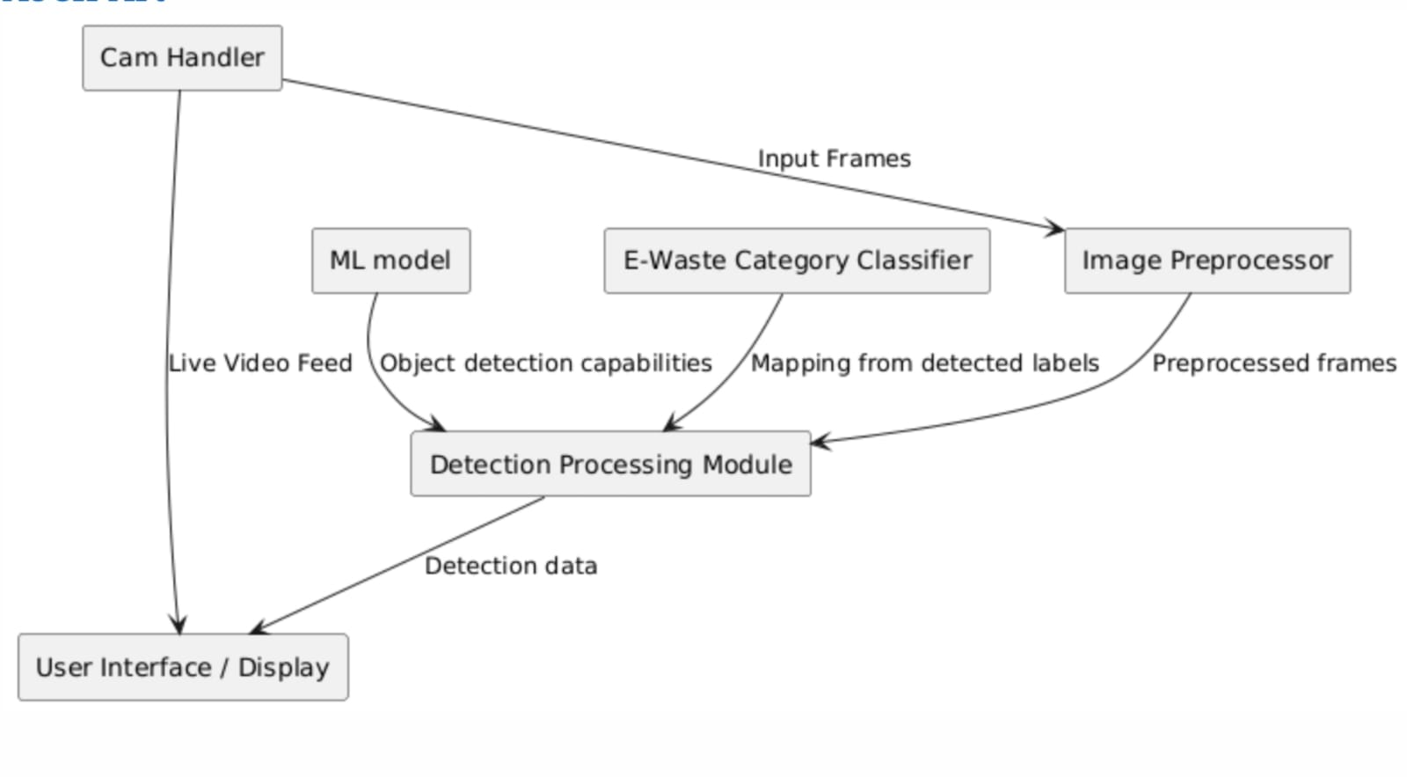

Fig 1: Block Diagram
4.3 UML Diagrams / ER Diagram

    - USE CASE DIAGRAM

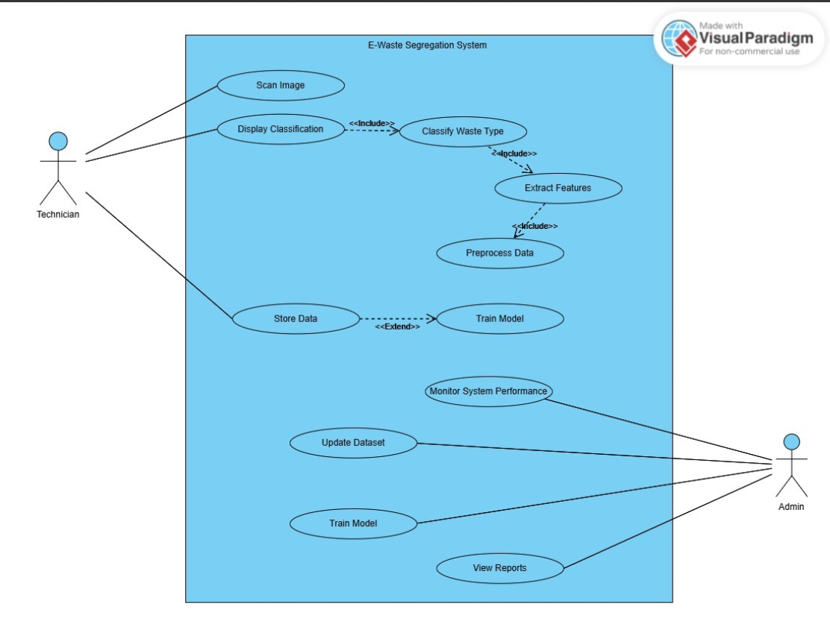

    - ACTIVITY DIAGRAM

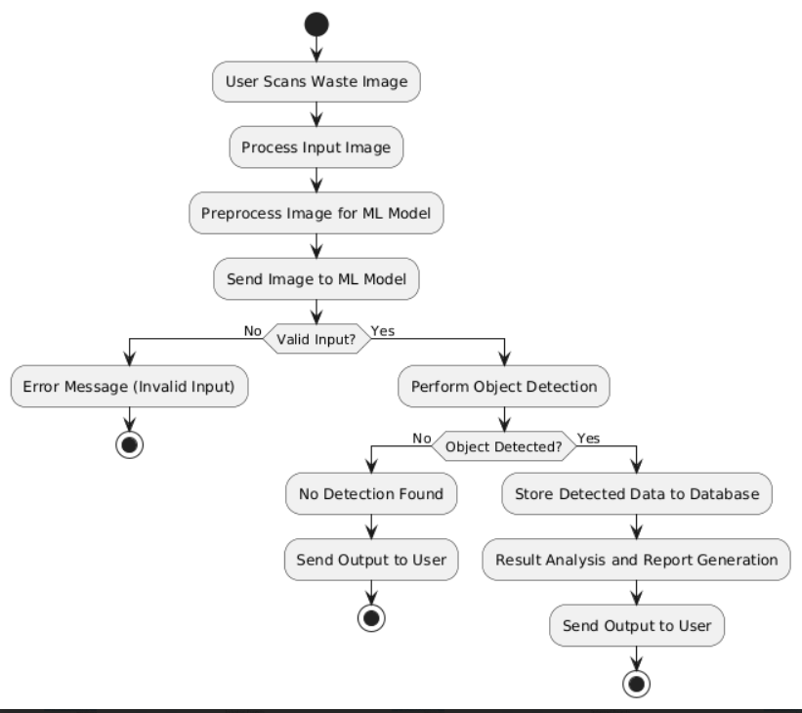

    - CLASS DIAGRAM

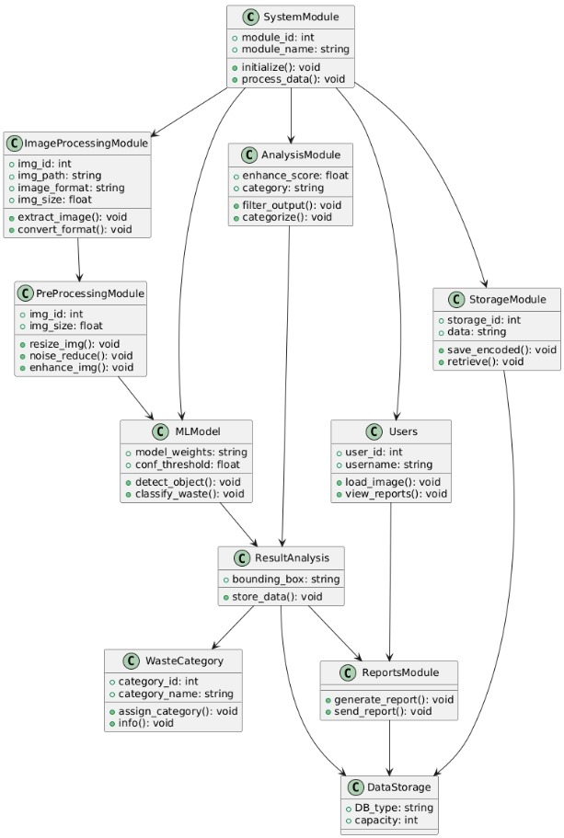
    - SEQUENCE DIAGRAM

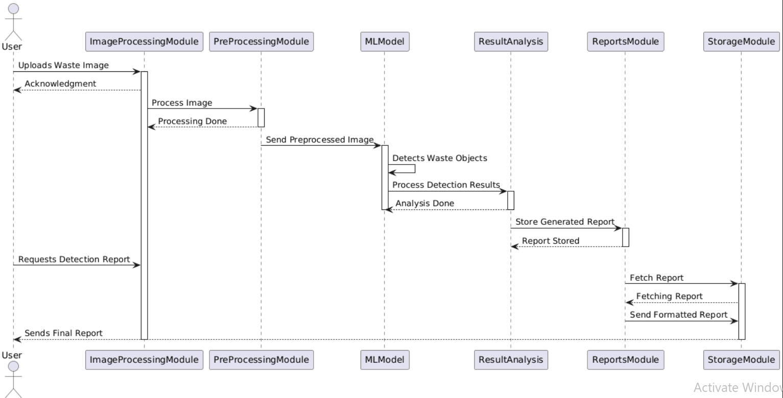

    - DFD LEVEL 0 & 1
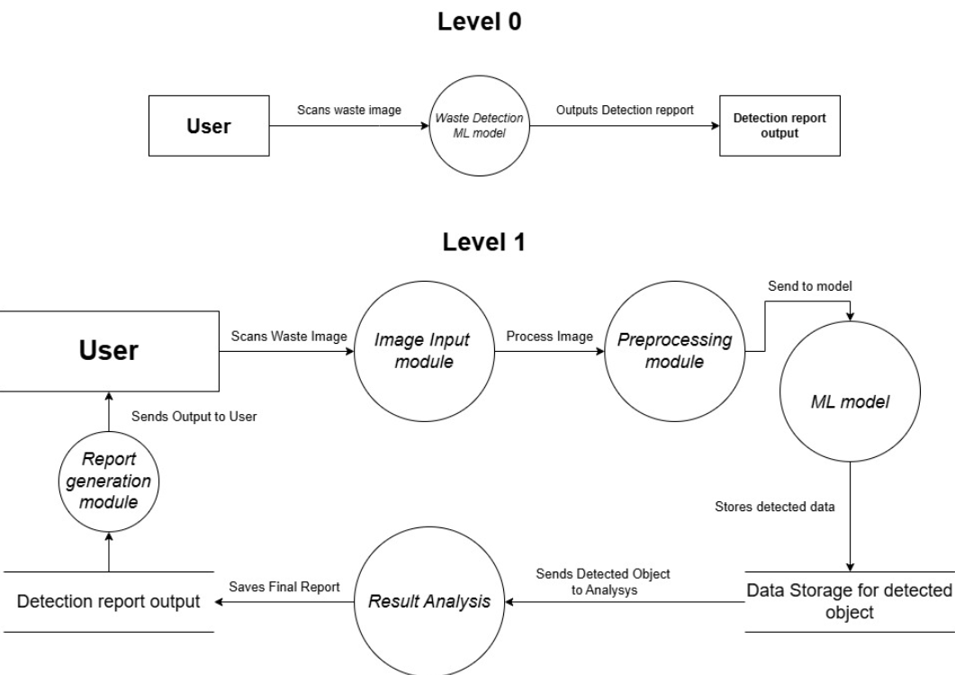

DFD LEVEL 2

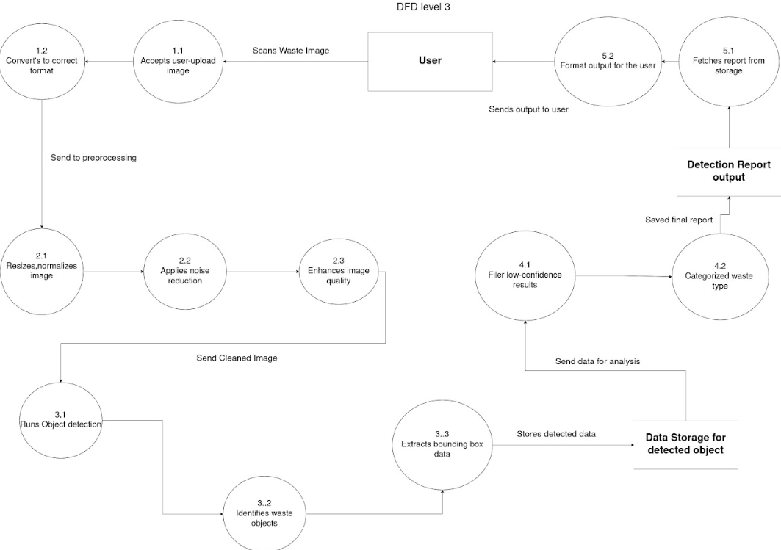

Ⅴ. GRAPHICAL USER INTERFACE

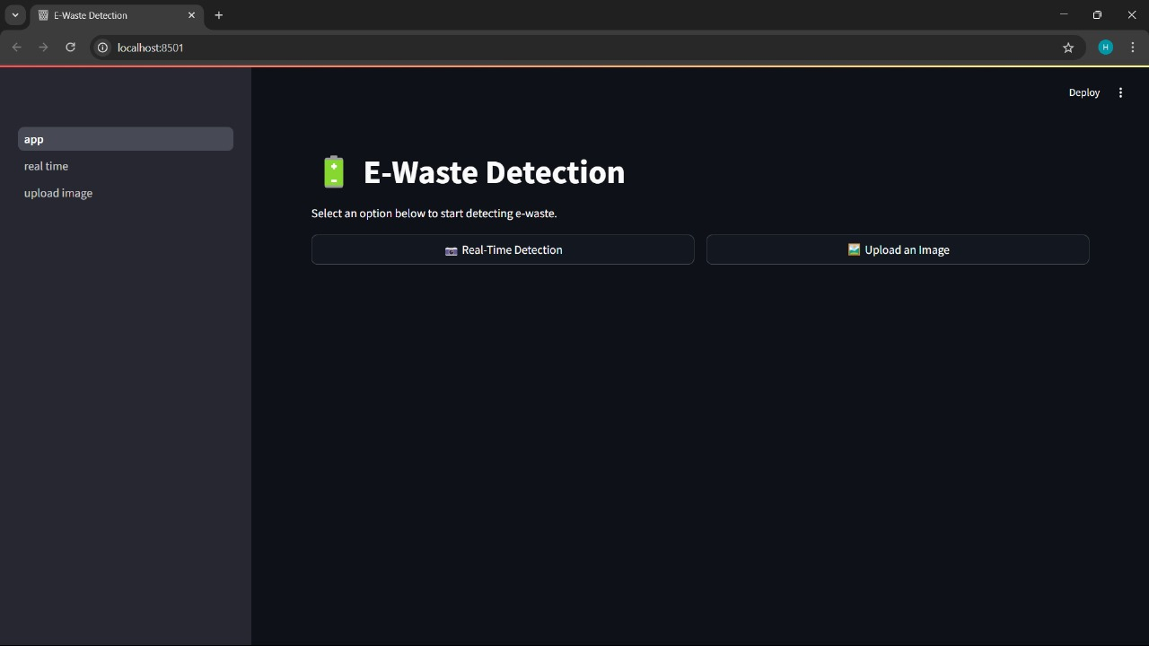

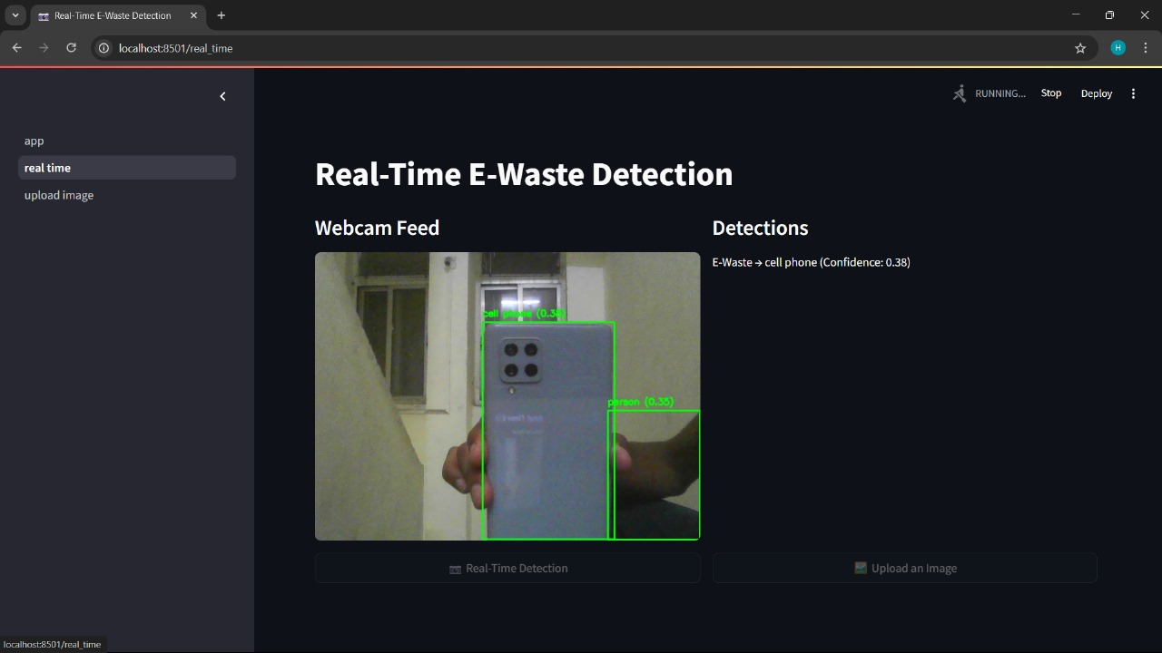

Ⅵ. FUTURE ENHANCEMENTS

Improved Datasets:

Expanding and diversifying datasets to include various types of waste and real-world scenarios, such as partially obscured or mixed waste, for better accuracy and generalization.

IoT Integration:

Combining ML model with IoT-enabled smart bins and sensors for real-time waste sorting, automatic notifications for collection services, and optimized waste management.

Edge Computing:

Optimizing ML model for deployment on edge devices like drones, cameras, and robots, enabling real-time waste detection on low-cost, decentralized devices without relying on cloud infrastructure.

AI Model Integration:

Enhancing ML model with additional AI models and sensor data for more accurate waste classification, improving sorting efficiency and promoting better recycling practices. These advancements will help ML model remain a powerful tool for future waste detection and management systems.

Ⅶ. CONCLUSION

In conclusion, we implemented a Machine Learning Model for waste detection which detected and sorted waste based on images, improving recycling efficiency, and promote sustainability. We used real images as datasets for improved detection accuracy and sorting. This technology enhances waste management systems and enables data-driven decisions, reduces human error, and supports smarter, more eco-friendly practices.

Ⅷ. REFERENCES

- [1] S. R. Gupta, M. Sharma, and A. K. Soni, "Automatic Garbage Classification Using ML model," International Advanced Research Journal in Science, Engineering and Technology, vol. 11, no. 3, pp. 110-113, Mar. 2024.

- [2] H. C. Lee, P. J. Tan, and R. S. Kwan, "Title of the Paper," Mathematics, vol. 12, no. 14, p. 2185, 2024.

- [3] A. R. Zhang, K. Liu, and W. P. Tan, "Real-Time Household Waste Detection and Classification for Recycling Systems Based on ML model," Sustainability, vol. 17, no. 5, p. 1902, 2025.

- [4] V. Singh, R. K. Mehta, and S. Kumar, "A Comparative Analysis of Deep Learning Models for Waste Segregation: ML model, EfficientDet, and Detectron 2," Multimedia Tools and Applications, 2025.

