
Brand Architecture
How CHITY GROUP and its businesses relate

1. Architecture model
CHITY GROUP uses an endorsed brand architecture. The parent company is the corporate owner and steward. Operating businesses keep independent brand identities suited to their own markets and are endorsed, where useful, by the descriptor “A Chity Group Company”.
- Operating businesses can build strong market identities without being limited by the parent's style.
- The parent brand stays sector-neutral and credible.
- New ventures and acquisitions can join the group without disturbing existing brands.
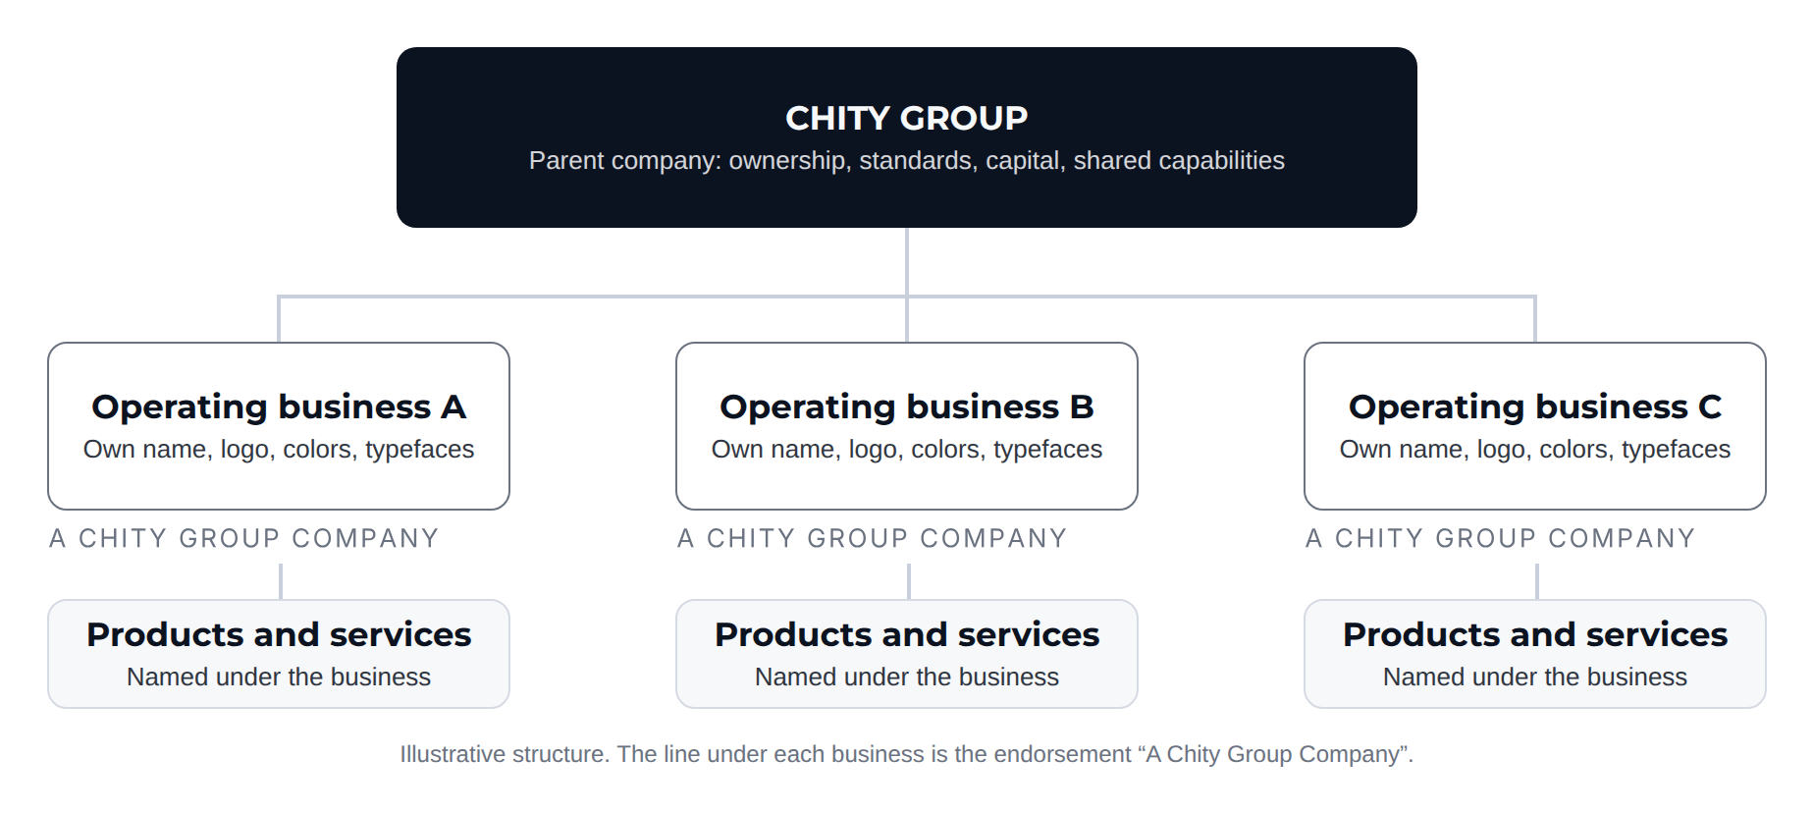

2. Hierarchy
LEVEL | ROLE | WHERE IT APPEARS
Parent brand  CHITY GROUP | Holds the legal, strategic and corporate identity. Provides direction, capital, standards and shared capabilities. | Governance, investor relations, group announcements, recruitment, legal contracts and corporate communications.
Operating businesses | Independent brands serving a specific market or audience, each with its own name, logo, colors and typefaces. | Packaging, commercial websites, social channels, advertising and customer touchpoints.
Products and services | Named under the operating business, never directly under the parent. | Product and service communication of each business.
The endorsement line “A Chity Group Company” is a relationship descriptor, not a fourth level. It links an operating business to the group and signals ownership, backing and high operating standards.

3. Relationship rules
DIMENSION | RULE
Naming | Operating businesses use independent names. The word “Chity” is not part of an operating business's name unless the Brand Owner approves an exception.
Logo | Each business has its own logo. The CHITY GROUP logo is never merged into a business's logo or placed inside it.
Color and typography | Businesses define their own. CHITY GROUP's colors and typefaces apply to materials issued by CHITY GROUP itself.
Voice | CHITY GROUP speaks as builder and owner on corporate topics. Businesses speak in their own voice to their customers.
Ownership language | Group ownership is expressed with the endorsement “A Chity Group Company”.
Sector neutrality | No single business may dominate the parent's identity, imagery or language.

4. Endorsement line
The endorsement line is a quiet, objective badge of ownership. It follows one specification in every business's materials.
PROPERTY | SPECIFICATION
Text | A Chity Group Company, set in capitals: A CHITY GROUP COMPANY
Typeface | Inter Regular, all capitals, +100 tracking (0.1 em)
Maximum size | Cap height no more than 25% of the height of the business's primary logo
Minimum size | 8 px on screen or 6 pt in print. Where the two rules conflict, the minimum applies.
Clear space | At least the cap height of the line on all four sides
Primary position | Directly beneath the business's logo, flush left
Secondary position | Bottom left or bottom right of digital screens, marketing materials and document footers
Color on light backgrounds | Slate Gray #6B7280, or the business's primary dark neutral
Color on dark backgrounds | Cloud White #F7F8FA
Never | In the business's accent color, over busy imagery, or combined with the CHITY GROUP logo in a single lockup
Artwork | Supplied as SVG and PNG in two colors (Slate Gray for light backgrounds, Cloud White for dark). Never retype the line.
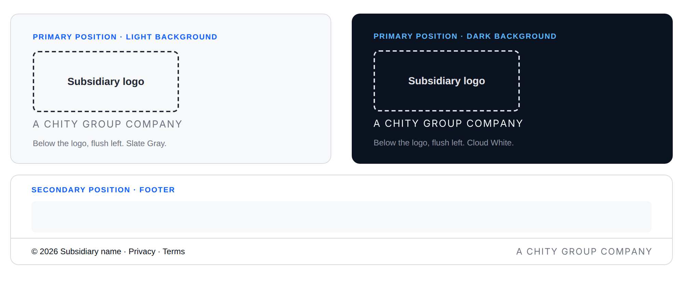

When the endorsement appears
- Always: corporate and official contexts, including website footers, press releases, corporate stationery, and legal and investor documents.
- Where useful: packaging, advertising, social channels and product interfaces, agreed for each business with the Brand Owner.
- Not used: where it would confuse customers or weaken a launch, as agreed with the Brand Owner.

5. Adding a business
- Create or confirm the business's own identity (name, logo, colors and typefaces) independently of CHITY GROUP styling.
- Agree with the Brand Owner how the endorsement applies.
- Apply the endorsement line to the agreed touchpoints.
- Record the business and its brand assets in the brand register.
- Pass launch materials through brand review before public release.

6. Responsibilities
The Brand Owner, a person or team designated by group leadership, approves how the endorsement is applied, any exception to the naming rule, and launch materials for new businesses. In all other respects, operating businesses make their own brand decisions.

