
Logo System
Which logo to use, how much space it needs, how small it can go, and what to avoid

1. The logo family
CHITY GROUP has one logo in several forms. Choose the form by the space available and the background it sits on. Primary is the stacked version (mark above the name). Secondary is the horizontal version (mark beside the name). Every form is supplied as SVG (vector, for web and print) and PNG (for Word, PowerPoint and Canva) on transparent backgrounds.
FORM | USE WHEN | FOLDER
Primary logo (stacked, with tagline) | The default. Covers, title slides, signage and packaging. At least 200 px or 50 mm wide. | 02_LOGO/Primary_Stacked
Primary logo, no tagline | Smaller sizes of the stacked logo, between 120 and 200 px. | 02_LOGO/Primary_Stacked
Secondary logo (horizontal, with tagline) | Wide spaces: website headers and footers, banners, letterhead. At least 300 px or 75 mm wide. | 02_LOGO/Secondary_Horizontal
Secondary logo, no tagline | Tight or wide spaces under 300 px: email signatures, app headers, small footers. At least 140 px or 37 mm. | 02_LOGO/Secondary_Horizontal
Submark (the C alone) | Avatars, app icons, favicons and watermarks, where the full name appears nearby or the brand is established. | 02_LOGO/Submark
App icon and favicon | Browser tabs, home screens, app stores and social profile pictures. | 02_LOGO/App_Icon_Favicon
One-color versions (Navy or White) | Single-ink printing, stamps, engraving, and backgrounds where the full-color logo does not work. | All logo folders
Endorsement line | "A CHITY GROUP COMPANY" for operating businesses. See Brand Architecture. | 02_LOGO/Endorsement_Line
Never rebuild, retype or redraw any part of the logo. Always use the supplied files.

2. Anatomy and proportions
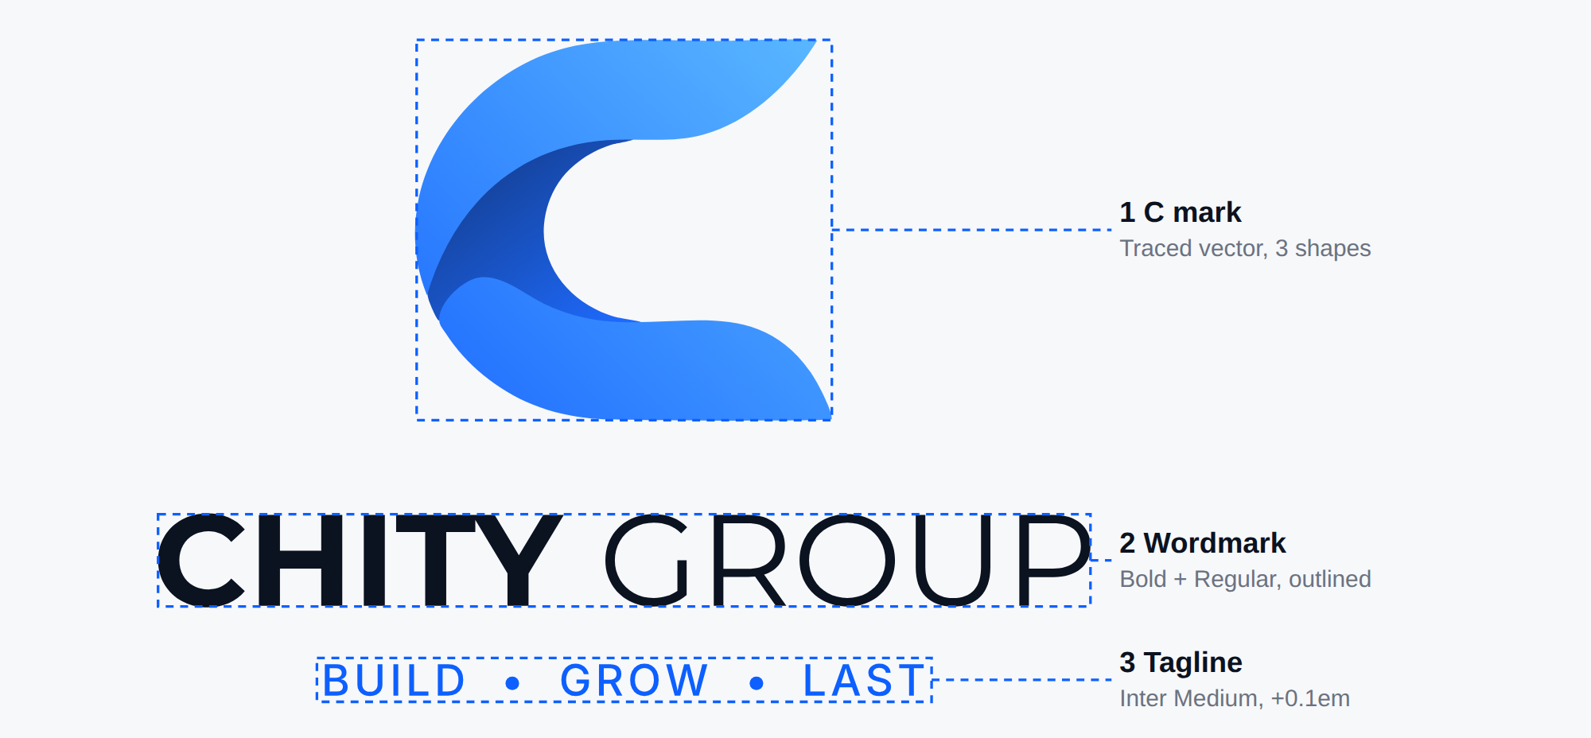
Let C be the cap height of the wordmark. In the stacked logo every distance is a fixed multiple of C.
MEASUREMENT (STACKED LOGO) | UNITS | IN C
Mark width | 315 | 4.6 C
Mark height (the clear-space unit X) | 288 | 4.2 C
Gap from mark to wordmark capitals | 72 | 1.04 C
Wordmark width | 708 | 10.3 C
Gap from wordmark baseline to tagline capitals | 44 | 0.64 C
Tagline cap height | 24 | 0.35 C
Tagline width, centered under the wordmark | 455 | 6.6 C
In the horizontal logo the mark and wordmark keep the same size and the gap between them is 55 units (0.8 C). The wordmark is Montserrat Bold (CHITY) and Montserrat Regular (GROUP) as outlined artwork. The tagline is Inter Medium in capitals with 0.1 em letter spacing. The mark is a true vector and every variant derives from one master shape.

3. Clear space
Keep a free margin of X on all four sides of every logo, where X is the full height of the C symbol in that logo. In the standard files X is 4.2 times the wordmark cap height. Nothing may enter this zone: text, images, other logos or the edge of the page.

- The same definition applies to every form: stacked, horizontal and submark (for the submark alone, X is the height of the mark).
- The app icon, favicon and social profile images are exempt; their navy container sets its own padding.
- Inside websites, apps and email signatures, where space is tight, the margin may reduce to 0.5 X. It may never be smaller.

4. Minimum sizes
The limiting factor is the tagline: below the sizes listed its capitals fall under about 6.5 px, so use the version without the tagline. For stamps, embroidery, engraving and anything below the one-color minimums, use the solid submark (24 px or 9 mm minimum). The favicon is supplied at 16 px.
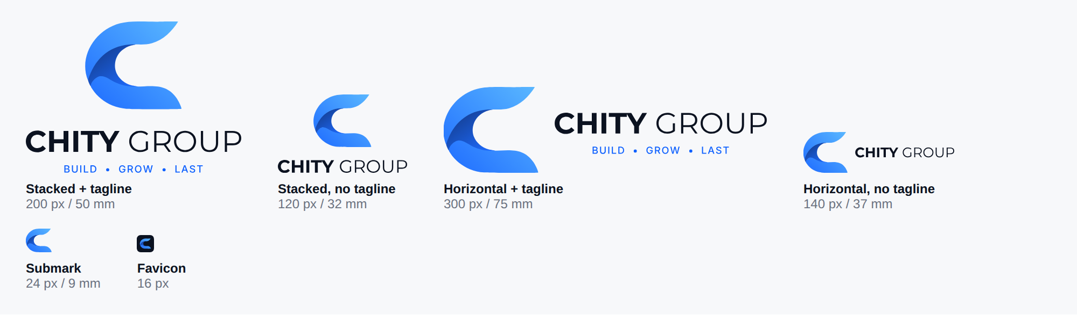
FORM | ON SCREEN | IN PRINT
Primary logo with tagline | 200 px wide | 50 mm (2 in)
Primary logo, no tagline | 120 px wide | 32 mm
Secondary logo with tagline | 300 px wide | 75 mm
Secondary logo, no tagline | 140 px wide | 37 mm
Submark, full color | 24 px wide | 9 mm (0.35 in)
Submark, one-color with fold line | 120 px wide | 30 mm

5. Backgrounds and contrast
Choose the file by the background. Contrast is measured between the logo color (Cloud White or Deep Navy) and the background.
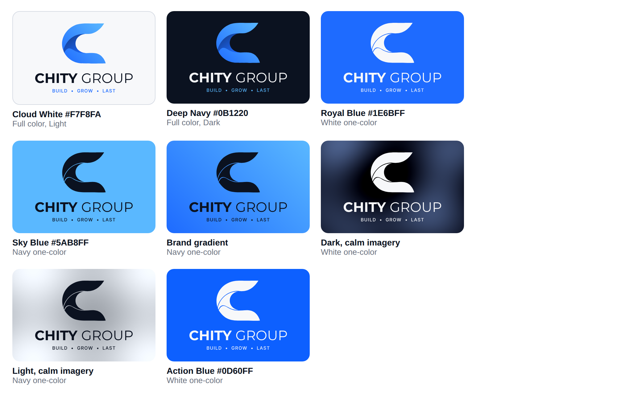
The imagery tiles are illustrations, not photographs.
BACKGROUND | USE THIS FILE | CONTRAST | NOTE
Cloud White #F7F8FA, white | Full color, Light | 17.6:1 | Default for light layouts.
Deep Navy #0B1220 | Full color, Dark | 17.6:1 | Default for dark layouts.
Royal Blue #1E6BFF | White one-color | 4.3:1 | Keep the logo large.
Action Blue #0D60FF | White one-color | 4.8:1
Slate Gray #6B7280 | White one-color | 4.6:1
Sky Blue #5AB8FF | Navy one-color | 8.7:1
Brand gradient | Navy one-color | 4.1:1 to 8.7:1 | Never the white logo: it falls to 2.0:1 at the Sky end.
Photography | White one-color on dark, calm areas; Navy one-color on light, calm areas | Judge by eye | If the logo is not clear at a glance, use a solid panel.
- The full-color logo is used only on Cloud White and Deep Navy. On any other color or on imagery, use a one-color version.
- Never place the logo over busy detail, text or an uneven photograph.

6. Placement and size
USE | FILE | SIZE
Website header | Secondary, no tagline | 140 to 180 px wide
Website footer | Secondary with tagline, or no tagline | 300 px, or 140 to 160 px
Email signature | Secondary, no tagline | 140 to 160 px wide (export at twice the size)
A4 letterhead | Secondary, no tagline, top left | 40 to 45 mm wide
Business card | Secondary, no tagline, Light or Dark | 40 to 45 mm wide
Presentation title slide | Primary with tagline | 4 to 5 in wide
Presentation content slides | Submark or Secondary, no tagline | Small, in a corner
Social profile picture | App icon | As the platform requires
Signage, vehicles, packaging | Primary with tagline, from the SVG | Largest practical size

7. Submark, app icon and favicon
- Submark: use the C alone only when the full name appears nearby (for example an avatar beside the account name) or when the brand is established (an app icon). Never as the only brand identification on first contact.
- App icon: a Deep Navy rounded square (corner radius 22.5% of the width) with the full-color mark centered at 56% of the width. 1024 by 1024 px.
- Favicon: the same design with the mark at 64% of the width so it stays readable. Files cover 16, 32, 48 and 64 px.
- Apple touch icon: a full-bleed navy square (the device rounds the corners), 180 by 180 px.
- Never recolor the navy container or change the mark inside it.

8. What to avoid
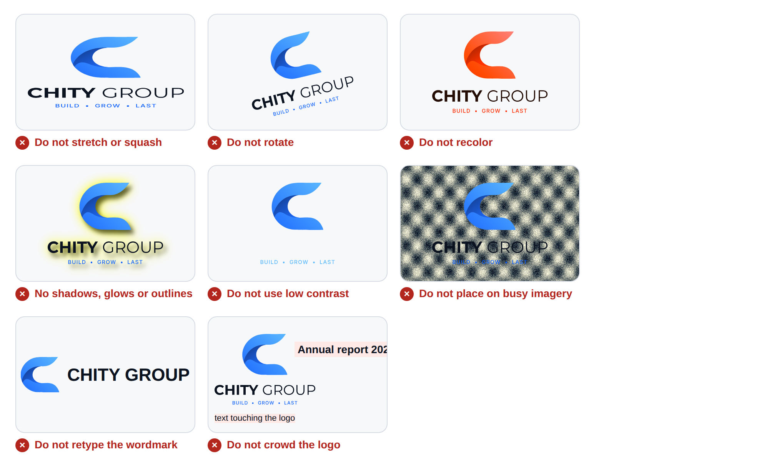
- Stretching, squashing, rotating, cropping or skewing the logo.
- Recoloring it, changing the gradient or swapping its colors.
- Adding shadows, glows, outlines, bevels or any effect.
- Using a version that clashes with its background, such as the Dark logo on a light background.
- Retyping the wordmark or changing its font, spacing or the gap between the words.
- Separating the elements, moving the tagline, or placing the tagline on a gradient.
- Entering the clear-space zone.
- Recreating the logo from a screenshot or photograph.

9. Files and naming
Names follow CHITYGROUP_[Asset]_[Variant]_[Background]_[FORMAT]. Example: CHITYGROUP_PrimaryLogo_FullColor_Light_SVG.svg.
FIELD | VALUES
Asset | PrimaryLogo, PrimaryLogoNoTagline, SecondaryLogo, SecondaryLogoNoTagline, Submark, AppIcon, Favicon, AppleTouchIcon, EndorsementLine
Variant | FullColor, Navy, White (submark also NavySolid, WhiteSolid); endorsement line: Slate, White
Background | Light (for light surfaces), Dark (for dark surfaces), Transparent (works on either)
Format | SVG (web and print), PNG (Office and Canva; 3000 px on the long edge), ICO (favicon)

