
Color Specifications
Palette, roles, gradient, accessibility and print

1. Palette
The CHITY GROUP palette communicates authority, innovation and long-term stability. A deep navy foundation is energized by two luminous blues and balanced by two neutrals. Copy HEX codes exactly and never recolor the logo; each logo file already carries the correct colors for its background.
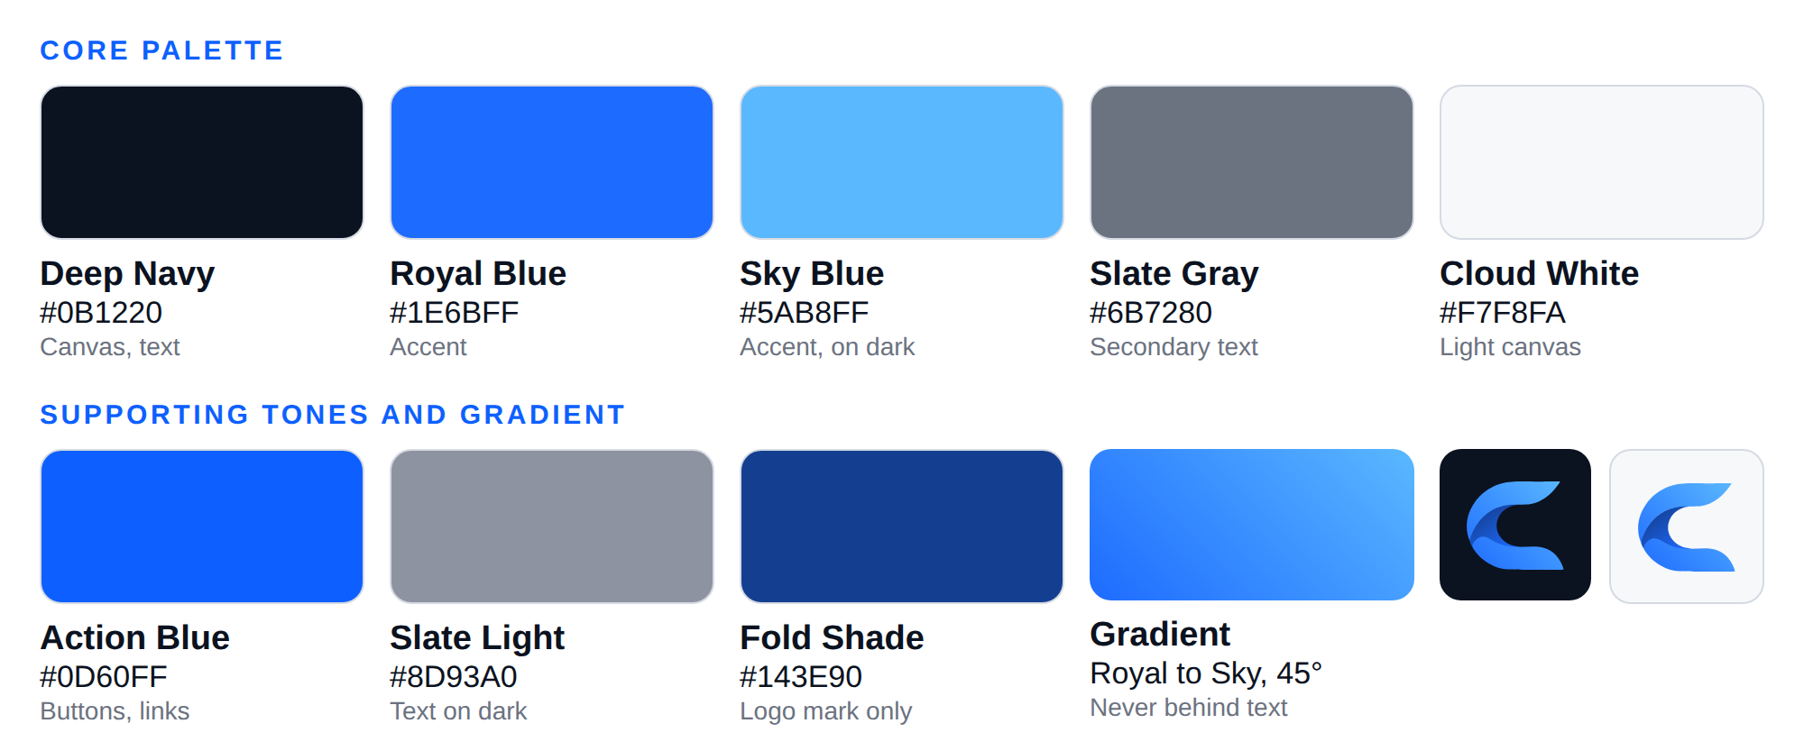

Core palette
 | NAME | HEX | RGB | CMYK | ROLE
 | Deep Navy | #0B1220 | 11, 18, 32 | 88, 71, 38, 91 | Primary canvas, dark backgrounds, text on light.
 | Royal Blue | #1E6BFF | 30, 107, 255 | 77, 56, 0, 0 | Primary accent, graphics, large headline accents.
 | Sky Blue | #5AB8FF | 90, 184, 255 | 58, 18, 0, 0 | Secondary accent, gradient end, text on dark.
 | Slate Gray | #6B7280 | 107, 114, 128 | 57, 44, 33, 23 | Secondary text on light, borders, lines.
 | Cloud White | #F7F8FA | 247, 248, 250 | 4, 3, 2, 0 | Light canvas; text on dark.

Supporting tones
 | NAME | HEX | RGB | CMYK | USE
 | Action Blue | #0D60FF | 13, 96, 255 | 80, 61, 0, 0 | Buttons, links and small blue text on light backgrounds; the tagline in light-background logos. Reaches 4.78:1 on Cloud White, where Royal Blue reaches 4.29:1.
 | Slate Light | #8D93A0 | 141, 147, 160 | 46, 35, 26, 11 | Secondary text on dark backgrounds. Reaches 6.07:1 on Deep Navy, where Slate Gray reaches 3.87:1.
 | Fold Shade | #143E90 | 20, 62, 144 | 97, 79, 0, 8 | The darkest band inside the C mark. Used in the logo only.
CMYK values are for coated paper (FOGRA39). Section 6 explains how they were produced and how the blues behave in print.

Interface neutrals
Panels and hairlines use four neutrals derived from the palette. They add no new colors.
 | USE | HEX | DEFINITION
 | Border, light backgrounds | #D4D6DC | Slate Gray at 25% on Cloud White
 | Surface tint, light backgrounds | #EAF0FA | Royal Blue at 6% on Cloud White
 | Surface, dark backgrounds | #19202D | Cloud White at 6% on Deep Navy
 | Border, dark backgrounds | #313743 | Cloud White at 16% on Deep Navy

2. Colors in the logo
LOGO ELEMENT | ON LIGHT BACKGROUNDS | ON DARK BACKGROUNDS
C mark, upper and lower arms | Gradient: Royal Blue (bottom-left) to Sky Blue (top-right), 45° | Same gradient
C mark, fold band | Fold Shade #143E90 blending into Royal Blue #1E6BFF | Same
Wordmark "CHITY GROUP" | Deep Navy #0B1220 | Cloud White #F7F8FA
Tagline "BUILD • GROW • LAST" | Action Blue #0D60FF | Sky Blue #5AB8FF
One-color logos | Deep Navy #0B1220 | Cloud White #F7F8FA

3. Brand gradient
- Start: Royal Blue #1E6BFF at the bottom-left (0%). End: Sky Blue #5AB8FF at the top-right (100%). Angle: 45 degrees.
- Web code: linear-gradient(45deg, #1E6BFF 0%, #5AB8FF 100%)
- Use it for large background shapes, hero areas and highlighted interface elements.
- Never add a third color, fade to black or white, place text on it, or use it on small elements.
- The fold gradient (Fold Shade to Royal Blue) belongs to the logo only.

4. Proportion and roles
About 60% Deep Navy or Cloud White (dominant canvas), about 30% Slate (secondary text, lines and containers), and about 10% blue accents.
ROLE | LIGHT MODE | DARK MODE
Page background | Cloud White #F7F8FA | Deep Navy #0B1220
Primary text | Deep Navy (17.62:1) | Cloud White (17.62:1)
Secondary text | Slate Gray (4.55:1) | Slate Light (6.07:1)
Links and small accents | Action Blue (4.78:1) | Sky Blue (8.68:1)
Button | Action Blue fill, Cloud White label (4.78:1) | Sky Blue fill, Deep Navy label (8.68:1)
Large headline accent (24 px or larger) | Royal Blue (4.29:1) | Royal Blue (4.10:1)
Borders and dividers | Slate Gray | Slate Gray (3.87:1, sufficient for non-text)

5. Accessibility
Ratios follow WCAG 2.1. AA requires 4.5:1 for normal text and 3:1 for large text (24 px or larger, or 18.66 px or larger in bold) and for interface graphics. AAA requires 7:1. Recheck whenever a color changes.
FOREGROUND | BACKGROUND | RATIO | RESULT
Cloud White | Deep Navy | 17.62:1 | AAA
Sky Blue | Deep Navy | 8.68:1 | AAA
Slate Light | Deep Navy | 6.07:1 | AA
Royal Blue | Deep Navy | 4.10:1 | Large text only
Action Blue | Deep Navy | 3.69:1 | Large text only
Slate Gray | Deep Navy | 3.87:1 | Large text only
Deep Navy | Cloud White | 17.62:1 | AAA
Action Blue | Cloud White | 4.78:1 | AA
Slate Gray | Cloud White | 4.55:1 | AA
Royal Blue | Cloud White | 4.29:1 | Large text only
Sky Blue | Cloud White | 2.03:1 | Fail
Slate Light | Cloud White | 2.90:1 | Fail
Cloud White | Royal Blue | 4.29:1 | Large text only
Deep Navy | Sky Blue | 8.68:1 | AAA
- Slate Gray on Cloud White (4.55:1) passes narrowly. Never use it on a tinted or photographic background; on the light surface tint it falls to 4.22:1, so use Deep Navy there.
- Sky Blue on Cloud White (2.03:1) and Slate Light on Cloud White (2.90:1) fail. Use them on dark backgrounds only.
- Royal Blue fails for small text on both canvases. Use Action Blue on light and Sky Blue on dark for small blue text.

6. Print and CMYK

Method
Each screen color (sRGB) was converted to CMYK with the FOGRA39 Coated press profile, the ISO 12647-2 standard for coated paper used by most commercial printers. Settings: relative colorimetric intent with black point compensation. Each result was converted back to screen color to show how it prints, and the difference measured with CIEDE2000 (ΔE): up to about 2 is barely noticeable, 2 to 5 is a slight shift, and above 5 is clearly visible side by side.

Results
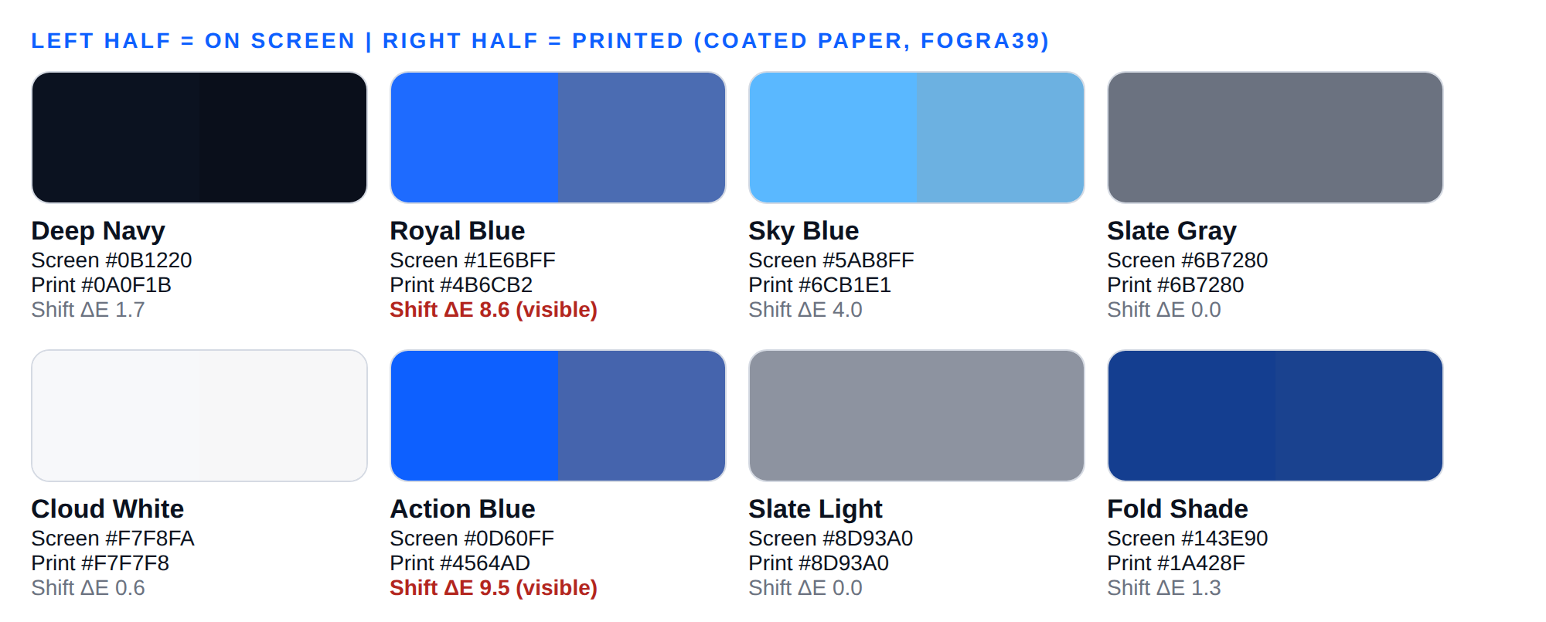
COLOR | CMYK | TOTAL INK | PRINTS AS | ΔE | READING
Deep Navy | 88, 71, 38, 91 | 288% | #0A0F1B | 1.7 | Barely noticeable
Royal Blue | 77, 56, 0, 0 | 133% | #4B6CB2 | 8.6 | Clearly visible shift
Sky Blue | 58, 18, 0, 0 | 76% | #6CB1E1 | 4 | Slight shift
Slate Gray | 57, 44, 33, 23 | 157% | #6B7280 | 0 | Barely noticeable
Cloud White | 4, 3, 2, 0 | 9% | #F7F7F8 | 0.6 | Barely noticeable
Action Blue | 80, 61, 0, 0 | 141% | #4564AD | 9.5 | Clearly visible shift
Slate Light | 46, 35, 26, 11 | 118% | #8D93A0 | 0 | Barely noticeable
Fold Shade | 97, 79, 0, 8 | 184% | #1A428F | 1.3 | Barely noticeable

The blues
Royal Blue and Action Blue cannot be fully reproduced in CMYK. On coated paper they print as a duller, greyer blue (#4B6CB2 and #4564AD), a clearly visible shift. The brand gradient is affected in the same way. This is a physical limit of CMYK ink.
- General printing (documents, brochures, reports): use the CMYK values above.
- Where the exact blue matters (business cards, signage, packaging, vehicles): print Royal Blue as a Pantone spot color, or use a digital press with an extended color range, and approve a proof.
- Deep Navy converts well and uses 288% total ink, within the limit of most coated stocks (FOGRA39 allows up to 330%). Tell your printer if their limit is lower.

Proofing and Pantone
- The values above are the standard starting point; results on a specific press and paper vary. Approve a printed proof before any large run. Appendix A is a sheet to give your printer.
- Pantone numbers come from a physical comparison against Pantone swatches. Ask the printer to match Royal Blue and Action Blue and record the numbers in Appendix A.
- Uncoated paper and newsprint print duller than coated paper. For these, ask the printer for their profile.

7. Common mistakes
- Small body text in Royal Blue or Sky Blue on a light background.
- Pure black or pure white. Use Deep Navy and Cloud White.
- Recoloring the logo or rebuilding the gradient in another application.
- Adding neon or other unapproved bright colors.
- Placing text on the gradient.
- Using Fold Shade outside the logo.
- Approving a blue from a screen for print without a printed proof.

8. Setting up your tools
Add the HEX codes as brand colors in Canva's Brand Kit and as custom theme colors in Word and PowerPoint. For websites, use these variables:
:root{
--navy:#0B1220; --royal:#1E6BFF; --sky:#5AB8FF; --slate:#6B7280; --cloud:#F7F8FA;
--action:#0D60FF; --slate-light:#8D93A0; --fold:#143E90;
--border:#D4D6DC; --surface:#EAF0FA;
--brand-gradient:linear-gradient(45deg,#1E6BFF 0%,#5AB8FF 100%);
}

Appendix A: Print proof request
Give this page to your printer. Screen values are sRGB. CMYK values were computed with the FOGRA39 Coated profile.
Client: CHITY GROUP Job: ______________________ Paper: ______________________
COLOR | HEX (SCREEN) | CMYK (STARTING VALUES) | CMYK CONFIRMED | PANTONE NUMBER | APPROVED (NAME, DATE)
Deep Navy | #0B1220 | 88, 71, 38, 91
Royal Blue | #1E6BFF | 77, 56, 0, 0
Sky Blue | #5AB8FF | 58, 18, 0, 0
Slate Gray | #6B7280 | 57, 44, 33, 23
Cloud White | #F7F8FA | 4, 3, 2, 0
Action Blue | #0D60FF | 80, 61, 0, 0

Requests to the printer
- Supply a printed proof of the colors above on the actual paper.
- Royal Blue and Action Blue cannot be matched in CMYK (printed shift of about 9 ΔE). Quote a Pantone spot color or an extended-gamut digital press for jobs where the blue matters.
- Confirm your maximum total ink coverage. Deep Navy needs 288%.
- Provide the ICC profile for the press and paper so values can be converted exactly.
- Print the logo from the supplied vector files (SVG or PDF), never from PNG previews. Use the one-color files for single-ink jobs.
- Do not alter the logo colors or gradient to match a proof. Direct questions to the Brand Owner.

