
Typography and Licensing
Typefaces, wordmark, type scale, web setup and font licensing

1. Overview
CHITY GROUP uses two typefaces. Montserrat, a geometric sans-serif, sets headlines. Inter, a highly legible interface sans-serif, sets everything else. Arial is the fallback where custom fonts cannot be used.
- Live text is text you type and format: documents, slides, websites and emails.
- Artwork is the logo. The wordmark is drawn artwork made from Montserrat letter shapes. It is supplied as files and never retyped.

2. The wordmark
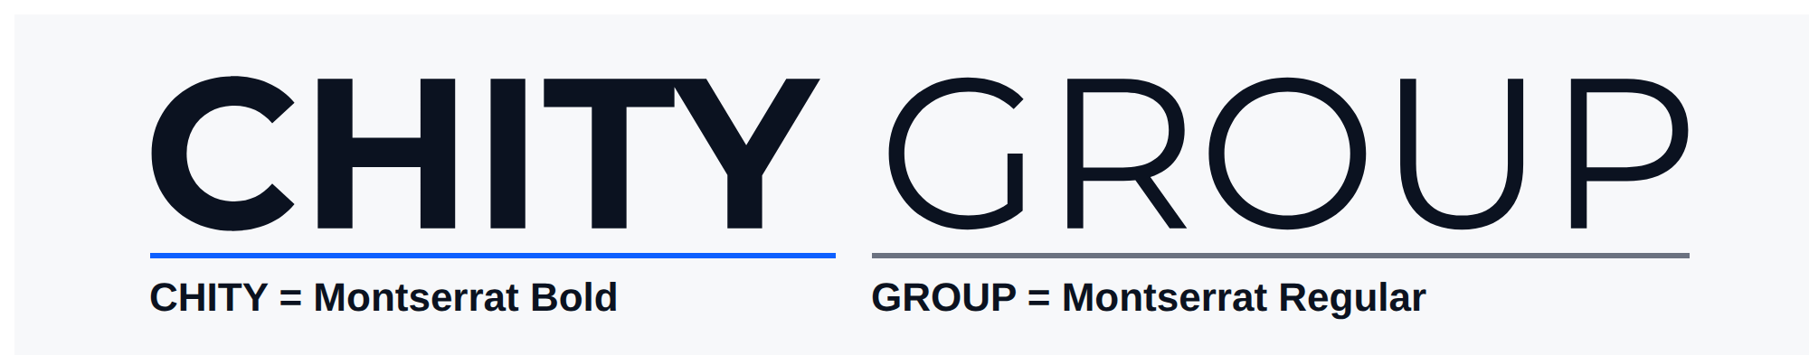
CHITY is set in Montserrat Bold and GROUP in Montserrat Regular. The spacing and the gap between the two words are fixed in the artwork.
Never retype the wordmark, even with the correct fonts. Always use the supplied logo files.

3. Fonts
FILE | FAMILY AND WEIGHT | VERSION | USE
Montserrat-Bold.ttf | Montserrat Bold | 9.000 | H1 headlines
Montserrat-SemiBold.ttf | Montserrat SemiBold | 9.000 | H2 section headers
Inter_18pt-Regular.ttf | Inter 18pt Regular | 4.001 | Body text (the text-size cut of Inter 4)
Inter_18pt-Medium.ttf | Inter 18pt Medium | 4.001 | H3 subheaders, labels, buttons
Montserrat-Regular.ttf | Montserrat Regular | 9.000 | Wordmark reference only. Not used for live text.

4. Type scale
One hierarchy applies to print, documents, slides and websites.
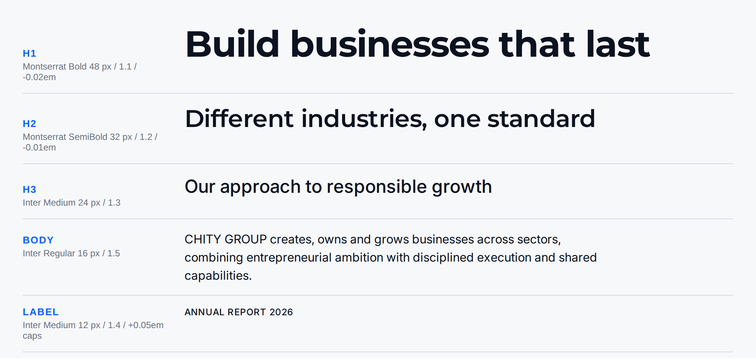
LEVEL | TYPEFACE | PRINT | WEB | LINE HEIGHT | TRACKING | CASE
H1 headline | Montserrat Bold | 36-48 pt | 48 px (40 mobile) | 1.1 | -0.02em | Sentence case
H2 section header | Montserrat SemiBold | 24-32 pt | 32 px (28 mobile) | 1.2 | -0.01em | Sentence case
H3 subheader | Inter Medium | 18-20 pt | 24 px | 1.3 | Normal | Title Case
Body | Inter Regular | 10-12 pt | 16 px | 1.5 | Normal | Sentence case
Small text | Inter Regular | 9-10 pt | 14 px | 1.5 | Normal | Sentence case
Label, caption, tag | Inter Medium | 8-9 pt | 12 px | 1.4 | +0.05em | UPPERCASE
- Left-align body text and avoid justified text. Keep lines to about 60 to 80 characters.
- Minimum sizes: body text 16 px on screen or 10 pt in print; labels 12 px or 8 pt.
- Tracking: 0.05em equals +50 in design software.
- The endorsement line "A CHITY GROUP COMPANY" is Inter Regular, capitals, +0.1em (+100). The tagline in the logo files is Inter Medium, capitals, +0.1em; it is part of the artwork.
- Use only the weights listed. Never apply faux bold or faux italic.
- Text and background pairings follow the Color Specifications.

5. Using the fonts in your tools
WHERE | WHAT TO DO
Websites | Self-hosted fonts (section 6).
Word and PowerPoint | Install the four approved fonts (see Installing below). On computers without them, text falls back to Arial.
Email and signatures | Arial only. Email programs do not display custom fonts reliably. Signatures: Arial 10 pt.
Canva | Both families are in Canva's font menu, but Canva's Inter may differ slightly from Inter 18pt. To use the exact files, upload them in the Brand Kit (a paid plan is required).
Print and PDF | Use the installed fonts and embed them when exporting a PDF.
Installing | Windows: right-click each .ttf file and choose Install. Mac: double-click each .ttf file and choose Install Font. Then restart Word or PowerPoint. Install only the four approved fonts.

6. Web implementation
Self-hosting keeps visitors' data off third-party font servers, removes an external dependency and usually loads faster. WOFF files of the four approved fonts are supplied.
@font-face{font-family:'Montserrat';font-weight:700;font-display:swap;
src:url('/fonts/Montserrat-Bold.woff') format('woff');}
@font-face{font-family:'Montserrat';font-weight:600;font-display:swap;
src:url('/fonts/Montserrat-SemiBold.woff') format('woff');}
@font-face{font-family:'Inter';font-weight:400;font-display:swap;
src:url('/fonts/Inter_18pt-Regular.woff') format('woff');}
@font-face{font-family:'Inter';font-weight:500;font-display:swap;
src:url('/fonts/Inter_18pt-Medium.woff') format('woff');}

h1{font-family:'Montserrat','Helvetica Neue',Arial,sans-serif;font-weight:700;
font-size:48px;line-height:1.1;letter-spacing:-0.02em;}
h2{font-family:'Montserrat','Helvetica Neue',Arial,sans-serif;font-weight:600;
font-size:32px;line-height:1.2;letter-spacing:-0.01em;}
h3{font-family:'Inter',system-ui,-apple-system,'Segoe UI',Roboto,Arial,sans-serif;
font-weight:500;font-size:24px;line-height:1.3;}
body,p,li,td,input,button{font-family:'Inter',system-ui,-apple-system,'Segoe UI',
Roboto,Arial,sans-serif;font-weight:400;font-size:16px;line-height:1.5;}
.label{font-family:'Inter',Arial,sans-serif;font-weight:500;font-size:12px;
line-height:1.4;letter-spacing:0.05em;text-transform:uppercase;}
@media (max-width:640px){h1{font-size:40px}h2{font-size:28px}}
WOFF2 files are slightly smaller. A developer can convert the TTF files with fontTools ("pip install fonttools brotli", then "fonttools ttLib.woff2 compress Montserrat-Bold.ttf"). Keep the license files with any converted fonts.

7. Licensing
Both families are licensed under the SIL Open Font License, Version 1.1. This summary is practical guidance, not legal advice.
FAMILY | LICENSE FILE NOTICE | NOTICE INSIDE THE FONT FILES
Montserrat | Copyright 2024 The Montserrat.Git Project Authors (https://github.com/JulietaUla/Montserrat.git) | Copyright 2011 The Montserrat Project Authors (https://github.com/JulietaUla/Montserrat)
Inter | Copyright 2020 The Inter Project Authors (https://github.com/rsms/inter) | Copyright 2016 The Inter Project Authors (https://github.com/rsms/inter)
Keep both notices unchanged and distribute each family's OFL.txt with its font files.

You may
- Use the fonts commercially in print, on screen, in apps, websites and PDFs.
- Embed them in documents and websites.
- Share the font files with agencies, printers and developers.
- Convert formats (for example to WOFF). Neither license names a Reserved Font Name.

Conditions
- Never sell the font files by themselves.
- Every copy of the fonts you share must include the copyright notice and the license text (the OFL.txt files).
- Do not release the fonts under any other license.
- Do not use the authors' names to promote or endorse a modified font.
- If a font is ever modified, do not reuse its name unless the license allows it.
The license requirements do not apply to documents created with the fonts. Your logo, brochures, slides and web pages remain yours; the license applies to the font files themselves.

8. Common mistakes
- Retyping the wordmark instead of using the logo files.
- Setting headlines in Montserrat Regular, Medium or Light. Headlines are Bold or SemiBold only.
- Setting body text in Montserrat.
- Setting headlines in capitals. Capitals are for labels only.
- Using faux bold or faux italic.
- Sending fonts to a vendor without the OFL.txt files.

