
Graphic Language
Shapes, surfaces, layout, iconography and data

1. Principles
The visual identity is built from four principles. Every layout, from a slide to a signboard, should be recognizable as CHITY GROUP before the logo is read.
PRINCIPLE | IN PRACTICE
Fluid momentum | Sweeping curves and rounded forms signal forward progress. They are taken directly from the C symbol.
Structural restraint | Deep, disciplined canvases and ordered, high-contrast typography. Structure comes from the grid; softness comes from curves.
Luminous clarity | Vibrant blue breaks through dark corporate tones. Gradients are smooth and directional, like light across a surface.
Grounded scale | Imagery combines architecture, people and natural detail so that the group never reads as belonging to one sector.

2. The brand curve
The brand curve is the identity's signature graphic. It is drawn from the arms of the C symbol and gives layouts movement without decoration. It is supplied as artwork and is never redrawn.
ARTWORK | DESCRIPTION | COLORS
Brand curve | A single sweeping arm. The default. | Gradient, Deep Navy, Cloud White
Brand curve pair | Both arms of the C without the fold. For large formats. | Gradient, Deep Navy, Cloud White

Rules
- One curve device per layout. Never repeat, tile or stack curves.
- Use it large and let the layout edge crop it. A small curve in the middle of a page is decoration.
- Keep text and logos off the curve. The gradient curve carries no text, and a clear gap of at least 24 px (6 mm in print) separates it from text and logos.
- Gradient curve only on Deep Navy or Cloud White. On other backgrounds use the flat Deep Navy or Cloud White curve.
- Mirror horizontally if needed. Do not rotate, stretch, outline, add effects or recolor.
- Never replace the logo's C with the curve, and never use the curve as a second logo.
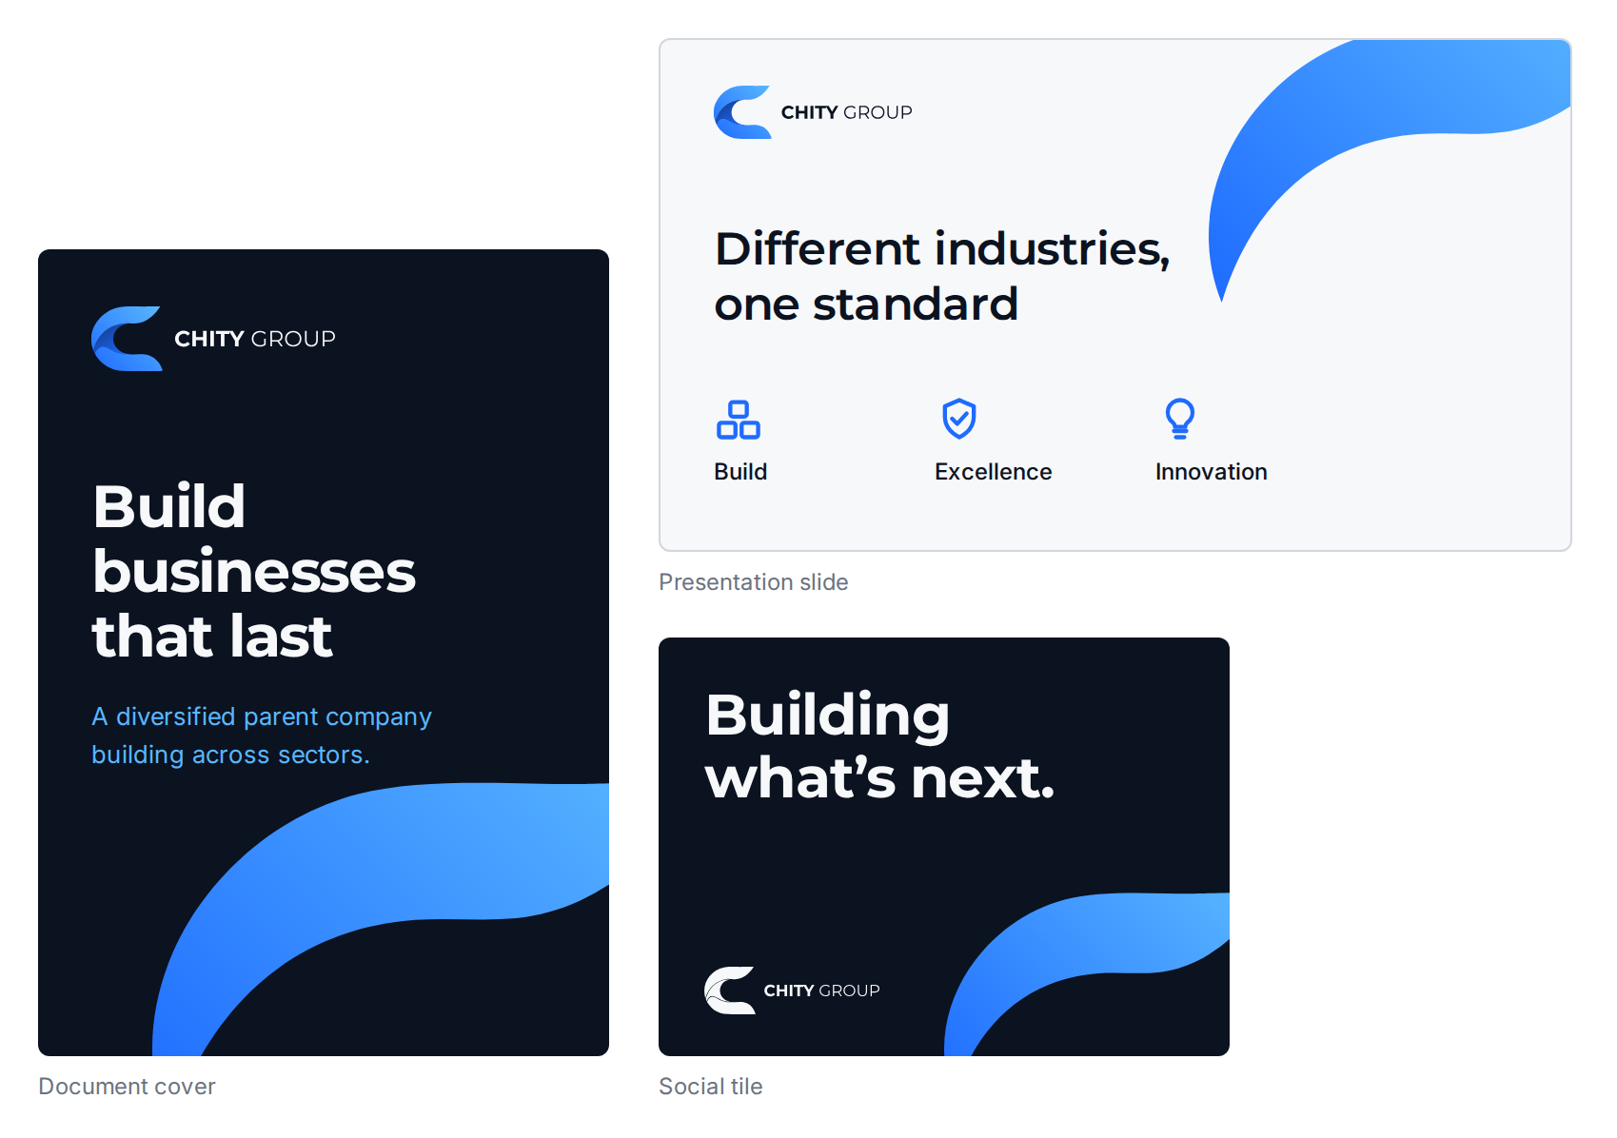

3. Color in layouts
- Build each layout on Deep Navy or Cloud White (about 60%), with Slate tones for secondary text and lines (about 30%) and blue accents (about 10%).
- Alternate dark and light sections in longer documents: dark for impact and summaries, light for detail and data.
- Use one focal accent per layout.
- The brand gradient runs at 45 degrees from Royal Blue to Sky Blue. No text is placed on it.
- Full values and contrast ratios are in the Color Specifications.

4. Layout and spacing
ITEM | RULE
Spacing scale | Base unit 8 px. Use 4, 8, 16, 24, 32, 48, 64 and 96 px. Space between page sections is 64 px or more.
Web grid | 12 columns. Maximum content width 1200 px. Gutters 24 px. Side margins 24 px on mobile and 48 px on desktop.
Print grid | A4 or Letter. 12 columns. Margins 20 mm.
Alignment and hierarchy | Left-aligned text on a visible column edge; avoid centered paragraphs. One headline, one supporting line, then detail, with generous white space.

5. Surfaces and lines
Interfaces and documents use four derived neutrals for panels and hairlines. They are mixes of palette colors, so nothing new enters the palette.
USE | VALUE | DEFINITION
Border, light backgrounds | #D4D6DC | Slate Gray at 25% on Cloud White
Surface tint, light backgrounds | #EAF0FA | Royal Blue at 6% on Cloud White
Surface, dark backgrounds | #19202D | Cloud White at 6% on Deep Navy
Border, dark backgrounds | #313743 | Cloud White at 16% on Deep Navy
Text contrast on these surfaces: Deep Navy on the light tint 16.4:1; Cloud White on the dark surface 15.4:1; Slate Light on the dark surface 5.3:1. Slate Gray text is used on Cloud White only. On the light tint it falls to 4.2:1, so use Deep Navy there.

6. Containers and components
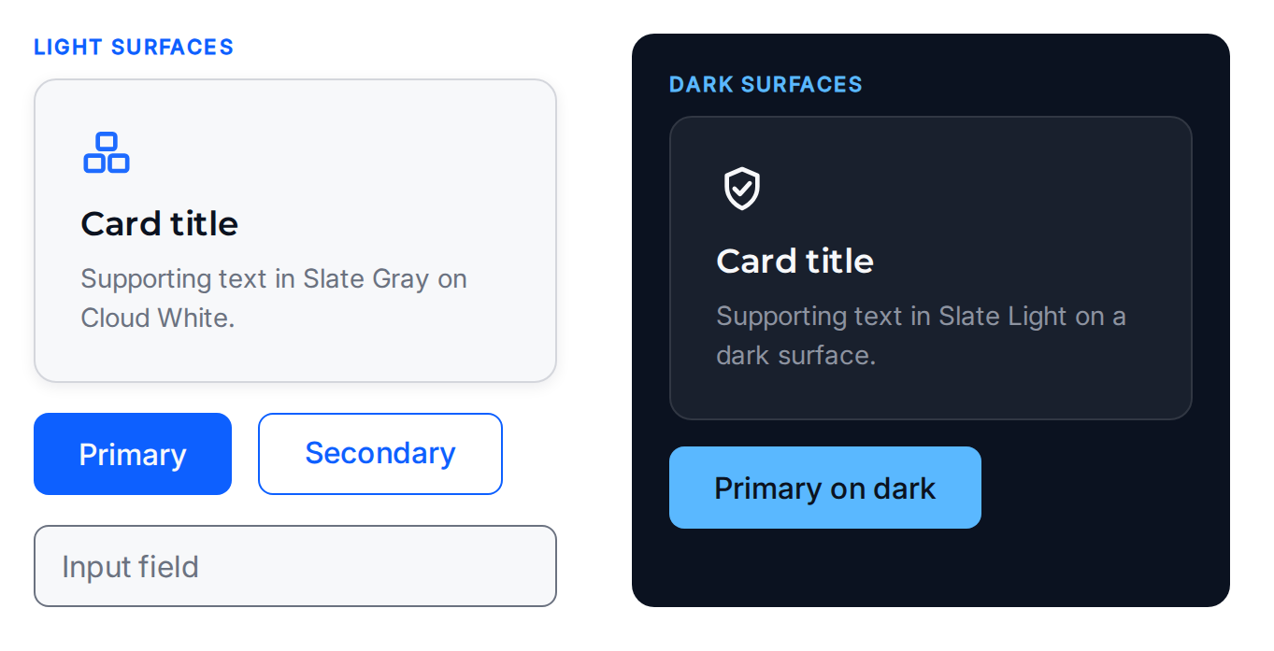
ELEMENT | SPECIFICATION
Card | Corner radius 12 px. Padding 24 px. 1 px border. Optional shadow: 0 2 px 8 px, Deep Navy at 8%.
Button | Height 44 px. Corner radius 8 px. Horizontal padding 24 px. Label Inter Medium 16 px. Light backgrounds: Action Blue fill, Cloud White label. Dark backgrounds: Sky Blue fill, Deep Navy label. The secondary button keeps the same size and radius with a 1.5 px outline and no fill.
Input field | Height 44 px. Corner radius 8 px. 1 px Slate Gray border.
Focus state | 2 px outline in Action Blue (light) or Sky Blue (dark), offset 2 px.
Shadows | Only on interface cards. Never on logos, icons, curves or imagery.

7. Iconography
Six linear icons express the six brand pillars. They share one construction so that they read as a family.
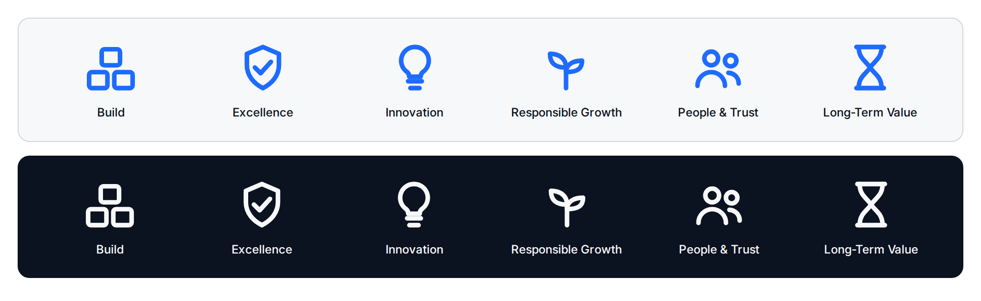
PILLAR | ICON
Build | Stacked blocks
Excellence | Shield with check mark
Innovation | Light bulb
Responsible Growth | Sprout
People & Trust | Two people
Long-Term Value | Hourglass

Construction
- 24 by 24 px grid. 2 px stroke with rounded ends and corners. No fills and no effects.
- One color per icon: Royal Blue on light backgrounds, Cloud White on dark, Deep Navy for neutral use. Royal Blue on Cloud White (4.29:1) meets the 3:1 requirement for graphics.
- Display at 24 px or larger, in multiples of 8 px (24, 32, 48, 64).
- Pair every icon with a text label. Icons never carry meaning alone.
- Any new icon follows the same grid, stroke and corner style and is added to the set before use.
Files: 6 icons in 3 colors, as SVG and PNG, named CHITYGROUP_Icon_[Name]_[Color]_Transparent_[FORMAT].

8. Charts and data
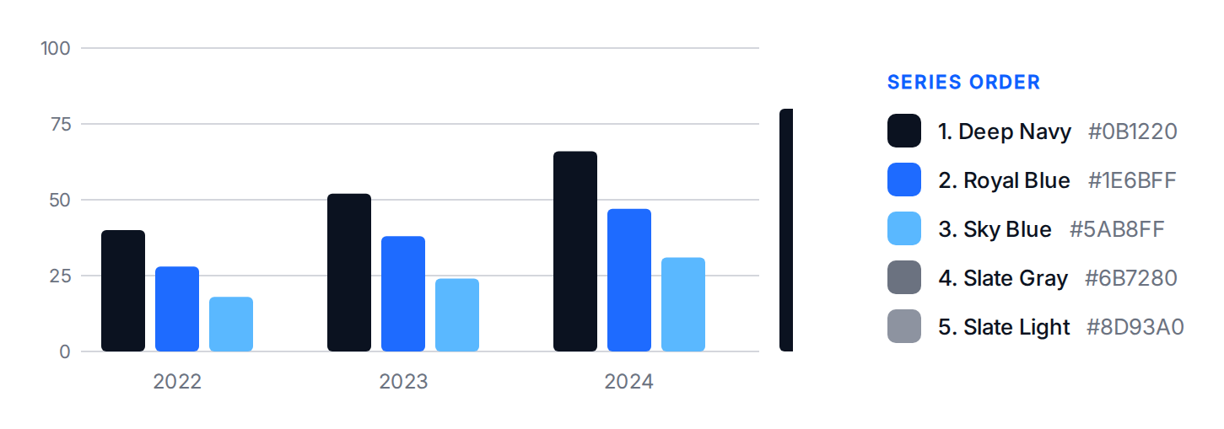
- Series order: Deep Navy, Royal Blue, Sky Blue, Slate Gray, Slate Light. Use no more than five series.
- To highlight one series, show it in Royal Blue and the others in Slate tones.
- Flat fills only. No gradients, shadows or three-dimensional effects.
- Gridlines use the light border color. Labels are Inter 12 px or larger in Slate Gray on Cloud White, or Deep Navy.
- Label series directly where possible. Never rely on color alone to carry meaning.

9. Patterns and texture
The identity uses no patterns or textures. Variety comes from the brand curve, the gradient, imagery and white space.

