
Imagery
Photography and image direction

1. Role of imagery
Imagery gives CHITY GROUP human scale and evidence. It shows progress, people and substance rather than decoration, and it keeps the parent brand sector-neutral. Images support the message; they never carry a sector, a subsidiary or a claim the group cannot prove.

2. Image families
Four families make up the imagery. Each answers a different part of the brand story.
FAMILY | SHOWS | DIRECTION
Structures | Architecture, glass, infrastructure and city detail. | Use sparingly so the group does not read as property or construction. Prefer detail and perspective to full skylines. Avoid recognizable third-party buildings and signage.
People | Real people at work and in partnership. | Candid, natural and diverse. Show competence and collaboration. No staged poses, forced handshakes or thumbs-up groups.
Nature and detail | Leaves, water, materials, light and macro texture. | Supports responsible growth and long-term thinking. Natural light and shallow depth of field.
Motion and abstract | Light trails, movement, and the brand curve set over calm imagery. | For banners and backgrounds. Keep it calm and uncluttered.

3. Style
ELEMENT | DIRECTION
Lighting | Natural and clean. Soft daylight, dusk and dawn. Avoid harsh flash and heavy artificial color.
Color | Cool and navy-leaning in the shadows, with natural, accurate skin tones. Never tint people blue.
Contrast | Moderate. No heavy filters, vignettes, high-dynamic-range effects or color overlays.
Composition | A clear subject and a calm area where text can sit. Generous space around the subject.
Cropping | Crop for the format: 16:9 for presentations and the web, 1:1 and 4:5 for social media, portrait for covers.
Authenticity | Real places and real people from the group's context where possible.

4. Building a set
- Any set of four or more images draws on at least two families, and no family exceeds half of the set.
- No single sector or operating business becomes the face of the parent brand.
- Each layout has one dominant image. Support it with calm detail or white space.
- Choose images that could sit equally well in any sector the group enters.

5. Sourcing and files
ITEM | REQUIREMENT
Rights | Use only commissioned photography or images licensed for commercial use. Keep the license and usage terms with the file.
Releases | Obtain model releases for identifiable people and property releases for private locations.
Resolution | At least 3000 px on the long edge for web heroes and covers; 300 dpi at final size for print.
Format | JPG or WebP for photography (quality 80 to 85). sRGB color profile.
Names | CHITYGROUP_Image_[Family]_[Subject]_[Orientation]_[Number].jpg
Accessibility | Every image placed online has descriptive alternative text. No essential text is embedded in an image.

6. Text and logos over images
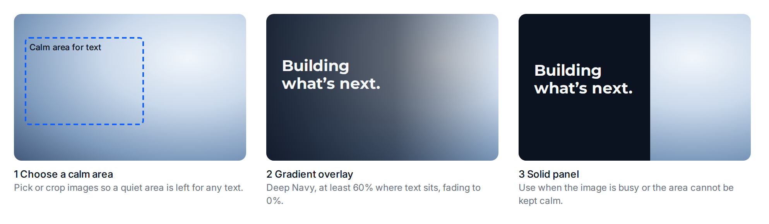
The panels above are illustrations, not photographs.
METHOD | RULE
Calm area | Choose or crop the image so a quiet area remains for text.
Gradient overlay | Deep Navy at 60% or more where text sits, fading to 0%. At 60% over a pure white image, Cloud White text still reaches 4.6:1; at 70% it reaches 6.6:1.
Solid panel | Use a solid Deep Navy panel when the image is busy or the area cannot be kept calm.
Headlines | Montserrat Bold, at most two lines, Cloud White on the overlay or panel.
Logo | Use the one-color White or Navy logo on imagery, on a calm area. Never place the full-color logo on an image.

7. Commissioning brief
Give this checklist to any photographer or image supplier.
- Subject: people at work, built environments, natural detail or abstract light, as agreed for the shoot.
- Mood: confident, calm, human. Progress and substance, not spectacle.
- Light and color: natural light, cool shadows, accurate skin tones.
- Composition: a clear subject with a calm area on one side for text. Supply both horizontal and vertical crops.
- People: candid and unposed, in real working situations.
- Avoid: clichés (handshakes, globes, stock office scenes), heavy filters, branded third-party products, and the visible logos of other companies.
- Deliverables: high-resolution originals with releases, usage terms and captions.

