
Applications
Stationery, presentations, documents, digital and social

1. Approach
Every application of the brand follows the same logic: one logo, solid color behind text, Montserrat for headlines and Inter for everything else, and at most one brand curve. Ready-made templates carry these rules so they do not have to be rebuilt each time.
ITEM | FORMAT | TEMPLATE FILE
Business card | Print PDF, 85 × 55 mm with 3 mm bleed | CHITYGROUP_BusinessCard_Template_Front_PDF.pdf and _Back_PDF.pdf
Letterhead | Word, A4 | CHITYGROUP_Letterhead_Template_DOCX.docx
Email signature | HTML | CHITYGROUP_EmailSignature_Template_HTML.html
Presentation | PowerPoint, 16:9, five layouts | CHITYGROUP_Presentation_Template_PPTX.pptx
Social media backgrounds | PNG: 1080 × 1080, 1080 × 1350, 1500 × 500 | CHITYGROUP_Social_[Tile or Banner]Background_Dark_[size]_PNG.png

2. Stationery
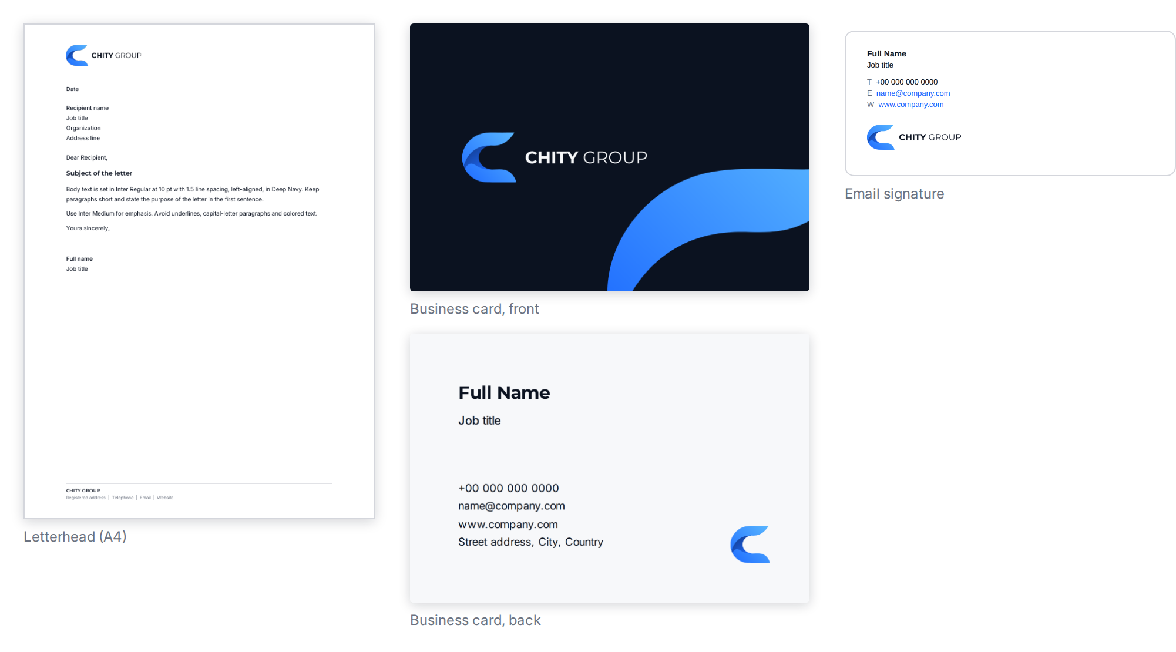

Business card
ELEMENT | SPECIFICATION
Size | 85 × 55 mm trim, with 3 mm bleed on all sides (91 × 61 mm).
Front | Deep Navy. Secondary logo without tagline, 42 mm wide, vertically centered, 9 mm inside the trim from the left. One brand curve at the bottom right, clear of the logo.
Back | Cloud White. Name in Montserrat Bold 11.5 pt. Job title in Inter Medium 7.5 pt. Contact details in Inter Regular 7 pt, 1.65 line spacing, in Deep Navy. Submark, 9 mm wide, at the bottom right. Keep all text at least 8 mm inside the trim.
Production | Artwork is supplied in RGB. Ask the printer for a printed proof before the run (see Color Specifications, section 6).

Letterhead
ELEMENT | SPECIFICATION
Page | A4. Margins: top 35 mm, bottom 26 mm, left and right 25 mm.
Logo | Secondary logo without tagline, 45 mm wide, top left.
Body text | Inter Regular 10 pt, line spacing 1.5, left-aligned, Deep Navy. Subject line in Montserrat SemiBold 11 pt. Emphasis in Inter Medium.
Footer | Hairline rule, then "CHITY GROUP" in Montserrat SemiBold 8 pt and the registered address, telephone, email and website in Inter Regular 7.5 pt, Slate Gray.

Email signature
- Arial 10 pt, because email programs do not display custom fonts reliably. Name in bold Deep Navy, title in Deep Navy, contact labels in Slate Gray, links in Action Blue.
- Secondary logo without tagline, 160 px wide on screen, supplied at 320 px for sharp displays. Host the image on a web address and point the signature to it.
- One signature format for everyone. No quotations, extra graphics or colored text. Any legal disclaimer sits below the logo in Slate Gray, 11 px.

3. Presentations
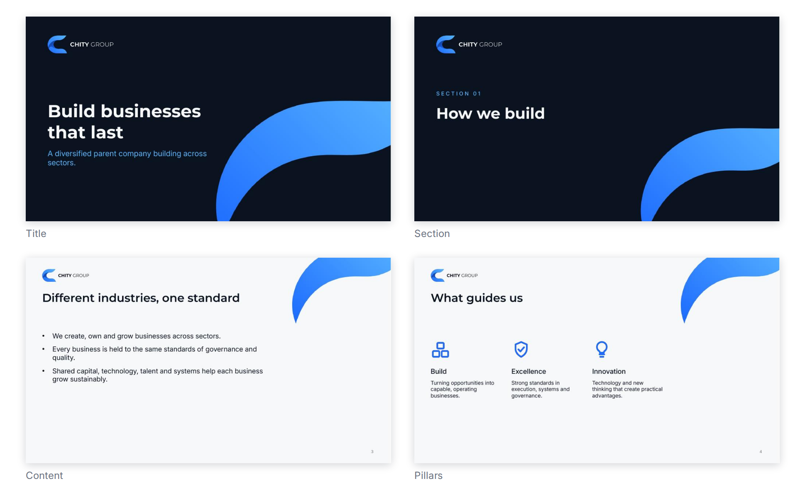
LAYOUT | USE
Title | Opening slide. Deep Navy with the brand curve.
Section | Divides a presentation. Section number above the title.
Content | Title and body text on Cloud White. Slide numbers included.
Pillars | Three columns, each with an icon, a label and a short line of text.
Closing | Primary logo with tagline, centered on Deep Navy.
- Dark layouts open and close a presentation; light layouts carry the detail.
- One idea per slide. Titles in Montserrat, body text in Inter at 18 pt or larger, supporting text no smaller than 14 pt.
- Create new slides from the supplied layouts. Do not move the logo, add a second curve or place text on the curve.
- Photographs and charts follow the Imagery and Graphic Language documents.
- Install the four brand fonts before editing (see Typography and Licensing).

4. Documents and reports
ELEMENT | RULE
Cover | Deep Navy with one brand curve, the logo at the top left and the title in Montserrat Bold. The cover carries no body text.
Pages | A4, margins about 22 mm. Cloud White or white pages with Deep Navy text.
Headings | Montserrat Bold (level 1) and SemiBold (level 2), Inter Medium for level 3, following the type scale.
Tables | A Deep Navy header row with small Inter Medium capitals in white; hairline rules between rows; no vertical lines.
Callouts | A 2 pt Action Blue bar at the left on the light surface tint, with Deep Navy text.
Footer | "CHITY GROUP | Document title" at the left and the page number at the right, in Slate Gray 8 pt, above a hairline rule.
Delivery | Share external documents as PDF with fonts embedded.
The CHITY GROUP brand documents are built to these rules and serve as the model.

5. Digital
ITEM | RULE
Website header | Secondary logo without tagline, 140 to 180 px wide, linking to the home page. Navigation in Inter Medium.
Website footer | Secondary logo with tagline, or without it at 140 to 160 px. For operating businesses, the endorsement line "A CHITY GROUP COMPANY".
Hero areas | Deep Navy with one brand curve, or a calm image with a Deep Navy overlay of at least 60% under the text.
Buttons and links | Action Blue fill with Cloud White label on light areas; Sky Blue fill with Deep Navy label on dark areas. Links in Action Blue (light) or Sky Blue (dark).
Browser and app icons | Favicon and app icon files from the logo package.
Newsletters | 600 px wide. Arial as the text font. Logo at the top, Cloud White background, buttons in Action Blue.
Accessibility | Contrast per the Color Specifications. Descriptive alternative text on every image.

6. Social media
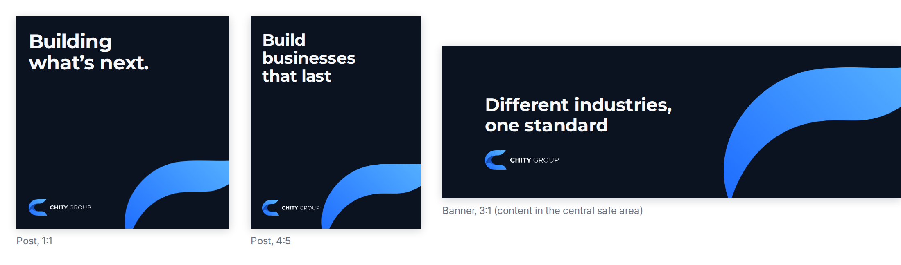
- Profile picture: the app icon, centered in the platform's circle or square.
- Posts and tiles: a Deep Navy background with one brand curve, a Montserrat Bold headline of six words or fewer, and the logo at the bottom left. Keep the headline and logo off the curve.
- Banners: design at 3:1 with every element in the central safe area, because platforms crop edges differently.
- Imagery: one dominant image, treated as described in the Imagery document.
- Platform dimensions change. Keep the ratios above and check each platform's current guidance before exporting.

7. Signage, vehicles and merchandise
ITEM | LOGO FILE | NOTES
Signage | Primary logo with tagline, SVG | Largest practical size, with the clear space intact. Deep Navy or Cloud White sign faces.
Vehicles | Primary or secondary logo, SVG | Vector artwork only. Keep the logo off panel seams and the curve off lettering.
Embroidery, engraving, stamps | Solid submark or one-color logo | Use the solid submark below 120 px (30 mm).
Merchandise (folders, bottles, notebooks) | Submark or one-color logo | Deep Navy items with the White logo. Ask for a sample before the full order.
Always supply vendors with the SVG files and require a proof before production.

