SonicSentinel AI
Project Documentation
  - Acoustic event detection for audio monitoring
Mentor: Sir Hamza Ali
Team leader: Moiz Jan
Team members: Sarim Owais, Ibad, Muhammad Hamza, Zarwasham Lodhi, and Alishba
Project report aligned to the SonicSentinel AI Software Requirements Specification, Version 1.0
September 2026

Project status at a glance
The application supports uploaded audio and live microphone monitoring, stores events in SQLite, and compares a Python prediction with a browser model. Saved evaluation evidence is mixed. The YAMNet transfer experiment clears the SRS model targets on its segment-level test, while the default XGBoost model and the Teachable Machine model do not clear all targets. This report distinguishes those results and their limits.

Contents
- 1 Project Overview
- 2 Scope and Requirements
- 3 Application Design
- 4 Dataset and Audio Processing
- 5 Python Model Development
- 6 Browser Model and Comparison
- 7 Alerts and Manual Review
- 8 Web Application and Data
- 9 Evaluation Results
- 10 Security Privacy and Responsible Use
- 11 Limitations and Next Steps
- 12 Running the Project
- Appendix A Project Structure
- Appendix B Requirements Status

1 Project Overview
SonicSentinel AI is a Flask web application for classifying sound events from uploaded recordings and live microphone input. It covers ten required sound classes and presents predictions, audio quality information, alerts, review decisions, and event history in a browser interface.

Acoustic monitoring illustration from the supplied rough documentation PDF.
For each event, the Python server model produces class scores. The browser can independently run a Google Teachable Machine model and return its own scores. The application compares the results and applies configurable rules to decide whether to log an event, raise an alert, or send it for human review. The Python prediction is not sent to the browser model.
This is a competition prototype for controlled and ethical testing. It is not a certified emergency response or law enforcement system. Operators must verify serious events and follow their site procedures.

1.1 Problem and purpose
People can miss sounds when they monitor recordings continuously, and video cameras cannot cover every sound source. The project helps a person notice relevant acoustic events sooner by classifying audio and organizing results for review. Its purpose is to support human monitoring, not to replace it.

1.3 Operating requirements
The SRS names a target computer with an Intel Core i5 or i7 processor, 8 or 16 GB of memory, and 500 GB of storage. It calls for a browser-based interface, Python backend, audio libraries, a database, machine-learning tools, and version control. The project uses Flask, SQLite, Python audio and machine-learning packages, JavaScript, and TensorFlow.js. The saved project does not include a benchmark proving the stated performance or availability targets.

1.2 Supported sound classes
Sound class | Sound class | Sound class
Machinery Fault | Glass Breaking | Alarm or Siren
Vehicle Horn | Animal Sound | Gunshot
Panic Scream | Aggression | Person Asking for Help
Background Noise

The alert rules identify Gunshot, Glass Breaking, Panic Scream, Aggression, and Person Asking for Help as critical classes. Severity and response depend on configured rule conditions and event context.

2 Scope and Requirements

2.1 Project scope
The application accepts audio, validates and prepares it, runs classification, evaluates audio quality, compares model results, applies alert rules, and stores event history. It provides pages for upload, live monitoring, event search, alerts, manual review, reports, and administration.
Speaker identification, speech transcription, multi-site orchestration, and certified emergency dispatch are outside the current scope. The project focuses on sound category detection.

2.2 Main assumptions
- The server can decode a supported audio file and access the local SQLite database.
- The browser supports microphone capture and can load the TensorFlow.js model.
- The exported browser labels match the canonical class order used by the application.
- Training, validation, and testing recordings remain separated by original recording and, for speech classes, by speaker where file metadata supports grouping.

2.3 Key requirements from the SRS
Area | Requirement summary
Input | Upload supported audio files and capture live microphone audio with permission.
Processing | Validate files, extract metadata, convert to mono 16 kHz audio, and segment long recordings.
Models | Train and compare at least three Python classifiers, and use an independent Google Teachable Machine classifier.
Decision | Compare class predictions and scores, evaluate quality, apply alert rules, and route uncertain events for review.
Records | Store audio metadata, scores, model versions, alerts, review decisions, and audit activity.
Reporting | Provide event search, dashboards, model metrics, and exportable records.
Targets | Both models target at least 85% accuracy, 0.80 macro F1, and 85% recall for each SRS critical class.

The last row is a target from the SRS, not a claim that the current models have met it. The measured results and gaps appear in Section 9.

3 Application Design
A user uploads a recording or grants microphone access. The Flask server validates the audio, preprocesses it, and creates detection records from fixed three-second segments. The Python model predicts from server-side features. The browser model independently evaluates the audio and sends its scores to the server after the detection record exists.
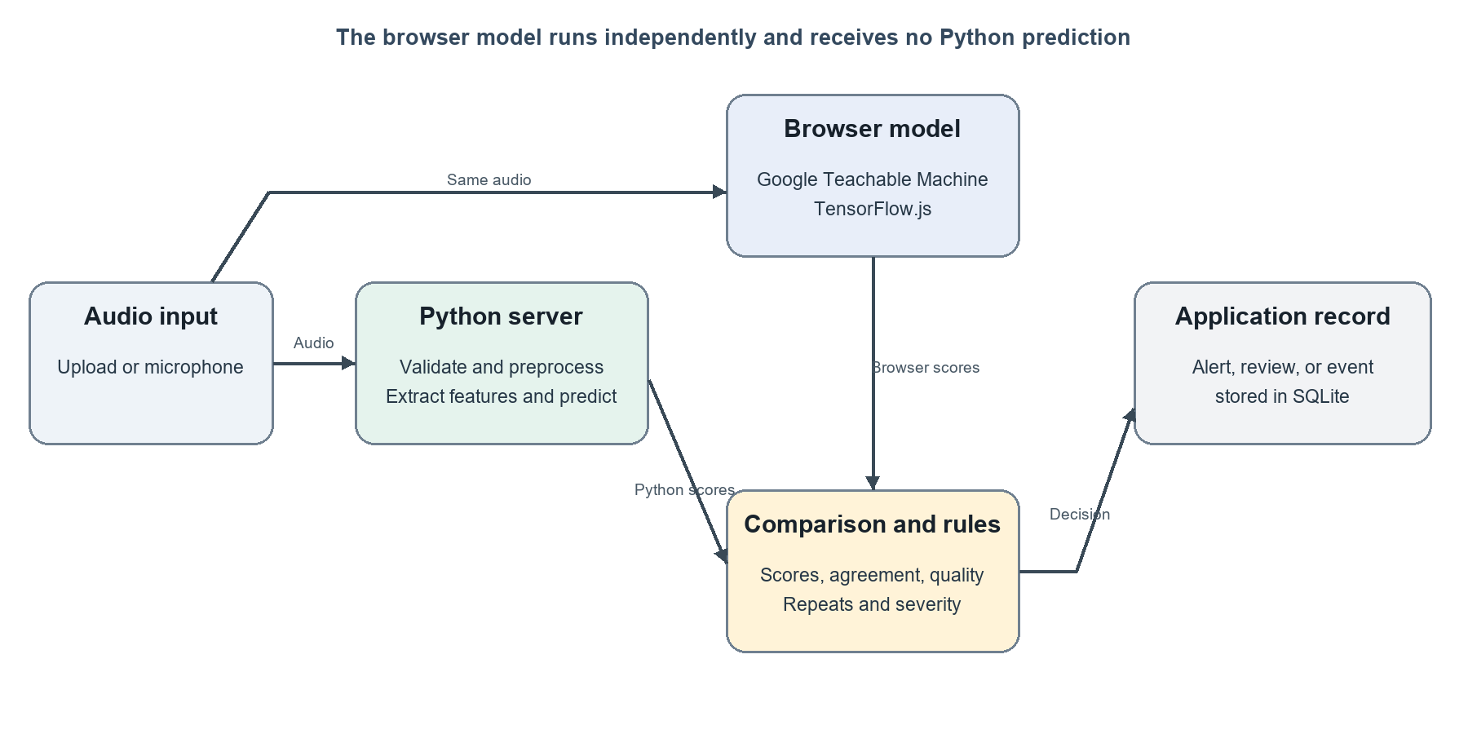
Figure 1. Application architecture based on the current source code.

3.1 Processing sequence
- The user selects a file or starts microphone monitoring.
- The application checks the file and extracts its audio metadata.
- Audio is converted to mono, resampled to 16 kHz, and divided into three-second segments.
- The Python model returns scores for the ten classes.
- The browser model may return a separate score vector for the same audio.
- The comparison and rule modules calculate agreement, quality, severity, alert status, and review reasons.
- The event, model outputs, and related actions are stored for later review and reporting.

3.2 Main software modules
Project area | Purpose
app.py | Flask routes, authentication flow, pages, uploads, and API endpoints.
audio_preprocessing | Audio validation, decoding, resampling, channel conversion, and segmentation.
feature_extraction | Summary features, spectrograms, and YAMNet embeddings.
src | Prediction analysis, model loading, comparison, quality, decision rules, reporting, and plots.
static/js | Browser-side model loading, audio capture, and prediction submission.
database | SQLite schema and queries for users, events, alerts, reviews, settings, and audit records.
templates | Pages for the dashboard, live monitoring, history, alerts, review, reports, and administration.

4 Dataset and Audio Processing

4.1 Dataset
The project contains 3,000 original recordings across the ten required classes. The saved split contains 2,096 training recordings, 459 validation recordings, and 445 testing recordings. The split is group-aware so derived segments stay with their source recording. These counts differ slightly from the SRS 70/15/15 example because grouping and class counts affect the final split.
Split | Original recordings | Use
Training | 2,096 | Fit model parameters and training-only augmentation.
Validation | 459 | Choose model settings and compare candidates.
Testing | 445 | Final held-out evaluation.

The source project describes hash checks for exact duplicate files. Augmented audio is stored separately from original recordings and is not counted as additional unique source recordings. The dataset includes a raw folder and generated splits.

4.2 Audio preparation
Supported upload extensions are WAV, MP3, FLAC, OGG, and M4A. The application validates and decodes uploads, checks for usable audio, converts stereo audio to mono, resamples it to 16 kHz, normalizes it, trims silence, and divides it into three-second segments. Short segments are padded and long segments are cut to the configured size. Noise reduction is available in code but disabled by default because project configuration records a validation result where it reduced accuracy.

4.3 Features
The default XGBoost pipeline uses a 215-value summary feature vector. It includes MFCC and delta statistics, mel-band values, chroma, spectral contrast, and other measures of energy and spectral shape. A separate YAMNet transfer experiment uses pooled 1,024-value embeddings to form a 2,048-value representation. CNN training code also uses log-mel spectrograms. These are separate model paths and should not be described as one shared feature vector.

4.4 Collection and augmentation
The dataset pipeline supports organized class folders, split metadata, class-balance checks, and training-only augmentation. The README lists noise addition, time shifting, pitch shifting, time stretching, volume change, reverberation, distance simulation, and recording-device simulation. Augmented examples remain linked to the original split and are not counted as unique recordings. Check source and consent metadata before submission, especially for speech and safety-event clips.

5 Python Model Development
The training pipeline fits models on the training split and uses the validation split to select settings. Saved test results are available for Logistic Regression, Random Forest, SVM, XGBoost, and YAMNet transfer. This satisfies the SRS requirement to compare at least three Python models.
Model | Test accuracy | Test macro F1 | Evaluation unit
Logistic Regression | 68.09% | 0.6812 | Clip
Random Forest | 69.44% | 0.6904 | Clip
SVM | 74.38% | 0.7424 | Clip
XGBoost | 74.83% | 0.7455 | Clip
YAMNet transfer | 90.02% | 0.9000 | Segment

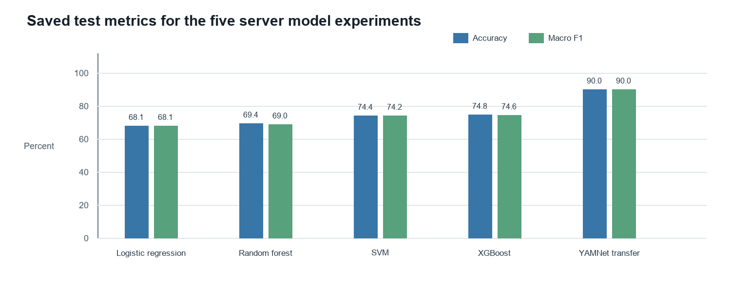
Figure 3. Test results from saved metric files. YAMNet transfer uses segment-level results.

5.1 Model selection and current configuration
The application configuration sets XGBoost as the default active Python model. The saved YAMNet transfer experiment has the strongest measured test metrics, but its test evaluation is segment-based and is not directly comparable to the clip-level results for the other four models. No active selection file was present in the project folder during this review. The report therefore records XGBoost as the configured default and YAMNet transfer as the strongest saved benchmark, rather than claiming they are the same deployment state.

5.2 Accuracy targets
SRS target | Configured XGBoost | YAMNet transfer experiment
Accuracy at least 85% | 74.83%, below target | 90.02%, above target
Macro F1 at least 0.80 | 0.7455, below target | 0.9000, above target
Gunshot recall at least 85% | 73.33%, below target | 86.67%, above target
Glass Breaking recall at least 85% | 88.89%, above target | 95.56%, above target
Panic Scream recall at least 85% | 86.67%, above target | 88.89%, above target
Aggression recall at least 85% | 97.78%, above target | 97.78%, above target
Person Asking for Help recall at least 85% | 80.00%, below target | 86.96%, above target

The YAMNet transfer results clear the numeric thresholds in the saved metric file, but the evaluation counts 451 test segments from 445 test recordings. Report-level comparison should use the same unit and same unseen recordings for every model. Re-run a per-recording evaluation before treating the result as a final SRS pass.

6 Browser Model and Comparison
The web application integrates a TensorFlow.js model exported from Google Teachable Machine. The browser loads the class labels and checks that their order matches the application. The browser scores the audio on its own and posts scores to the server endpoint after the server has saved its Python prediction. This supports independent model comparison and follows the SRS design.
The saved Teachable Machine prediction file contains 445 test examples. Recalculation from that file gives 35.96% accuracy and 0.3421 macro F1 across the ten classes. These results are below the SRS targets of 85% accuracy and 0.80 macro F1.
A separate browser CNN experiment appears in the project reports, with saved results of 75.73%% accuracy and 0.7555 macro F1. That experiment is not the current browser integration described by the application code and should be presented as an experiment, not as a replacement for the required Teachable Machine classifier.

6.1 Comparison values
- Predicted class from each model and the full class score vectors.
- Whether the top class agrees and the difference between the two top-class confidence scores.
- The margin between the top two scores, used to identify uncertain predictions.
- Model version, quality result, severity, alert state, and review status.
Confidence values from two independently trained models are not necessarily calibrated to the same scale. The application records their difference as a review aid; matching confidence values do not prove that the models are equally reliable.

7 Alerts and Manual Review
Alert rules are stored in alert_rules/alert_rules.json. Each class can define a minimum confidence, a margin between the top two classes, required repeated detections, whether model agreement is required, a minimum audio quality, severity, a recommended action, review conditions, and escalation conditions. Administrators can adjust application settings through the admin pages.
The decision logic checks for disagreements, low confidence, poor audio quality, close scores, possible overlapping sounds, unknown patterns, and critical events that do not satisfy their configured confirmation rules. Events that need a person are added to the manual review queue. Reviewers can play the audio, confirm or correct a class, and record comments while preserving original model outputs.

7.1 Example severity rules
Class | Configured severity | Example rule behavior
Gunshot | Critical | Requires high confidence, a clear score margin, repeated detections, model agreement, and acceptable quality.
Panic Scream | Critical | Requires confidence, score margin, model agreement, and acceptable quality.
Person Asking for Help | Critical | Requires model agreement and acceptable quality.
Glass Breaking | High | Requires model agreement and acceptable quality.
Aggression | High | Repeated detections can raise severity to Critical.
Background Noise | Informational | Can rise to Medium when the measured noise level exceeds its rule.

Configured rule outcomes are recommendations for an operator. They do not contact emergency services or verify that an incident occurred.

7.2 Decision sequence
The application first compares model classes and scores, then evaluates audio quality and the matching class rule. If a review condition applies, the event enters the review queue. Otherwise, a qualifying rule can create an alert. Events that meet neither condition remain in the event history. A missing browser prediction is recorded as awaiting comparison rather than as model agreement.

8 Web Application and Data

8.1 Main pages
Page | Purpose
Dashboard | Upload audio and review predictions, score comparisons, quality, severity, and actions.
Live Monitor | Capture microphone audio with permission and display current detections.
Event History | Search and filter stored detections.
Alerts | Acknowledge, dismiss, escalate, and inspect alert history.
Manual Review | Listen to uncertain events and record reviewer decisions.
Reports | View detection analytics and saved model metrics.
Admin | Manage users, settings, alert configuration information, and audit records.

8.2 Roles
Role | Typical access
User | Upload and view events.
Reviewer | Review uncertain events and record decisions.
Operator | Handle alerts and support event review.
Maintenance | Handle maintenance-related alerts.
Admin | Manage users, settings, exports, and audit information.

8.3 Stored information
The SQLite schema stores user accounts, audio metadata, detections, model scores, predictions, model versions, alerts, reviews, settings, and audit events. Detection records can include audio quality, confidence, agreement state, severity, alert state, and review status. Uploaded audio and related files are held in project data folders according to configured storage paths.

8.4 Data dictionary summary
Record | Key fields | Use
Audio file | Audio ID, filename, format, duration, sample rate, channels, size, hash, upload time. | Describe the source recording and identify duplicate files.
Detection | Detection ID, audio ID, segment time, class scores, model versions, quality, severity, status. | Keep a traceable result for each analyzed segment.
Alert | Alert ID, detection ID, severity, status, assigned user, timestamps. | Track acknowledgment, dismissal, or escalation.
Review | Review ID, detection ID, reviewer, decision, corrected class, comment, time. | Preserve a human confirmation or correction.
User and audit | User ID, role, account details; action, actor, record, and time. | Control access and record important account actions.

9 Evaluation Results

9.1 Summary
Area | Evidence in project | Status against SRS
Python model candidates | Five saved test metric files. | At least three compared.
Default Python model | XGBoost: 74.83% accuracy and 0.7455 macro F1. | Does not meet the overall targets.
YAMNet transfer experiment | 90.02% accuracy and 0.9000 macro F1 on 451 segments. | Numerically clears thresholds, but needs like-for-like recording-level evaluation.
Teachable Machine browser model | Saved prediction table with 445 examples, accuracy 35.96%, macro F1 0.3421. | Does not meet the overall targets.
Browser CNN experiment | Separate saved test metrics in reports. | Experiment only; not current Teachable Machine integration.
Runtime and scale targets | No saved benchmark for 8-second upload processing, 3-second live response, 20,000 records, concurrent users, or 99%% uptime. | Not verified.
Comparison report | Prediction exports exist. | Verify completeness against the SRS 100-recording, ten-per-class report and required fields.

The project is functional as a prototype, but the performance requirement for both models is not met by configured XGBoost and Teachable Machine results. The YAMNet transfer result is promising but needs a comparable, recording-level evaluation and confirmation as the application model before reporting the requirement as met.

9.2 Test evidence
The rough draft reports an automated test suite with 168 passing tests, including preprocessing, validation, feature extraction, model loading, decision logic, routes, and browser label mapping. This review did not rerun that suite. The repository includes test files, but the count should be refreshed before a competition submission.

9.3 Error and noise review
The XGBoost confusion matrix shows that 33 of 45 gunshot examples were correct. The remaining examples were labeled Background Noise, Glass Breaking, or Machinery Fault. For Background Noise, 22 of 45 examples were correct, with false positives spread across Machinery Fault, Gunshot, Alarm or Siren, and other classes. False positives can consume operator attention, while false negatives can hide a real event.
Saved noise-robustness values are available for some experiments, including Logistic Regression and Random Forest, but the XGBoost metric file has no noise-robustness measurements. The project therefore does not yet provide a complete noise-robustness comparison for its default model.

10 Security Privacy and Responsible Use
The application hashes passwords and checks roles before allowing protected actions. It records activity such as registration, review, model results, exports, and alert handling in an audit table. Microphone capture starts only after the user grants browser permission, and the interface displays microphone status.
The source project is configured for local storage in SQLite and local project folders. If the Flask application or Teachable Machine model is hosted remotely, administrators should review where uploaded audio, derived segments, database files, and model downloads are stored. The application must not be used for covert recording or treated as an emergency service.
The SRS requires disclosure of AI tools used during development in AI_USAGE.md. That file is empty in the reviewed project folder, so the team should complete it before submission. This documentation rewrite does not make that separate source-file change.

11 Limitations and Next Steps
- Improve Gunshot recall for configured XGBoost, which is 73.33% on saved clip-level test results.
- Improve Teachable Machine performance and document training sample counts, settings, export version, and evaluation method.
- Evaluate all models on the same held-out original recordings using the same unit of analysis.
- Confirm which Python model should be active, then align model files, configuration, reports, and demonstration.
- Measure upload and live prediction latency against SRS time limits.
- Test storage growth, concurrent users, retention behavior, and recovery before making scale or availability claims.
- Complete the SRS comparison report with at least 100 unseen recordings, ten per class, full confidence vectors, quality, decision, and error analysis.
- Complete AI_USAGE.md and retain a development log and model evidence required by the competition.

12 Running the Project
The project README is the source for installation and operation details. In brief, install the requirements in an isolated Python environment, prepare the SQLite database, place the trained Python model and Teachable Machine export in their configured folders, and start app.py. Open the local Flask address in a supported browser. Live monitoring requires microphone permission.
The first account created becomes the administrator. Keep the development secret key out of shared deployments and configure a secure secret key before exposing the application beyond a trusted local environment. Training notebooks run in Google Colab as described in README.md.

Appendix A Project Structure
Folder or file | Contents
app.py | Flask web application and routes.
config | Model, class, path, and setting defaults.
audio_dataset | Raw audio and training, validation, testing, and augmented splits.
audio_preprocessing | Audio validation and preparation.
feature_extraction | Model input feature code.
src | Prediction, model, decision, quality, metrics, and reporting modules.
python_models | Trained Python models and related metadata.
gtm_model | Browser model export and metadata.
alert_rules | Editable category rules.
database | SQLite schema and database functions.
templates and static | Web pages, CSS, and JavaScript.
notebooks | Exploration and model training notebooks.
reports | Saved model metrics, predictions, and figures.
tests | Automated test suite.

Appendix B Requirements Status
This summary records what is visible in the source and saved project evidence. It is not a substitute for a full requirement-by-requirement acceptance test.
SRS area | Observed evidence | Documentation status
Audio upload and validation | Upload routes and audio validation/preprocessing modules are present. | Implemented in source.
Live microphone | Browser microphone scripts and live page are present. | Implemented in source; latency not measured.
Ten mandatory classes | Canonical class list contains all ten. | Implemented.
Three or more Python models | Five saved model metric files. | Evidence available.
Independent GTM model | GTM model directory and browser submission endpoint exist. | Integration present; model thresholds not met.
Audio quality and visuals | Quality analysis, waveform, and spectrogram modules are present. | Implemented in source.
Alerts and manual review | Rules, alert, and reviewer workflows are present. | Implemented in source.
Event storage and roles | SQLite schema and role checks are present. | Implemented in source.
Accuracy and recall targets | Saved metrics show mixed outcomes by model and evaluation unit. | Not met by configured XGBoost and GTM; transfer experiment needs comparable evaluation.
Performance, scale, availability | No benchmark evidence found in reviewed material. | Not verified.
AI tool disclosure | AI_USAGE.md is empty. | Needs completion.

Appendix C System Diagrams
These diagrams show the main user actions and application flows described in this report. The architecture and data flow appear in Figure 1.

Use Case Diagram
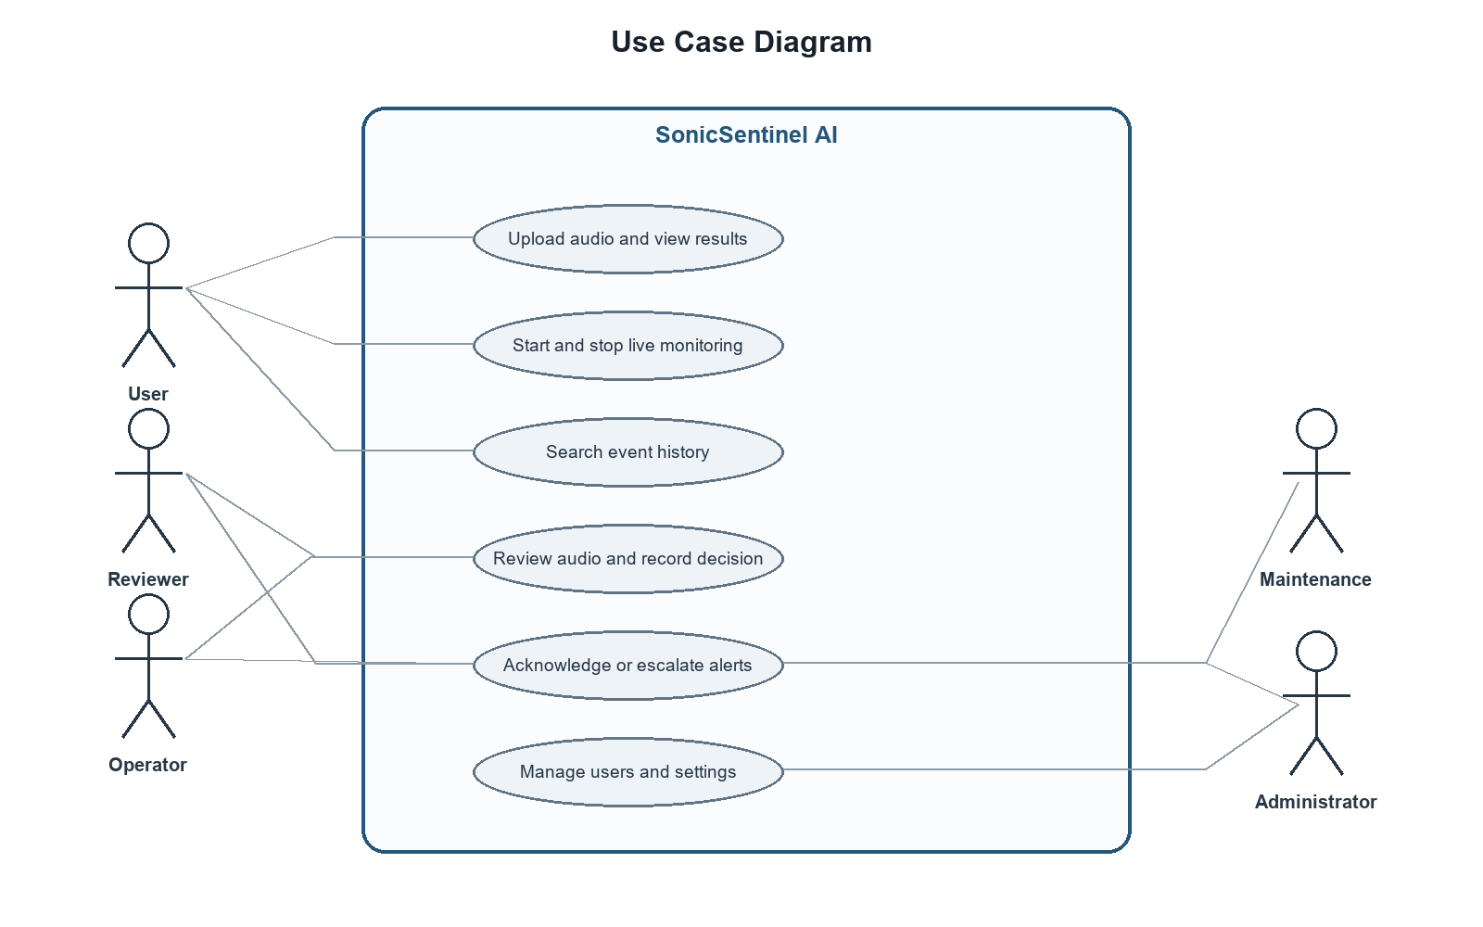
Figure 4. Main actions by user role.

Activity Diagram
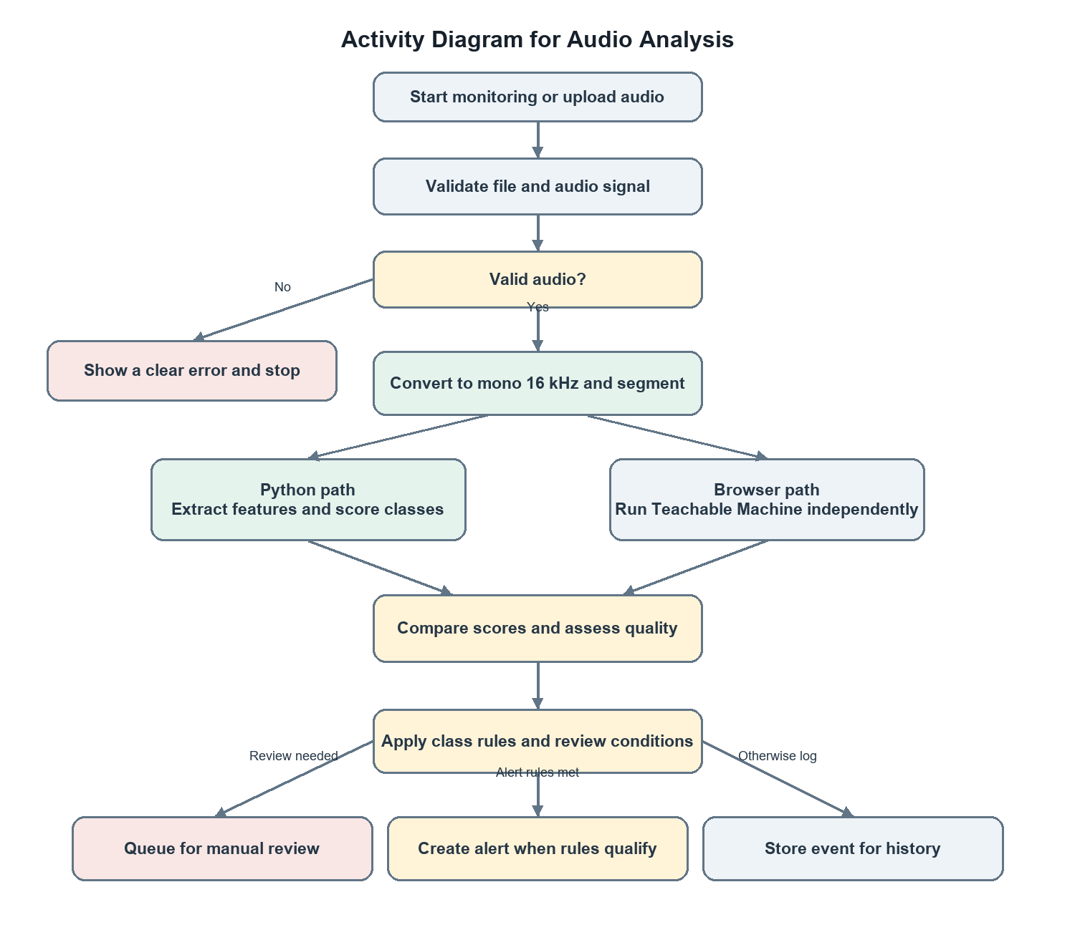
Figure 5. Audio analysis and decision flow.

Sequence Diagram
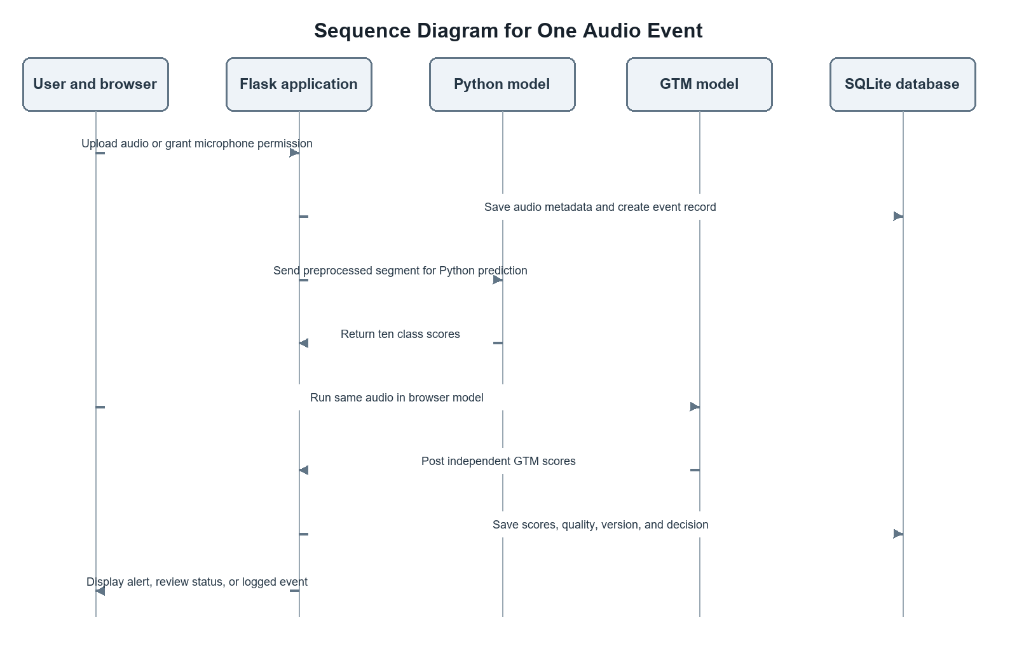
Figure 6. Messages exchanged while processing one event.

