You know, I know what you're thinking, because right now I'm thinking the same thing. Actually, I've been thinking it ever since I got here.

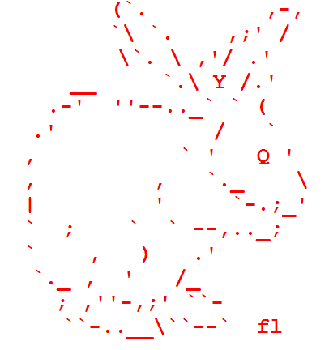

Why, oh why didn't I take the blue pill?