PROJECT REPORT

Enterprise Network Design with VLANs, Trunking,
Inter-VLAN Routing, DHCP and DNS

Submitted By
SAROJ YADAV

Roll-No: 34
Bachelor's Program in Computer Science
March 2026

1. Introduction
This project involves the design and configuration of an enterprise network consisting of two routers and four switches. The network implements Virtual Local Area Networks (VLANs) spanning multiple switches using IEEE 802.1Q trunking. Inter-VLAN routing is achieved using the Router-on-a-Stick method on Router0. A DHCP server provides automatic IP addressing for all end devices, and a DNS server handles internal hostname resolution.

2. Objectives
- Design a network using 2 routers (Cisco 1941) and 4 switches (Cisco 2960-24TT)
- Configure VLANs spanning multiple switches using trunk links
- Implement inter-VLAN routing using Router-on-a-Stick on Router0
- Deploy a DHCP server for automatic IP address assignment
- Configure a DNS server for internal hostname resolution
- Verify configuration using show vlan brief and show interfaces trunk commands

3. Network Topology
The network follows a hierarchical design with Router0 as the core routing device, Switch1 as the central distribution switch, and Switch0, Switch2, and Switch3 as access switches serving different departments.
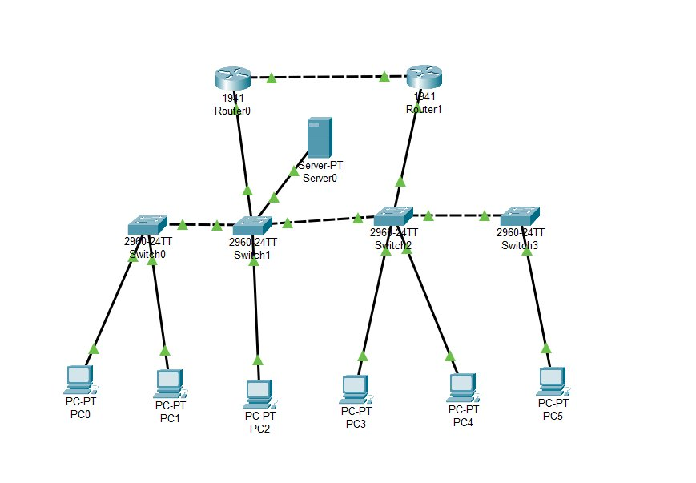
Figure 1: Network Topology Diagram

4. Device & IP Address Plan

4.1 Device Summary
Device | Model | Role | Interface | IP Address
Router0 | Cisco 1941 | Edge + Inter-VLAN | Gi0/1 | 10.0.0.1/30
Router1 | Cisco 1941 | Distribution | Gi0/0 | 192.168.2.1/24
Router1 | Cisco 1941 | Distribution | Gi0/1 | 10.0.0.2/30
Switch1 | 2960-24TT | Core L2 Switch | VLAN 99 | 192.168.99.1/24
Switch0 | 2960-24TT | Dept A Access | VLAN 99 | 192.168.99.11/24
Switch2 | 2960-24TT | Dept B/C Dist. | VLAN 99 | 192.168.99.12/24
Switch3 | 2960-24TT | Dept C Access | VLAN 99 | 192.168.99.13/24
Server0 | Server-PT | DHCP + DNS | Fa0 | 192.168.100.200/24

4.2 VLAN Plan
VLAN ID | Name | Subnet | Gateway | Devices
10 | DEPT_A | 192.168.10.0/24 | 192.168.10.1 | PC0, PC1
20 | DEPT_B | 192.168.20.0/24 | 192.168.20.1 | PC2, PC3
30 | DEPT_C | 192.168.30.0/24 | 192.168.30.1 | PC4, PC5
99 | MANAGEMENT | 192.168.99.0/24 | 192.168.99.1 | All switches
100 | SERVERS | 192.168.100.0/24 | 192.168.100.1 | Server0

5. VLAN Configuration
VLANs were created on all switches using the following commands (shown for Switch1; repeated on Switch0, Switch2, and Switch3 for their respective VLANs):

Switch1# configure terminal
Switch1(config)# vlan 10
Switch1(config-vlan)# name DEPT_A
Switch1(config-vlan)# vlan 20
Switch1(config-vlan)# name DEPT_B
Switch1(config-vlan)# vlan 30
Switch1(config-vlan)# name DEPT_C
Switch1(config-vlan)# vlan 99
Switch1(config-vlan)# name MANAGEMENT
Switch1(config-vlan)# vlan 100
Switch1(config-vlan)# name SERVERS
Switch1(config-vlan)# exit

6. Trunk Configuration
Trunk links carry traffic from multiple VLANs between switches using IEEE 802.1Q encapsulation. VLAN 99 is set as the native VLAN on all trunk ports.

6.1 Switch1 Trunk Ports
interface GigabitEthernet0/1
switchport mode trunk
switchport trunk allowed vlan 10,20,30,99,100
switchport trunk native vlan 99
interface FastEthernet0/1
switchport mode trunk
switchport trunk allowed vlan 10,99
switchport trunk native vlan 99
interface FastEthernet0/2
switchport mode trunk
switchport trunk allowed vlan 20,30,99
switchport trunk native vlan 99

6.2 Access Switch Trunk Uplinks
! Switch0 uplink to Switch1
interface GigabitEthernet0/1
switchport mode trunk
switchport trunk allowed vlan 10,99
! Switch2 uplink to Switch1
interface FastEthernet0/1
switchport mode trunk
switchport trunk allowed vlan 20,30,99
! Switch3 uplink to Switch2
interface GigabitEthernet0/1
switchport mode trunk
switchport trunk allowed vlan 30,99

7. Inter-VLAN Routing
Since all switches are Cisco 2960 (Layer 2 only), inter-VLAN routing is implemented using the Router-on-a-Stick method on Router0. Subinterfaces are created on GigabitEthernet0/0, one per VLAN, each with IEEE 802.1Q encapsulation.

interface GigabitEthernet0/0
no ip address
no shutdown
!
interface GigabitEthernet0/0.10
encapsulation dot1Q 10
ip address 192.168.10.1 255.255.255.0
ip helper-address 192.168.100.200
!
interface GigabitEthernet0/0.20
encapsulation dot1Q 20
ip address 192.168.20.1 255.255.255.0
ip helper-address 192.168.100.200
!
interface GigabitEthernet0/0.30
encapsulation dot1Q 30
ip address 192.168.30.1 255.255.255.0
ip helper-address 192.168.100.200
!
interface GigabitEthernet0/0.99
encapsulation dot1Q 99 native
ip address 192.168.99.1 255.255.255.0
!
interface GigabitEthernet0/0.100
encapsulation dot1Q 100
ip address 192.168.100.1 255.255.255.0

8. DHCP Configuration
The DHCP server (Server0 at 192.168.100.200) provides automatic IP addressing for all three department VLANs. The ip helper-address command on each Router0 subinterface relays DHCP broadcasts from clients to the server.

Pool Name | Start IP | Subnet Mask | Gateway | DNS
POOL_VLAN10 | 192.168.10.11 | 255.255.255.0 | 192.168.10.1 | .100.200
POOL_VLAN20 | 192.168.20.11 | 255.255.255.0 | 192.168.20.1 | .100.200
POOL_VLAN30 | 192.168.30.11 | 255.255.255.0 | 192.168.30.1 | .100.200

9. DNS Configuration
The DNS service runs on Server0 alongside DHCP. The following A records were configured through the Packet Tracer Services GUI:

Hostname | Type | IP Address
server0.local | A Record | 192.168.100.200
router0.local | A Record | 192.168.10.1
switch1.local | A Record | 192.168.99.1

10. Verification

10.1 show vlan brief — Switch1
Switch1# show vlan brief

VLAN Name Status Ports
---- -------------------- -------- --------------------
1 default active
10 DEPT_A active
20 DEPT_B active
30 DEPT_C active
99 MANAGEMENT active
100 SERVERS active Fa0/24

10.2 show interfaces trunk — Switch1
Switch1# show interfaces trunk

Port Mode Encapsulation Status Native vlan
Gi0/1 on 802.1q trunking 99
Fa0/1 on 802.1q trunking 99
Fa0/2 on 802.1q trunking 99

Port Vlans allowed on trunk
Gi0/1 10,20,30,99,100
Fa0/1 10,99
Fa0/2 20,30,99

10.3 Connectivity Test Results
Test | Source | Destination | Result | Type
Intra-VLAN ping | PC0 (VLAN 10) | PC1 (VLAN 10) | Pass | Same VLAN
Inter-VLAN ping | PC0 (VLAN 10) | PC2 (VLAN 20) | Pass | Via RoaS
DHCP lease | PC4 (VLAN 30) | Server0 | Pass | Auto IP
DNS resolution | PC0 | server0.local | Pass | DNS
Server ping | PC0 | 192.168.100.200 | Pass | Cross-VLAN

11. Conclusion
- A two-router, four-switch enterprise network was successfully designed and implemented in Cisco Packet Tracer
- Five VLANs (10, 20, 30, 99, 100) were created and verified across all switches
- IEEE 802.1Q trunk links established between Switch1 and all connected switches
- Inter-VLAN routing implemented using Router-on-a-Stick with subinterfaces on Router0 (Gi0/0.10, .20, .30, .99, .100)
- DHCP relay configured using ip helper-address on each subinterface; all PCs received IPs automatically
- DNS server configured with A records for internal hostname resolution
- Configuration verified using show vlan brief, show interfaces trunk, and ping tests — all passed

