LAB 4
SUBNETTING AND SUPERNETTING USING CISCO PACKET TRACER

OBJECTIVES
• To gain hands-on experience in logically dividing IP networks using Subnetting and combining multiple networks using Supernetting.
• To configure and implement the designed network topology in Cisco Packet Tracer, ensuring proper routing between subnets.
• To observe and analyze packet flow between subnets via a router, verifying connectivity and network performance.

THEORY

1. Subnetting
Subnetting represents a fundamental network segmentation technique that enables administrators to partition a single large network into multiple smaller, logically separated network segments. This hierarchical division is achieved through the manipulation of IP address structure, specifically by extending the network prefix beyond its classful boundary.
Mechanism of Operation: The process involves borrowing bits from the host portion of an IP address to create an extended network identifier. By applying a customized subnet mask, network devices can differentiate between the network portion, subnet identifier, and host portion of an address. Consider a Class C network with a default /24 prefix: by borrowing two additional bits, we create four distinct subnet identifiers (2² = 4), effectively quadrupling the number of manageable network segments while proportionally reducing the host capacity per segment.
Practical Benefits: This segmentation strategy delivers tangible improvements in network architecture. By constraining broadcast domains to smaller logical boundaries, subnetting reduces unnecessary traffic propagation and minimizes collision potential. The isolation of network segments enhances security posture by limiting lateral movement and containing potential threats within defined boundaries. Furthermore, the hierarchical structure improves overall network efficiency by localizing traffic patterns and optimizing routing decisions.

2. Supernetting
Supernetting, alternatively termed route aggregation or Classless Inter-Domain Routing (CIDR), functions as the conceptual inverse of subnetting. Rather than fragmenting networks into smaller units, this technique consolidates multiple contiguous network addresses into a single, unified routing entry.
Mechanism of Operation: The aggregation process operates by decreasing the network prefix length, effectively moving the network-host boundary leftward in the address structure. This creates a supernet address that encompasses multiple traditional network ranges. By reducing the number of network bits in the mask, routing infrastructure can represent numerous specific networks with a single summarized route entry.
Practical Benefits: The primary advantage of supernetting manifests in routing table optimization. By consolidating multiple route entries into singular aggregate routes, this technique significantly reduces the memory footprint and computational overhead required for routing table maintenance. This optimization directly translates to faster routing table lookups, reduced processor utilization, and improved scalability in large-scale internetwork environments. The technique has proven particularly valuable in managing the explosive growth of internet routing tables and optimizing backbone router performance.

NETWORK DESIGN

Subnetting

Calculations
Network Address: 192.168.1.0/24
Required number of subnets: 4
Number of IP address per subnet: 64 (Block size)
/26 (Borrowed 2 bits: 2² = 4 subnets)
Subnet Mask: 255.255.255.192

Subnet Calculation Table
Subnet | Network ID | 1st Host | Last Host | Broadcast ID
1 | 192.168.1.0 | 192.168.1.1 | 192.168.1.62 | 192.168.1.63
2 | 192.168.1.64 | 192.168.1.65 | 192.168.1.126 | 192.168.1.127
3 | 192.168.1.128 | 192.168.1.129 | 192.168.1.190 | 192.168.1.191
4 | 192.168.1.192 | 192.168.1.193 | 192.168.1.254 | 192.168.1.255

Network Topology
Subnetting Implementation
Your topology shows a hierarchical network structure with:
- Router0 (1941 RTR_Utsav) at the top level
- Two switches: Switch0 (2960-24TT SW1_Utsav) on the left and Switch1 (2960-24TT SW2_Utsav1) on the right
- Left subnet devices connected to Switch0:
  - PC-PT Utsav_PC1
  - PC-PT Utsav_PC2
  - Laptop-PT Utsav_Laptop0
- Right subnet devices connected to Switch1:
  - PC-PT Utsav_PC3
  - Laptop-PT Utsav_Laptop1
  - Laptop-PT Utsav_Laptop2
A topology was created using Router0 (1941 RTR_Utsav) to connect two subnets: 192.168.1.0/26 and 192.168.1.64/26. Switch0 (SW1_Utsav) connects Utsav_PC1, Utsav_PC2, and Utsav_Laptop0 in the first subnet. Switch1 (SW2_Utsav1) connects Utsav_PC3, Utsav_Laptop1, and Utsav_Laptop2 in the second subnet. Both switches are linked to separate interfaces on Router0, allowing communication between the two subnets through the router acting as the default gateway.

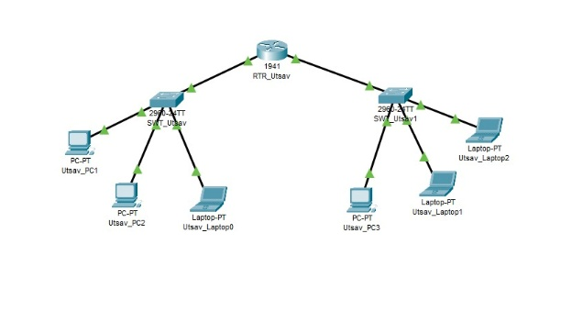
Supernetting Implementation :
Your topology shows:
- Router1 (1941 RTR_Utsav) at the top
- One switch (2960-24TT SW1_Utsav) connected to Router1
- Four devices connected to the switch:
  - PC-PT Utsav_PC0
  - PC-PT Utsav_PC1
  - PC-PT Utsav_PC2
  - PC-PT Utsav_PC3
A topology was created using Router1 (1941 RTR_Utsav) to demonstrate supernetting. The switch (SW1_Utsav) connects Utsav_PC0, Utsav_PC1, Utsav_PC2, and Utsav_PC3, all within the same aggregated network using a /22 subnet mask (255.255.252.0). Each device is connected using straight-through Ethernet cables, and the switch is linked to Router1 to provide routing capabilities. This setup demonstrates how supernetting aggregates multiple smaller networks into a larger address space, reducing routing table entries while maintaining connectivity between all devices.
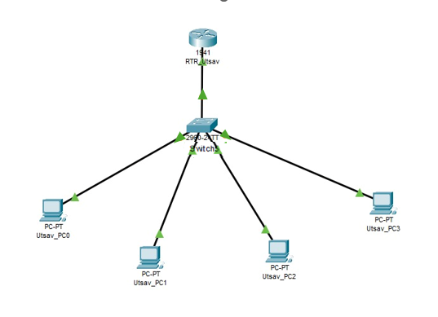

CONFIGURATION TABLE

Subnetting
Device | IPV4 | Subnet Mask | Default Gateway
Router0 (FastEthernet0/0) | 192.168.1.1 | 255.255.255.192 | N/A
Router0 (FastEthernet0/1) | 192.168.1.65 | 255.255.255.192 | N/A
Utsav_PC1 (Subnet 1) | 192.168.1.2 | 255.255.255.192 | 192.168.1.1
Utsav_PC2 (Subnet 1) | 192.168.1.3 | 255.255.255.192 | 192.168.1.1
Utsav_Laptop0(Subnet 1) | 192.168.1.4 | 255.255.255.192 | 192.168.1.1
Utsav_PC3 (Subnet 2) | 192.168.1.66 | 255.255.255.192 | 192.168.1.65
Utsav_Laptop1(Subnet 2) | 192.168.1.67 | 255.255.255.192 | 192.168.1.65
Utsav_Laptop2(Subnet 2) | 192.168.1.68 | 255.255.255.192 | 192.168.1.65

Supernetting
Device | IPV4 | Subnet Mask | Default Gateway
Router1 (FastEthernet0/0) | 192.168.1.1 | 255.255.252.0 | N/A
Utsav_PC0 | 192.168.1.10 | 255.255.252.0 | 192.168.1.1
Utsav_PC1 | 192.168.1.10 | 255.255.252.0 | 192.168.1.1
Utsav_PC2 | 192.168.2.10 | 255.255.252.0 | 192.168.1.1
Utsav_PC3 | 192.168.3.10 | 255.255.252.0 | 192.168.1.1

Discussion
This laboratory exercise focused on understanding subnetting and supernetting using Cisco Packet Tracer. Subnetting was implemented by dividing a network into two subnets, 192.168.1.0/26 and 192.168.1.64/26, which improved IP address management and reduced broadcast traffic. A central router enabled communication between the subnets, clearly demonstrating routing concepts. Supernetting was also explored to show how multiple networks can be summarized into a single routing entry, improving routing efficiency. The experiment strengthened practical knowledge of IP addressing and network topology design.

Conclusion
The lab successfully demonstrated the practical use of subnetting and supernetting in network design. Cisco Packet Tracer helped visualize network behavior and routing between subnets. Overall, the exercise enhanced understanding of efficient IP allocation and routing strategies, providing a strong foundation for designing scalable and organized network infrastructures.

