Lab 5: Configuration of Static Routes and Default Routes

Objectives:
• To establish communication between disparate local area networks (LANs) by manually defining paths across an internetwork of at least two routers.
• To observe how the router processes a static route by looking up the next-hop IP address in the routing table.

Theory:
Routers forward packets between networks by examining destination addresses and consulting routing tables. This forwarding process requires knowledge of available paths through the internetwork.

Static Routing:
Network administrators can manually configure routing entries that specify exact paths for traffic. These entries remain fixed unless explicitly modified by an administrator.

The Cisco IOS command structure is:
Router(config)# ip route <destination network> <subnet mask> <next hop ip>

Key Characteristics:
• Resource Efficiency: Manual routes eliminate periodic update messages between routers, reducing network overhead.
• Security: Fixed routing entries prevent unauthorized route injection attacks common with dynamic protocols.

Network Topology:

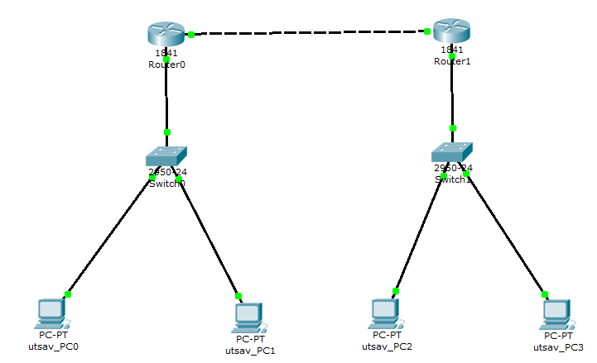

Configuration:

For PCs:
Device | IPv4 address | Subnet Mask | Default Gateway
utsav_PC0 | 192.168.1.2 | 255.255.255.0 | 192.168.1.1
utsav_PC1 | 192.168.1.3 | 255.255.255.0 | 192.168.1.1
utsav_PC2 | 192.168.2.2 | 255.255.255.0 | 192.168.2.1
utsav_PC3 | 192.168.2.3 | 255.255.255.0 | 192.168.2.1

For Routers:
Device | IPv4 address | Subnet Mask | Next Hop | Ethernet Cable | Default Gateway
Router 0 | 192.168.2.0 | 255.255.255.0 | 10.0.0.2 | gig 0/0 | 10.0.0.1
 |  |  |  | gig 0/1 | 192.168.1.1
Router 1 | 192.168.1.0 | 255.255.255.0 | 10.0.0.1 | gig 0/0 | 10.0.0.2
 |  |  |  | gig 0/1 | 192.168.2.1

Observation(cmd):

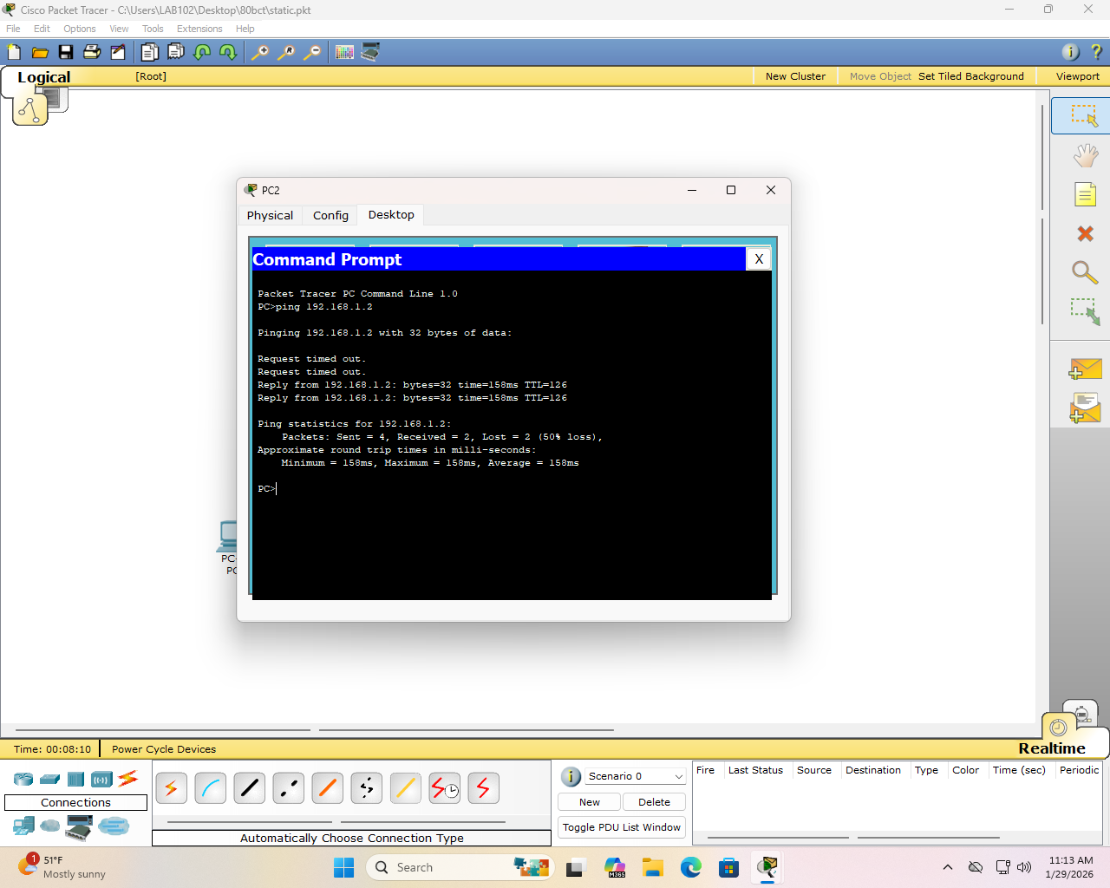

Default Routing:
When a router encounters traffic destined for networks not in its routing table, a default route provides a catchall forwarding path. This uses the 0.0.0.0 0.0.0.0 notation to match all destinations.

Syntax: ip route 0.0.0.0 0.0.0.0 <next hop ip>

Usage:
Edge routers typically employ default routes to forward Internet-bound traffic toward ISP gateways rather than maintaining extensive Internet routing tables.

Network Topology:


Configuration:

For PCs:
Device | IPv4 address | Subnet Mask | Default Gateway
utsav_PC0 | 192.168.1.2 | 255.255.255.0 | 192.168.1.1
utsav_PC1 | 192.168.1.3 | 255.255.255.0 | 192.168.1.1
utsav_PC2 | 192.168.2.2 | 255.255.255.0 | 192.168.2.1
utsav_PC3 | 192.168.2.3 | 255.255.255.0 | 192.168.2.1

For Routers:
Device | Destination Network | Subnet Mask | Next Hop
Router 0 | 0.0.0.0 | 0.0.0.0 | 10.0.0.2
Router 1 | 0.0.0.0 | 0.0.0.0 | 10.0.0.1

Observation(cmd):

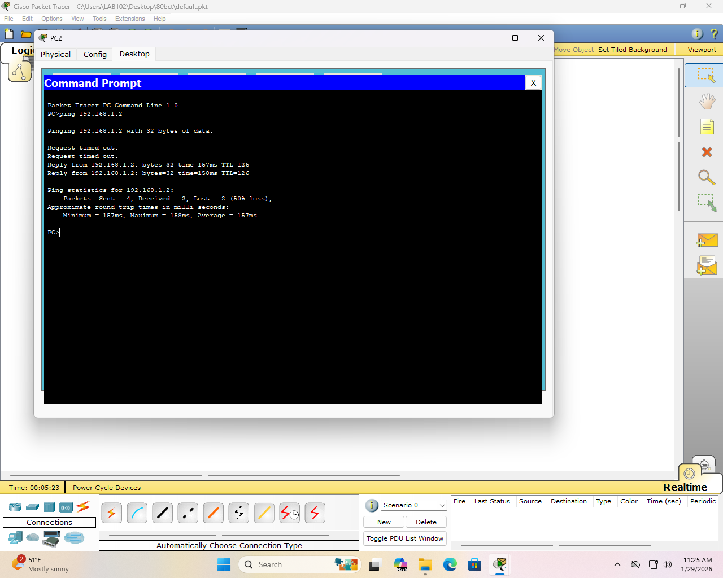

Result:
Static Routing Success: After applying the ip route command with specific destination networks (192.168.2.0 for Router 0 and 192.168.1.0 for Router 1), connectivity was established between different LANs. This was verified through a successful ping test from a host in the 192.168.1.0 network to the 192.168.2.2 address, despite initial packet loss.

Default Routing Success: By implementing the "Quad-Zero" route (0.0.0.0 0.0.0.0) on both routers, all traffic without a specific destination in the routing table was successfully forwarded to the next-hop IP (10.0.0.2 for Router 0 and 10.0.0.1 for Router 1). Connectivity was confirmed with successful ping.

Discussion:
The experiment demonstrated two approaches to inter-network routing configuration. Initially, devices on separate LANs could not communicate due to the absence of routing information. Manual configuration of specific network paths on each router enabled successful connectivity between the 192.168.1.0 and 192.168.2.0 networks. This approach eliminated routing protocol overhead.
The alternative configuration using catchall routes simplified the setup process. Both routers forwarded unmatched traffic to their respective next-hop addresses. Initial ICMP requests experienced timeouts during ARP resolution, but subsequent packets transmitted successfully once MAC addresses were cached.

Conclusion:
The laboratory exercise validated both targeted and catchall routing configurations in a multi-router environment using Cisco Packet Tracer. Manual path specification proved effective for connecting known networks, while default routes provided a simplified configuration model for forwarding traffic beyond the local topology. Both methods achieved inter-LAN connectivity as evidenced by successful ICMP echo exchanges.

