7. VLAN CONFIGURATION, SWITCH CONFIGURATION
AND INTER-VLAN ROUTING

1. Objective
To configure VLANs on a switch, assign ports to VLANs, configure switchport modes (access and trunk), and implement Inter-VLAN routing using a router-on-a-stick configuration in Cisco Packet Tracer.

2. Topology Overview
The network consists of one router connected to a switch via a trunk link. The switch has four PCs connected to different ports, which are assigned to two VLANs (VLAN 10 and VLAN 20). Inter-VLAN routing is configured on the router using subinterfaces.
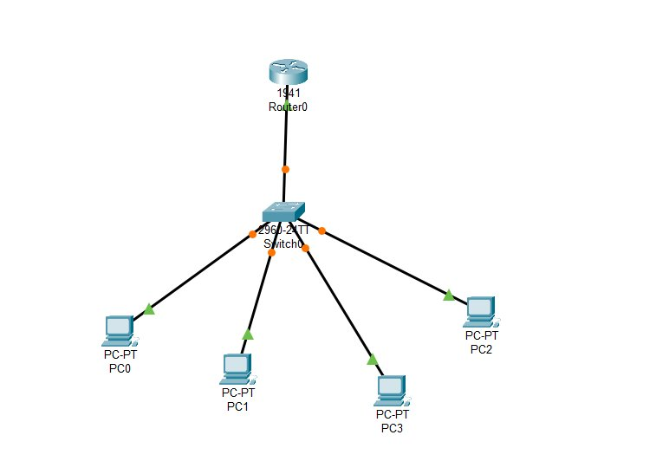
Figure 1: Network Topology Diagram

3. Devices Used
• 1 × Router (1941)
• 1 × Switch (2960)
• 4 × PC-PT (PC0, PC1, PC2, PC3)

4. VLAN and IP Addressing Scheme
The network is segmented into two VLANs:
VLAN ID | VLAN Name | Network | Gateway
10 | Computer | 192.168.10.0/24 | 192.168.10.1
20 | Electronics | 192.168.20.0/24 | 192.168.20.1

4.1 Device IP Addressing Table
Device | Interface/Port | IP Address | VLAN
Router0 | Gi0/0.10 | 192.168.10.1 | 10
Router0 | Gi0/0.20 | 192.168.20.1 | 20
PC0 | Fa0/1 (Switch) | 192.168.10.2 | 10
PC1 | Fa0/2 (Switch) | 192.168.10.3 | 10
PC2 | Fa0/3 (Switch) | 192.168.20.2 | 20
PC3 | Fa0/4 (Switch) | 192.168.20.3 | 20

5. Configuration Steps
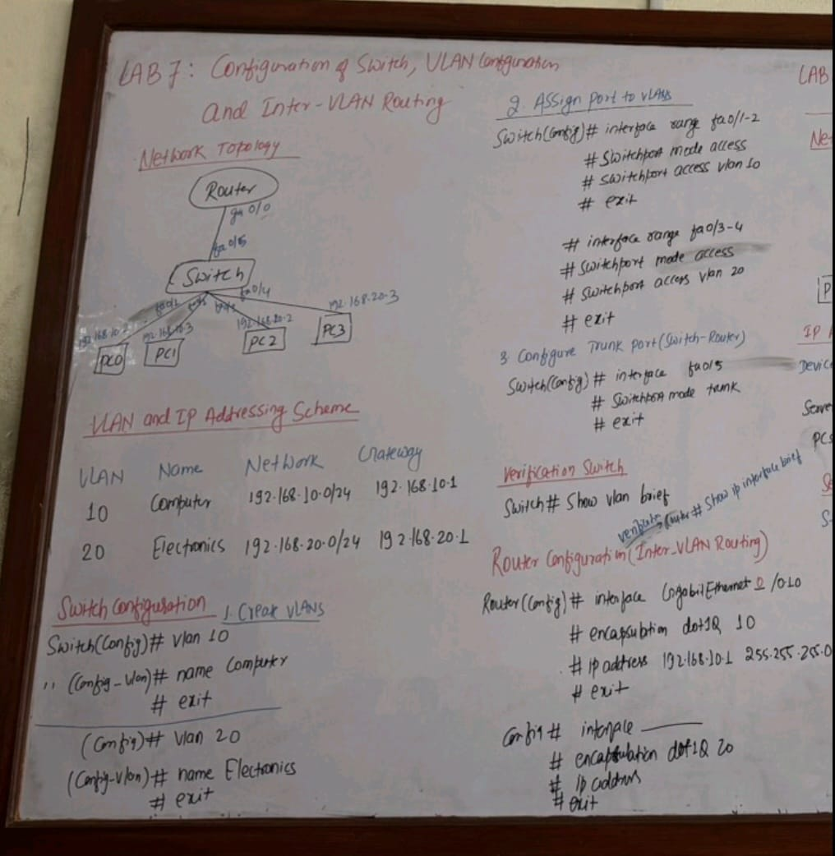
Figure 2: Configuration Notes

5.1 Switch VLAN Configuration

5.1.1 Create VLANs
Switch(config)# vlan 10
Switch(config-vlan)# name Computer
Switch(config-vlan)# exit
Switch(config)# vlan 20
Switch(config-vlan)# name Electronics
Switch(config-vlan)# exit

5.1.2 Assign Ports to VLANs
For VLAN 10 (Ports Fa0/1-2):
Switch(config)# interface range fa0/1-2
Switch(config-if-range)# switchport mode access
Switch(config-if-range)# switchport access vlan 10
Switch(config-if-range)# exit
For VLAN 20 (Ports Fa0/3-4):
Switch(config)# interface range fa0/3-4
Switch(config-if-range)# switchport mode access
Switch(config-if-range)# switchport access vlan 20
Switch(config-if-range)# exit

5.1.3 Configure Trunk Port
Switch(config)# interface fa0/5
Switch(config-if)# switchport mode trunk
Switch(config-if)# exit

5.2 Router Inter-VLAN Configuration

5.2.1 Configure Subinterface for VLAN 10
Router(config)# interface gigabitEthernet 0/0.10
Router(config-subif)# encapsulation dot1Q 10
Router(config-subif)# ip address 192.168.10.1 255.255.255.0
Router(config-subif)# exit

5.2.2 Configure Subinterface for VLAN 20
Router(config)# interface gigabitEthernet 0/0.20
Router(config-subif)# encapsulation dot1Q 20
Router(config-subif)# ip address 192.168.20.1 255.255.255.0
Router(config-subif)# exit

5.2.3 Enable Physical Interface
Router(config)# interface gigabitEthernet 0/0
Router(config-if)# no shutdown
Router(config-if)# exit

5.3 PC IP Configuration
Configure each PC with static IP addresses as shown in the Device IP Addressing Table (Section 4.1), using their respective VLAN gateway addresses.
Subnet mask for all devices: 255.255.255.0

6. Verification Commands

6.1 Switch Verification
Switch# show vlan brief
Purpose: Displays VLAN configuration and port assignments

6.2 Router Verification
Router# show ip interface brief
Purpose: Displays interface status and IP addresses

7. Connectivity Testing

7.1 Intra-VLAN Testing
From PC0, ping PC1 (both in VLAN 10):
C:\> ping 192.168.10.3
Expected Result: Successful replies (devices in same VLAN communicate directly through switch)

7.2 Inter-VLAN Testing
From PC0 (VLAN 10), ping PC2 (VLAN 20):
C:\> ping 192.168.20.2
Expected Result: Successful replies (traffic routed through router subinterfaces)

7.3 Gateway Testing
From any PC, ping its default gateway:
From PC0: C:\> ping 192.168.10.1
From PC2: C:\> ping 192.168.20.1
Expected Result: Successful replies

8. Observations
• VLANs successfully created and ports assigned to respective VLANs.
• Trunk link established between switch and router for VLAN traffic.
• Devices within the same VLAN can communicate directly through the switch.
• Inter-VLAN communication requires routing through the router subinterfaces.
• Router-on-a-stick configuration successfully enables communication between VLANs.
• All connectivity tests passed without packet loss.

9. Result
VLANs were successfully configured on the switch with appropriate port assignments. Inter-VLAN routing was implemented using router subinterfaces with 802.1Q encapsulation. All devices can communicate within their VLANs and across VLANs through the router, demonstrating successful network segmentation and inter-VLAN routing.

10. Conclusion
This lab successfully demonstrated VLAN configuration, switchport mode configuration (access and trunk), and Inter-VLAN routing using the router-on-a-stick method. The lab illustrates how VLANs provide network segmentation for security and traffic management, while Inter-VLAN routing enables communication between different VLANs. Understanding these concepts is essential for designing scalable and secure enterprise networks.

