LAB 8: Server Configuration- DHCP, DNS, and Web Server in Cisco Packet Tracer

Objectives
- Configure a server to deliver DHCP, DNS, and HTTP (Web) services within a Cisco Packet Tracer simulation environment.
- Gain a practical understanding of how DHCP handles automatic IP address distribution and how DNS translates domain names to IP addresses.
- Confirm that all configured services are functioning correctly by accessing the web server from client machines using a domain name.

Theory

1. Server Configuration
Setting up a server involves preparing it to offer various network services to connected client devices. A fixed (static) IP address is typically assigned to a server so that clients always know where to find it. In this laboratory exercise, a single server hosts three services simultaneously: DHCP, DNS, and HTTP. Properly configured servers enable stable communication, centralised control of network resources, and more efficient administration across the network.

2. DHCP (Dynamic Host Configuration Protocol)
DHCP is a protocol that removes the need for manual IP configuration on client machines by automatically distributing network parameters — including IP address, subnet mask, default gateway, and DNS server — whenever a device connects to the network. This automated approach minimises the risk of configuration mistakes, speeds up device setup, and simplifies overall network management.

3. DNS (Domain Name System)
The Domain Name System serves as a translator between human-readable domain names and the numeric IP addresses that computers use for routing. It is considerably easier for users to remember names such as www.hcoe.com than to recall a numeric address. The DNS server holds resource records that link each domain name to its associated IP address. Upon receiving a domain-based request from a client, the DNS server looks up the record and returns the matching IP address.

4. Web Server (HTTP Service)
A web server responds to client requests by delivering web page content via the HTTP protocol. It stores and serves files such as HTML pages and handles browser-initiated requests. Enabling the HTTP service on the server in this lab allows the client PCs to browse to a hosted page.

Integration of DHCP, DNS, and Web Server
These three services complement one another to create a seamless networking experience. DHCP takes care of automatic address assignment, DNS handles name-to-address resolution, and the web server fulfils content delivery requests. Together, they eliminate the need for manual client setup and demonstrate the value of centralised, server-driven service management in contemporary networks.

Network Topology
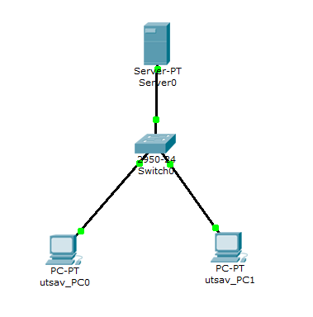

Configuration

IP Addressing Scheme

Device | IP Address | Subnet Mask | Gateway
Server | 192.168.1.2 | 255.255.255.0 | 192.168.1.1
PC | DHCP | DHCP | DHCP

IP settings obtained by each PC via DHCP:

Device | IPv4 Address | Subnet Mask | Default Gateway | DNS Server
utsav_PC0 | 192.168.1.1 | 255.255.255.0 | 0.0.0.0 | 192.168.1.2
utsav_PC1 | 192.168.1.3 | 255.255.255.0 | 0.0.0.0 | 192.168.1.2

Server network settings:

Device | Default Gateway | DNS Server
Server0 | 192.168.1.1 | 192.168.1.2

Procedure

Server Configuration
Step 1: Assign a Static IP to the Server
- Click on Server0 to open its settings.
- Navigate to Desktop > IP Configuration.
- Enter the following static network parameters:
- IP Address: 192.168.1.2
- Subnet Mask: 255.255.255.0
- Default Gateway: 192.168.1.1
- DNS Server: 192.168.1.2

DHCP Configuration
Step 2: Enable the DHCP Service
- On the server, go to Services > DHCP.
- Toggle DHCP to ON.

Step 3: Create a DHCP Address Pool
Click Add after filling in the pool parameters as shown in the table below:

Field | Value
Pool Name | LAB_POOL
Default Gateway | 192.168.1.1
DNS Server | 192.168.1.2
Start IP Address | 192.168.1.10
Subnet Mask | 255.255.255.0
Maximum Users | 50

Verification
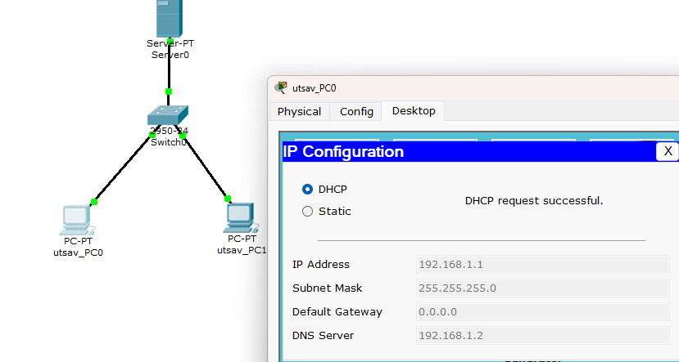

DNS Server Configuration
Step 4: Enable the DNS Service
- On the server, navigate to Services > DNS.
- Switch DNS to ON.

Step 5: Add a DNS Resource Record
- Name: www.hcoe.com
- Type: A record
- Address: 192.168.1.2
Click Add to save the record.

Verification
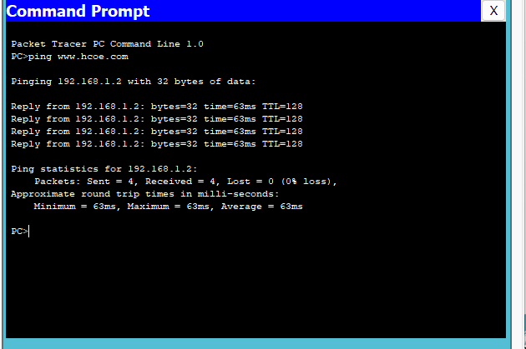

Web Server Configuration
Step 6: Enable the HTTP Service
- On the server, go to Services > HTTP.
- Switch HTTP to ON.
- Modify the index.html file to customise the displayed page content.
- Ping www.hcoe.com

Verification
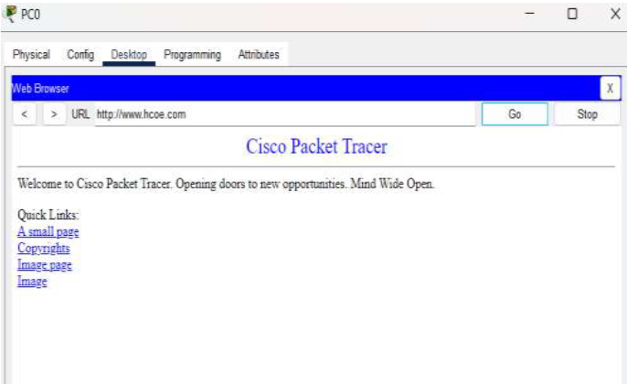4

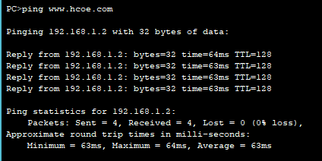

Result
All three services — DHCP, DNS, and HTTP — were configured and verified successfully in Cisco Packet Tracer. The server was given a static IP address, and client PCs automatically received valid network configurations through DHCP. DNS name resolution operated as expected, enabling clients to reach the web server via the domain name www.hcoe.com. The HTTP service delivered the hosted web page to both client devices without error, confirming that all configured services are working as intended.

Discussion
This lab provided hands-on exposure to the configuration and interaction of three fundamental network services. The use of DHCP eliminated the need to manually assign network parameters to each client, thereby reducing the chance of human error. DNS abstracted the need to remember IP addresses by allowing resource access through a meaningful domain name. The ability to successfully load the web page via a browser validated correct application-layer communication. Working through the lab also reinforced knowledge of service interdependencies, configuration accuracy, and basic diagnostic steps in a simulated yet realistic network environment.

Conclusion
The lab successfully met its goals of configuring DHCP, DNS, and HTTP services on a single server within Cisco Packet Tracer.

