WIRELESS NETWORK SETUP AND PACKET ANALYSIS
USING CISCO PACKET TRACER

1. Objective
To design and configure a basic wireless local area network (WLAN) using a wireless router and client laptops in Cisco Packet Tracer, and to observe packet flow between connected devices.

2. Topology Overview
The network consists of one wireless router (WRT300N) acting as an access point and DHCP server. Two laptops are connected to the router over Wi-Fi.
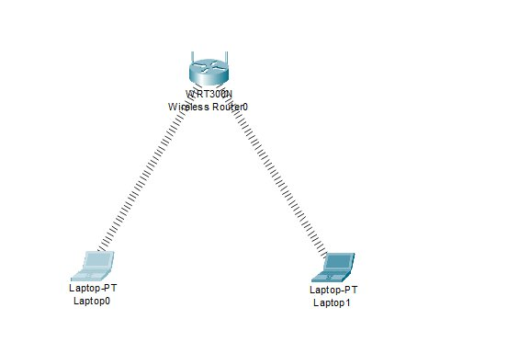
Figure 1: Network Topology Diagram

3. Devices Used
• 1 × WRT300N Wireless Router
• 2 × Laptop-PT (wireless enabled)

4. IP Addressing Table
Dynamic IP addressing using DHCP from the wireless router.
S.N. | Device Name | Interface | IP Address | Subnet Mask | Default Gateway
1 | WRT300N Wireless Router | LAN | 192.168.0.1 | 255.255.255.0 | —
2 | Laptop0 | Wireless0 | DHCP Assigned | 255.255.255.0 | 192.168.0.1
3 | Laptop1 | Wireless0 | DHCP Assigned | 255.255.255.0 | 192.168.0.1

5. Configuration Steps

5.1 Wireless Router Setup
1. Place WRT300N in the workspace.
2. Open the device → GUI tab.
3. Set SSID (e.g., LabWiFi).
4. Enable DHCP service.
5. Configure wireless security (WPA2-PSK) and set a password.

5.2 Laptop Wireless Configuration
For each laptop:
1. Open Desktop → PC Wireless.
2. Connect to the SSID (LabWiFi).
3. Enter the password.
4. IP address will be assigned automatically via DHCP.

6. Connectivity Testing
After connection:
1. Go to Desktop → Command Prompt.
2. Use the ping command from Laptop0 to Laptop1.
Example: ping 192.168.0.103
Expected Result: Successful replies confirm proper connectivity.

7. Packet Analysis Procedure
1. Switch Packet Tracer to Simulation Mode.
2. Send a ping between the laptops.
3. Observe the following:
• ARP request and reply
• ICMP echo request
• ICMP echo reply
4. Verify the path through the wireless router.

8. Observations
• Both laptops successfully received IP addresses from DHCP.
• ARP was used to map IP to MAC address before ICMP transmission.
• Packets traveled wirelessly via the access point.
• Communication was successful without packet loss.

9. Result
The wireless LAN was successfully established. End devices communicated with each other, and packet movement was verified using simulation tools.

10. Conclusion
This lab demonstrated how to configure a wireless router, connect clients over Wi-Fi, obtain IP addresses automatically, and analyze packet exchange. It improves understanding of WLAN operation, DHCP services, and basic network troubleshooting using Cisco Packet Tracer.

