Lab 1: Connecting Network Devices Using Ethernet

Preparation of Ethernet Cable with RJ45 Connectors

Materials Required
- Ethernet cable (Cat5e or Cat6)
- RJ45 connectors
- Crimping tool
- Wire stripper
- Cable tester

Procedure

Type 1: Straight-Through Cable
1. Cut the Ethernet cable according to the required length.
2. Remove approximately 1 inch of the outer insulation from both ends of the cable using a wire stripper.
3. Separate and straighten the twisted wire pairs, then arrange them following the T568B wiring standard:
Pin 1: White/Orange
Pin 2: Orange
Pin 3: White/Green
Pin 4: Blue
Pin 5: White/Blue
Pin 6: Green
Pin 7: White/Brown
Pin 8: Brown
4. Cut the wires evenly so that all conductors are of equal length.
5. Carefully insert the wires into the RJ45 connector, making sure each wire is placed in the correct pin slot.
6. Use a crimping tool to firmly attach the RJ45 connector to the cable.
7. Repeat the same steps for the other end of the Ethernet cable.
8. Verify the cable connection using a cable tester to confirm proper wiring.

Type 2: Crossover Cable
1. Perform steps 1 to 4 from the straight-through cable procedure.
2. Arrange one end of the cable using the T568A wiring standard:
Pin 1: White/Green
Pin 2: Green
Pin 3: White/Orange
Pin 4: Blue
Pin 5: White/Blue
Pin 6: Orange
Pin 7: White/Brown
Pin 8: Brown
3. Arrange the other end using the T568B wiring standard:
Pin 1: White/Orange
Pin 2: Orange
Pin 3: White/Green
Pin 4: Blue
Pin 5: White/Blue
Pin 6: Green
Pin 7: White/Brown
Pin 8: Brown
4. Trim the wires so they are all the same length.
5. Insert the arranged wires into the RJ45 connectors, ensuring correct placement.
6. Crimp both RJ45 connectors securely using the crimping tool.
7. Test the completed crossover cable using a cable tester.

Connection Testing Using Cable Tester
1. Plug one end of the Ethernet cable into the transmitter section of the cable tester.
2. Connect the opposite end of the cable to the receiver section of the tester.
3. Power on the cable tester and examine the displayed results:
• Straight-through: Pins light up sequentially from 1 to 8.
• Crossover: Transmit and receive pairs are crossed (1-3, 2-6, 3-1, 6-2).

Output: Straight
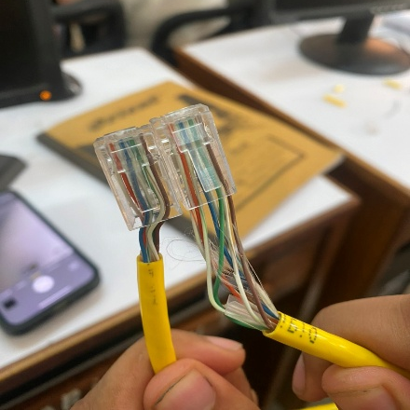 |  | 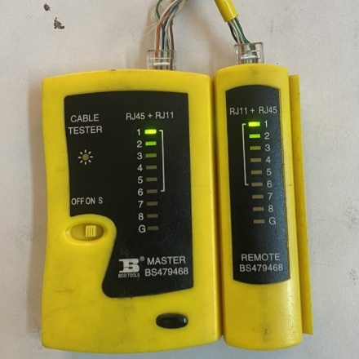 |  | 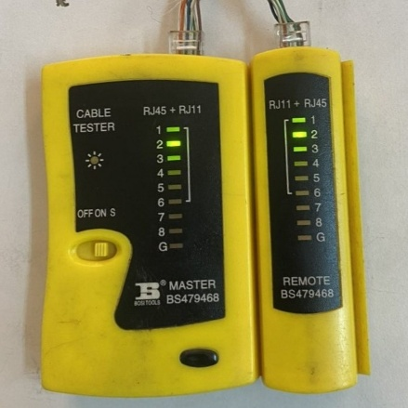
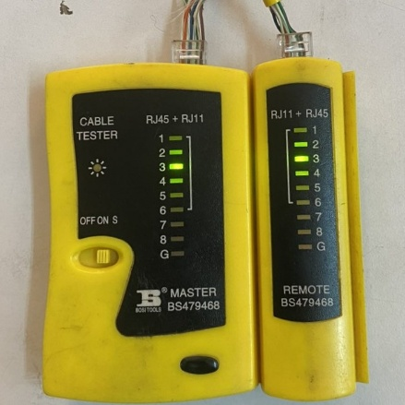 |  | 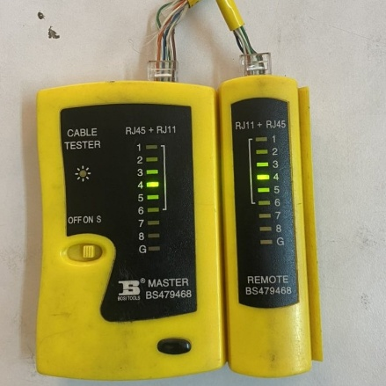 |  | 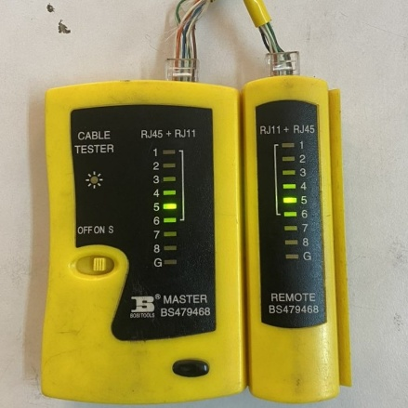
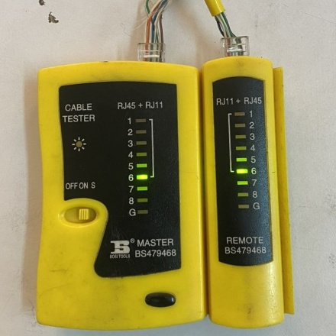 |  | 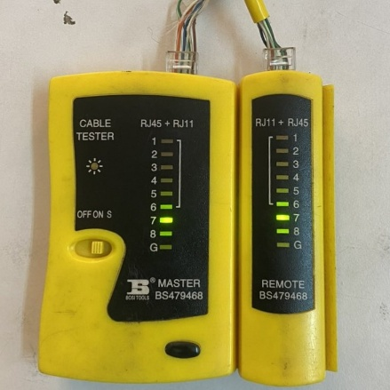 |  | 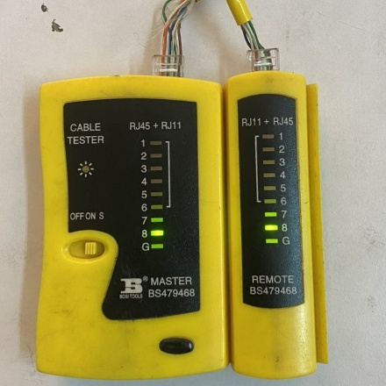

Output: Crossover
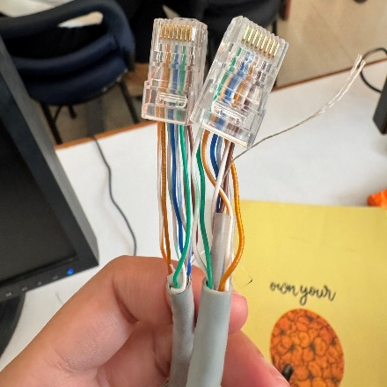 |  | 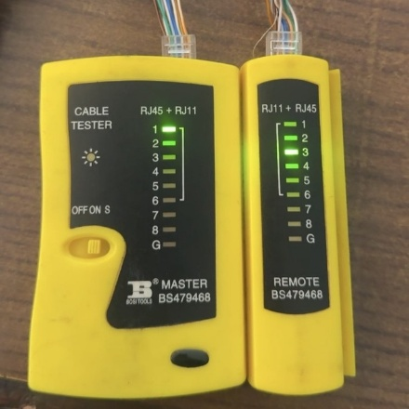 |  | 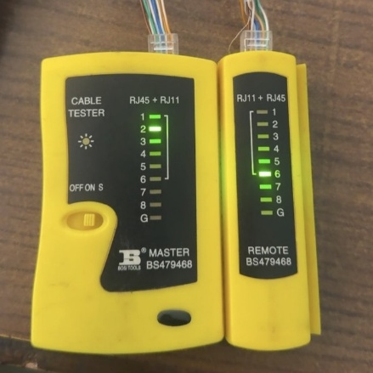
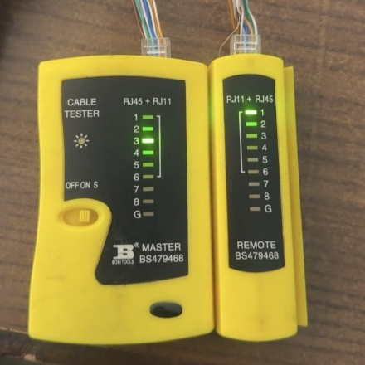 |  | 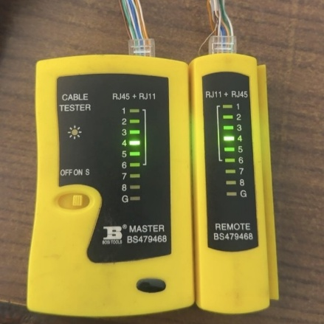 |  | 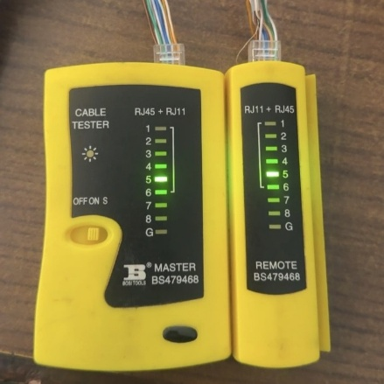
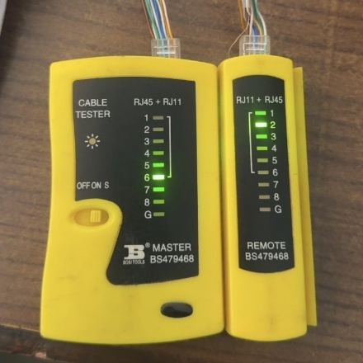 |  | 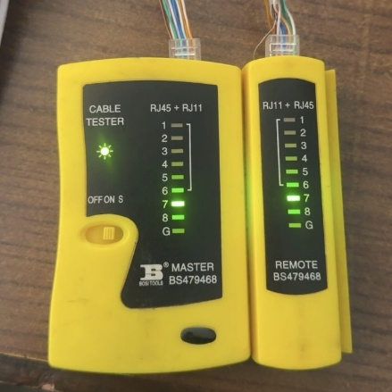 |  | 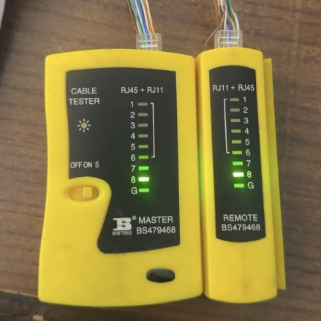

Results:
The cable tester confirms that all wire connections are correct and free from errors. The output images demonstrate successful testing of both straight-through and crossover cables.
Conclusion:
In this lab, we successfully prepared and tested both straight-through and crossover Ethernet cables. By carefully following the wiring standards and checking the cables with a tester, we ensured proper connections without any faults. This practical exercise helped us better understand how Ethernet cables work and showed the importance of correct cable making for smooth and reliable network communication.

