POSTMAN API TESTING :
POST : http://localhost:8081/api/auth/login?email=admin@example.com&role=ADMIN
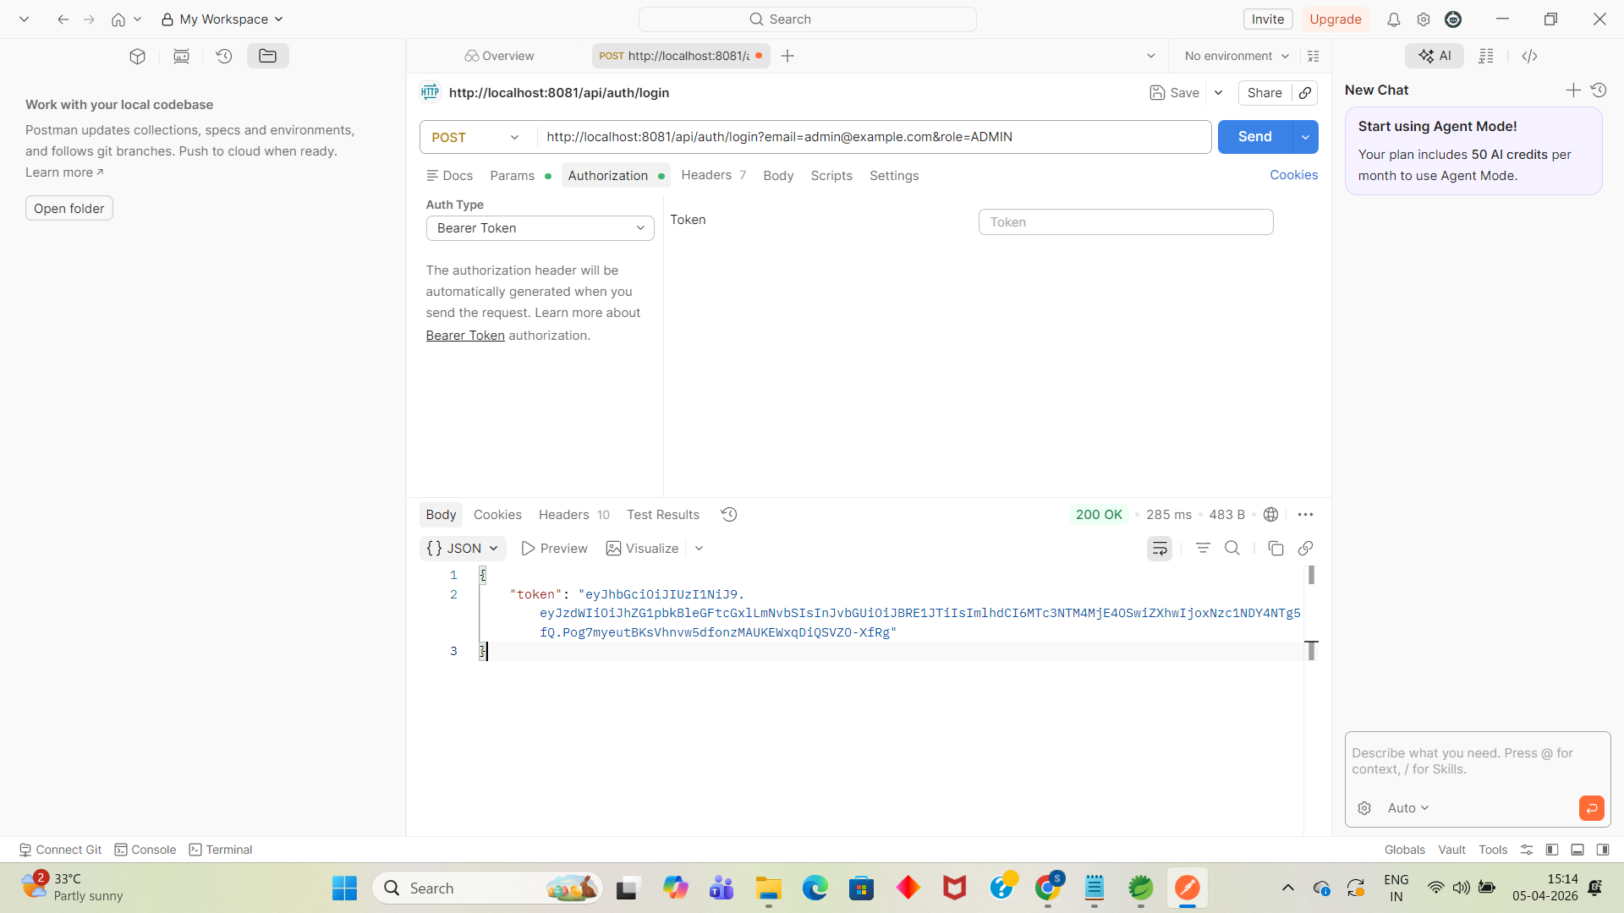
POST : http://localhost:8081/api/finance
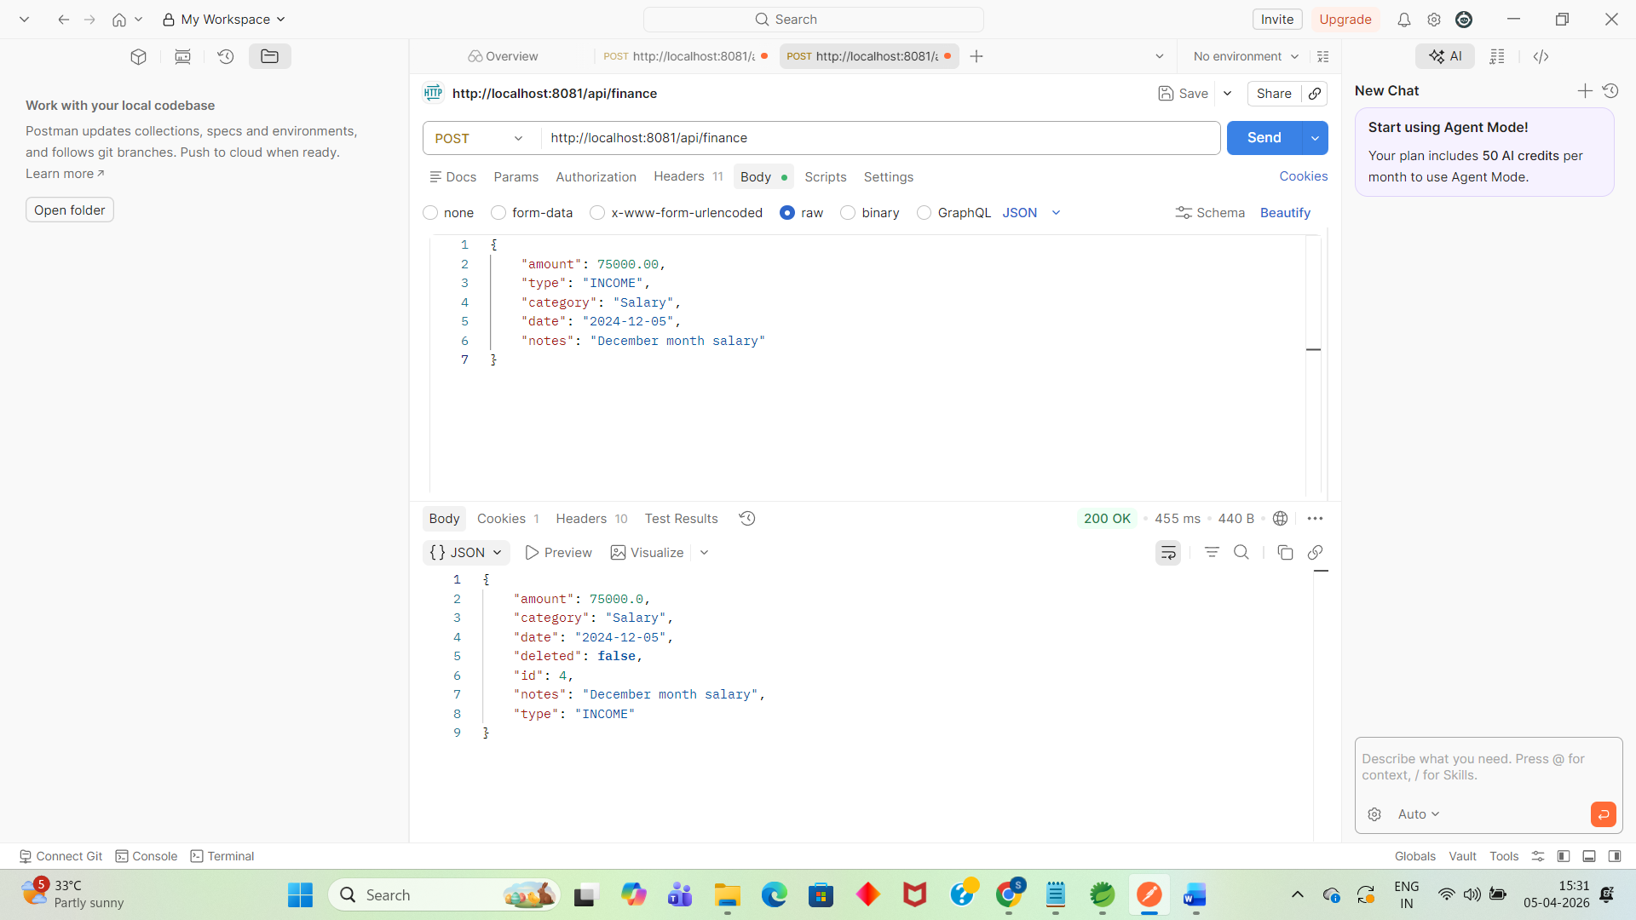

CREATE AN EXPENSE RECORD
POST : http://localhost:8081/api/finance
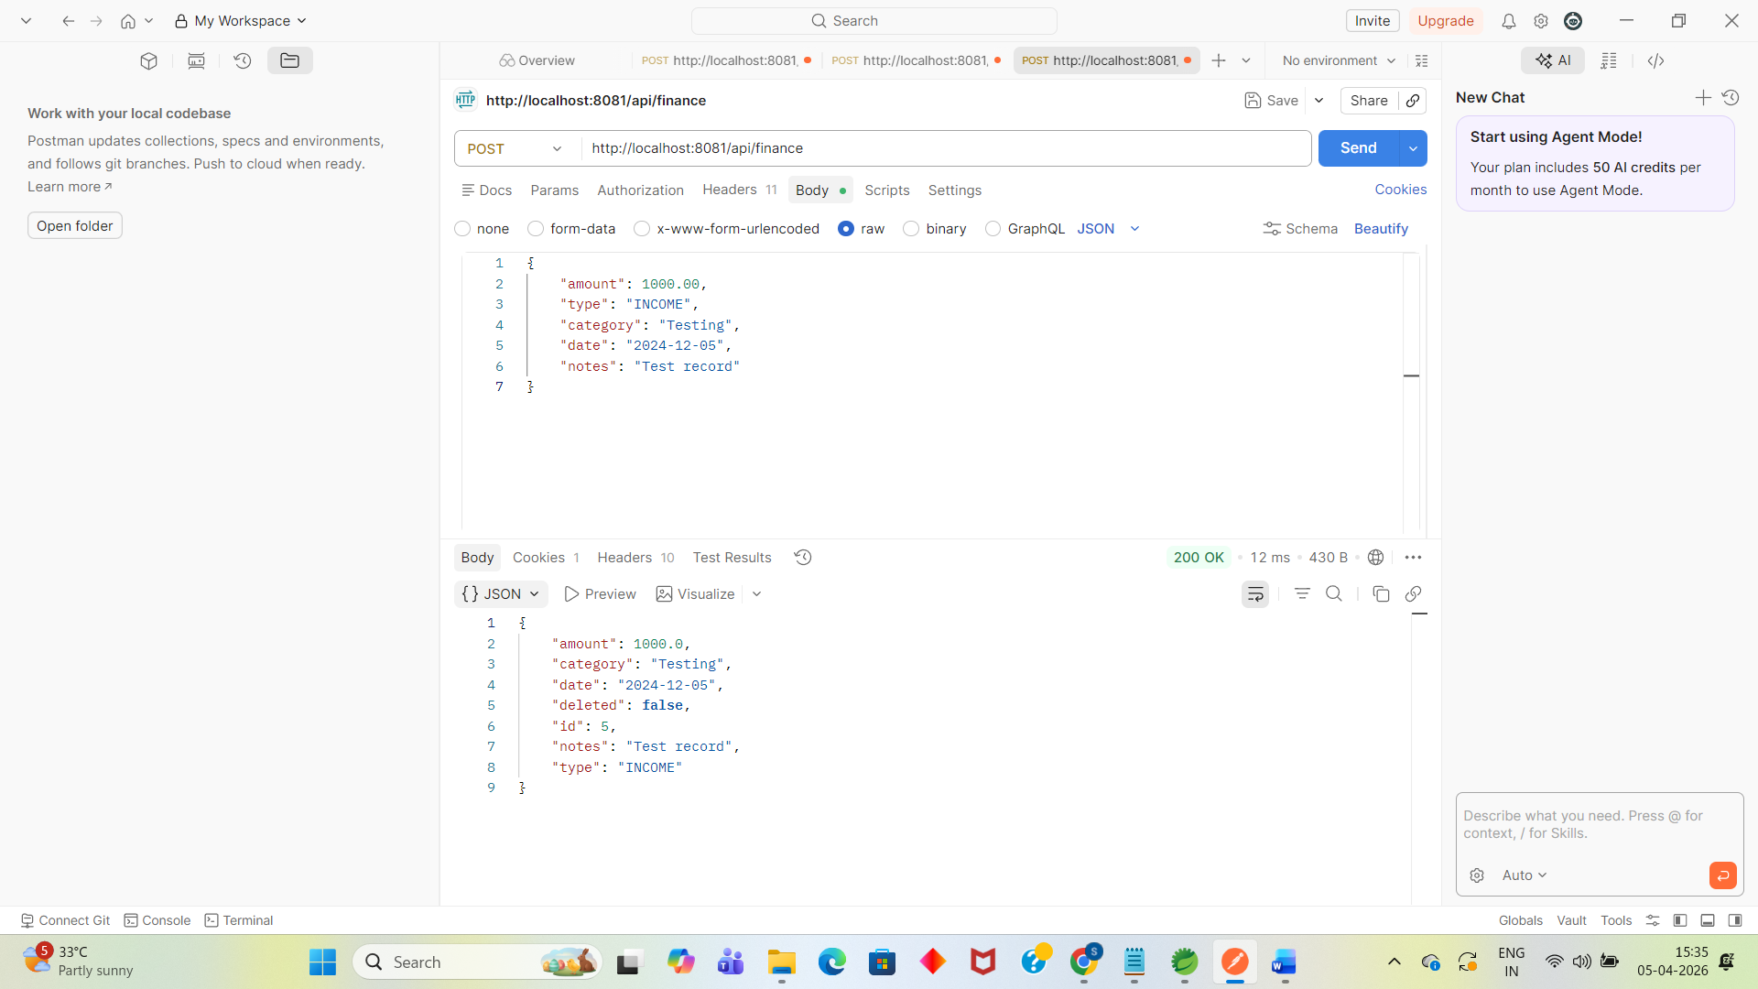
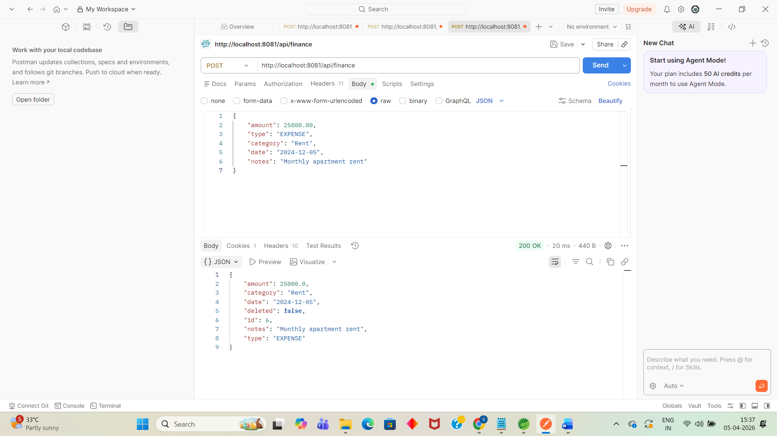
GET : http://localhost:8081/api/finance
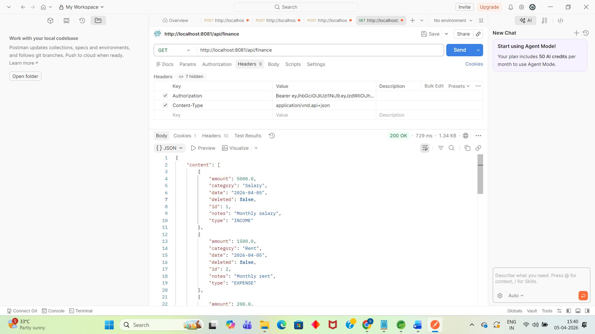
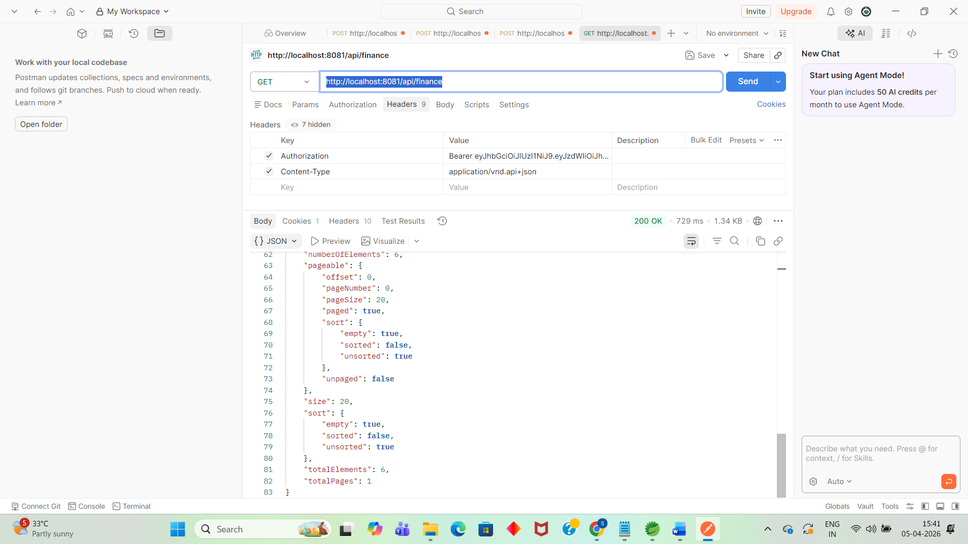

PART 3: TEST SECURITY (VERY IMPORTANT)
This shows your role-based security is working!
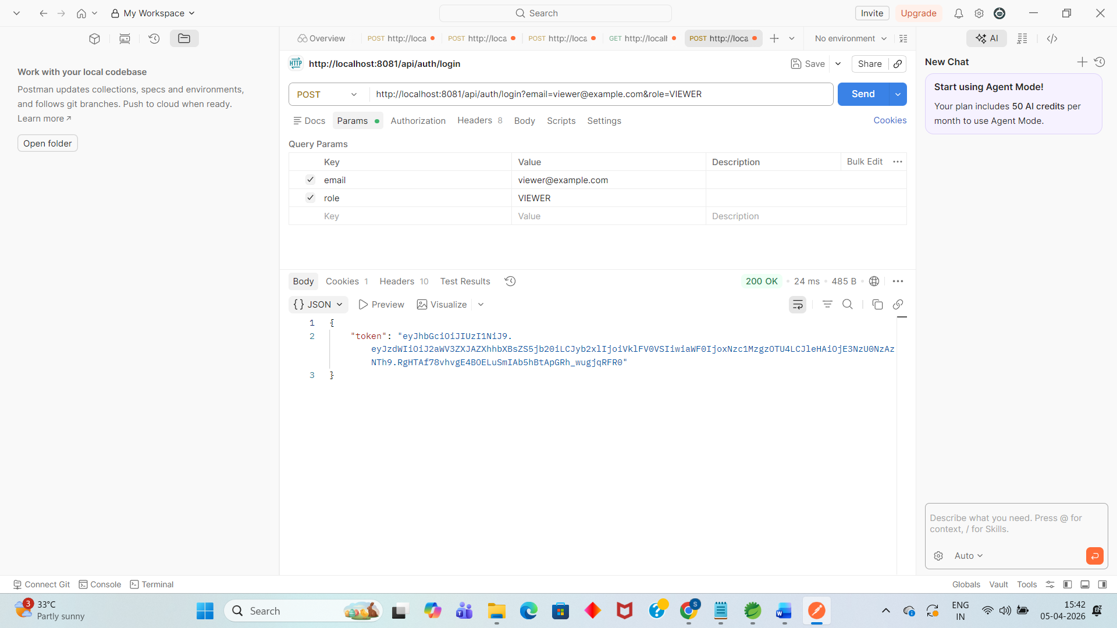
✅ This is CORRECT! VIEWER cannot access finance APIs - only ADMIN and ANALYST can.
