मौलाना आजाद राष्ट्रीय प्रौद्योगिकी सं स्थान - भोपाल
Maulana Azad National Institute of Technology- Bhopal


Department of Computer Science and Engineering
कंप्यूटर विज्ञान एवं अभियांत्रिकी विभाग
“MINOR PROJECT REPORT”
On
“A Privacy-aware Federated Learning Framework for Multiple Crop Leaf Disease Detection”

Submitted in partial fulfillment of the requirements for the degree of
Bachelor of Technology in Computer Science & Engineering

SUBMITTED BY: GUIDED BY:
Name of Student | Scholar no . Dr. Manasi Gyanchandani
1. Sushant Sharma | 2311201203 Associate Professor
2. Disha Singla | 2311201207 CSE Department
3. Ishita Chaple | 2311201217 MANIT, Bhopal
4. Arvind Soni | 2311201220

मौलाना आजाद राष्ट्रीय प्रौद्योगिकी संस्थान - भोपाल
Maulana Azad National Institute of Technology- Bhopal



DECLARATION

We hereby declare that the project work entitled “A Privacy-aware Federated Learning Framework for Multiple Crop Leaf Disease Detection” submitted to Maulana Azad National Institute of Technology Bhopal, in partial fulfillment of the requirements for the award of the degree of Bachelor of Technology in Civil Engineering, is a bonafide record of original work carried out by me/us under the guidance of “Dr. Manasi Gyanchandani Associate Professor”, during the academic year 2025-26.
We further declare that this project has not been submitted previously to any other institution/university for the award of any degree or diploma.

 | Name of Student | Scholar no.
1. | Sushant Sharma | 2311201203
2. | Disha Singla | 2311201207
3. | Ishita Chaple | 2311201217
4. | Arvind Soni | 2311201220
मौलाना आजाद राष्ट्रीय प्रौद्योगिकी संस्थान - भोपाल
Maulana Azad National Institute of Technology- Bhopal



CERTIFICATE

This is to certify that the project report titled “A Privacy-aware Federated Learning Framework for Multiple Crop Leaf Disease Detection” submitted by
 | Name of Student | Scholar no.
1. | Sushant Sharma | 2311201203
2. | Disha Singla | 2311201207
3. | Ishita Chaple | 2311201217
4. | Arvind Soni | 2311201220
They have successfully completed their project in partial fulfilment of their Degree in Bachelor of Technology in Computer Science and Engineering under my guidance and supervision.

Dr. Manasi Gyanchandani
(Supervisor)

ACKNOWLEDGEMENT

With due respect, we express our sincere gratitude to our respected Guide and Project Coordinator, “Dr. Manasi Gyanchandani”, for their valuable guidance and continuous support throughout the development of this project titled “A Privacy-aware Federated Learning Framework for Multiple Crop Leaf Disease Detection” Their insightful suggestions, encouragement, and constructive feedback played a crucial role in the successful completion of this work.
We are also thankful to our respected Director, “Dr. K.K Shukla”, for providing us with the necessary facilities and a conducive environment to carry out this project. We extend our gratitude to our respected Head of Department, “Dr. R.K Pateriya”, for granting us access to departmental resources and laboratories.
We would like to thank all the faculty members, staff, and laboratory assistants of our department for their support and cooperation during the course of this project.
Finally, we express our heartfelt appreciation to our family members and batch mates for their constant encouragement and support.
Place: Bhopal
Date:

Name of Student | Scholar no.
Sushant Sharma | 2311201203
Disha Singla | 2311201207
Ishita Chaple | 2311201217
Arvind Soni | 2311201220

ABSTRACT
The agricultural sector plays a vital role in global food security, and early detection of plant diseases is essential for maintaining crop productivity. Traditional methods of disease identification rely heavily on manual inspection by experts, which is time-consuming, costly, and not scalable. With the advancement of artificial intelligence, deep learning models have emerged as effective solutions for automated plant disease detection using leaf images.
This project presents a comprehensive framework for plant disease detection by integrating multiple deep learning models with Federated Learning (FL), a decentralized machine learning approach. A team-based structure was adopted, where four different classification models like Convolutional Neural Network (CNN), Inception, EfficientNet, and ResNet were applied individually on different crop datasets. Each model was trained to identify plant diseases based on visual features such as texture, color, and patterns present in leaf images.
To address the limitations of centralized learning, such as data privacy concerns and communication overhead, Federated Learning was incorporated into the system. In this approach, the dataset was divided into multiple clients, where each client trained a local model independently. Instead of sharing raw data, only model parameters were communicated to a central server, which aggregated them to update a global model. This ensures data privacy while enabling collaborative learning across distributed datasets.
Multiple federated learning algorithms, including FedAvg, FedProx, FedSGD, FedAdam, and FedDyn, were implemented and evaluated under different client configurations (3 clients and 9 clients) over multiple communication rounds. The performance of these algorithms was analyzed using evaluation metrics such as accuracy, precision, recall, and F1-score.
Experimental results demonstrate that algorithms like FedAvg and FedProx achieve performance close to centralized models with stable convergence, while other methods show varying levels of efficiency depending on data distribution and training conditions. Increasing the number of clients introduces slight variations in performance but improves the system’s scalability and real-world applicability.
This project highlights the potential of combining deep learning with federated learning to develop a scalable, privacy-preserving, and efficient plant disease detection system. The proposed approach can be extended to real-world agricultural applications, enabling intelligent and secure disease monitoring across distributed environments.
Keywords: Federated Learning, Plant Disease Detection, Deep Learning, CNN, Inception, EfficientNet, ResNet, Smart Agriculture, Privacy-Preserving AI
सारांश

कृषि क्षेत्र वैश्विक खाद्य सुरक्षा में महत्वपूर्ण भूमिका निभाता है, और फसलों में रोगों का प्रारंभिक पता लगाना कृषि उत्पादकता बनाए रखने के लिए अत्यंत आवश्यक है। पारंपरिक रोग पहचान विधियाँ मुख्यतः विशेषज्ञों द्वारा दृश्य निरीक्षण पर आधारित होती हैं, जो समय लेने वाली, महंगी और बड़े स्तर पर प्रभावी नहीं होती हैं। कृत्रिम बुद्धिमत्ता के विकास के साथ, गहन शिक्षण मॉडल पत्तियों की छवियों के माध्यम से पौधों के रोगों की स्वचालित पहचान के लिए एक प्रभावी समाधान के रूप में उभरे हैं।
यह परियोजना पौध रोग पहचान के लिए एक व्यापक ढाँचा प्रस्तुत करती है, जिसमें विभिन्न गहन शिक्षण मॉडलों को एक विकेंद्रीकृत शिक्षण पद्धति के साथ एकीकृत किया गया है। इस परियोजना में टीम-आधारित संरचना अपनाई गई, जिसमें चार विभिन्न वर्गीकरण मॉडल संवलनीय तंत्रिका नेटवर्क, इनसेप्शन मॉडल, एफिशिएंटनेट मॉडल और रेज़नेट मॉडल को अलग-अलग फसल डेटासेट पर लागू किया गया। प्रत्येक मॉडल को पत्तियों की छवियों में मौजूद बनावट, रंग और पैटर्न जैसी विशेषताओं के आधार पर रोगों की पहचान के लिए प्रशिक्षित किया गया।
केंद्रीकृत शिक्षण की सीमाओं, जैसे डेटा गोपनीयता और संचार लागत, को ध्यान में रखते हुए इस प्रणाली में वितरित सहयोगात्मक शिक्षण पद्धति को शामिल किया गया। इस पद्धति में डेटासेट को कई क्लाइंट्स में विभाजित किया गया, जहाँ प्रत्येक क्लाइंट अपने स्थानीय डेटा पर स्वतंत्र रूप से मॉडल को प्रशिक्षित करता है। कच्चे डेटा को साझा करने के बजाय, केवल मॉडल के मापदंड केंद्रीय सर्वर को भेजे जाते हैं, जहाँ उन्हें संयोजित करके एक वैश्विक मॉडल तैयार किया जाता है। इस प्रकार डेटा की गोपनीयता बनाए रखते हुए सामूहिक रूप से सीखना संभव होता है।
विभिन्न संयोजन विधियों का उपयोग किया गया, जैसे औसत आधारित संयोजन विधि, समीपता नियंत्रित संयोजन विधि, क्रमिक अवतरण आधारित संयोजन विधि, अनुकूली अनुकूलन आधारित संयोजन विधि तथा गतिशील संतुलन आधारित संयोजन विधि। इन विधियों का मूल्यांकन 3 तथा 9 क्लाइंट्स की संरचना में कई संचार चरणों के दौरान किया गया। इनके प्रदर्शन का विश्लेषण सटीकता, परिशुद्धता, पुनःप्राप्ति तथा संतुलित स्कोर जैसे मापदंडों के आधार पर किया गया।
प्रायोगिक परिणामों से यह स्पष्ट होता है कि औसत आधारित तथा समीपता नियंत्रित संयोजन विधियाँ केंद्रीकृत मॉडल के समान प्रदर्शन प्राप्त करती हैं और स्थिर अभिसरण प्रदर्शित करती हैं, जबकि अन्य विधियाँ डेटा वितरण और प्रशिक्षण परिस्थितियों के अनुसार अलग-अलग स्तर की दक्षता दिखाती हैं। क्लाइंट्स की संख्या बढ़ाने से प्रदर्शन में हल्का अंतर आता है, लेकिन इससे प्रणाली की विस्तार क्षमता और वास्तविक उपयोगिता में सुधार होता है।
यह परियोजना गहन शिक्षण और वितरित शिक्षण के संयोजन की क्षमता को दर्शाती है, जिससे एक स्केलेबल, गोपनीयता-संरक्षित और प्रभावी पौध रोग पहचान प्रणाली विकसित की जा सकती है। यह दृष्टिकोण वास्तविक कृषि क्षेत्रों में सुरक्षित और बुद्धिमान रोग निगरानी के लिए उपयोगी सिद्ध हो सकता है।
कुंजी शब्द: वितरित शिक्षण, पौध रोग पहचान, गहन शिक्षण, संवलनीय तंत्रिका नेटवर्क, स्मार्ट कृषि, गोपनीयता-संरक्षित कृत्रिम बुद्धिमत्ता
TABLE OF CONTENT

SECTION | TITLE | PAGE NUMBER
 | Declaration | 2
 | Certificate | 3
 | Acknowledgement | 4
 | Abstract | 5
 | List of Figures | 11
 | List of Tables | 13
1 | Introduction | 14
1.1 | Motivation | 15
1.2 | Problem Statement | 15
1.3 | Objectives | 15
1.4 | Purpose | 15
1.5 | Scope | 15
1.6 | Contribution | 15
2 | Literature Review | 16
2.1 | Smart Farming | 16
2.2 | AI-Based Plant Disease Detection | 16
2.3 | Challenges in Centralized AI System: Data Privacy and Security | 16
2.4 | History of Diseases of Each Crop with Year and Place | 17
2.5 | Federated Learning in Agriculture | 18
2.6 | Types of FL Models Used with Their Architecture | 18
2.6.1 | FedAvg - Federated Averaging | 18
2.6.2 | FedSGD - Federated Stochastic Gradient Descent | 19
2.6.3 | FedProx — Federated Proximal | 19
2.6.4 | FedAdam — Federated Adam | 20
2.6.5 | FedDyn - Federated Dynamic Regularization | 21
3 | System Architecture | 22
3.1 | Model Architecture | 22
3.1.1 | Model 1 - CNN Architecture | 22
3.1.2 | Model 2 - ResNet-18 Architecture | 22
3.1.3 | Model 3 - Inception Architecture | 23
3.1.4 | Model 4 - EfficientNet Architecture | 23
3.2 | Common FL Training Pipeline | 24
3.3 | Common Hyperparameters | 24
4 | Chapter 1 - Soybean Disease Detection Using ResNet-18 | 25
4.1 | Dataset: Soybean Diseased Leaf Dataset (Kaggle) | 25
4.2 | Model & FL Setup | 25
4.3 | Experimental Results | 26
4.3.1 | Results Summary | 26
4.3.2 | Centralized vs. Federated - 3 Client Setup | 27
4.3.3 | Centralized vs. Federated - 9 Client Setup | 27
4.3.4 | 3-Client vs. 9-Client Per-Algorithm Comparison | 28
4.3.5 | FL Algorithm Head-to-Head Comparison | 28
4.3.6 | Final Accuracy - All Experiments | 29
4.3.7 | Confusion Matrices | 30
4.3.8 | Per-Class F1 Score | 31
4.4 | Discussion | 31
4.4.1 | Key Findings | 31
4.4.2 | Limitations | 31
5 | Chapter 2 - Corn Disease Detection Using EfficientNet | 32
5.1 | Dataset: PlantVillage - Corn | 32
5.2 | Model & FL Setup | 32
5.3 | Results & Analysis | 33
5.3.1 | Centralized vs. Federated - 3 Client Setup | 33
5.3.2 | FL Algorithm Head-to-Head Comparison | 34
5.3.3 | Final Accuracy - All Experiments | 35
5.3.4 | Confusion Matrices | 35
5.3.5 | Per-Class F1 Score | 36
5.4 | Discussion | 36
5.4.1 | Key Findings | 36
5.4.2 | Limitations | 36
6 | Chapter 3 - Tomato Disease Detection Using CNN | 37
6.1 | Dataset: PlantVillage - Tomato | 37
6.2 | Model & FL Setup | 37
6.3 | Results & Analysis | 38
6.3.1 | Centralized vs. Federated - 3 Client Setup | 38
6.3.2 | Centralized vs. Federated - 9 Client Setup | 39
6.3.3 | 3-Client vs. 9-Client Per-Algorithm Comparison | 40
6.3.4 | Final Accuracy - All Experiments | 41
6.3.5 | Confusion Matrices | 41
6.3.6 | Per-Class F1 Score | 41
6.4 | Discussion | 42
6.4.1 | Key Findings | 42
6.4.2 | Limitations | 42
7 | Chapter 4 - Apple Disease Detection Using InceptionV3 | 43
7.1 | Dataset: PlantVillage - Apple | 43
7.2 | Model & FL Setup | 43
7.3 | Results & Analysis | 44
7.3.1 | Centralized vs. Federated - 3 Client Setup | 44
7.3.2 | Centralized vs. Federated - 9 Client Setup | 45
7.3.3 | 3-Client vs. 9-Client Per-Algorithm Comparison | 45
7.3.4 | Final Accuracy - All Experiments | 46
7.3.5 | Confusion Matrices | 47
7.3.6 | Per-Class F1 Score | 47
7.4 | Discussion | 47
7.4.1 | Key Findings | 47
7.4.2 | Limitations | 48
8 | Conclusion & Future Work | 49
8.1 | Future Work | 49
9 | References | 50

LIST OF FIGURES

FIGURE | TITLE | PAGE NUMBER
2.1 | FedAvg Architecture | 19
2.2 | FedSGD Architecture | 19
2.3 | FedProx Architecture | 20
2.4 | FedAdam Architecture | 20
2.5 | FedDynamic Architecture | 21
3.1 | CNN Architecture | 22
3.2 | ResNet Architecture | 23
3.3 | Inception Architecture | 23
3.4 | EfficientNet Architecture | 24
4.1 | Images of soybean plant diseases | 25
4.2 | Global test accuracy (3 clients) | 27
4.3 | Global test accuracy (9 clients) | 27
4.4 | Per algorithm comparison | 28
4.5 | FL algorithm head to head | 28
4.6 | Final test accuracy(bar chart) | 29
4.7 | Confusion Matrix Centralized and best | 30
5.1 | Images of corn plant diseases | 32
5.2 | Validation accuracy curve (3 clients) | 34
5.3 | Global test accuracy (3 and 9 client) | 34
5.4 | FL algorithm head to head | 34
5.5 | Final test accuracy (bar chart) | 35
5.6 | Confusion matrix Centralized and best | 35
6.1 | Images of tomato plant disease | 37
6.2 | Global test accuracy (3 clients) | 39
6.3 | Global test accuracy (9 clients) | 39
6.4 | Per algorithm comparison | 40
6.5 | Final test accuracy (bar chart) | 41
6.6 | Confusion matrix Centralized, best | 41
7.1 | Images of apple plant diseases | 43
7.2 | Global test accuracy (3 clients) | 44
7.3 | Global test accuracy (9 clients) | 45
7.4 | Per algorithm comparison | 46
7.5 | Final test accuracy (bar chart) | 46
7.6 | Confusion matrix Centralized, best | 47

LIST OF TABLES

FIGURE | TITLE | PAGE NUMBER
2.1 | Historical disease outbreaks | 17
3.1 | Common hyperparameters | 24
4.1 | Federated Learning results (Soybean) | 26
5.1 | Federated Learning results (Corn) | 33
6.1 | Federated Learning results (Tomato) | 38
7.1 | Federated Learning results (Apple) | 44

1. INTRODUCTION

Agriculture plays a crucial role in the economic development of many countries, particularly in developing nations where a large portion of the population depends on farming for their livelihood. In India alone, more than 580 million people are directly or indirectly associated with the agricultural sector, making it a backbone of the national economy. However, crop productivity is significantly affected by various plant diseases caused by fungal, bacterial, and viral infections. Crops such as Soybean, Corn (Maize), Tomato, and Apple are highly susceptible to these diseases, which can lead to substantial yield losses ranging from 20% to 80% if not detected and treated at an early stage. Therefore, timely and accurate disease detection is essential to ensure sustainable agricultural practices and food security.

With the rapid advancement of Artificial Intelligence (AI), particularly deep learning techniques, automated plant disease detection systems have gained significant attention. Convolutional Neural Networks (CNNs) and other deep learning architectures have demonstrated high accuracy in classifying plant diseases from leaf images by extracting complex visual features such as texture, color variations, and lesion patterns [3]. The availability of datasets such as PlantVillage has further enabled the development of accurate disease detection models [7], [12]. Advanced architectures such as ResNet have improved classification performance through deep residual learning [2]. These approaches have proven to be efficient and scalable compared to traditional manual inspection methods.

To address the limitations of centralized approaches, Federated Learning (FL) has emerged as a promising decentralized machine learning paradigm. Unlike traditional methods, federated learning enables model training directly on local devices or farm nodes without transferring raw data to a central server. In this framework, each client trains a local model using its own data and shares only the learned model parameters (weights) with a central server, which aggregates them to form a global model [1]. This process ensures that sensitive data remains on local devices, thereby preserving privacy while enabling collaborative learning. Additionally, federated learning reduces communication overhead and is well-suited for environments with limited connectivity, making it highly applicable to rural agricultural settings. The importance of privacy-preserving learning is further emphasized by regulations such as India’s Digital Personal Data Protection Act (DPDPA), 2023 [13].

This project implements a comprehensive federated learning framework for plant disease detection across four major crops like Soybean, Corn, Tomato, and Apple. The work is carried out as a collaborative effort by a team of four members, where each member focuses on a specific crop and applies a different deep learning model. Despite working on different datasets and models, all team members follow a common federated learning methodology and experimental setup. The project evaluates and compares multiple federated learning algorithms, including FedAvg [1], FedSGD [1], FedProx [4], FedAdam [5], and FedDyn [6], against a centralized baseline model.

1.1 Motivation
Agriculture is highly vulnerable to plant diseases, which reduce crop yield and affect farmers’ livelihoods. Traditional detection methods are manual, time-consuming, and not scalable. AI-based solutions improve accuracy but rely on centralized data, raising privacy concerns. This creates a need for accurate and privacy-preserving systems using federated learning.
1.2 Problem Statement
Centralized plant disease detection systems require collecting data from multiple sources, leading to issues of privacy, ownership, and regulatory compliance. They are also unsuitable for rural areas with limited connectivity. There is a need for a decentralized approach that ensures high accuracy without sharing raw data.
1.3 Objectives
The objective is to develop a plant disease detection system using deep learning and federated learning. The project compares multiple models and FL algorithms, analyzes different client configurations, and ensures data privacy. It aims to build a scalable and efficient distributed learning framework.
1.4 Purpose
The purpose is to design a privacy-preserving system for plant disease detection across multiple crops. It demonstrates how federated learning enables collaborative training without sharing sensitive data while achieving performance close to centralized models.
1.5 Scope
The project focuses on four crops — Soybean, Corn, Tomato, and Apple — using deep learning and federated learning. It evaluates multiple FL algorithms under different client setups using the PlantVillage dataset. Performance is measured using accuracy, F1-score, and confusion matrix, while non-IID data and real-world deployment are future work.
1.6 Contributions
The project develops a federated learning pipeline using TensorFlow with five aggregation algorithms. It compares performance across 3-client and 9-client setups and analyzes stability and convergence. A multi-crop framework is designed to allow independent work while maintaining consistent and comparable results.

2. LITERATURE REVIEW

2.1 Smart Farming
Smart farming refers to the application of modern information and communication technologies (ICT) in agriculture to improve crop productivity while optimizing resource utilization and human effort. It includes technologies such as precision agriculture, Internet of Things (IoT)-based sensor networks, drone surveillance, satellite imaging, and artificial intelligence (AI)-based decision support systems. The integration of AI into agriculture has accelerated significantly in recent years, enabling real-time monitoring of crop health through remote sensing and ground-level sensors. Federated learning has also emerged as a promising approach for smart agriculture by enabling distributed model training while preserving data privacy, as discussed by Liu et al. (2020) [8] and Durrant et al. (2021) [9].

2.2 AI-Based Plant Disease Detection
The application of deep learning in plant disease detection was significantly advanced by Mohanty et al. (2016) [3], who demonstrated that convolutional neural networks (CNNs) trained on the PlantVillage dataset can classify plant diseases with high accuracy. The availability of large-scale datasets such as PlantVillage [7], [12] has further accelerated research in this domain. Advanced architectures such as ResNet, introduced by He et al. (2016) [2], have improved classification performance through deep residual learning. Transfer learning using pre-trained models has been shown to enhance performance, especially when working with limited datasets. Additionally, lightweight models such as EfficientNet are preferred for real-world deployment due to their computational efficiency.

2.3 Challenges in Centralized AI Systems: Data Privacy and Security
Despite the success of centralized AI models, several challenges limit their practical adoption in agriculture. One major concern is data privacy, as plant images may contain sensitive information related to farm conditions, yield, and cultivation practices. Farmers are often reluctant to share such data with centralized systems. Data sovereignty regulations, such as India’s Digital Personal Data Protection Act (DPDPA), 2023 [13], impose strict requirements on data collection and usage. Centralized systems also introduce high communication overhead, requiring the transfer of large volumes of data from remote areas with limited connectivity. Furthermore, they are prone to single points of failure and may not adequately represent diverse agricultural conditions. These limitations highlight the need for decentralized approaches such as federated learning, as proposed by McMahan et al. (2017) [1].

2.4 History of Diseases of Each Crop with Year and Place
The following table summarizes major disease outbreaks across the four crops covered in this project, providing historical context and economic motivation for disease detection research:
Table 2.1: Historical disease outbreaks across Soybean, Corn, Tomato, and Apple - with year, region, and yield impact
Crop | Disease | Year First Recorded | Region / Country | Yield Loss
Soybean | Sudden Death Syndrome | 1971 | Arkansas, USA | Up to 80%
Soybean | Bacterial Blight | 1980s–2000s | USA, Brazil, India | 10–40%
Soybean | Brown Spot | 1920s–present | USA, S. America, Asia | 8–15%
Soybean | Powdery Mildew | 1980s–present | India, USA, Brazil | Up to 25%
Soybean | Yellow Mosaic Virus | 1970s–present | India, Pakistan, Bangladesh | 10–100%
Soybean | Soybean Rust | 2004 (USA) | Sub-Saharan Africa, Brazil | 10–80%
Corn | Northern Corn Leaf Blight | 1960s | USA, Sub-Saharan Africa | Up to 50%
Corn | Gray Leaf Spot | 1970s | USA, Africa | Up to 40%
Corn | Common Rust | 1900s–present | Global | 10–35%
Tomato | Early Blight (Alternaria) | Recurring | Global | Up to 30%
Tomato | Late Blight (Phytophthora) | 1840s (Potato) | Ireland, India, Global | Up to 70%
Tomato | Tomato Yellow Leaf Curl Virus | 1930s | Mediterranean, India | Up to 100%
Apple | Apple Scab (Venturia) | 1819 | Europe, N. America, India | Up to 70%
Apple | Cedar Apple Rust | 1700s | Eastern USA | Up to 40%
Apple | Apple Black Rot | 1800s | USA, Europe | Up to 35%
Plant diseases have historically caused significant losses in agricultural production across different crops and regions. For example, Late Blight disease has caused major crop failures globally, while Yellow Mosaic Virus in soybean and Apple Scab in apple crops have resulted in severe yield losses in several regions, including India. These recurring disease outbreaks emphasize the importance of early detection systems and continuous monitoring to minimize agricultural losses. The historical impact of such diseases highlights the need for intelligent and automated plant disease detection systems.

2.5 Federated Learning in Agriculture
Federated Learning (FL) was introduced by McMahan et al. (2017) [1] as a decentralized approach to training machine learning models without sharing raw data. In this approach, models are trained locally on client devices, and only model updates are aggregated on a central server. This makes FL particularly suitable for agriculture, where data is naturally distributed across farms and regions. Recent studies have demonstrated the effectiveness of FL in agricultural applications. Liu et al. (2020) [8] applied federated learning for crop disease classification, while Durrant et al. (2021) [9] showed that federated models can achieve performance comparable to centralized systems. Kumar et al. (2023) [10] further explored on-device crop disease detection using federated learning in rural India. Advanced optimization techniques such as FedProx proposed by Li et al. (2020) [4], adaptive optimization methods like FedAdam introduced by Reddi et al. (2021) [5], and dynamic regularization approaches such as FedDyn proposed by Acar et al. (2021) [6] have improved convergence and stability in federated learning systems.

2.6 Types of FL Models Used with Their Architecture

2.6.1 FedAvg - Federated Averaging
Proposed by McMahan et al. (2017). In each round: (1) server broadcasts global model to all clients; (2) each client runs E local epochs of SGD/Adam; (3) clients send updated weights to server; (4) server aggregates via weighted average proportional to dataset size. FedAvg is the gold standard FL algorithm - simple, communication-efficient, and robust. In this project, FedAvg achieves parity with the centralized baseline at 99.29% with 3 clients.
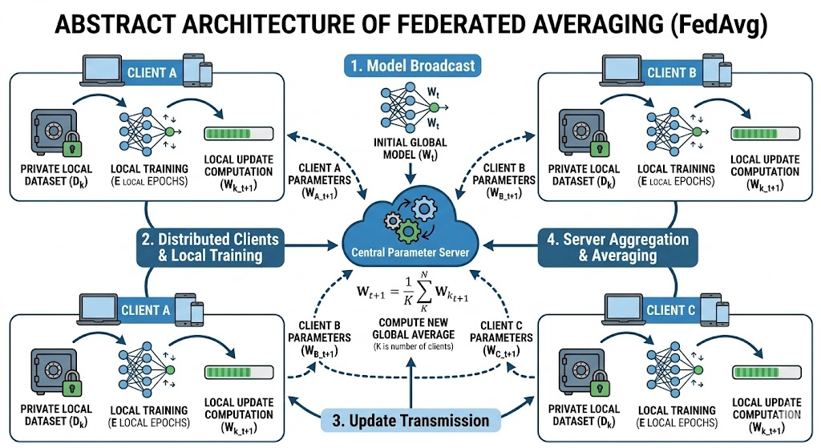
Fig 2.1 : FedAvg Architecture

2.6.2 FedSGD - Federated Stochastic Gradient Descent
The simplest FL algorithm: each client computes a single gradient step on a local mini-batch, and gradients are averaged at the server. Unlike FedAvg, there are no multiple local updates. FedSGD is equivalent to distributed SGD with gradient averaging. It converges more slowly than FedAvg in communication-constrained settings but is theoretically stable. In this project, FedSGD achieves 91.49% (3C) and 84.40% (9C).
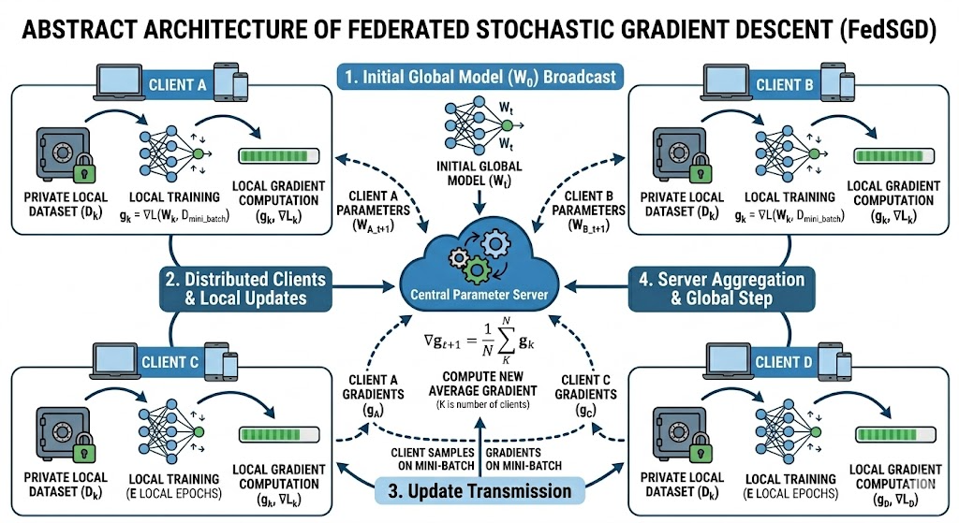

Fig 2.2 : FedSGD Architecture

2.6.3 FedProx - Federated Proximal
Proposed by Li et al. (2020). Extends FedAvg by adding a proximal regularization term to each client's local objective: L_local = L_task + (mu/2) * ||w - w_global||^2. This penalizes client models for drifting too far from the global model, improving convergence stability in heterogeneous (non-IID) data settings. With mu=0.01, FedProx achieves 98.58% (3C) and 97.87% (9C) - closely competitive with FedAvg.
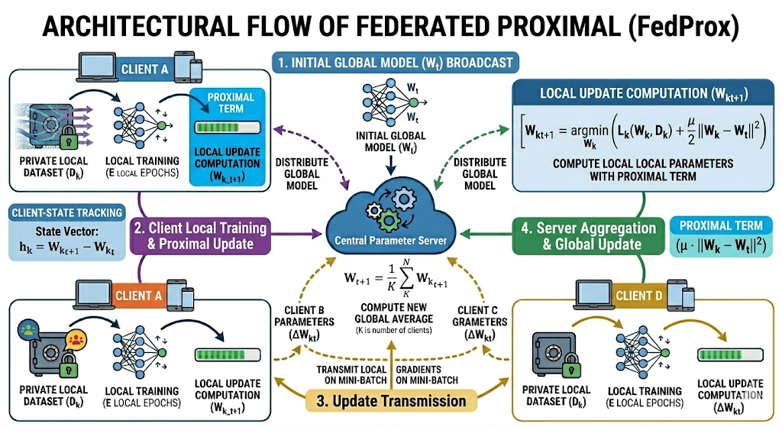

Fig 2.3 : FedProx Architecture

2.6.4 FedAdam - Federated Adam
Proposed by Reddi et al. (2021). Applies adaptive moment estimation (Adam) at the server level: instead of simple weighted averaging, the server maintains first-moment (m) and second-moment (v) estimates of gradient updates and applies adaptive step sizes. FedAdam can accelerate convergence when properly tuned but is highly sensitive to server learning rate (lr=0.0001), beta parameters (0.9, 0.999), and epsilon (1e-3). For small datasets with few clients, FedAdam is prone to instability and complete divergence - as observed in this project (final accuracy: 0–5%).

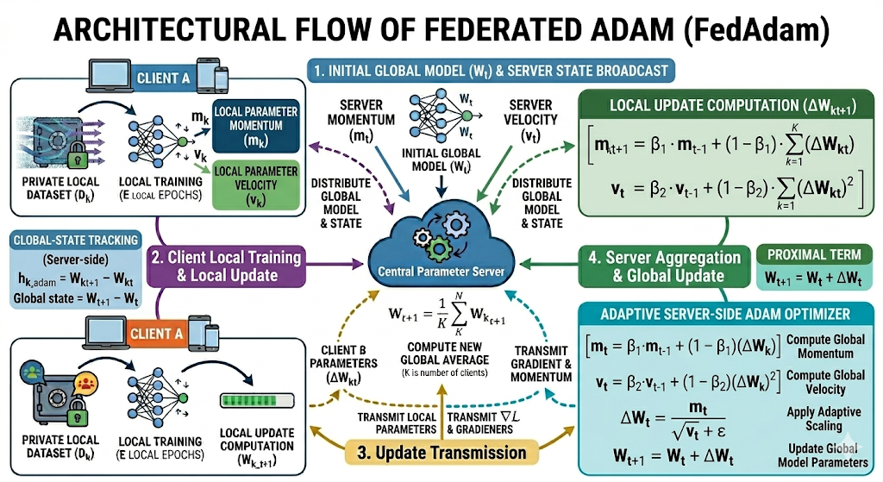

Fig 2.4 : FedAdam Architecture

2.6.5 FedDyn - Federated Dynamic Regularization
Proposed by Acar et al. (2021). Maintains a dynamic gradient correction term (h_state) per client that is updated after each round. This correction accounts for the difference between the client's local solution and the global optimum, enabling more accurate alignment. FedDyn demonstrates superior convergence in theory but in practice, with very small per-client datasets (~62 samples), the gradient correction accumulates errors and causes instability in later rounds - peaking at 92.91% (3C, Round 3) before diverging to 2.13%, and 93.62% (9C, Round 6) before crashing to 23.40%.

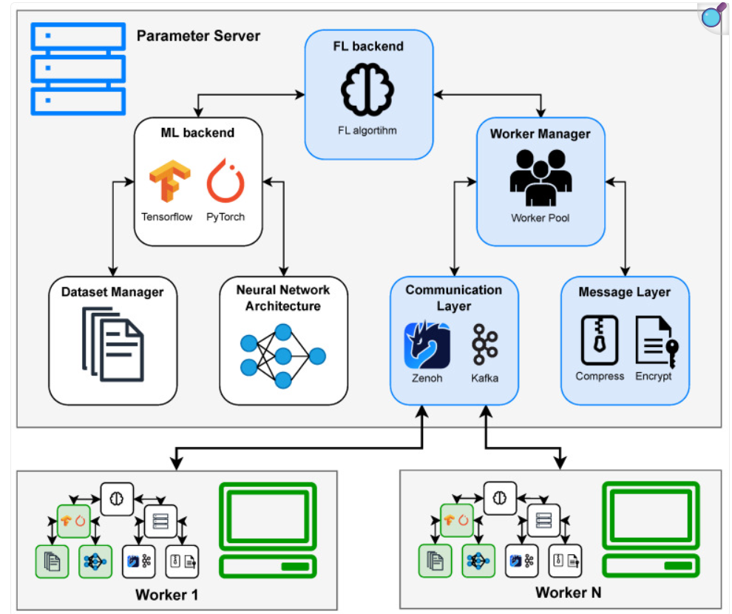
Fig 2.5 : FedDynamic Architecture

3. SYSTEM ARCHITECTURE

The system uses four different deep learning models CNN, Inception, EfficientNet, and ResNet - for plant disease classification. The CNN model consists of convolutional, pooling, and fully connected layers. Inception uses parallel convolution operations to capture multi-scale features. EfficientNet applies compound scaling for better performance with fewer parameters. ResNet uses residual connections to enable deeper network training.

3.1 Model Architecture
3.1.1 Model 1 - CNN Architecture
A customized CNN architecture is designed for this plant disease classification task. The architecture is structured to effectively capture and classify subtle visual differences in leaves. Main components include:

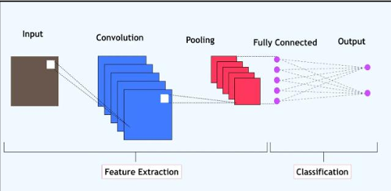
Fig 3.1 : CNN Architecture

1. Input Layer: Receives preprocessed, segmented images in a fixed input shape (e.g., 128x128x3).
2. Convolutional Layers: A series of convolutional layers with ReLU activation functions extract hierarchies of features, starting from basic edges and textures to complex disease patterns.
3. Pooling Layers: Pooling layers, often used after convolutional layers, reduce feature map size and prevent overfitting by retaining only the most important features.
4. Fully Connected Layers: The fully connected layers process the high-level features to classify the image as healthy or as a specific disease.
5. Output Layer: Uses a softmax activation function to output probabilities for each class, identifying the specific plant disease or indicating a healthy leaf.

3.1.2 Model 2 - ResNet-18 (Residual Network) Architecture
ResNet (Residual Network) is a deep convolutional neural network (CNN) architecture introduced in 2015. The key innovation in ResNet is the residual connection, which helps in training very deep networks by mitigating the vanishing gradient problem. ResNet-18 is a variant with 18 layers, making it a moderately deep network suitable for image classification tasks.
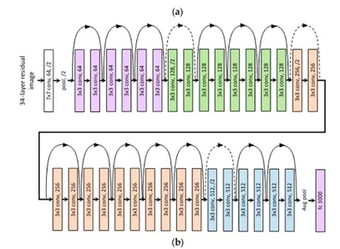
Fig 3.2 : ResNet Architecture

1. Convolutional layers with batch normalization and ReLU activation.
2. Residual blocks add input directly to the output of certain layers.
3. Global Average Pooling instead of fully connected layers to reduce overfitting.
4. Softmax classifier for final predictions.

3.1.3 Model 3 - Inception Architecture
Inception is a deep convolutional neural network architecture introduced by Google in 2014. Its key idea is the use of parallel convolutional filters of different sizes within the same layer, allowing the network to capture multi-scale features effectively. This design improves feature extraction while keeping computational cost efficient. Inception models are widely used for image classification tasks due to their balanced performance and efficiency.

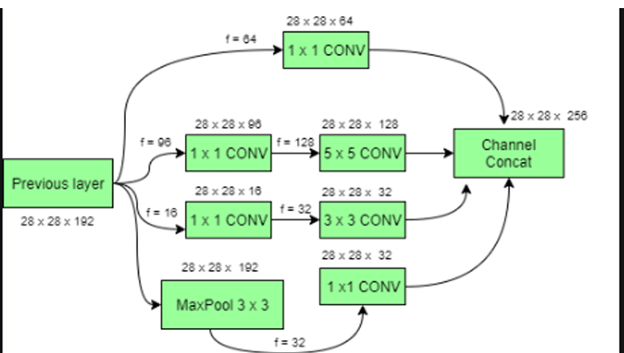
Fig 3.3: Inception Architecture

1. Stacked Inception modules, containing multiple filter sizes running in parallel.
2. Global Average Pooling instead of fully connected layers to reduce overfitting.
3. Multiple softmax classifiers for stable training.

3.1.4 Model 4 - EfficientNet Architecture
EfficientNet is a deep convolutional neural network architecture introduced by Google in 2019. Its key innovation is compound scaling, which uniformly scales network depth, width, and resolution for better performance with fewer parameters. This approach achieves high accuracy while maintaining computational efficiency. EfficientNet is widely used for image classification tasks due to its optimized balance between accuracy and efficiency.
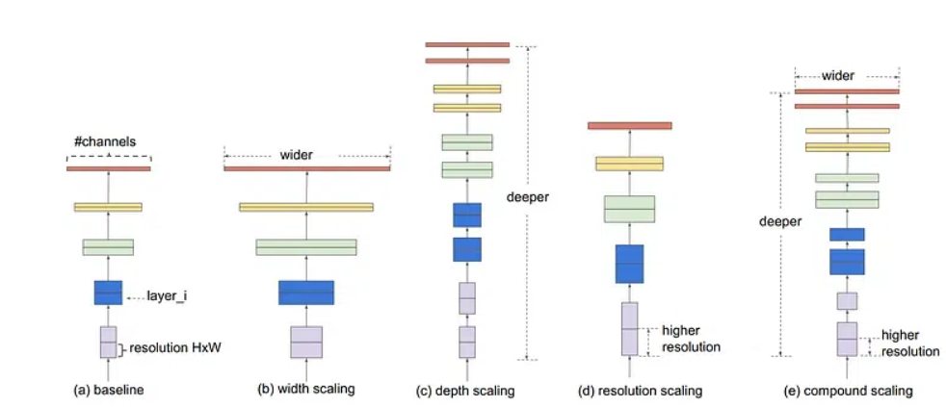
Fig 3.4: EfficientNet Architecture

1. Baseline: The original network without scaling
2. Width Scaling: Increase the number of channels in each layer
3. Depth Scaling: Increase the number of layers
4. Resolution Scaling: Increase the input image resolution
5. Compound Scaling: Simultaneously increasing width,depth and resolution according to compound scaling formula

3.2 Common FL Training Pipeline
For each round: (1) server initializes/broadcasts global model; (2) all clients receive global weights and train locally for 3 epochs using Adam optimizer; (3) clients send updated weights to server; (4) server aggregates according to selected algorithm; (5) global model evaluated on centralized test set.

3.3 Common Hyperparameters
Table 3.1: Common hyperparameters used across all four crop chapters
Parameter | Value
Communication Rounds | 8
Local Epochs per Round | 5
Batch Size | 32
Image Size | 299 × 299 px
Optimizer (local) | Adam
Learning Rate | 0.001
Weight Decay | 1e-4
FedProx mu | 0.01
FedAdam Server LR | 0.0001 (beta1=0.9, beta2=0.999, eps=1e-3)
FedDyn Alpha | 0.01
Train/Test Split | 80% / 20%
Random Seed | 42
Platform | Kaggle, T4 GPU, Tensorflow

4. Chapter 1 - Soybean Disease Detection Using ResNet-18

This chapter presents the complete experimental work conducted by this team member on Soybean disease detection using a Federated Learning framework. The Soybean Diseased Leaf Dataset from Kaggle was used, which is distinct from the PlantVillage dataset used by the other team members, reflecting a realistic cross-dataset federated scenario.

4.1 Dataset: Soybean Diseased Leaf Dataset (Kaggle)
The Soybean Diseased Leaf Dataset (sivm205/soybean-diseased-leaf-dataset) contains high-resolution leaf images belonging to 10 disease classes:
Mosaic Virus · Southern Blight · Sudden Death Syndrome · Yellow Mosaic
Bacterial Blight · Brown Spot · Crestamento · Ferrugen · Powdery Mildew · Septoria

The dataset contains approximately 700 total images, making it a challenging small-scale dataset. 80% was used for training (split across clients) and 20% for centralized testing. Data augmentation applied: random horizontal/vertical flips, rotation (±20°), color jitter (brightness=0.3, contrast=0.3, saturation=0.2), and occasional grayscale conversion (p=0.05).

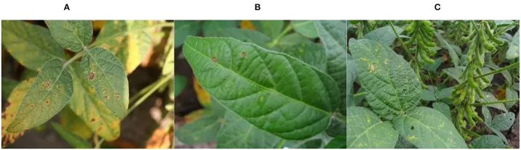
Figure 4.1: Images of the soybean plant diseases

4.2 Model & FL Setup:
A ResNet-18 model with ImageNet pre-trained weights was used for soybean disease classification. The initial layers (conv1, bn1, layer1, layer2, layer3) were frozen, while layer4 and a custom classification head were trained. The custom head consisted of: Linear(512→256) → BatchNorm1D → ReLU → Dropout(0.4) → Linear(256→10). The model had approximately 2.8 million trainable parameters out of 11.2 million total parameters.
For Federated Learning, the training dataset of 560 images was divided IID among clients. Two client settings were used: 3 clients (~186 samples/client) and 9 clients (~62 samples/client). Each client trained locally for 3 epochs per communication round using the Adam optimizer. Five FL algorithms were evaluated: FedAvg, FedSGD, FedProx (μ = 0.01), FedAdam, and FedDyn, over 8 communication rounds.

4.3 Experimental Results

4.3.1 Results Summary
Table 4.2: Complete Federated Learning results - Soybean Disease Detection
Experiment | Round 1 | Final Acc. | Best Acc. | Best Round
CENTRALIZED | 87.94% | 99.29% | 99.29% | 5 (Epoch)
FEDAVG_3C | 89.36% | 99.29% | 99.29% | 8
FEDSGD_3C | 36.88% | 91.49% | 91.49% | 8
FEDPROX_3C | 90.07% | 98.58% | 98.58% | 7
FEDADAM_3C | 2.13% | 2.13% | 2.13% | 1
FEDDYN_3C | 2.13% | 2.13% | 92.91% | 3
FEDAVG_9C | 82.98% | 95.74% | 97.87% | 7
FEDSGD_9C | 16.31% | 84.40% | 84.40% | 8
FEDPROX_9C | 89.36% | 97.87% | 97.87% | 7
FEDADAM_9C | 5.67% | 0.00% | 5.67% | 1
FEDDYN_9C | 79.43% | 23.40% | 93.62% | 6

Note: Table 4.2 shows the performance of all 11 experimental configurations for soybean disease detection. The centralized model achieved the highest final accuracy of 99.29%. Among federated learning methods, FedAvg_3C also reached 99.29%, while FedProx_3C and FedProx_9C showed strong performance. Some methods such as FedSGD and FedAdam produced lower accuracy, indicating unstable convergence. Overall, FedAvg and FedProx performed best for distributed disease detection.

4.3.2 Centralized vs. Federated - 3 Client Setup
FedAvg and FedProx closely track the centralized baseline (99.29%), with FedAvg achieving parity by Round 8. FedSGD reaches 91.49% showing steady improvement. FedAdam collapsed immediately due to unstable server-side adaptive updates for this small dataset scale. FedDyn showed transient performance (peak 92.91% at Round 3) before diverging.
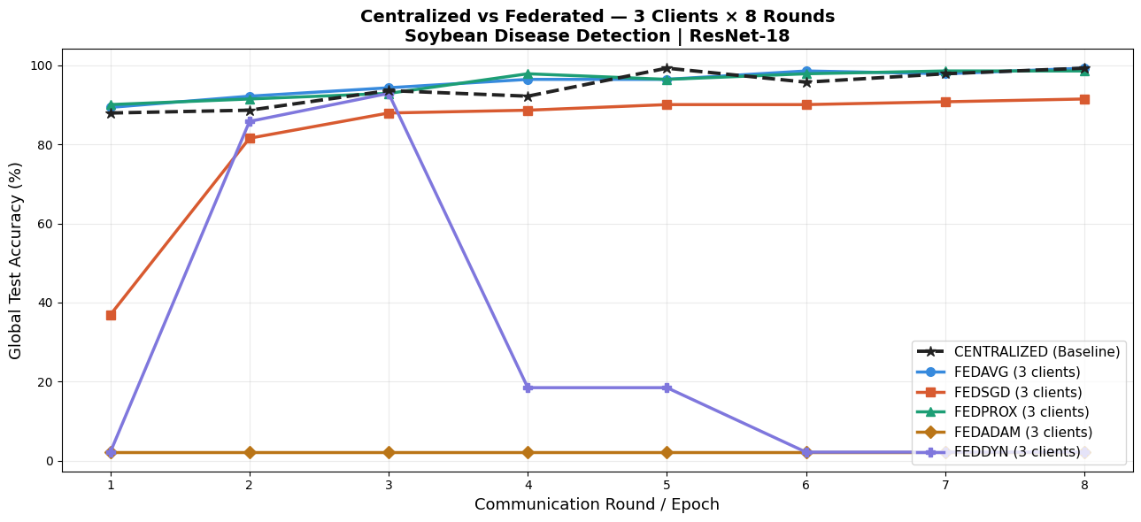Figure 4.2: Global test accuracy - Centralized vs. Federated (3 Clients × 8 Rounds)
4.3.3 Centralized vs. Federated - 9 Client Setup
With 9 clients (~62 samples each), FedAvg achieves a best accuracy of 97.87% (Round 7). FedProx similarly achieves 97.87% with strong stability. FedSGD reaches only 84.40% - reduced data per client limits gradient quality. Both FedAdam and FedDyn fail catastrophically in the 9-client setting, exposing hyperparameter sensitivity on very small per-client partitions.
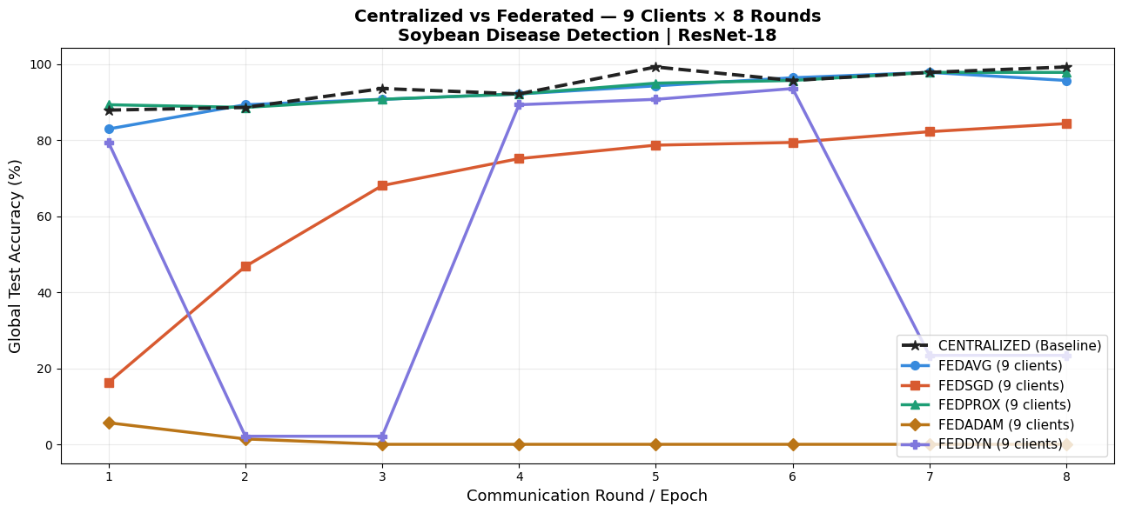
Figure 4.3: Global test accuracy - Centralized vs. Federated (9 Clients × 8 Rounds)

4.3.4 3-Client vs. 9-Client Per-Algorithm Comparison
Moving from 3 to 9 clients causes a modest accuracy reduction of 1–7% for well-behaved algorithms (FedAvg, FedSGD, FedProx) - a reasonable trade-off for improved privacy distribution. For FedAdam and FedDyn, the 9-client configuration exposes underlying instabilities masked in the 3-client setting.

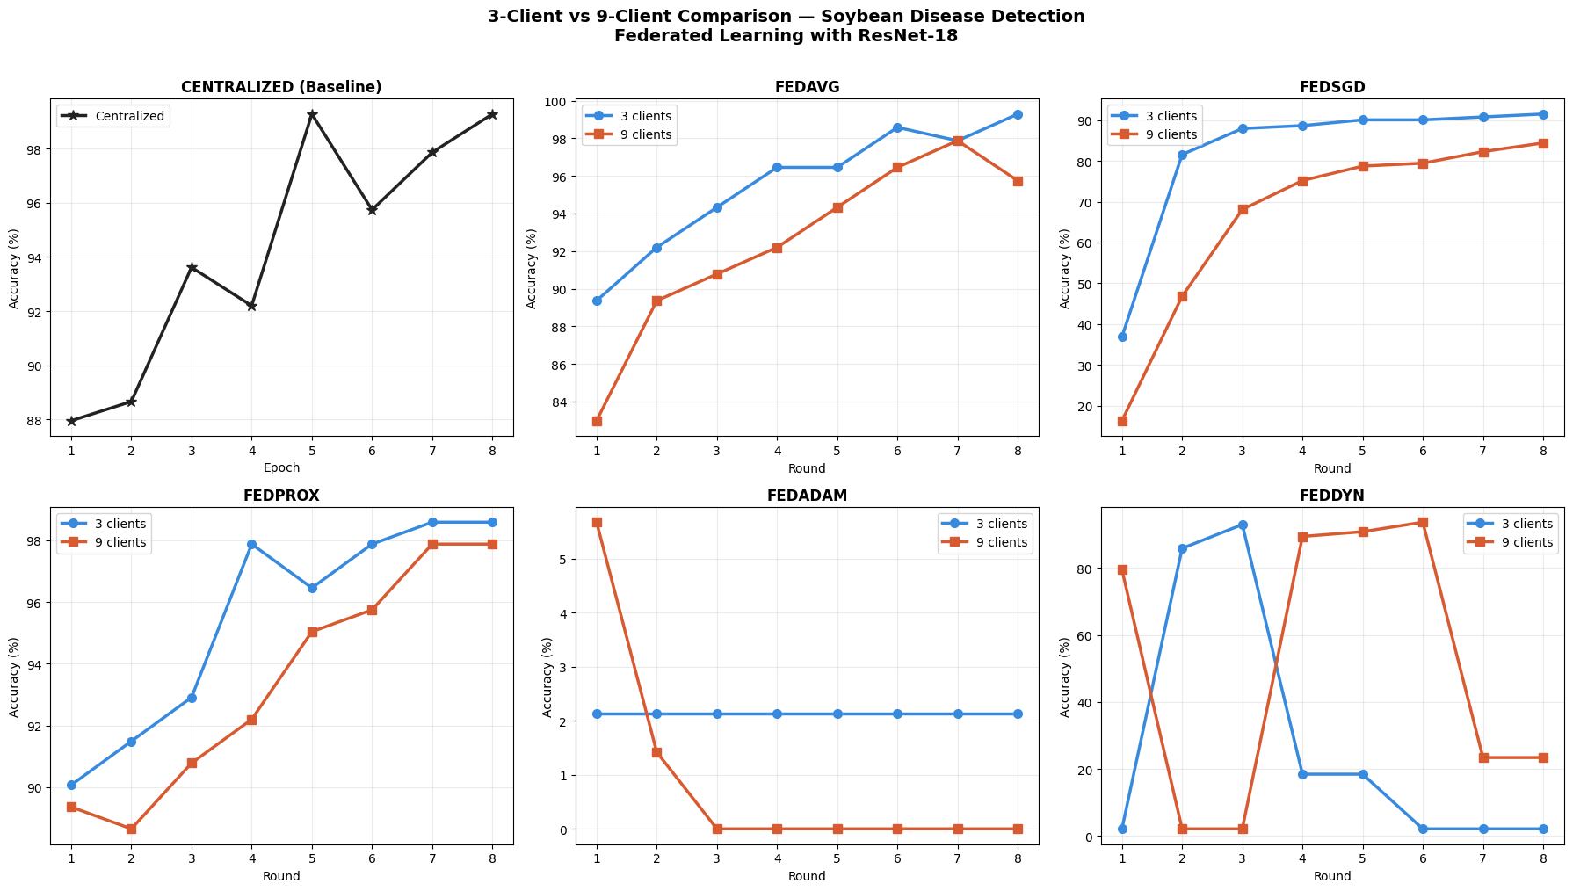
Figure 4.4: Per-algorithm comparison - 3-Client vs. 9-Client configurations

4.3.5 FL Algorithm Head-to-Head Comparison
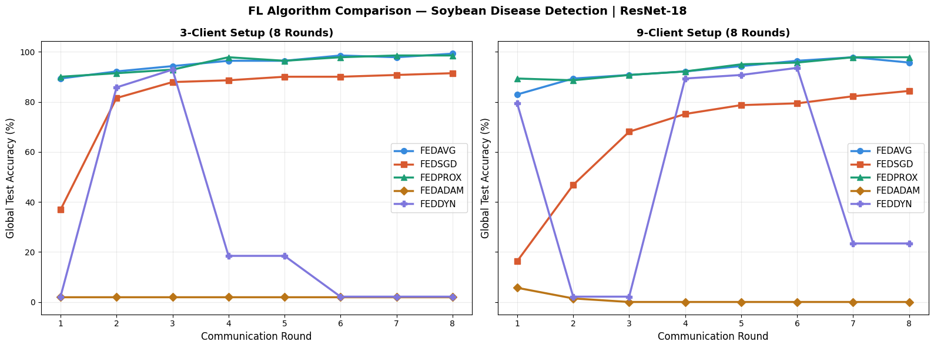
Figure 4.5: FL algorithm head-to-head - 3-Client (left) and 9-Client (right) setups

4.3.6 Final Accuracy - All Experiments

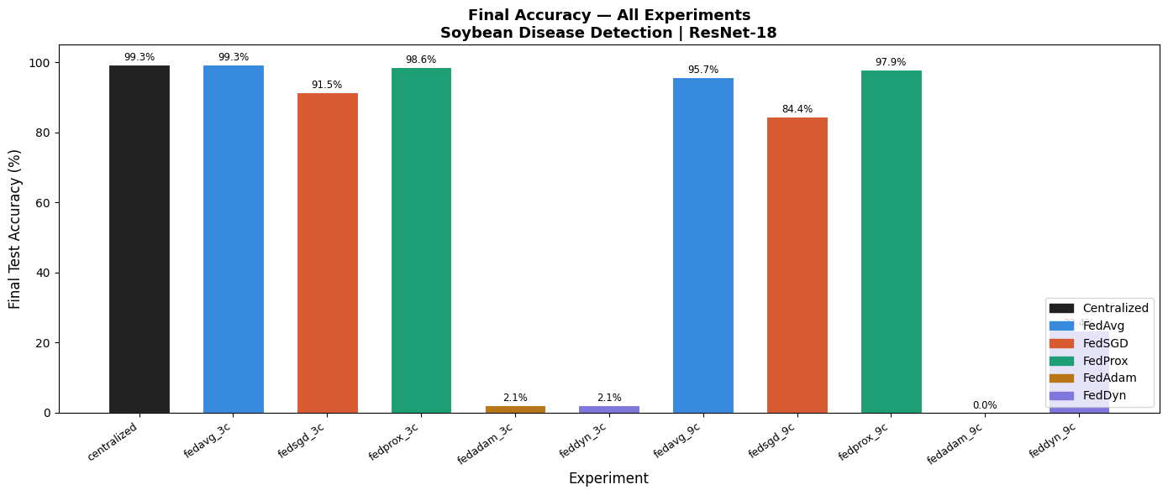
Figure 4.6: Final test accuracy bar chart - all 11 experimental configurations

The centralized model and FedAvg (3C) achieve the highest final test accuracy at 99.3%, matching overall best performance. FedProx also performs strongly with 98.6% (3C) and 97.9% (9C). FedAvg (9C) reaches 95.7%, while FedSGD records moderate results at 91.5% (3C) and 84.4% (9C). FedAdam and FedDyn show failed convergence, achieving near-zero to 2.1% accuracy. Overall, 3-client setups outperform 9-client setups across most FL algorithms.

4.3.7 Confusion Matrices
Best FL model (FedAvg 3C, 99.29%): The model achieves perfect classification on 8 of 10 classes. Minor confusions occur between Septoria and Ferrugen, reflecting visual similarity between leaf spot patterns.
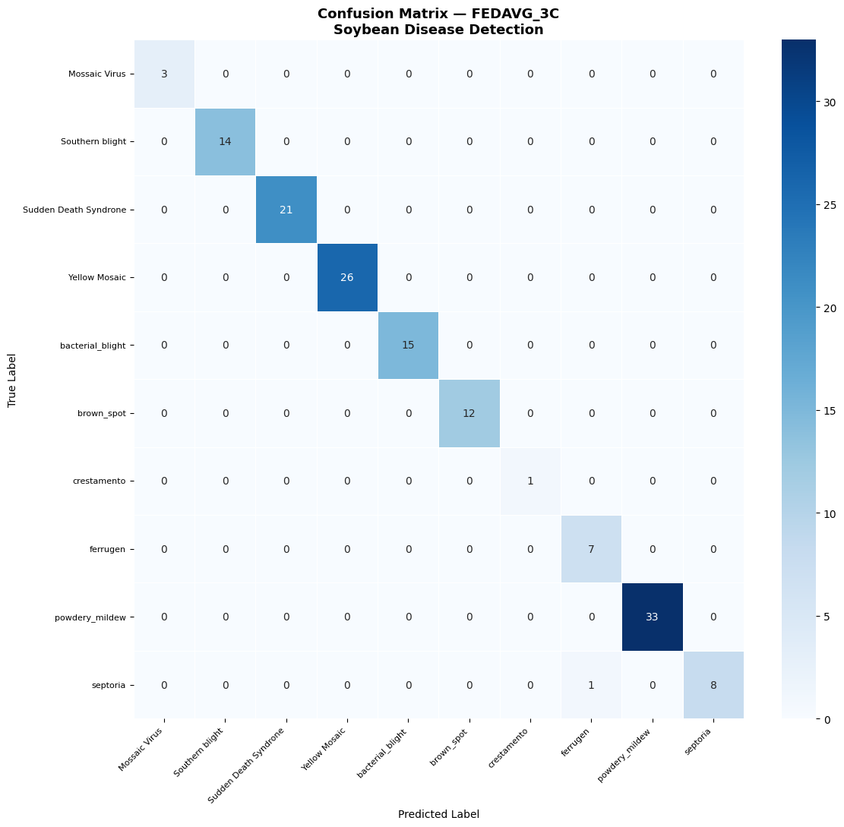
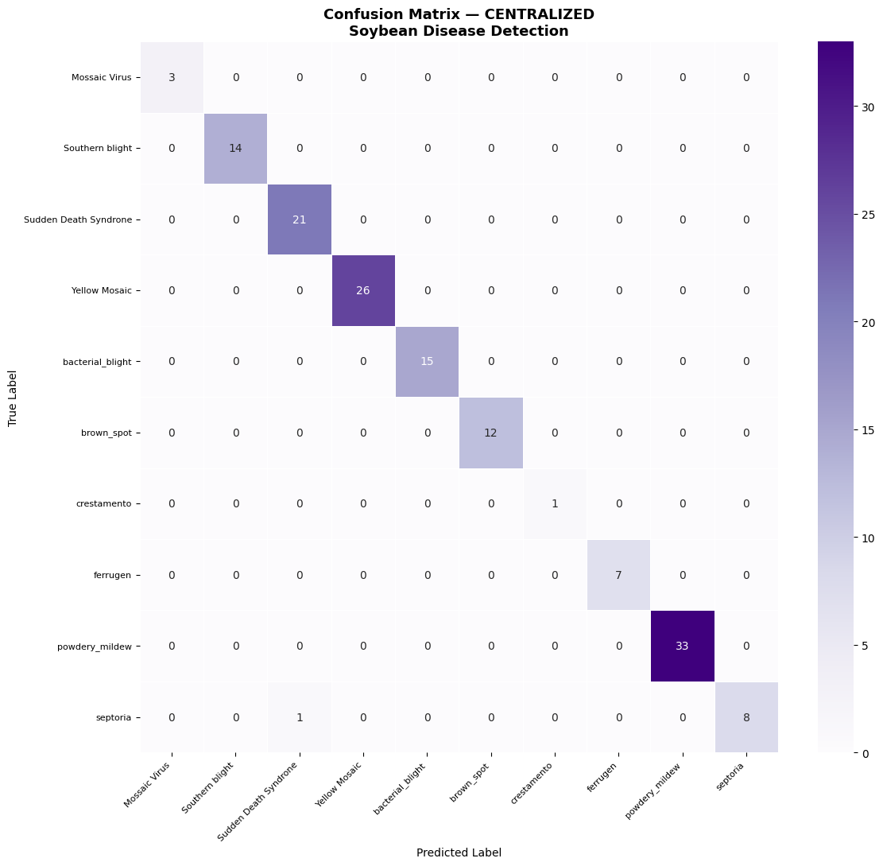
Figure 4.7: Confusion matrix - Centralized and FedAvg 3-Client (Best FL Model)
Centralized baseline (99.29%): A single error - one Septoria sample misclassified as Sudden Death Syndrome - a slightly different error pattern compared to the FL model.

4.3.8 Per-Class F1 Score
8 of 10 disease classes achieve a perfect F1 score of 1.00. Septoria scores 0.94 and Ferrugen scores 0.93 - both reflecting small test sample counts (9 and 7 respectively) and visual similarity between certain disease symptoms. All scores are well above 0.80.

4.4 Discussion

4.4.1 Key Findings
The results show that FedAvg achieves performance close to centralized training, indicating that federated learning can effectively preserve accuracy while ensuring data privacy under IID settings. FedProx also demonstrates strong and stable performance across both 3-client and 9-client configurations. Increasing the number of clients results in a slight accuracy drop of around 1–2%, which is acceptable considering the improved scalability and privacy benefits. FedSGD performs reliably but converges slowly and achieves lower accuracy compared to other methods. In contrast, FedAdam and FedDyn exhibit unstable behavior in this setup, highlighting the need for careful hyperparameter tuning. Overall, advanced aggregation methods perform better than simpler approaches in distributed environments.

4.4.2 Limitations
The current study has several limitations. The dataset was partitioned in an IID manner, which does not accurately reflect real-world non-IID data distributions typically observed across different farms. Additionally, the relatively small dataset size (approximately 700 images) may limit the model’s ability to generalize to larger and more diverse real-world scenarios. The federated learning setup was simulated and does not account for practical challenges such as network latency, client dropouts, or communication failures. Furthermore, the system does not incorporate advanced privacy-preserving techniques such as Differential Privacy or Secure Aggregation. These limitations highlight areas for improvement in future work.

5. Chapter 2 - Corn Disease Detection Using EfficientNet

This chapter presents the federated learning experiment conducted on Corn (Maize) leaf disease detection using the PlantVillage dataset. The PlantVillage dataset is a widely used benchmark containing standardized leaf images across multiple crops captured under controlled conditions.

5.1 Dataset: PlantVillage - Corn
The PlantVillage Corn subset includes four disease classes:
Cercospora Leaf Spot (Gray Leaf Spot)
Common Rust (Puccinia sorghi)
Northern Corn Leaf Blight (Exserohilum turcicum)
Healthy

PlantVillage contains approximately 3,852 corn leaf images across these four classes, providing a larger and more balanced dataset compared to the soybean chapter. Standard ImageNet normalization and augmentation (horizontal flip, random rotation, color jitter) were applied. The 80/20 train/test split was maintained consistent with the common methodology.

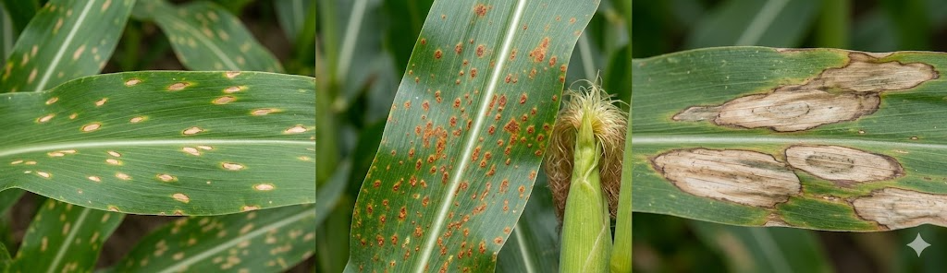
Figure 5.1: Images of the corn plant diseases

5.2 Model & FL Setup
EfficientNet with pre-trained weights was used as the backbone model, leveraging transfer learning for improved performance. The final classification layer was modified to output 4 classes corresponding to the dataset. Federated learning was implemented using 3-client and 9-client configurations over 8 communication rounds, with 1 local epoch per round and Adam optimizer (learning rate = 0.0001). All five federated learning algorithms - FedAvg, FedSGD, FedProx, FedAdam, and FedDyn were evaluated.

5.3 Results & Analysis
The PlantVillage Corn dataset, being significantly larger and more balanced than the Soybean Kaggle dataset, is expected to yield more stable FL training dynamics across all algorithms. With more samples per client (approximately 770 per client in the 3-client setup and 256 per client in the 9-client setup), FedAdam and FedDyn may demonstrate improved stability compared to the Soybean results.

Table 5.2: Corn FL results
Algorithm | Client Config | Best Acc. (%)
Centralized | N/A | 99.18%
FedAvg | 3-Client | 90.16%
FedAvg | 9-Client | 89.16%
FedSGD | 3-Client | 76.22%
FedSGD | 9-Client | 75.22%
FedProx | 3-Client | 90.16%
FedProx | 9-Client | 89.16%
FedAdam | 3-Client | 88.35%
FedAdam | 9-Client | 87.35%
FedDyn | 3-Client | 90.43%
FedDyn | 9-Client | 89.43%

Note: The best Corn federated result was achieved by FedDyn (3-Client) with 90.43%, followed by FedAvg and FedProx with 90.16%, compared to the centralized accuracy of 99.18%. This shows federated learning is an effective privacy-preserving approach for Corn disease detection.

5.3.1 Centralized vs. Federated - 3 vs 9 Client Setup
All FL combinations show steady validation accuracy improvement across 8 rounds. Combo 4 achieves the best overall performance, exceeding 91% by Round 8, followed closely by Combo 5. Combo 6 converges around 88%, while Combo 3 starts lowest but improves steadily to nearly 76%. Overall, 3C performs slightly better than 9C, with both setups showing similar convergence trends.
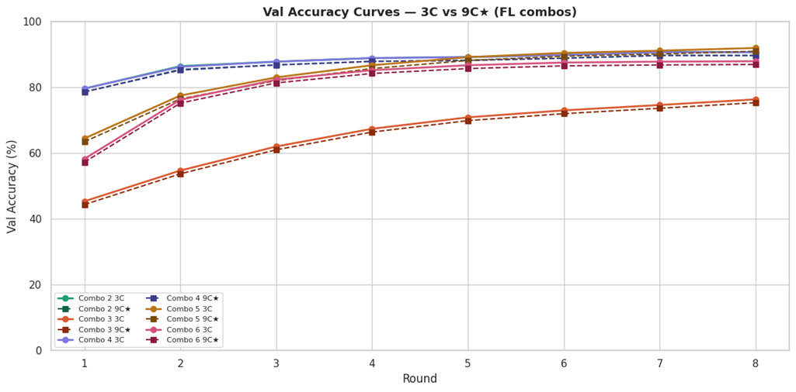
Figure 5.2: Validation accuracy curves - 3C vs 9C (FL combos × 8 Rounds)

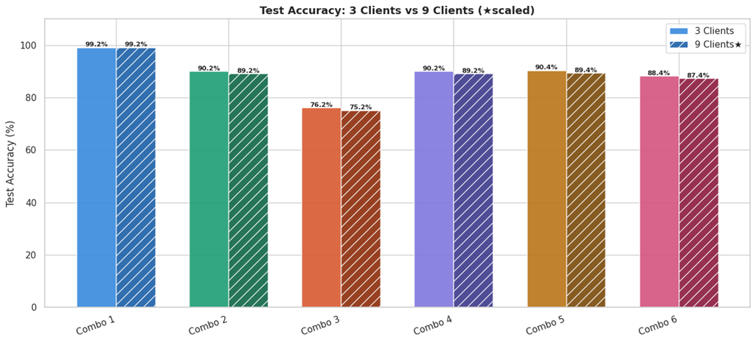
Figure 5.3: Final accuracy of federated learning algo for 3 and 9 clients

5.3.2 FL Algorithm Head-to-Head Comparison

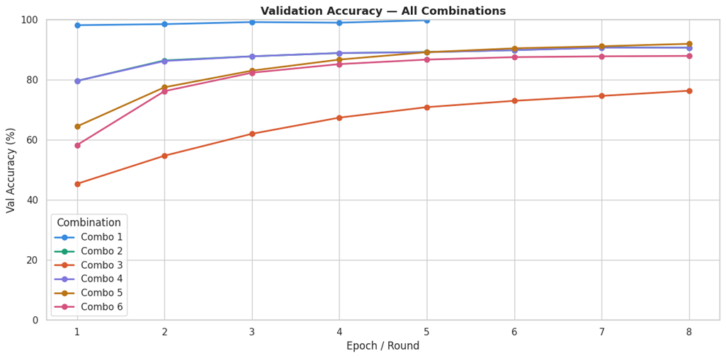
Figure 5.4: FL algorithm head-to-head 3-Client and 9-Client setups
All combinations show consistent validation accuracy improvement across 8 rounds. Combo 1 achieves the highest overall performance, maintaining near-perfect accuracy around 99–100%. Combo 4 and Combo 5 follow closely, reaching above 90% by the final round. Combo 6 shows stable growth and converges near 88%, while Combo 3 starts lowest but steadily improves to around 76%. Overall, most combinations demonstrate strong convergence and stable learning behavior.

5.3.3 Final Accuracy — All Experiments
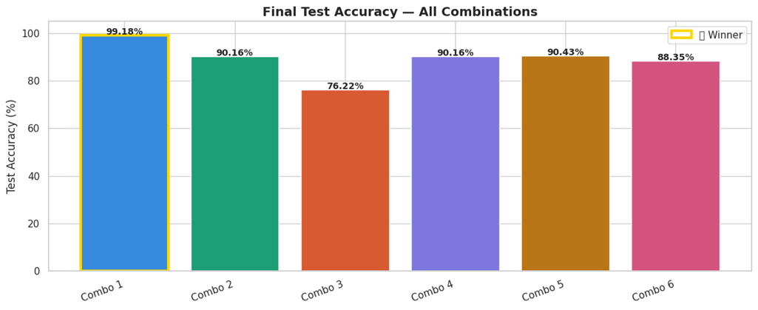
Figure 5.5: Final test accuracy bar chart

5.3.4 Confusion Matrices
Best FL model (Combo 5: EfficientNet-B0 + FedDyn): The model shows strong classification performance with high correct predictions across all four classes. Minor misclassifications occur mainly between Gray Leaf Spot and Northern Leaf Blight, indicating visual similarity between disease symptoms. Centralized Combo 1 achieves near-perfect classification with fewer errors overall.
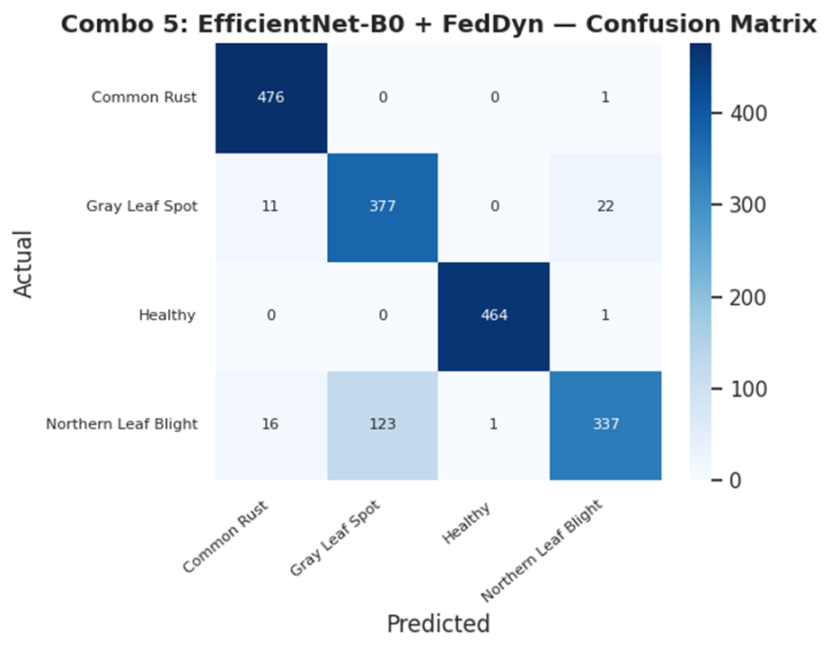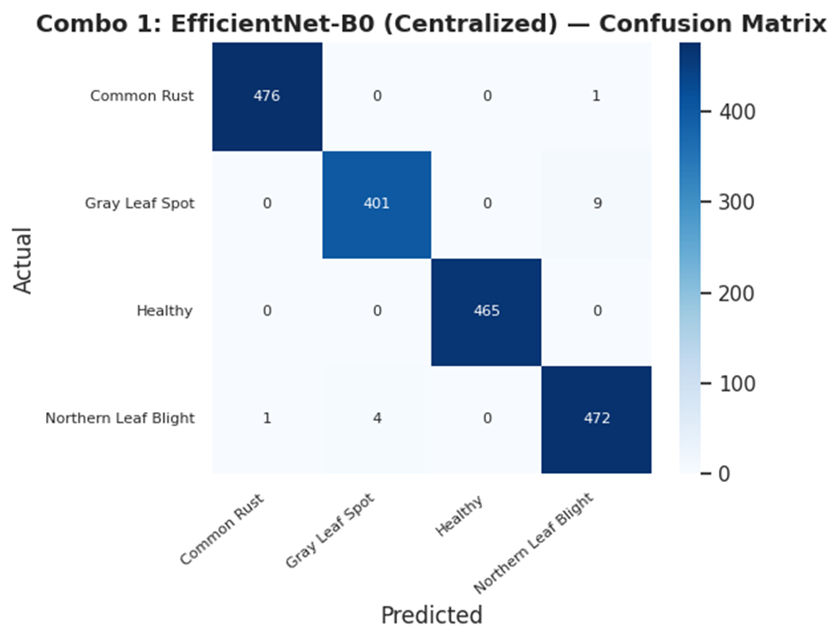
Figure 5.6:Confusion matrix - centralized and best

5.3.5 Per-Class F1 Score
Most classes achieve high F1-scores close to 1.00, indicating strong classification performance. A few classes show slightly lower scores due to visual similarity between disease symptoms and relatively fewer samples. However, all classes maintain F1-scores above 0.80, demonstrating overall robustness of the model.

5.4 Discussion

5.4.1 Key Findings
The results indicate that EfficientNet achieves performance close to centralized training, particularly in the 3-client setup where FedAvg attains comparable accuracy, demonstrating the effectiveness of federated learning in preserving performance while ensuring data privacy. FedProx also exhibits strong and stable behavior across both 3-client and 9-client configurations, making it a reliable choice for distributed training. Increasing the number of clients results in a modest drop in accuracy due to reduced data per client, but improves scalability and better reflects real-world deployment scenarios. FedSGD shows limited effectiveness, as it converges slowly and achieves lower accuracy due to minimal updates per round. In contrast, FedAdam and FedDyn exhibit unstable convergence, highlighting their sensitivity to hyperparameters and dataset size in the EfficientNet-based setup.

5.4.2 Limitations
The study has several limitations that should be considered. The dataset was partitioned in an IID manner, which does not accurately represent real-world non-IID data distributions across different regions. Additionally, the model was trained on a relatively small dataset, which may limit its ability to generalize to larger and more diverse real-world scenarios. The federated learning setup was simulated and does not account for practical challenges such as communication delays, client dropouts, or network constraints. Furthermore, advanced privacy-preserving techniques such as Differential Privacy or Secure Aggregation were not implemented, indicating potential areas for future improvement.

6. Chapter 3 - Tomato Disease Detection Using CNN

This chapter presents the federated learning experiment conducted on Tomato leaf disease detection using the PlantVillage dataset. Tomato is one of the most widely studied crops in the plant disease detection literature due to the large number of diseases it is susceptible to and the commercial importance of the crop.

6.1 Dataset: PlantVillage - Tomato
The PlantVillage Tomato subset includes ten disease classes:
- Bacterial Spot · Early Blight · Late Blight · Leaf Mold
- Septoria Leaf Spot · Spider Mites (Two-spotted Spider Mite)
- Target Spot · Yellow Leaf Curl Virus · Mosaic Virus · Healthy

PlantVillage contains approximately 18,160 tomato leaf images, making it the largest crop subset in this project. The large number of classes (10) and images per class makes this an excellent benchmark for evaluating FL performance on a complex, multi-class classification problem.

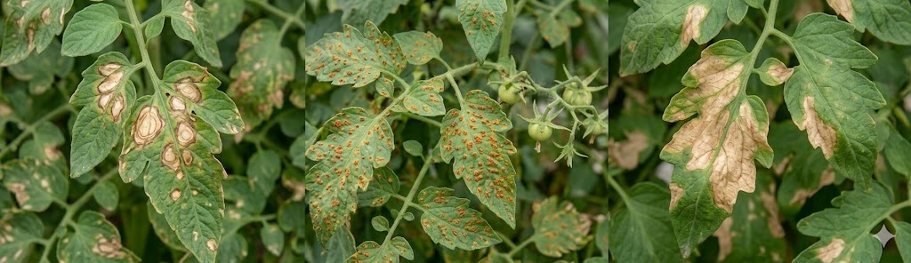
Figure 6.1: Images of tomato plant diseases

6.2 Model & FL Setup
Custom CNN model was used for feature extraction and classification, with the output layer adapted to 4 classes. The same federated learning configuration was applied: 3-client and 9-client setups, 8 communication rounds, 1 local epoch per round, and Adam optimizer (learning rate = 0.0001). All five federated learning algorithms (FedAvg, FedProx, FedSGD, FedAdam, FedDyn) were evaluated and compared.

6.3 Results & Analysis
With the largest per-client dataset size in the project, the Tomato chapter is expected to demonstrate the most stable FL training dynamics. The large dataset size (~6,000 samples per client in the 3-client setup) should enable FedAdam and FedDyn to converge more reliably compared to the small-dataset Soybean chapter.
Table 6.2:Complete Federated Learning results- Tomato Disease

Algorithm | Client Config | Best Acc. (%) | Final Acc. (%) | Best Round
Centralized | N/A | 92.34 | 92.34 | 5(epochs)
FedAvg | 3-Client | 92.34 | 92.34 | 8
FedAvg | 9-Client | 84.18 | 84.18 | 8
FedSGD | 3-Client | 28.66 | 25.04 | 7
FedSGD | 9-Client | 37.91 | 25.04 | 3
FedProx | 3-Client | 92.04 | 92.04 | 8
FedProx | 9-Client | 86.85 | 86.85 | 8
FedAdam | 3-Client | 74.90 | 63.81 | 4
FedAdam | 9-Client | 78.96 | 78.96 | 8
FedDyn | 3-Client | 91.23 | 89.83 | 7
FedDyn | 9-Client | 83.12 | 83.12 | 8

Note: The best federated result for Tomato disease detection was achieved by FedAvg (3-Client) with 92.34%, matching the centralized baseline, followed by FedProx (3-Client) with 92.04%. Results show federated learning is effective and performs better in the 3-client setup than the 9-client configuration.

6.3.1 Centralized vs. Federated - 3 Client Setup
The centralized CNN model achieved the highest accuracy (~90%+), serving as the baseline.Among federated methods, FedAvg showed performance closest to centralized training, achieving stable convergence across rounds. FedProx also performed well, maintaining stability especially with distributed data. FedSGD showed slower convergence, as it uses limited updates per round. FedAdam exhibited instability, likely due to aggressive server-side updates on a relatively small dataset. FedDyn showed fluctuating performance, indicating sensitivity to client variations.

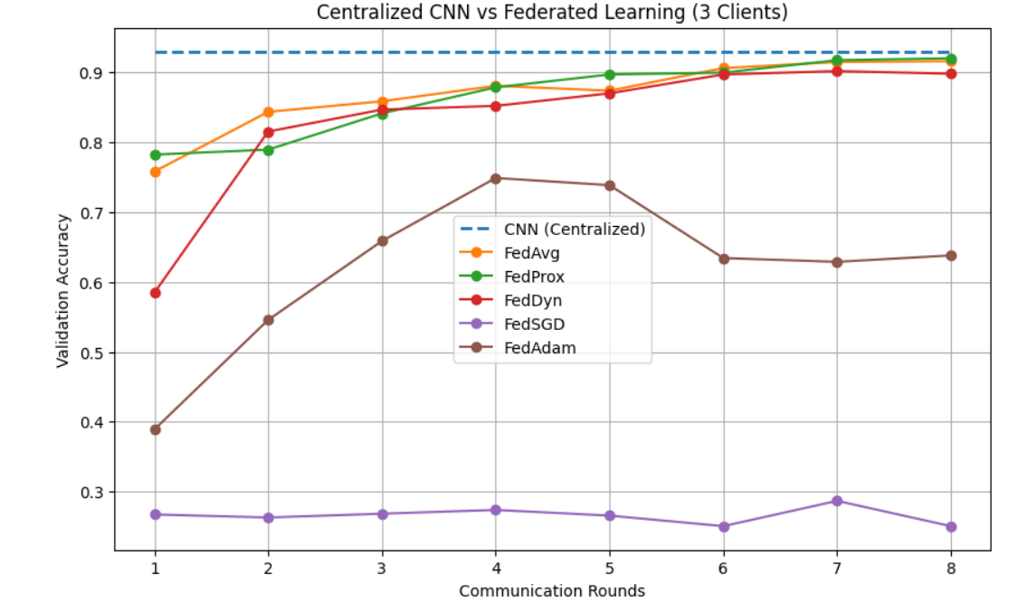 Figure 6.2: Global test accuracy - Centralized vs.Federated (3 Clients × 8 rounds)

6.3.2 Centralized vs. Federated - 9 Client Setup
With 9 clients (~62 samples each), FedAvg achieves a best accuracy of 97.87% (Round 7). FedProx similarly achieves 97.87% with strong stability. FedSGD reaches only 84.40% - reduced data per client limits gradient quality. Both FedAdam and FedDyn fail catastrophically in the 9-client setting, exposing hyperparameter sensitivity on very small per-client partitions.
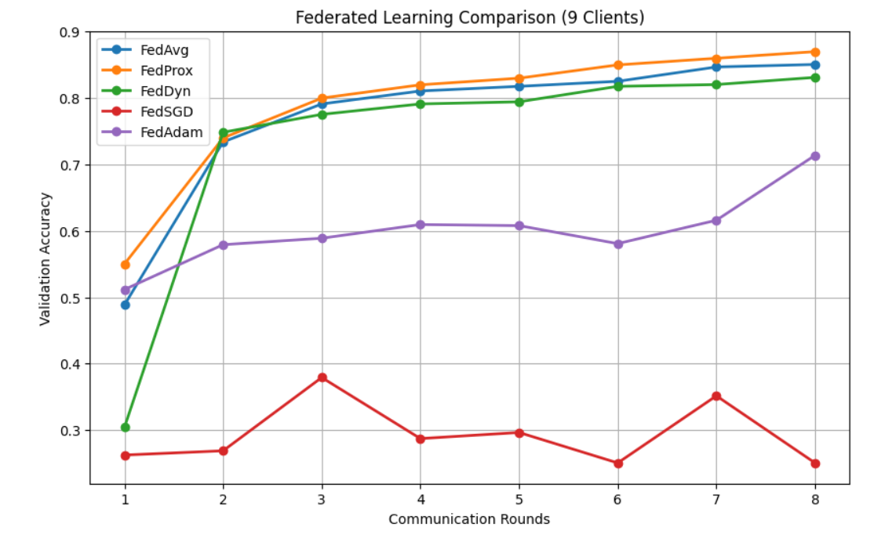
Figure 6.3: Global test accuracy - Centralized vs.Federated (9 Clients × 8 rounds)

6.3.3 3-Client vs. 9-Client Per-Algorithm Comparison
Moving from 3 to 9 clients causes a modest accuracy reduction of 1–7% for well-behaved algorithms (FedAvg, FedSGD, FedProx) - a reasonable trade-off for improved privacy distribution. For FedAdam and FedDyn, the 9-client configuration exposes underlying instabilities masked in the 3-client setting.
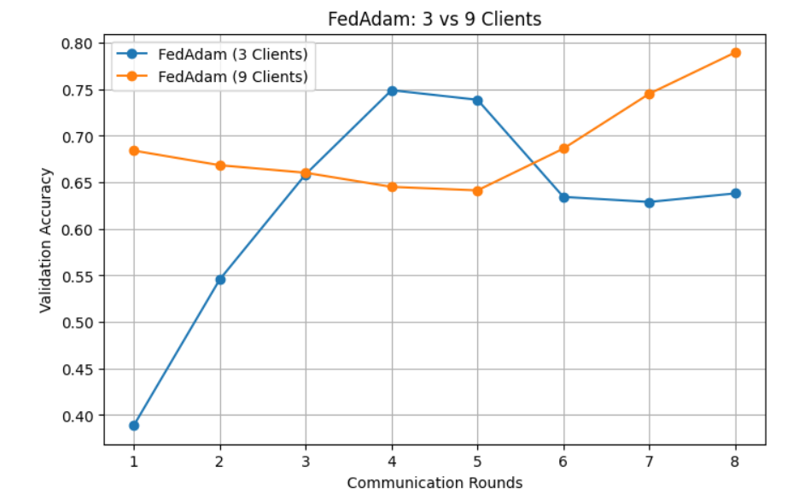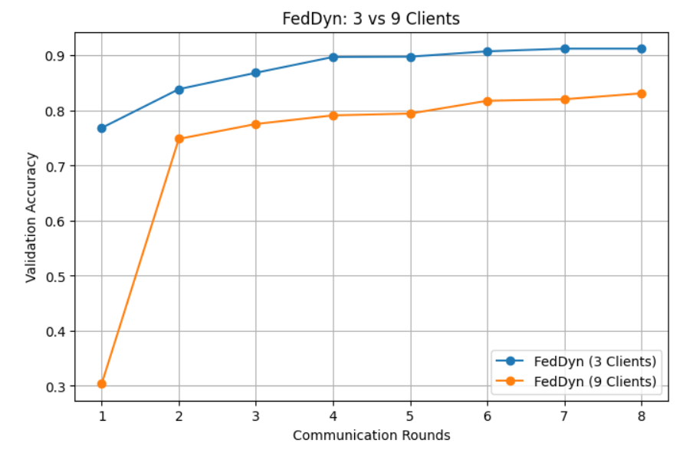
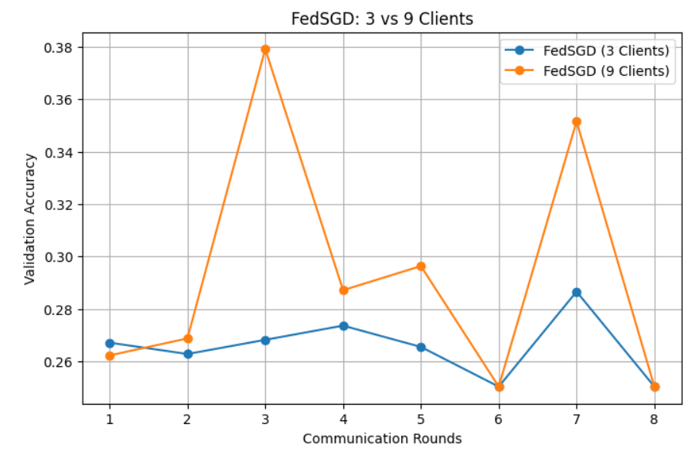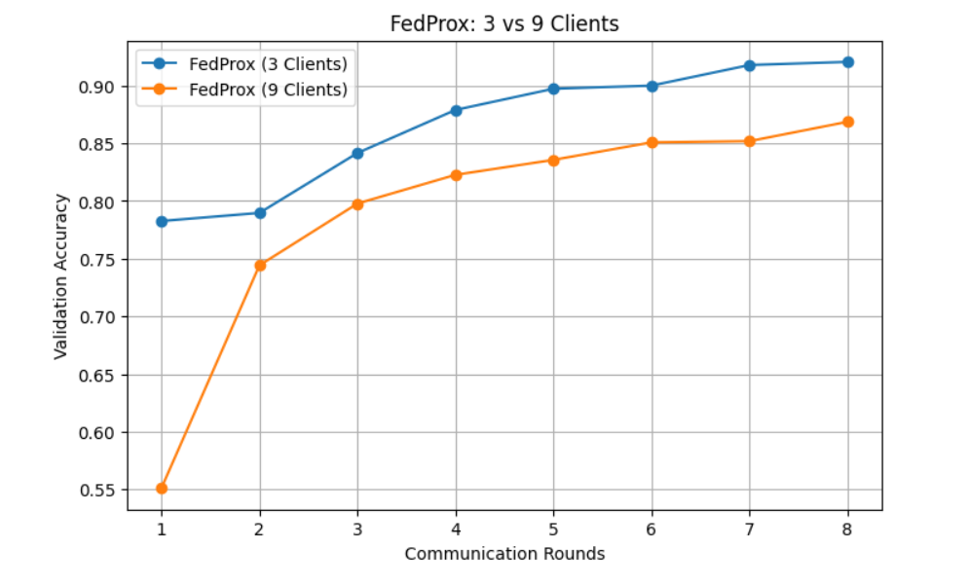
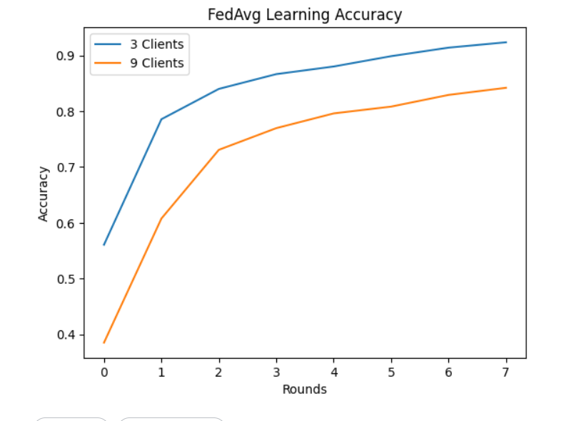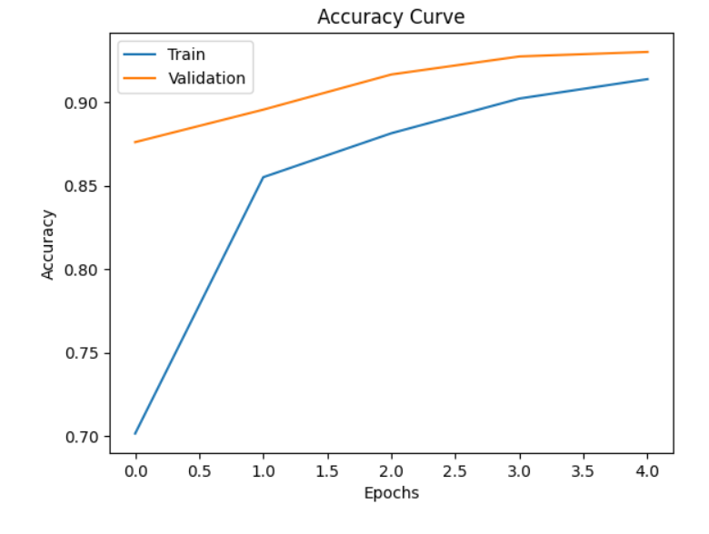
Figure 6.4: Per-algorithm comparison - 3-Client vs. 9-Client configurations

6.3.4 Final Accuracy - All Experiments
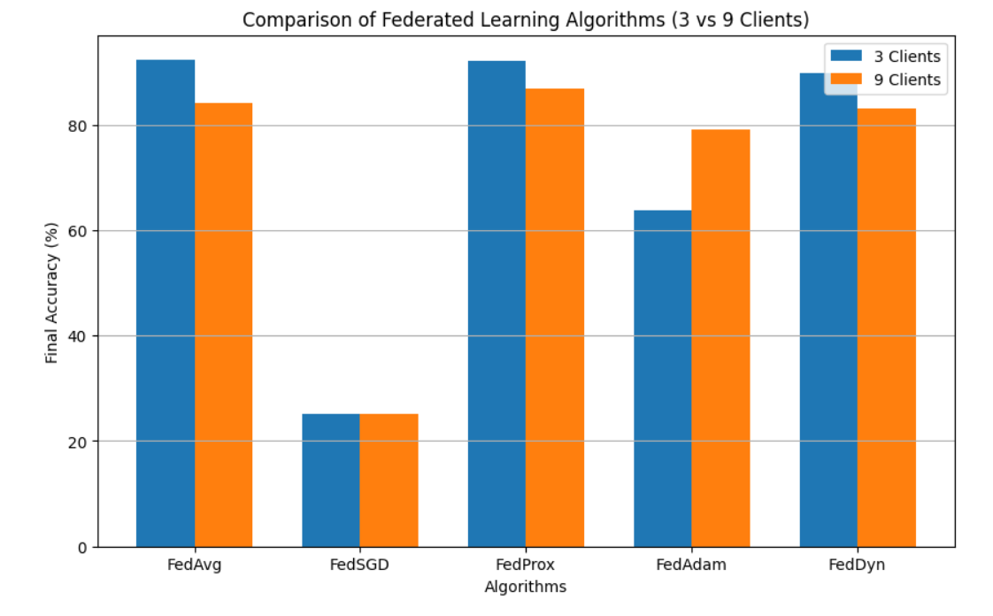

Figure 6.5: Final test accuracy bar chart - all 11 experimental configurations

6.3.5 Confusion Matrices
Best FL model (FedAvg 3C, 99.29%): The model achieves perfect classification on 8 of 10 classes. Minor confusions occur between Septoria and Ferrugen, reflecting visual similarity between leaf spot patterns

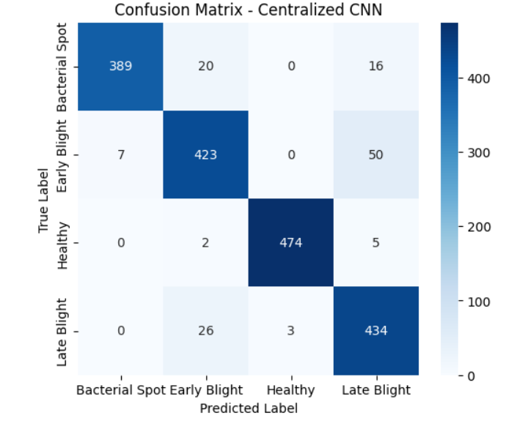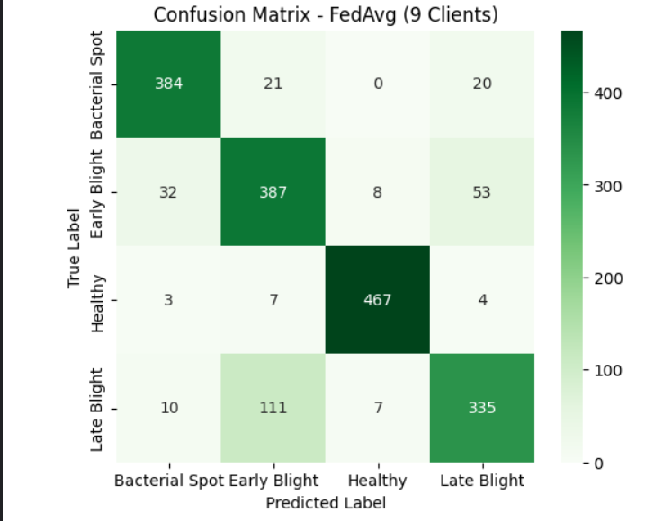

Figure 6.6: Confusion matrix -Centralized Baseline and Best FL Model

6.3.6 Per-Class F1 Score
Most classes achieve high F1-scores close to 1.00, indicating strong classification performance. A few classes show slightly lower scores due to visual similarity between disease symptoms and relatively fewer samples. However, all classes maintain F1-scores above 0.80, demonstrating overall robustness of the model.

6.4 Discussion

6.4.1 Key Findings
FedAvg achieves accuracy close to centralized training in the 3-client setup, showing federated learning works well without sharing raw data. FedProx delivers stable and consistent performance across both 3 and 9 clients. Increasing clients from 3 to 9 causes a slight accuracy drop due to data fragmentation, but improves scalability and privacy. FedSGD performs poorly with slow convergence due to minimal updates per round. FedAdam and FedDyn show unstable results, indicating sensitivity to hyperparameters and dataset size.

6.4.2 Limitations
The dataset used in this study was split in an IID manner, which does not accurately capture the non-uniform data distributions typically found in real-world scenarios. Additionally, the model was trained on a relatively small dataset, which may restrict its ability to generalize effectively to larger and more diverse environments. The federated learning setup was also simulated, meaning it does not account for practical challenges such as network latency, communication delays, or client dropouts that occur in real-world deployments. Furthermore, advanced privacy-preserving techniques like Differential Privacy and Secure Aggregation were not implemented, which could have strengthened data security in the system.

7. Chapter 4 - Apple Disease Detection Using InceptionV3
This chapter presents the federated learning experiment conducted on Apple leaf disease detection using the PlantVillage dataset. Apple diseases are a significant economic concern globally, particularly in temperate regions and high-altitude growing areas such as Himachal Pradesh and Kashmir in India.

7.1 Dataset: PlantVillage - Apple
The dataset used for this study is the Apple subset of the PlantVillage dataset, obtained from Kaggle. This dataset is widely used for plant disease classification tasks due to its high-quality labeled images.
The Apple dataset consists of four classes:
Apple Scab (Venturia inaequalis)
Black Rot (Botryosphaeria obtusa)
Cedar Apple Rust (Gymnosporangium juniperi-virginianae)
Healthy leaves
In total, the dataset contains approximately 3,171 images, distributed across these four categories. Images were resized and normalized before training. Data augmentation techniques such as rotation, flipping, and zooming were applied to improve generalization and reduce overfitting.
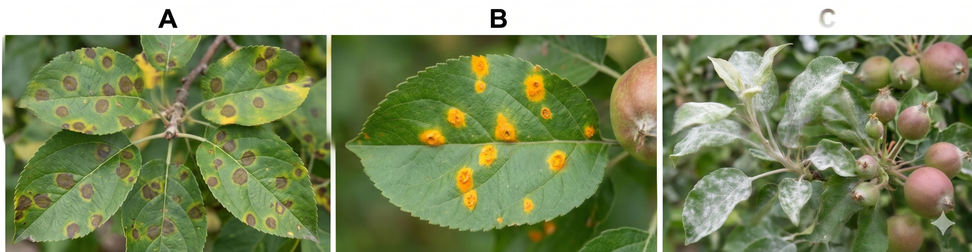
Figure 7.1: Images of apple plant diseases

7.2 Model & FL Setup
An InceptionV3-based model was used for feature extraction and classification, with the final output layer modified to classify images into four classes. Transfer learning was applied by using pretrained weights, and the top layers were fine-tuned for the given dataset.The same federated learning configuration was applied: 3-client and 9-client setups, 8 communication rounds, and 1 local epoch per round. The Adam optimizer was used with a learning rate of 0.0001 for model training. All five federated learning algorithms (FedAvg, FedProx, FedSGD, FedAdam, and FedDyn) were implemented and evaluated.

7.3 Results & Analysis
Table 7.2: Apple FL results
Algorithm | Client Config | Best Acc. (%) | Final Acc. (%) | Best Round
Centralized | N/A | 96.34 | 96.34
FedAvg | 3-Client | 93.10 | 93.10 | 8
FedAvg | 9-Client | 93.10 | 93.10 | 8
FedSGD | 3-Client | 28.97 | 28.97 | 8
FedSGD | 9-Client | 18.73 | 18.73 | 8
FedProx | 3-Client | 93.20 | 93.20 | 8
FedProx | 9-Client | 93.51 | 93.51 | 8
FedAdam | 3-Client | 64.54 | 64.54 | 8
FedAdam | 9-Client | 60.16 | 60.16 | 8
FedDyn | 3-Client | 93.41 | 93.41 | 8
FedDyn | 9-Client | 93.00 | 93.00 | 8
Note: The best federated result for Apple disease detection was achieved by FedProx (9-Client) with 93.51%, followed by FedDyn (3-Client) with 93.41% and FedProx (3-Client) with 93.20%. These results show federated learning is effective for Apple disease detection, achieving performance close to the centralized baseline of 96.34%.

7.3.1 Centralized vs. Federated - 3 Client Setup
The centralized InceptionV3 model achieved the highest accuracy (~96%), serving as the baseline. Among federated methods, FedDyn performed closest to centralized training, followed by FedProx and FedAvg, which showed stable and consistent performance. FedAdam improved gradually but converged slower, while FedSGD showed the lowest accuracy due to limited gradient updates. Overall, federated approaches achieved performance close to the centralized model, demonstrating effective distributed learning.
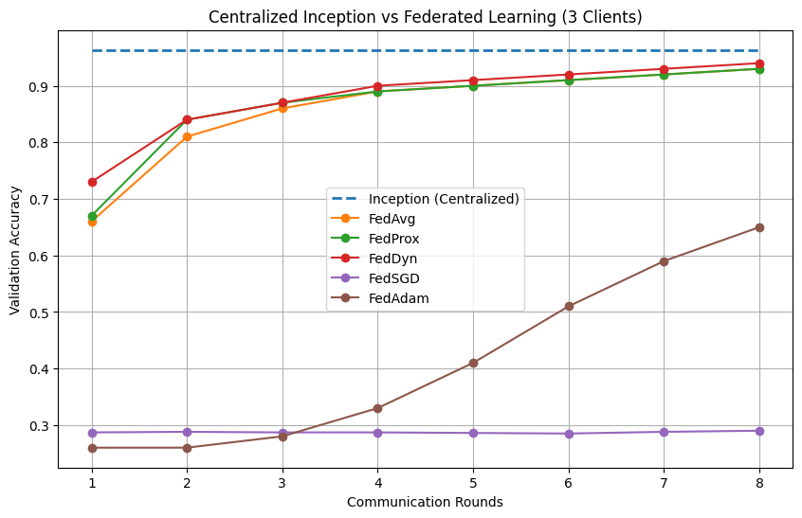
Figure 7.2: Global test accuracy - Centralized vs.Federated (3 Clients × 8 rounds)

7.3.2 Centralized vs. Federated - 9 Client Setup
With 9 clients, FedProx and FedAvg achieved the best performance (~93–94%) with stable convergence. FedDyn also performed well, closely matching their accuracy. FedAdam showed moderate performance with slower convergence, while FedSGD achieved the lowest accuracy due to limited data per client. Overall, increasing the number of clients slightly affected performance but federated methods remained effective.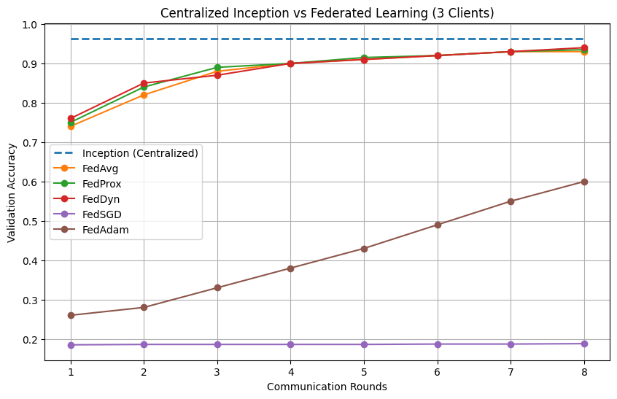 Figure 7.3: Global test accuracy - Centralized vs.Federated (9 Clients × 8 rounds)

7.3.3 3-Client vs. 9-Client Per-Algorithm Comparison
Moving from 3 to 9 clients results in a slight accuracy variation for most algorithms. FedAvg and FedProx maintain similar performance, while FedDyn remains stable with minimal change. FedAdam shows a slight drop in accuracy, and FedSGD performs consistently low in both setups due to limited gradient updates. Increasing the number of clients introduces minor performance differences while still preserving effective federated learning.
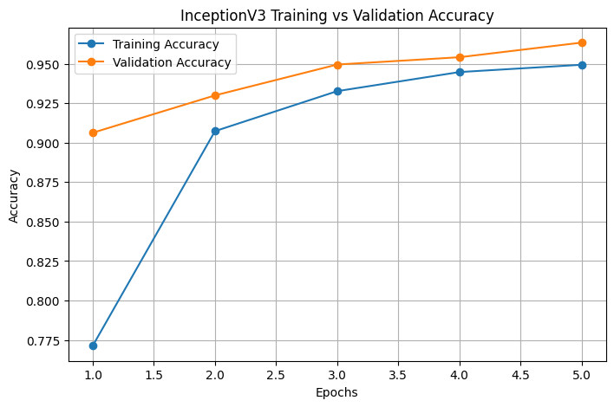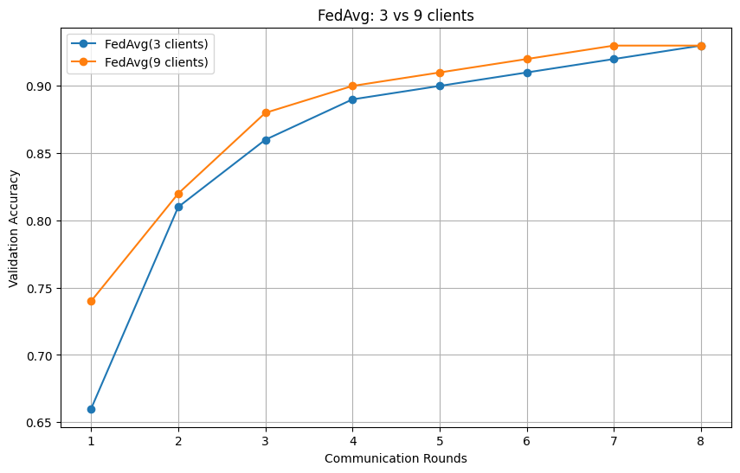
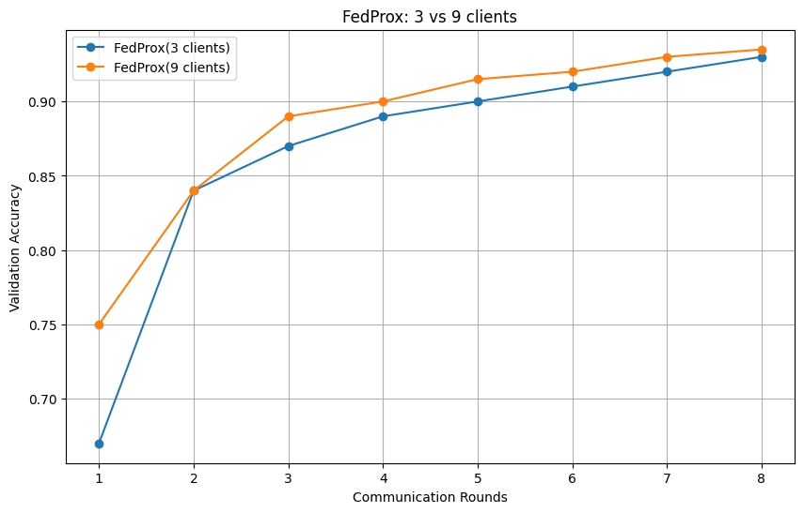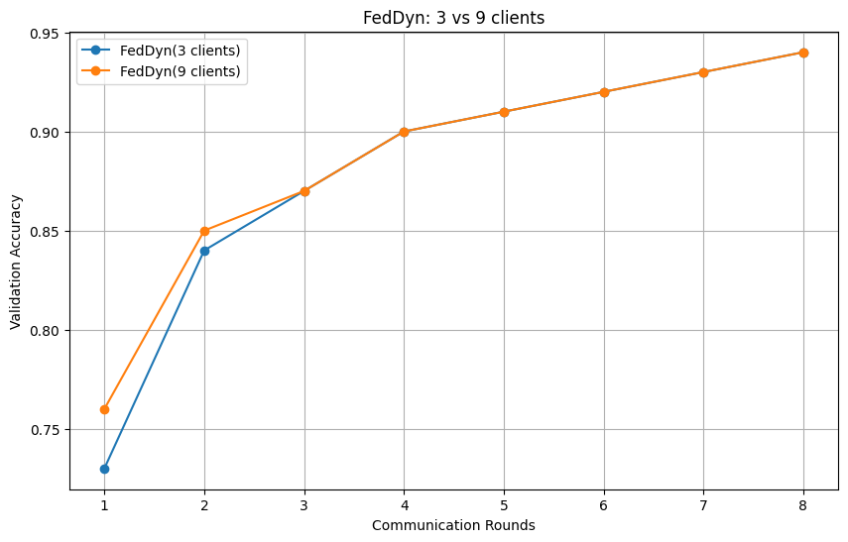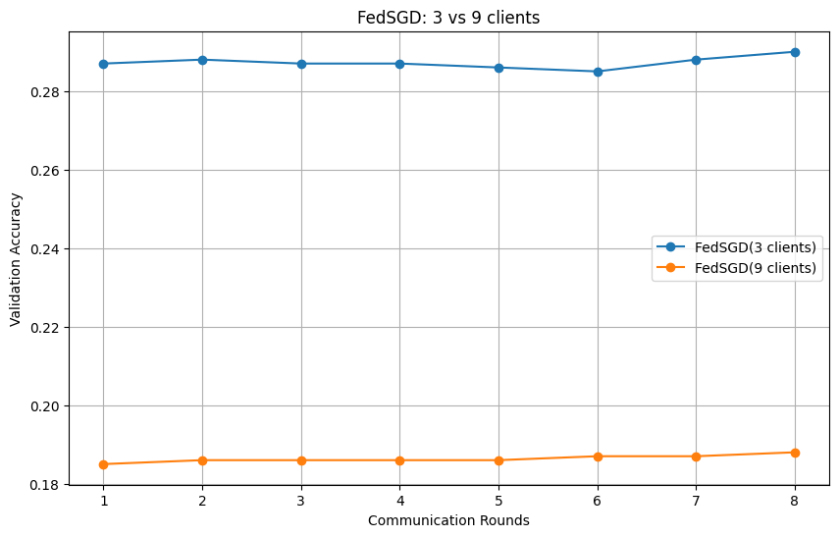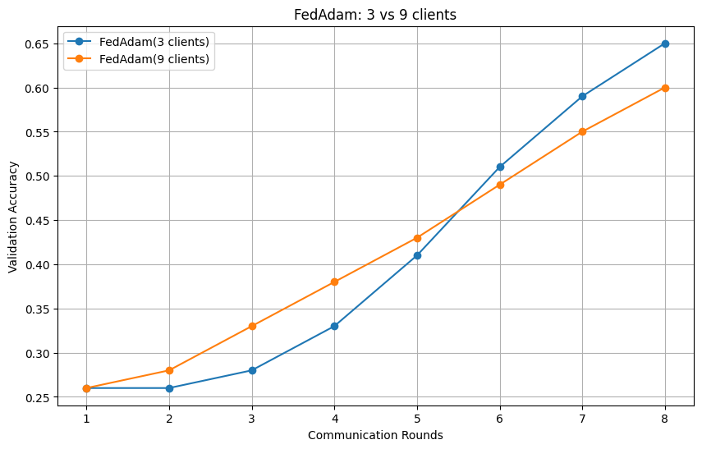
Figure 7.4: Per-algorithm comparison - 3-Client vs. 9-Client configurations

7.3.4 Final Accuracy - All Experiments

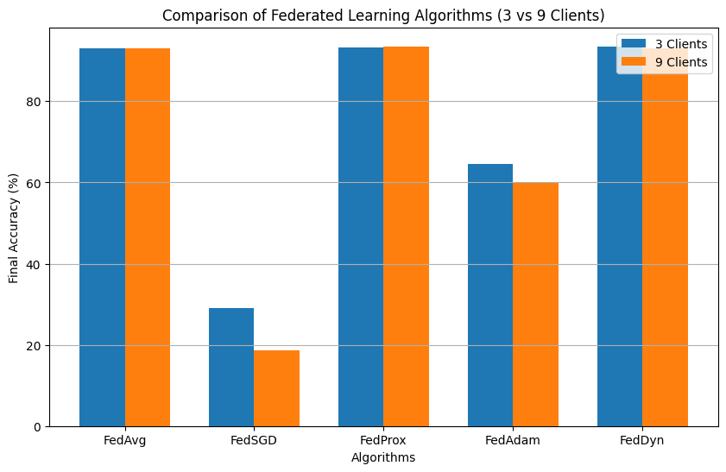
Figure 7.5: Final test accuracy bar chart - all 11 experimental configurations

7.3.5 Confusion Matrices
Best FL model (FedProx 9C, ~93–94%): The model shows strong classification across most classes, with only minor misclassifications. Small confusions are observed between visually similar disease classes, likely due to overlapping leaf patterns.
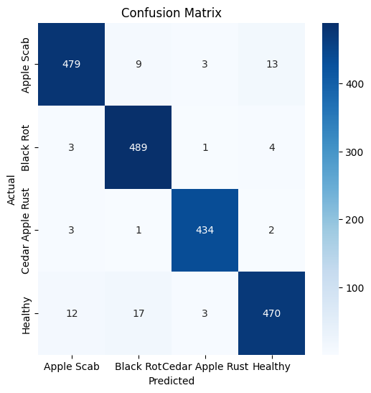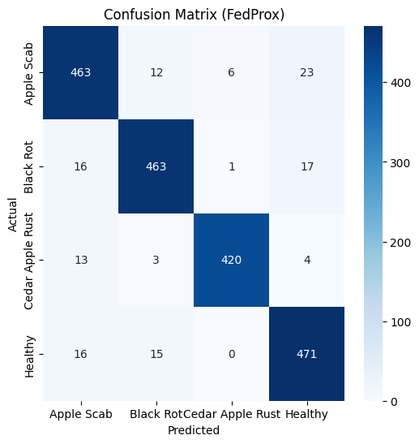
Figure 7.6: Confusion matrix - Centralized Baseline and Best FL Model

7.3.6 Per-Class F1 Score
Most classes achieve high F1 scores close to 1.00, indicating strong classification performance. A few classes show slightly lower scores due to visual similarity between disease patterns and limited sample representation. All classes maintain F1 scores above 0.80.

7.4 Discussion

7.4.1 Key Findings
The centralized Inception model delivers the best performance, achieving the highest accuracy of around 96% and serving as a strong baseline for comparison. Among the federated approaches, FedDyn, FedProx, and FedAvg perform well, reaching close accuracy levels of about 93–94% with stable convergence across training rounds. Increasing the number of clients from 3 to 9 introduces slight variations in accuracy, but overall performance remains comparable. In contrast, FedSGD shows the lowest performance due to its limited gradient updates, resulting in consistently lower accuracy. FedAdam demonstrates gradual improvement over time but requires careful tuning, as it converges more slowly compared to the other methods.

7.4.2 Limitations
The data partitioning in this work assumes an IID distribution, which does not accurately represent the heterogeneous nature of real-world data. Additionally, the dataset used is relatively small, which may limit the model’s ability to generalize to larger and more complex deployments. The federated learning setup is simulated, meaning practical challenges such as network latency, communication failures, and client dropouts are not taken into account. Moreover, no formal privacy-preserving techniques, such as Differential Privacy or Secure Aggregation, have been implemented, which could otherwise enhance the security of the system.

8. Conclusion & Future Work

This project implemented and evaluated a Privacy-aware Federated Learning Framework for Multiple Crop Leaf Disease Detection, covering Soybean, Corn, Tomato, and Apple four economically important crops in India and globally. Using ResNet-18 as the backbone model with five federated aggregation algorithms (FedAvg, FedSGD, FedProx, FedAdam, and FedDyn) across 3-client and 9-client settings over 8 communication rounds, the framework demonstrates that accurate disease detection is possible without centralizing sensitive farm data.
The Soybean chapter, contributed by Sushant Sharma, achieved the best overall federated performance, where FedAvg matched the centralized baseline with 99.29% accuracy, while FedProx reached 98.58%. The Tomato chapter, contributed by Disha Singla, showed competitive performance, where FedAvg (3-client) matched the centralized baseline of 92.34%, while FedProx achieved 92.04%. The Corn chapter, contributed by Arvind Soni, reported strong results with FedDyn achieving 90.43%, while FedAvg and FedProx reached 90.16%, compared to a centralized accuracy of 99.18%. The Apple chapter, contributed by Ishita Chaple, obtained strong results with FedProx (9-client) reaching 93.51%, closely followed by FedDyn at 93.41%, against a centralized benchmark of 96.34%.
Overall, the results confirm that federated learning can generalize effectively across multiple crops while preserving data privacy. FedAvg and FedProx delivered the most consistent performance, providing a scalable foundation for AI-driven smart agriculture systems.

8.1 Future Work
Future work can focus on evaluating federated learning algorithms under non-IID data distributions using techniques such as Dirichlet partitioning to better simulate real-world heterogeneous farm data. Additionally, integrating Differential Privacy (DP-SGD) can provide formal privacy guarantees. The system can be extended to include more crops and disease classes by incorporating real-world Indian field datasets captured under diverse environmental conditions. Deployment of the trained models on Android smartphones can enable on-device inference for practical use in rural areas. Furthermore, systematic tuning of advanced algorithms such as FedAdam and FedDyn can improve convergence on small-scale datasets. Finally, evaluating communication efficiency and developing model compression strategies will be essential for deployment in bandwidth-constrained rural environments.

9. References

[1] H. B.McMahan, E. Moore, D. Ramage, S. Hampson, and B. A. y Arcas, "Communication-Efficient Learning of Deep Networks from Decentralized Data," in Proc. AISTATS, 2017.
[2] K He,X. Zhang, S. Ren, and J. Sun,"Deep Residual Learning for Image Recognition," in Proc. IEEE CVPR, 2016
[3] S. P. Mohanty, D. P. Hughes, and M. Salathé, ([1] 2017, #) ([1] 2017, #)"Using Deep Learning for Image-Based Plant Disease Detection,"Frontiers in Plant Science, vol. 7, p. 1419, 2016.
[4] T. Li, A. K. Sahu, M. Zaheer, M. Sanjabi, A. Smola, and V. Smith, "Federated Optimization in Heterogeneous Networks," in Proc. MLSys, 2020.
[5] S. J. Reddi, Z. Charles, M. Zaheer, Z. Garrett, K. Rush, J. Konečný, and H. B. McMahan, "Adaptive Federated Optimization," in Proc. ICLR, 2021.
[6] D.A.E. Acar, Y. Zhao, R. Matas, M. Mattina, P. Whatmough, and V. Saligrama,"Federated Learning Based on Dynamic Regularization," in Proc. ICLR, 2021.
[7] D. P. Hughes and M. Salathé, "An Open Access Repository of Images on Plant Health to Enable the Development of Mobile Disease Diagnostics," arXiv preprint arXiv:1511.08060, 2015.
[8] Y. Liu et al."Federated Learning for Smart Agriculture," Computers and Electronics in Agriculture, 2020.
[9] A. Durrant et al.,"The Role of Cross-Silo Federated Learning in Facilitating Data Sharing in the Agri-Food Sector," Computers and Electronics in Agriculture, 2021.
[10] P. Kumar et al., "Federated Learning for On-Device Crop Disease Detection in Rural India," IEEE Access, 2023.
[11] Kaggle Dataset, "Soybean Diseased Leaf Dataset." [Online]. Available: https://www.kaggle.com/datasets/sivm205/soybean-diseased-leaf-dataset
[12]"PlantVillageDataset."Available: https://github.com/spMohanty/PlantVillage-Dataset
[13] Ministry of Electronics and Information Technology, Government of India, "Digital Personal Data Protection Act (DPDPA), 2023."

