ESL Interview Coach — System Architecture
A multi-agent ESL interview practice system built with Google's Agent Development Kit (ADK), a standalone MCP server, and a safety guardrail.
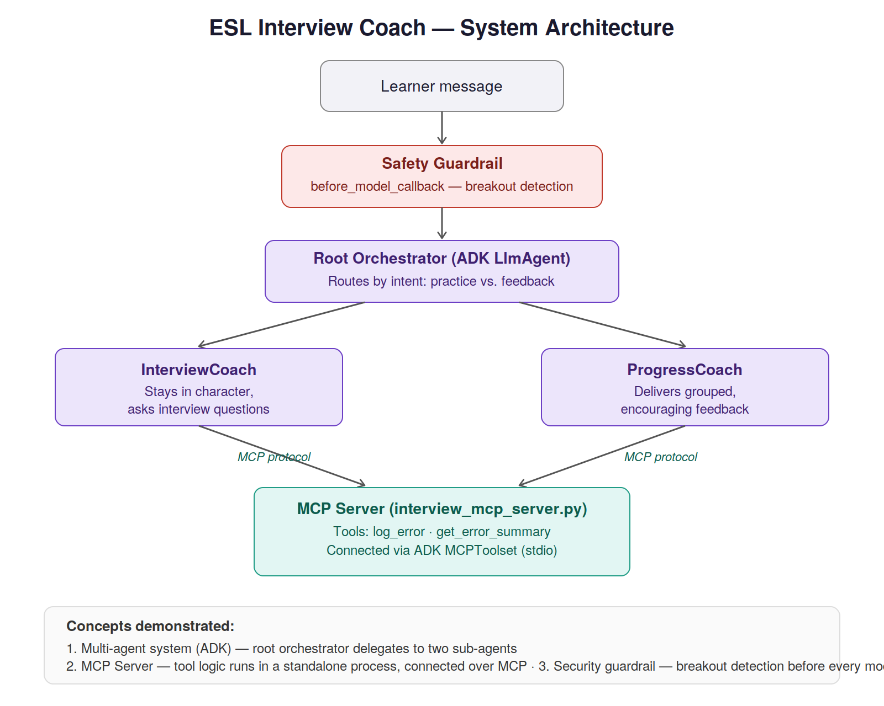
Concepts demonstrated
1. Multi-agent system (ADK): a root orchestrator delegates to two sub-agents — InterviewCoach and ProgressCoach — based on the learner's intent.
2. MCP Server: error-logging and feedback-retrieval tools run in a standalone MCP server process (interview_mcp_server.py), connected to both agents via ADK's MCPToolset over stdio.
3. Security guardrail: a before_model_callback intercepts every message before it reaches the model, detecting when a learner has stepped out of practice and breaking character honestly rather than relying on the model's judgment.

