Software Requirements Specification

for

Tiffin Service Web Application

Version 1.0 approved

Prepared by

|  |  |  |
| --- | --- | --- |
| **Zarana Solanki** | **18CP020** | **zaranasolanki41014@gmail.com** |
| **Kavya Jani** | **18CP057** | **janikavya23@gmail.com** |

Organization: Birla Vishwakarma Mahavidyalaya

Instructor: Dr. Hemant D. Vasava

Course: Software Engineering

Date: 25/01/2021

Table of Contents

Table of Contents ii

Revision History ii

1. Introduction 1

1.1 Purpose 1

1.2 Document Conventions 1

1.3 Intended Audience and Reading Suggestions 1

1.4 Product Scope 1

1.5 References 1

2. Overall Description 2

2.1 Product Perspective 2

2.2 Product Functions 3

2.3 User Classes and Characteristics 3

2.4 Operating Environment 3

2.5 Design and Implementation Constraints 3

2.6 User Documentation 4

2.7 Assumptions and Dependencies 4

3. External Interface Requirements 5

3.1 User Interfaces 5

3.2 Hardware Interfaces 5

3.3 Software Interfaces 5

3.4 Communications Interfaces 5

4. System Features 6

4.1 User Registration 6

4.2 User Login 6

4.3 Subscription……………………………………………………………………………… 6

4.4 Payment……………………………………………………………………………………7

4.5 Delivery Boy Registration and Login……………………………………………………..7

5. Other Nonfunctional Requirements 9

5.1 Performance Requirements 9

5.2 Safety Requirements 9

5.3 Security Requirements 9

5.4 Software Quality Attributes 9

5.5 Business Rules 9

6. Other Requirements 10

Appendix A: Glossary 10

Appendix B: Analysis Models 10

Appendix C: To Be Determined List 13

Revision History

|  |  |  |  |
| --- | --- | --- | --- |
| **Name** | **Date** | **Reason for Changes** | **Version** |
| Zarana Solanki | 05/03/21 | Revised System Features, Updated Description | 1.0 |
|  |  |  |  |

# Introduction

## Purpose

The purpose of this TIFFIN SERVICE WEB APPLICATION(TSWA) IS:

* To develop a Free and Open-Source Software (FOSS) Tiffin Service Web Application
* To create a website that a person can use to get food from his own home at his workplace/college/school.
* Main goal is to provide hot, hygienic and hassle-free delivery.

## Document Conventions

This document will use IEEE format. For clarity, acronyms and technical jargon, deemed uncommon by the author, will be annotated and included in the glossary. The format for headings is as followed:

Major headings are in **bold 18pt font**, and concurrent headings in **bold 14 pt font**. Sections are

in the format of x.y, where x and y are real, positive integers.

## Intended Audience and Reading Suggestions

This Software Requirements Specification document is intended for software engineers, system testers and software designers in developing, testing, and producing the TWSA and for the project. It is suggested to read the sections sequentially, and to reference the appendices as one progresses, in order to clarify jargon terms and definitions.

## Product Scope

TWSA is a website primarily designed for people wanting to eat home-made food in their workplace or schools, colleges. It is a food delivery application which will allow customers to get hygienic, home-made food. The system also allows a quick and easy-to-get subscription in just a few steps. Delivery partners then use these orders through an easy to navigate graphical interface for efficient processing.

## References

Online Food Ordering System for Restaurants <https://scholarworks.gvsu.edu/cgi/viewcontent.cgi?article=1222&context=cistechlib>

Online Food Delivery System

<https://www.slideshare.net/FatimaQayyum1/srs-software-requirement-specification-document>

SRS for Hospital Management System

# Overall Description

## Product Perspective

The Tiffin Service Web Application is a web-based system. Basically, it allows the user to get ‘home-made’ food delivered to him/her. This product uses easy and manageable interface and hence allowing both the users i.e., customer and delivery person a trouble-free experience.

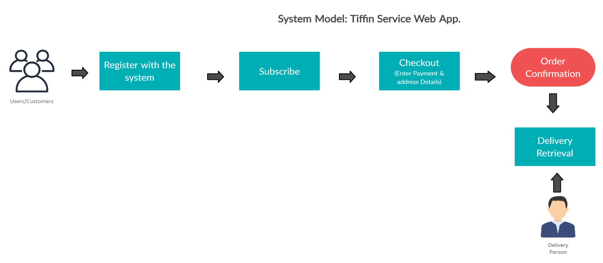

## Product Functions

This TSWA has the following functions:

* Registration process of both the customer and the delivery person shall include them to fill the common necessary details like name, address, phone number, email id, password.
* Login process for both the customer/delivery person.
* Subscription shall include the details of the customer subscription, delivery time, delivery addresses, delivery frequency.
* Each delivery guy will have a rating associated with it.
* Delivery guy will have to provide certain identification documents.
* Payment details will include information regarding the customer subscription, payment mode, payment status, transaction number, and payment date.

0 LEVEL DFD:

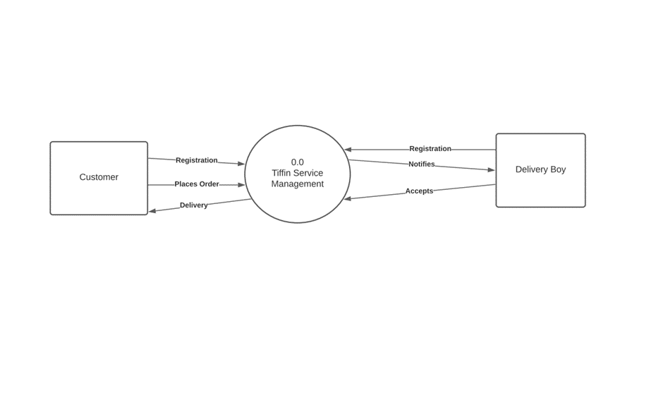

## User Classes and Characteristics

The user can be any of the following persons, associated with it are its characteristics:

Employee, Officers, Students, Teacher, Manager, Normal Person.

* Employee, Officers, Teachers, Managers: can apply for a subscription for a particular time such as a month or even a single day to get his food delivered.
* Student: can get his food delivered at his/her preferred lunch time at his/her school, college or even all kinds of tuition classes.
* Normal Person: can get food delivered on any day/any time when they want it (given that food is prepared at home).
* The most important user classes are the people who want their tiffin delivered on a ‘daily basis for a long time’ such as employees of a multinational company, teachers or professors. Whereas, students might be considered as a less important class.

## Operating Environment

TSWA runs on Windows 10, for 32-bit/x86 and 64-bit/x64 PC architectures. The software for TSWA will be written in ASP .NET CORE, using Microsoft Visual Studio 2019 for backend and HTML, CSS, BOOTSTRAP for frontend. This program will be GUI-based (like with most modern Windows Software).

The database server will utilize SQL Server Express Database integrated with Visual Studio 2019. The operating system shall be MS-Windows or Linux. Integration to the server shall be done via a HTTPS, SFTP or VPN to create, update, fetch or delete data.

## Design and Implementation Constraints

The user/customer cannot track their delivery real-time. Although, delivery status will be provided at certain time intervals to make sure the customers know the where-abouts of his food. Even if the customer wants to get the delivery service for only a day, he/she will be required to subscribe and pay for the service beforehand.

## User Documentation

The steps or “How-To-Use panel” will be provided on the website itself.

## Assumptions and Dependencies

We shall implement Google Authentication for registration process for both the customer and delivery person. We are assuming that both the users have a legitimate google account. Also, the customer is required to provide the correct address details for the delivery, correct contact number to reach him/her in case something happens such as cancellation of order or un-availability of delivery boy. At last, the delivery boy needs to provide legitimate identification proofs.

# External Interface Requirements

## User Interfaces

▪ Front-end software: HTML, CSS, Bootstrap

▪ Back-end software: Database (TBD), ASP .Net Core MVC architecture

## Hardware Interfaces

H1: Operating System: Windows 7/xp, Windows 10/ Linux

H2: Processor: Pentium 3.0 GHz or higher

H3: RAM: 1 Gb or more

H4: Hard Drive: 10 GB or more

H7: Mobile Phone which has internet

Client side:

H5: A browser that supports CGI, HTML and Bootstrap

H6: A stable internet connection

## Software Interfaces

* This website will work on browsers that support HTML, CSS and Bootstrap.
* The user will be allowed to enter his information which is necessary for the website.
* Operating system chosen is Windows for its best support and user-friendliness.
* ASP .NET Core MVC is used to develop and deploy the website.

## Communications Interfaces

Browser shall communicate with the server using simple HTTPS protocol.

# System Features

## User Registration

4.1.1 Description and Priority

In this feature, user will have to get registered themselves with the application through unique email id and password or can register through Google Account. Also, necessary details such as phone number, address and name. This feature is of high priority.

4.1.2 Stimulus/Response Sequences

User/Customer opens the application, the home page of the website appears. Then, if the user wishes to use to app, he will be redirected to a registration page where he will be needed to provide his email id and password to store into the system. After the registration process is completed, the user can further use the application and can navigate to the delivery page.

4.1.3 Functional Requirements

REQ-1: The user must have a valid email and password and/or a valid Google account.

REQ-2: The user must have a stable internet connection to go through the registration process.

REQ-3: If the user has failed to register, he will not be allowed to use the website any further.

## User Login

4.2.1 Description and Priority

In this feature, the user will have to login using the same email id and password used during the registration process or the Google account.

4.2.2 Stimulus/Response Sequences

After the login process, the user can subscribe for the delivery.

4.2.3 Functional Requirements

REQ-1: The user must have a valid email and password and/or a valid Google account.

REQ-2: The user must have a stable internet connection to go through the registration process.

REQ-3: If the user has failed to login or his/her email or password is incorrect or his Google Account details cannot be verified, he will not be allowed to use the website any further.

## Subscription

4.3.1 Description and Priority

In this feature, the user will have to subscribe to our application in order to avail the delivery services. It is a high priority feature. Anyone who wishes to get food delivery “must” subscribe with the application. If the subscription fails, the user/customer will not be able to get delivery.

4.3.2 Stimulus/Response Sequences

In order to complete the subscription feature, the user will be re-directed to a payment gateway. If the payment is successful then the service will be implemented as when the user wants. If the payment fails for some reason, the user will not be allowed to incur the service.

4.3.3 Functional Requirements

REQ-1: The user must have an account registered with the system.

REQ-2: The user must have a stable internet connection to go through the subscription process.

REQ-3: If the user has failed to pay for the service, he will not be redirected to the application page, he might have to do the subscription process all over again to be eligible to place a delivery request.

REQ-4: TBD

## Payment

4.4.1 Description and Priority

In this feature, the user will have to pay for the subscription if he/she wants to avail the delivery service. He/she can pay using Card, UPI or Net Banking.

4.4.2 Stimulus/Response Sequences

If the payment is successful, the user shall be able to go further.

4.4.3 Functional Requirements

REQ-1: The user must have paid a valid amount less than or equal to the subscription price. The money will be deposited in his “Wallet Balance” tab into his TSWA account.

REQ-2: The user must have a stable internet connection to go through the payment process.

REQ-3: If the “Wallet Balance” becomes zero/Rs. 0.00, the delivery will not be proceeded further.

REQ-4: If the Payment fails somehow, the user will not be eligible to avail the service.

## Delivery Boy Registration and Login

4.5.1 Description and Priority

In this feature, the delivery person will have to register and login using the same email id and password used during the registration process or the Google account. He will have to provide some legal identification to prove that he/she is above 18 and has a legitimate Government issued Drivers’ License. He/she can provide other proofs too but Drivers’ License is a must. He/she will have to provide address details, DOB, phone number and name. This a high priority feature.

4.5.2 Stimulus/Response Sequences

After the login process, the delivery person can choose the delivery which he/she wants to deliver. The delivery person will be able to see the details of the delivery such as Pick-up Location, Drop Location, Delivery Fare, Distance, Name and Phone Number of the Customer. If the delivery person chooses a particular delivery, the system will alert the customer that a delivery boy has been assigned and then the order status will be updated to him at regular time intervals.

4.5.3 Functional Requirement

REQ-1: The delivery person must have a valid email and password and/or a valid Google account.

REQ-2: The user must have a stable internet connection to go through the registration process.

REQ-3: If the delivery person has failed to login or his/her email or password is incorrect or his Google Account details cannot be verified, he will not be allowed to use the website any further.

REQ-4: If the delivery person’s age is below 18 and if he does not possess a valid Drivers’ License then he will not be eligible to become a delivery partner.

REQ-5: There is a “Review” or “Rating” associated with each delivery partner. If he/she has multiple negative reviews then that might be brought to his/her notice. REQ-6: TBD

# Other Nonfunctional Requirements

## Performance Requirements

The software should have high performance and low failure rates. The hardware and software

should be able to transmit/receive data from databases with high baud rates, ranging from Mbps to Gbps. Machines should have all recent Windows updates installed, and have their security not compromised by viruses. Machines must have firewalls installed and active virus scanning software in usage. Machines should solely be used for operation of the software, in order to maximize performance and security.

## Safety Requirements

User will be responsible if something happens to their computer, this software is Tested and does not contain any virus. All offline and online access will be monitored, for transparency purposes, and in order to reduce abuse and unauthorized access of the system. All the Crucial actions will require a yes/no confirmation before it will actually be

performed. all computers must be used solely for operation of the software as dedicated workstations, and must have all recent Windows updates installed, an active firewall

instance, and have solid anti-virus software, in order to protect the User’s private and confidential information.

## Security Requirements

All computers must have firewalls, have a stable Wi-Fi connection. Moreover, all computers must

have all recent Windows updates installed, and must have solid anti-virus software.

## Software Quality Attributes

The project must have an adaptable environment which should be maintainable, portable, reliable and robust.

Other details TBD.

## Business Rules

Any user who wants to use our service has to “Subscribe” to our service and pay the respective charges.

# Other Requirements

The major requirement for both the user/customer and the delivery person is the presence of “secure, stable internet connection”.

Appendix A: Glossary

TWSA: Tiffin Service Web Application

FOSS: Free and Open-Source Software

HTML: Hyper Text Markup Language

CSS: Cascading Style Sheet

GUI: Graphical User Interface

HTTP: Hyper Text Transfer Protocol

Appendix B: Analysis Models

0 Level DFD:

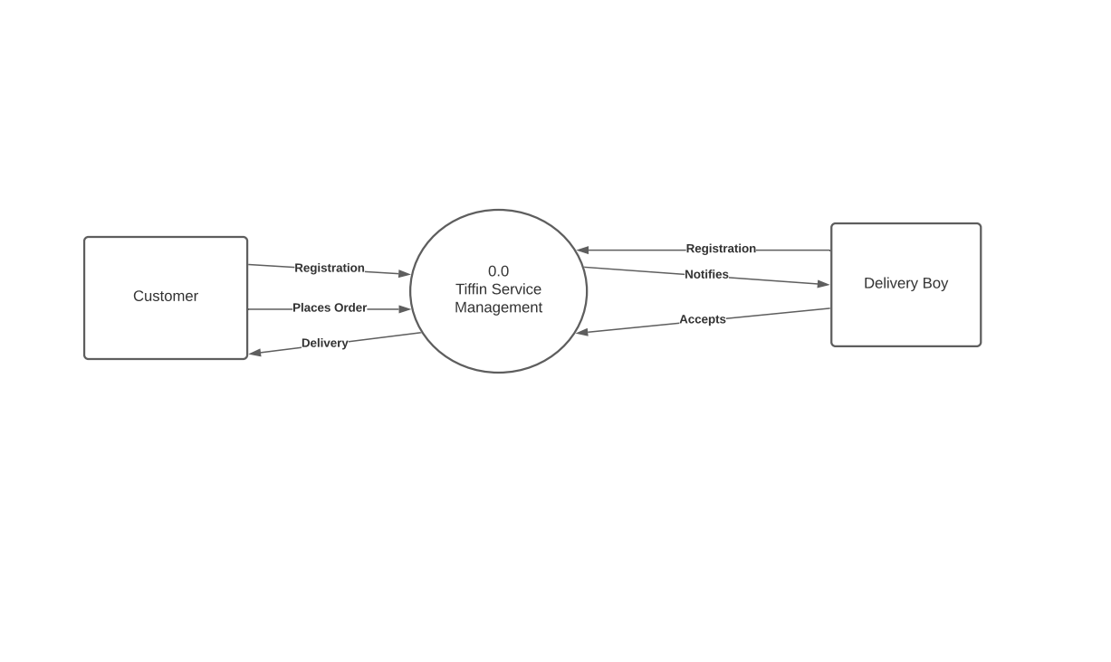

1 Level DFD:

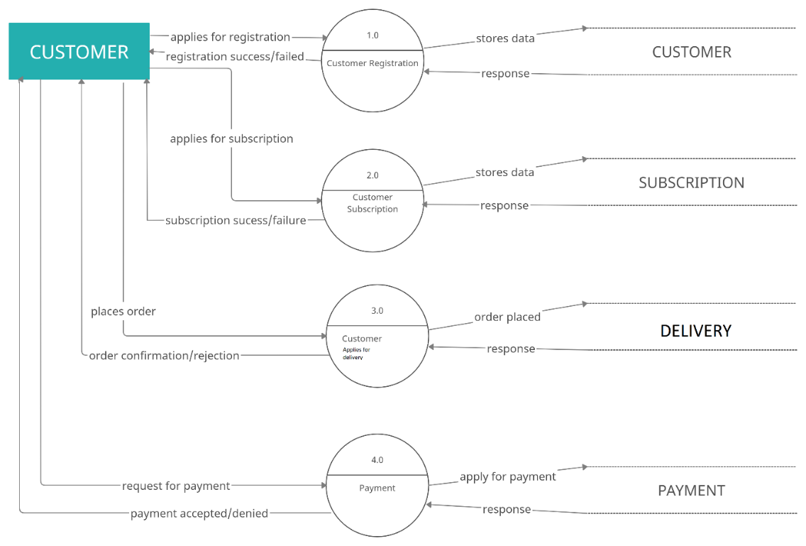

2 Level DFD:

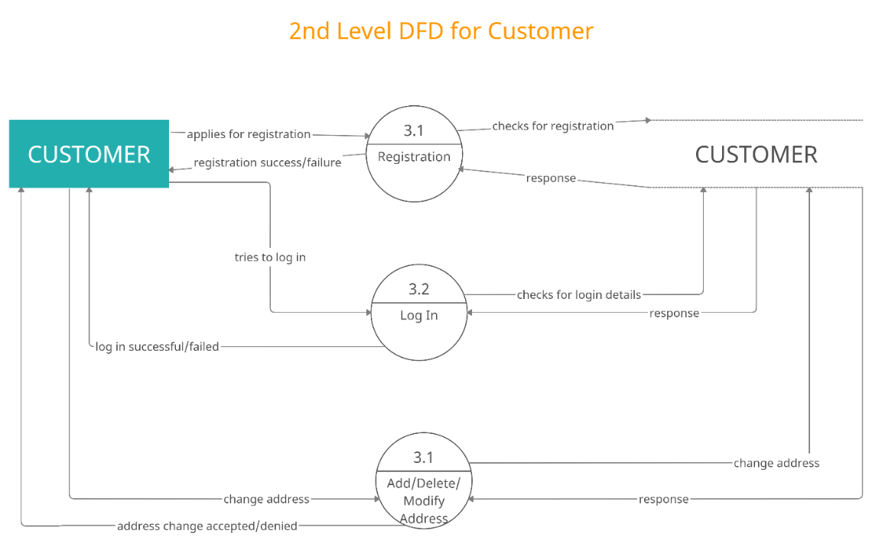

DFD for Delivery Boy:

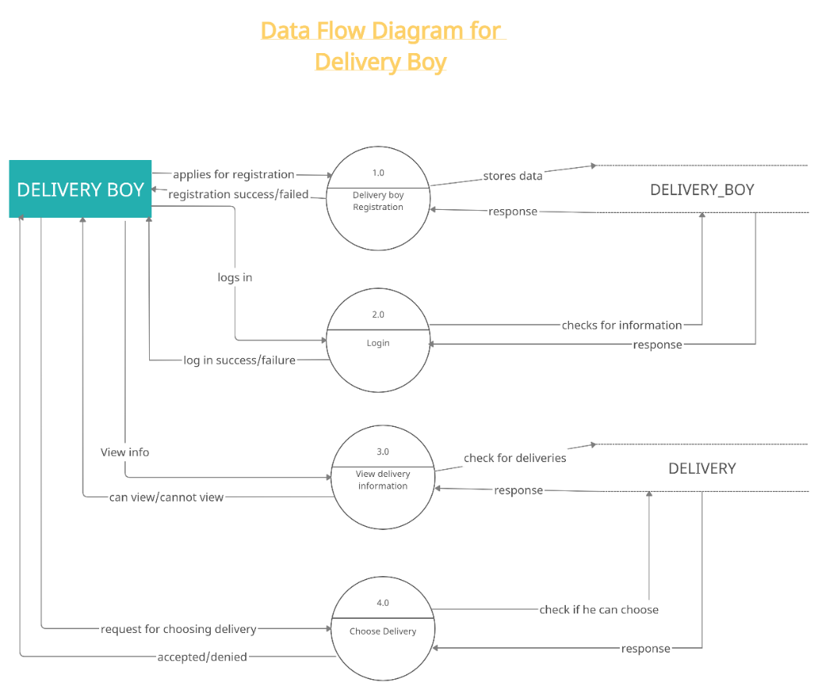

ERD:

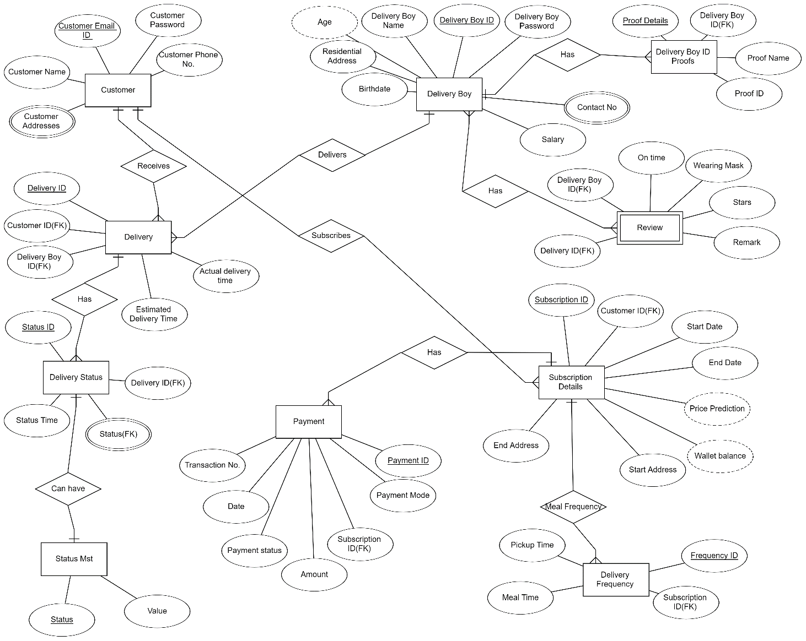

Appendix C: To Be Determined List

1. 4.3.3 Subscription-REQ-4
2. 4.5.3 Delivery boy Registration and Login REQ-6
3. 5.4 Software Quality Details