An Overview of my Student Marking Application - Isaac Adeyeye

This application connects to an access database to display various reports and grading information. It queries the database for information, depending on what option the user chooses. The reporting features develop a Word document containing that displays the chart for "Standard Deviation", "Min/Max" or "Assignment/Lab" This application also includes averages and standard deviation of grades. Start By pressing the button "Display Access Data". You can view all data by choosing any of the import functions, Import Student Grades, Import Course Enrollment or Import List of Courses. To view any specific Category, click on it and choose a file, this will add the data to the excel file. To represent data on the chart, choose "Standard Deviation", "Min/Max" or "Assignment/Lab" To create a word document containing the data press "Generate Report". A new word document will be created and saved.

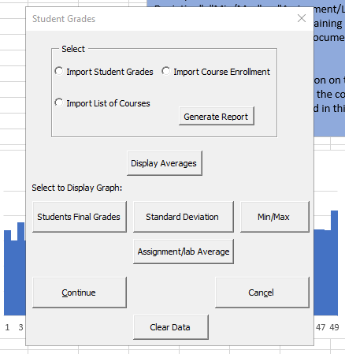My application also allows user to select a course from the course when the "Display Student Enrollment" button on the "student" sheet is clicked it display the details of the students enrolled in this course (first name, last name, student ID) in the worksheet. My application reads information from “registrar.mdb.” database. Open the database to view the field names of the different tables.

I chose this application because it relates to a potential future career path for me and has a lot of moving components that allow me to show off my VBA skills. Being a computer science student, there is a good chance that I will be engaged in the creation of complex Microsoft Office features and VBA in the near future, and this provided me with plenty of opportunities to practise and use my newly gained knowledge. It also allowed me to keep improving my effective and efficient coding skills, helping me to learn more on creating macros to automate repetitive word and data-processing functions, and generate custom forms, graphs, and reports.