TundraXR Button & Brain API Manual
Oct 17, 2026 · @Lulu

1. Overview
The headset app talks to the Tundra brain on the laptop over HTTP (default http://localhost:8787). Every request goes through LocalBrain.kt; only the voice fallback in VoiceInput.kt calls the brain on its own.
- Connection: over USB, the brain runs adb reverse tcp:8787 tcp:8787 every 4 seconds, so localhost on the headset is the laptop. Over Wi‑Fi, build with ./gradlew installDebug -Ptundra.serverUrl=http://<laptop IP>:8787.
- Identity: every headset request sends user-agent: TundraXR/1.0. The brain records headsetSeenAt, and the dashboard shows “headset connected”.
- Offline fallback: if the device list or a question fails, the app uses the built-in DemoBrain sample data. A failed upload is marked “Not sent · laptop offline” and is not retried.
- Layers: button (ui/**) → Actions (MainActivity.kt) → SessionViewModel → TundraBrain interface (LocalBrain / DemoBrain) → HTTP → brain (server/src/server.ts).
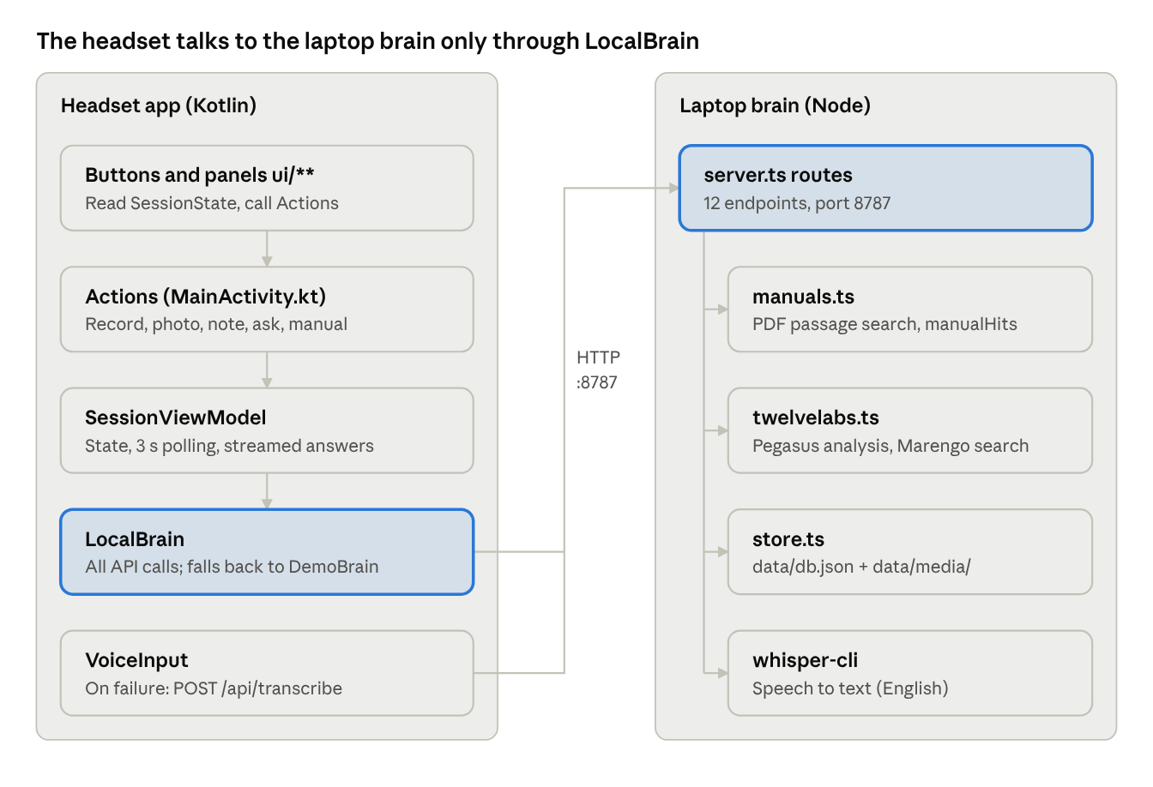
Architecture · 5 headset layers, 5 brain modules
Buttons never call the network directly: requests pass down to LocalBrain, then over HTTP to server.ts. The dashboard in the laptop browser talks to the same server.ts.

Timeouts
Request | Connect | Read
GET requests (device list, status polling) | 3 s | 5 s
POST /api/captures (media upload) | 3 s | 120 s
POST /api/ask | 3 s | 30 s
POST /api/transcribe | 3 s | 60 s

2. Button → API map
Only six kinds of action touch the network: recording, photos, voice notes, questions (typed, spoken or suggested), opening the manual, and loading at startup. All other buttons change local UI state only.

2.1 Buttons that call the brain
Button (where) | Action → ViewModel | API called | Input sent | Output received | What the UI does
Record / Stop (control bar) | record → onRecordingStarted(); again → onRecordingStopped(file) | After stop: POST /api/captures | MP4 file (FHD, with audio) + meta kind:"video", durationSec | New Capture (id, tl) | Adds a video to the timeline: Sending → Analyzing → Analyzed
Take photo camera icon (control bar) | photo → onShutter() + onPhotoTaken(file) | POST /api/captures | JPEG file + meta kind:"photo" | New Capture | Flash effect; adds a photo to the timeline
Voice note mic (control bar) | note → voice.toggle(Note) → onFinalTranscript() | If recognition fails: POST /api/transcribe; then POST /api/captures | Transcribe: WAV; upload: empty body + meta kind:"note", text | {text}; then new Capture | Shows live transcript; adds a note when done
Send ↑ (Ask input, or keyboard Enter) | send → ask(askDraft) | POST /api/ask | {sessionId, question, device} | {answer, manualHits, moments} | Answer streams in word by word with source chips; opens the manual at a cited page
Suggested question chips (Ask panel, per device) | ask(text) | POST /api/ask | Same; question = chip text | Same | Same
Ask by voice mic (next to Ask input) | askVoice → voice.toggle(Ask) → ask(text) | POST /api/transcribe if needed; then POST /api/ask | WAV; then same as above | {text}; then same | Input shows “Listening…” and live text
Manual source chip (under an answer, e.g. “p.142 · Alarms”) | openSource(source) → openManual(target) | If not yet downloaded: GET /manuals/{id}.pdf | — | PDF file (cached after first download) | Manual scrolls to the page and highlights the box area
Manual book icon (control bar) | toggleManual | On first show: GET /manuals/{id}.pdf | — | PDF file | Shows/hides the manual panel
Device name chip (top of Capture panel) | selectDevice(device) | No new request (uses cached device list); the manual panel downloads the new PDF | — | — | Switches device, clears chat, swaps manual and suggestions

2.2 Buttons that only change local state
Button | Action | Effect
Ask Tundra ✦ (control bar) | toggleAsk | Shows/hides the Ask panel; in narrow windows switches to the Ask page
Close ✕ (Ask / manual panel) | toggleAsk / toggleManual | Closes the panel
Zoom in / Zoom out / double tap (manual panel) | Panel-internal state | Zooms the PDF, no network
Typing in the input | draft(text) | Updates askDraft
Switch to Home Space / Full Space | XR session.scene | Changes space mode, no network

2.3 Automatic requests (no button)
When | API | Purpose
App start | GET /api/devices | Loads devices and manuals; after 1.2 s the first device becomes the “identified” device
Every 3 s | GET /api/captures?sessionId=… | Heartbeat (is the laptop online) + refreshes each capture's analysis status

3. Brain API reference
The brain has 12 endpoints: the headset uses 6, the laptop dashboard uses the other 6. JSON responses carry access-control-allow-origin: *. Errors always return { "error": "…" } with status 400, 404, 500 or 501.

3.1 GET /api/devices — device and manual catalog
Input: none.
Output: an array, one entry per device, read from server/manuals/catalog.json. Devices whose PDF is missing are left out.
[{
"id": "pb980", "name": "Puritan Bennett 980", "manufacturer": "Medtronic",
"category": "Ventilator", "assetTag": "ICU-VNT-0412", "serial": "35B1800412",
"location": "ICU 3 · Bed 7", "lastPm": "14 Jul 2026", "openWorkOrders": 1,
"manual": { "id": "pb980-om", "title": "PB980 Operator's Manual", "docNumber": "PT00169219",
"kind": "Operator's manual", "file": "pb980-operators-manual.pdf",
"pages": 412, "url": "/manuals/pb980-om.pdf" }
}]
Field | Meaning
id | The device's unique id in the brain; /api/ask uses it to find the manual
assetTag / serial / location | Hospital asset tag, serial number, location (demo values for now; will come from the CMMS)
lastPm / openWorkOrders | Date of the last preventive maintenance, number of open work orders
manual.docNumber | OEM document number; shown in the app as the manual revision
manual.pages | Total PDF pages
manual.url | PDF path; the app prepends baseUrl

3.2 GET /manuals/{manualId}.pdf — manual file
Input: the manual id in the path; a Range header is supported. Output: an application/pdf file. The app downloads it once, caches it, and renders it with PdfRenderer.

3.3 POST /api/captures — upload one capture
Input: metadata travels in a header, and the body is the raw media bytes (empty for a voice note). Large videos stream straight up with no multipart encoding.
Header | Value
content-type | image/jpeg (photo) or video/mp4 (video); omitted for notes
x-tundra-meta | URI-encoded JSON, below
{
"sessionId": "s_1760700000000",
"kind": "photo",
"at": "02:14",
"durationSec": 0,
"text": "voice notes only: the transcript",
"device": { "id": "pb980", "name": "…", "manufacturer": "…", "category": "…",
"assetTag": "…", "serial": "…", "location": "…" }
}
Meta field | Meaning
sessionId | Session id created at app start (s_ + epoch ms); groups captures from one job
kind | photo / video / note
at | Time since the session started, mm:ss
durationSec | Video length in seconds; 0 for other kinds
text | Voice-note transcript
device | The current device's identity, stored as sent
Output: 201 with the full Capture record. The app reads only id, tl and analysis.findings.
{
"id": "a1b2c3d4", "sessionId": "…", "kind": "video", "at": "02:14",
"createdAt": "2026-10-17T09:30:00.000Z", "device": { "…": "…" },
"file": "a1b2c3d4.mp4", "mime": "video/mp4", "bytes": 18300000, "durationSec": 12,
"tl": { "upload": "pending", "analysis": "pending", "index": "pending" },
"qa": []
}
Capture field | Meaning
id | 8-character id from the brain; the app stores it as remoteId and matches on it when polling
file / mime / bytes | File name in server/data/media/, type, size
tl.upload | Progress of the video upload to TwelveLabs
tl.analysis | Progress of AI analysis (photos and videos)
tl.index | Progress of video indexing (for later search)
tl.error | Failure reason, up to 400 characters
analysis | The structured maintenance record once analysis finishes; see section 5
qa | Questions asked about this video on the dashboard
Each tl step is one of: pending (queued), running, done, failed, skipped (not done: no TwelveLabs key, or a capture with no media such as a note).

3.4 GET /api/captures?sessionId=… — status polling
Input: query parameter sessionId (omit it to get everything). Output: that session's Captures, same shape as 3.3. The app calls it every 3 s: success means the laptop is online, and each capture's status is updated by id (mapping in section 4).

3.5 POST /api/ask — ask a question
Input:
{ "sessionId": "s_1760700000000", "question": "How do I run SST?",
"device": { "id": "pb980", "…": "…" } }
Output:
{
"answer": "PB980 Operator's Manual, p. 142 · Short Self Test:\n“…”\n\nAlso see p. 143, p. 150.",
"manualHits": [
{ "manualId": "pb980-om", "title": "PB980 Operator's Manual", "page": 142,
"section": "Short Self Test", "text": "…", "box": [0.08, 0.31, 0.92, 0.47] }
],
"moments": [ { "captureId": "a1b2c3d4", "start": 12.5, "end": 18.0, "rank": 1, "thumbnailUrl": "…" } ]
}
Field | Meaning
answer | The answer shown to the engineer: a quote of the best-matching manual passage (about 360 characters max), then other matching pages
manualHits[].page | Page number in the PDF, starting at 1
manualHits[].section | Heading of the section the passage sits in
manualHits[].text | Excerpt of the passage
manualHits[].box | Where the passage sits on the page, [left, top, right, bottom] as 0–1 page fractions from the top-left; the app draws the highlight from it
moments[] | Clips from videos of the same device that match the question; start/end in seconds, viewed on the laptop dashboard
The app turns each manualHit into a tappable “p.142 · Short Self Test” chip and each moment into a “00:12–00:18 · on laptop” chip. The question and answer are also stored in the session as a kind:"question" Capture.

3.6 POST /api/transcribe — speech to text
Input: a 16 kHz, mono, 16-bit WAV body with content-type: audio/wav. The headset records up to 20 s and stops after 1.6 s of silence. Output: { "text": "recognized words" }. Returns 501 when no whisper model is installed.

3.7 Dashboard-only endpoints
Method and path | Input | Output
GET / | — | The dashboard page
GET /api/state | — | { twelveLabs, indexId, headsetSeenAt, addresses, captures[] }: whether TwelveLabs is on, index id, last headset request time, laptop IPs, all captures
GET /api/events | — | SSE stream: status (every 5 s) and capture (whenever a capture is added or changes; the whole Capture)
GET /media/{file} | Range supported | Photo or video file
POST /api/search | { query } | { moments[], photos[] }, each with match (does it really match) and description (one sentence); 400 without a key
POST /api/captures/{id}/ask | { question } | The updated Capture, with the new Q&A appended to qa

4. Status and error handling
Each capture on the headset shows one of five states, set by the brain's tl.analysis (LocalBrain.toStatus()).
Brain returns | Headset SyncState | Small text on the timeline
Request still in flight | Sending | —
tl.analysis = skipped | InBrain (stored, no further changes) | —
tl.analysis = pending / running | Analyzing | “Uploading” while tl.upload = running
tl.analysis = done | Analyzed | “N findings” (count of analysis.findings) or “No findings”
tl.analysis = failed | Failed | “Analysis failed”
Upload request itself failed | Failed | “Not sent · laptop offline”

Online status
- brainOnline = null: no poll has run yet since start.
- brainOnline = true: the last GET /api/captures succeeded.
- brainOnline = false: a poll failed, or an upload failed.

What the app does when a request fails
Failed request | App behavior
GET /api/devices | Uses DemoBrain's sample device (Evita V500) and built-in manual pages
POST /api/captures | Marks that capture Failed; no automatic retry
POST /api/ask | Uses DemoBrain's scripted answer
POST /api/transcribe | Shows a voice error for 4 s; no note or question is created
GET /manuals/{id}.pdf | Manual panel stays on “Opening manual…”
After the system speech recognizer fails hard once, all voice input for the rest of that run goes straight to /api/transcribe.

5. Inside the brain
The brain saves each capture and replies at once; AI processing runs in the background. Results are written back to the same Capture, which the headset sees by polling and the dashboard sees over SSE. Without TWELVELABS_API_KEY it stores but does not analyze; add the key and restart, and earlier photos and videos are analyzed automatically.

5.1 Storage
- Records: server/data/db.json (writes batched, at most one per 200 ms).
- Media: server/data/media/{id}.jpg|mp4.
- Manual index: server/data/manual-index/, rebuilt when a PDF changes.

5.2 Video pipeline (TwelveLabs)
- Upload: assets.create sends the MP4 to TwelveLabs and waits until ready (tl.upload).
- Analyze: the Pegasus 1.6 model writes a maintenance record in a fixed JSON schema (tl.analysis).
- Index: the video joins the tundra-clinical-engineering index (Marengo 3.0, visual + audio), so later questions and searches can find clips in it (tl.index, waits up to 15 min).
Photos get step 2 only (no upload, no index). Voice notes get no AI processing, but they are sent to the analysis model as context for the same session.

5.3 Fields in analysis
Field | Video | Photo | Meaning
summary | yes | yes | 2–3 sentence summary (1 sentence for photos)
findings[] | yes | yes | Each finding: title, severity (info / minor / major / critical), detail; videos also have start_time/end_time in seconds. The headset shows only the count
safety_concerns[] | yes | yes | Issues affecting patient or staff safety
work_type | yes | — | Preventive maintenance, corrective repair, inspection, calibration, incoming inspection, troubleshooting, other
device_identification | yes | — | Model, serial, asset tag and calibration stickers visible in the footage
steps_performed[] | yes | — | What the technician did, with start times
parts_and_consumables[] / tools_and_test_equipment[] | yes | — | Parts, consumables, tools and test equipment seen or named
recommended_follow_up[] | yes | — | Suggested next actions
device_status_after | yes | — | in_service / out_of_service / needs_follow_up / unknown
documentation_gaps[] | yes | — | Records an auditor would expect that the footage does not show (e.g. no electrical safety test result)
visible_labels[] | — | yes | kind and text of every readable label in the photo
tags[] | — | yes | 3–6 search keywords

5.4 Manual search (answers /api/ask)
pdfjs-dist splits each PDF into passages with page, section and position box. A question takes the 3 best-scoring passages from the current device's manual. With TwelveLabs on, it also searches 6 video clips and keeps the top 3 from the same device. Today the answer is a quote from the manual, not text generated by a language model.

5.5 Speech to text
Runs the local whisper-cli with model server/models/ggml-base.en.bin, English only. At startup it transcribes 1 s of silence to warm up, so the first question doesn't wait about 15 s.

