PRACTICAL EXAM - SWD392 -SPR26
Date time:
Exam Code:

Question 1: Class Diagram (3.0 points)
- Your Class Diagram:
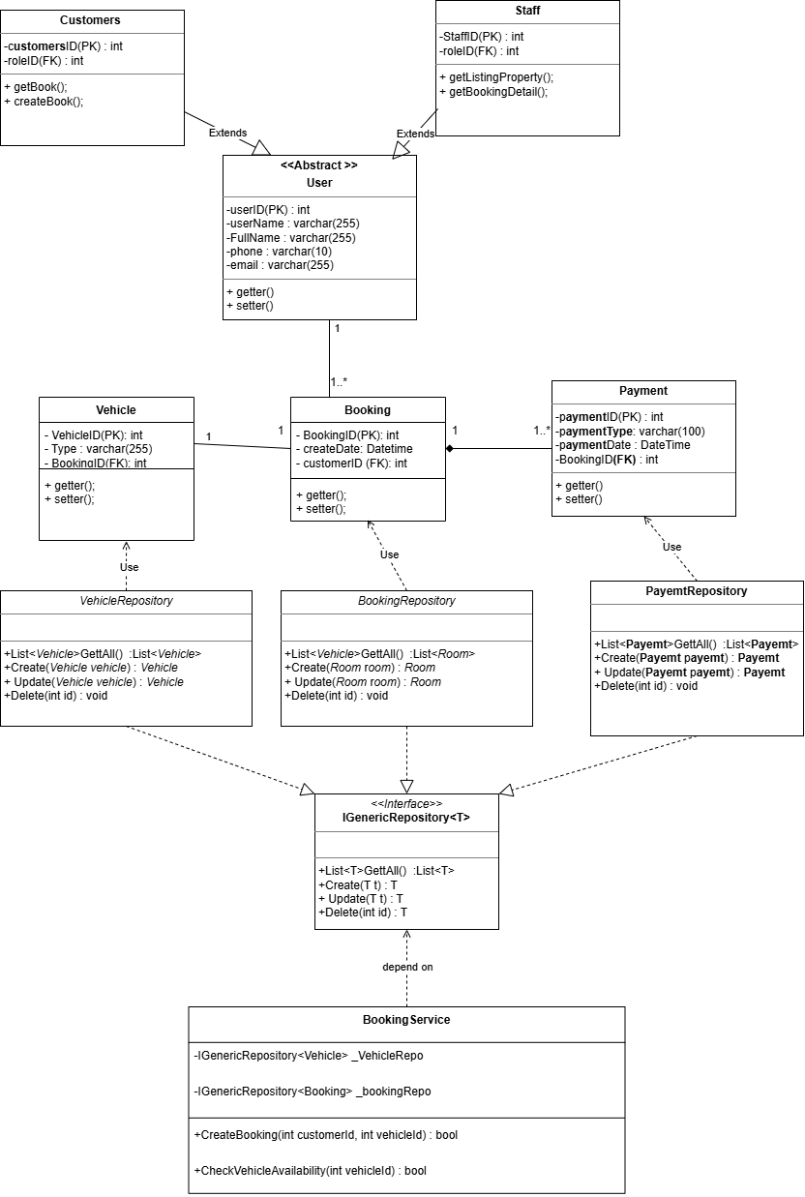

Brief Explanation: This class diagram models the structure of the system by showing the main classes, their attributes, methods, and relationships. The central class is Booking, which is responsible for BookingRepository. Vehicle class is used to save information and status of vehicle, Payment class is used to save information of payment and status to show for staff. These classes interact with each other through associations/dependencies to support and make clearly the business process. The relationship between Booking class and Payment is composition, which means customer need to payment fee before booking vehicle. The relationship between Booking class and Vehicle class is association, which mean one booking have exactly one vehicle. The relationship between IGenericRepository and repositories is inheritance, which means all repositories implement from IgenericRepository. The relationship between IGenericRepository and BookingService. Overall, this diagram helps describe the static structure of the system and shows how responsibilities are distributed among classes.

Question 2: Sequence diagram (4.0 points)
- Your Diagram (Sequence Diagram):
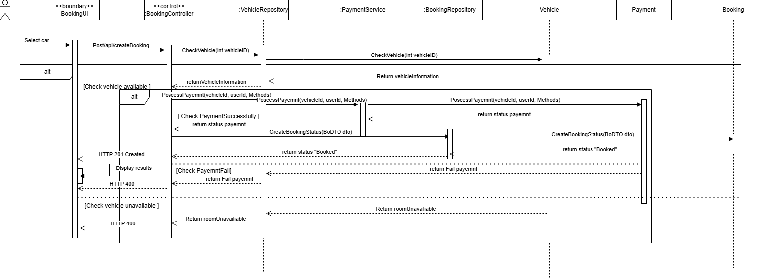

- Brief Explanation:
This class diagram models the structure of the system. The process begin when the customer select a vehicle want to booking in BookingUI. BookingUI send request to BookingController and after that BookingController send method checkVehicle with parameter vehicleID to checks availability of the vehicle for VehicleRepository class and VehicleRepository class send to Vehicle entity and Vehicle entity will return vehicle information. If vehicle is available a booking is created and the customer proceeds to payment.

Question 3: Activity Diagram/ State-chart diagram(3.0 points)
- Your Diagram (Statechart Diagram):
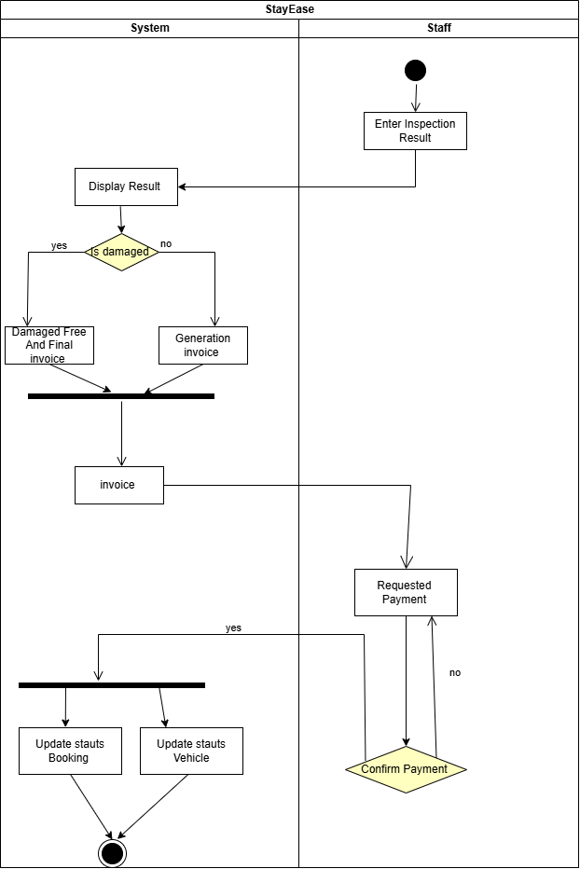

- Brief Explanation: The actitvity diagram to show workflow when a customer return a rented cả. After the car is returned, a staff member inspects its condition and report to the system, if the car is dameged the customer need to pay to damaged fee and invoice, Unless will go generation invoice.If invoice, staff send requested payment to system, cofirm payment is no it return to request payment again and confirm yes the system will update status of booking and status of vehicle and end.

END OF SUBMISSION

