Architetture dei Sistemi di Elaborazione  O2GOLOV | Delivery date:  16th November 2023
Laboratory  4 | Expected delivery of lab_4.zip must include:  - each configuration of the custom architecture (riscv_o3_custom.py) that you modify.  - This document with all the field compiled and in PDF form.

Introduction and Background

Simulating an Out-of-Order (OoO) CPU (O3CPU)
Dispatch/Issue
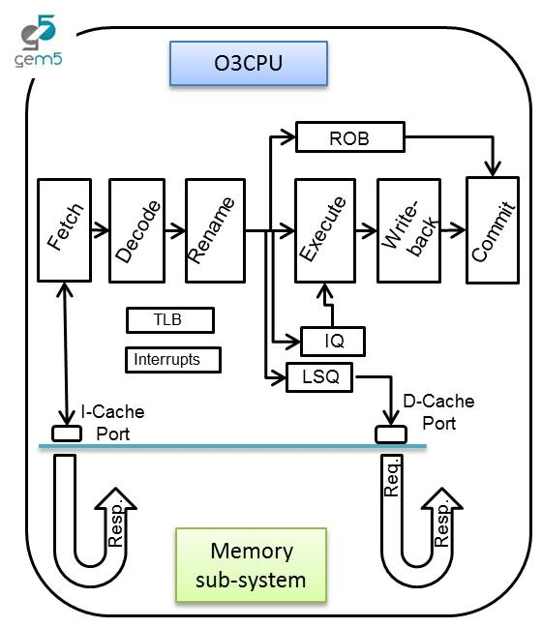

In this laboratory, you will be able to configure an OoO CPU by using a script called riscv_o3_custom.py. In a few words, the script configures an Out-of-Order (O3) processor based on the DerivO3CPU, a superscalar processor with a reduced number of features.

Pipeline

The processor pipeline stages can be summarized as:

- Fetch stage: instructions are fetched from the instruction cache. The fetchWidth parameter sets the number of fetched instructions. This stage does branch prediction and branch target prediction.
- Decode stage: This stage decodes instructions and handles the execution of unconditional branches. The decodeWidth parameter sets the maximum number of instructions processed per clock cycle.
- Rename stage: As suggested by the name, registers are renamed, and the instruction is pushed to the IEW (Issue/Execute/Write Back) stage. It checks that the Instruction Queue (IQ)/Load and Store Queue (LSQ) can hold the new instruction. The maximum number of instructions processed per clock cycle is set by the renameWidth parameter.

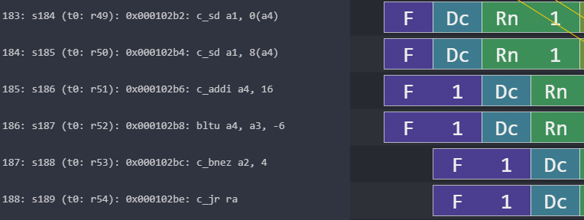
renameWidth=2
fetchWidth=4
Stalls: the pipeline can’t move on
decodeWidth=2
Figure 1: Understanding configurable OoO CPU parameters.

- Dispatch stage: instructions whose renamed operands are available are dispatched to functional units (FU). For loads and stores, they are dispatched to the Load/Store Queue (LSQ). The maximum number of instructions processed per clock cycle is set by the dispatchWidth parameter.
- Issue stage: The simulated processor has a single instruction queue from which all instructions are issued. Ordinarily, instructions are taken in-order from this queue. An instruction is issued if it does not have any dependency.
- Execute stage: the functional unit (FU) processes their instruction. Each functional unit can be configured with a different latency. Conditional branch mispredictions are identified here. The maximum number of instructions processed per clock cycle depends on the different functional units configured and their latencies.
- Writeback stage: it sends the result of the instruction to the reorder buffer (ROB). The maximum number of instructions processed per clock cycle is set by the wbWidth parameter.
- Commit stage: it processes the reorder buffer, freeing up reorder buffer entries. The maximum number of instructions processed per clock cycle is set by the commitWidth parameter. Commit is done in order.

In the event of a branch misprediction, trap, or other speculative execution event, "squashing" can occur at all stages of this pipeline. When a pending instruction is squashed, it is removed from the instruction queues, reorder buffers, requests to the instruction cache, etc.

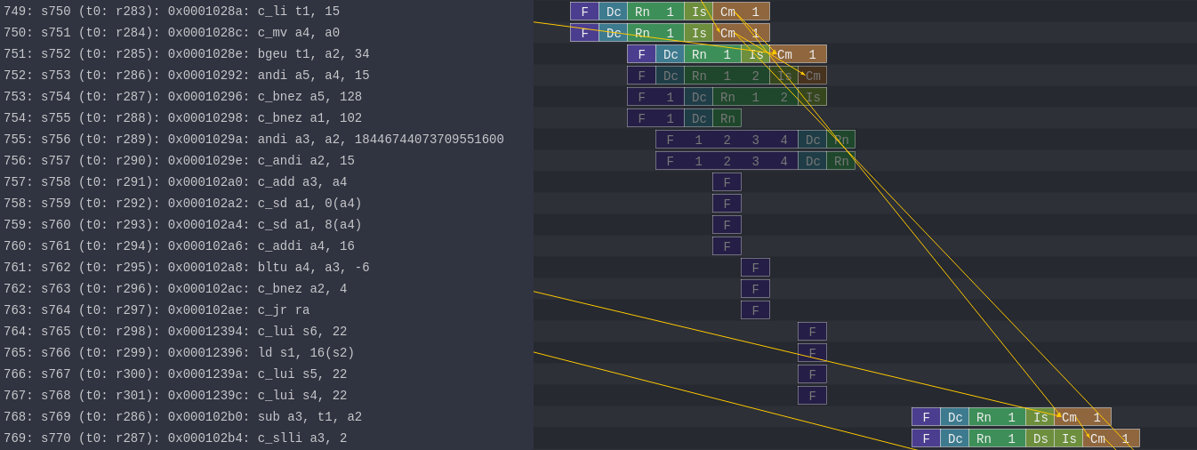
Flushed Instructions
Mispredicted branch
Figure 2: Example of a branch misprediction (transparent rows)

Pipeline Resources
Additionally, it has the following structures:
- Branch predictor (BP)
  - Allows for selection between several branch predictors, including a local predictor, a global predictor, and a tournament predictor. Also has a branch target buffer (BTB) and a return address stack (RAS).
- Reorder buffer (ROB)
  - Holds instructions that have reached the back end. Handles squashing instructions and keep instructions in program order.
- Instruction queue (IQ)
  - Handles dependencies between instructions and scheduling ready instructions. Uses the memory dependence predictor to tell when memory operations are ready.
- Load-store queue (LSQ)
  - Holds loads and stores that have reached the back end. It hooks up to the d-cache and initiates accesses to the memory system once memory operations have been issued and executed. Also handles forwarding from stores to loads, replaying memory operations if the memory system is blocked, and detecting memory ordering violations.
- Functional units (FU)
  - Provides timing for instruction execution. Used to determine the latency of an instruction executing, as well as what instructions can issue each cycle.
  - Floating point units, floating point registers, and respective instructions are supported.
Figure 3: Pipeline example of FP instructions and FP registers

Laboratory: hands-on

All the needed resources are at a GitHub repository:
https://github.com/cad-polito-it/ase_riscv_gem5_sim

To create your simulation environment:
For HTTPS clone:

~/my_gem5Dir$ git clone https://github.com/cad-polito-it/ase_riscv_gem5_sim.git

For SSH:

~/my_gem5Dir$ git clone git@github.com:cad-polito-it/ase_riscv_gem5_sim.git

The environment is configured to be executed on the LABINF MACHINES.

Follow the HOWTO instructions available on the GitHub Repository for simulating a program.

Exercise 1:

Simulate the benchmark my_c_benchmark (main.c) by using the gem5 simulator to obtain the trace.out file. Then, you can visualize the pipeline (i.e., load the trace.out file on Konata).

Based on the CPU architecture described in riscv_o3_custom.py , visualize the Konata’s pipeline to find out the conditions:
- Out-of-order execution (issue), in-order commit (commit)
- Two commits in the same clock cycle
- Flush of the pipeline.

For every condition, fill the following tables.

Condition | Out-of-order execution, in-order commit
Screenshot from Konata | 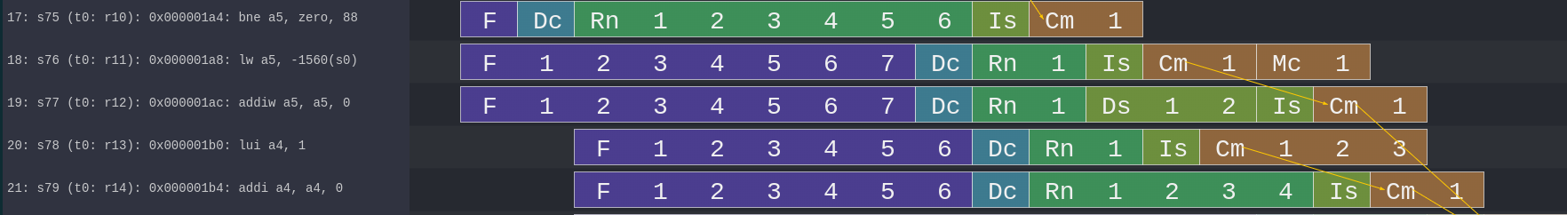
Explain the reason behind the condition | L’esecuzione OoO avviene nella linea 19 durante l’esecuzione dell’istruzione addiw, tale operazione richiede il valore dell’operazione precedente e quindi stalla, a differenza dell’istruzione succesiva la quale ne è indipendente e può procedere con la fase exe.
Briefly explain the advantages of the OoO execution in a CPU | I vantaggi di eseguire “out of order operations” riguardano prevalentemente la riduzione complessiva di cicli di clock per singola istruzione, tale fenomeno permette l’esecuzione di operazioni indipendenti in parallelo riducendo drasticamente I clock cycle causati da hazard strutturali che si possano verificare in una situazione in cui ogni istruzione deve aspettare che le altre finiscano prima di procedere all’accesso alla memoria.
Condition | Two or more commits in the same clock cycle
Screenshot from Konata | 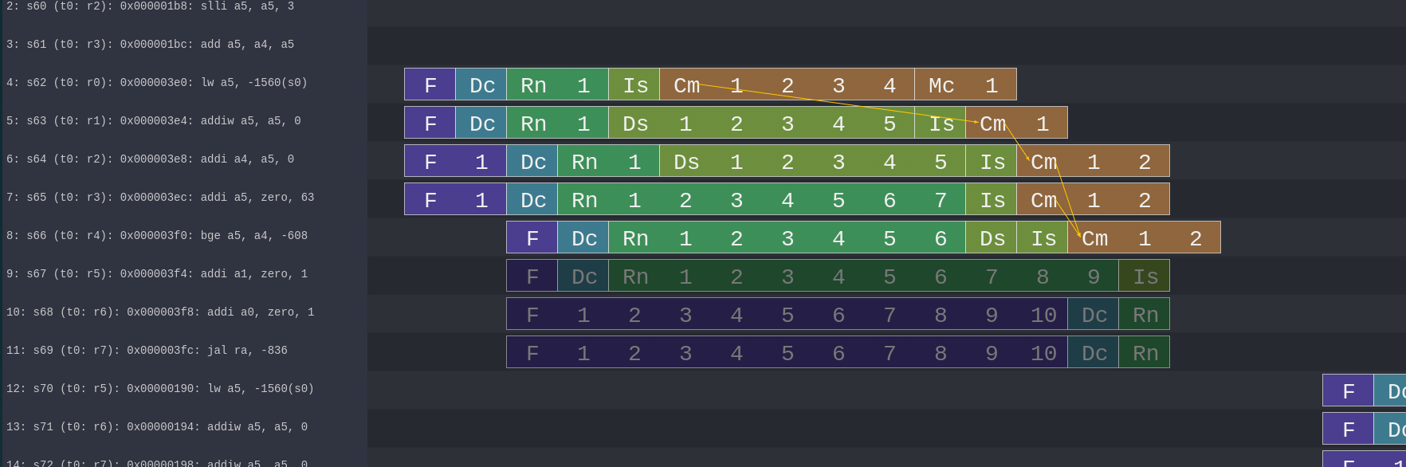
Explain the reason behind the condition | Le due operazioni addi finiscono nella stesso stesso ciclo la loro fase exe e quindi essendo l’unità di commit con width maggiore di uno, può eseguire il push finale dei registri nello stesso colpo di clock
Briefly explain the Commit functioning | A differenza della situazione mostrata in figura la fase di commit è molto utile per riordinare le operazioni fuori ordine, difatti l’esempio mostrato effettua due commit nello stesso ciclo di clock rendendo la seconda operazione “a costo zero”, ma la vera efficacia dell’unità risiede nella sua abilità di ridurre I vari data hazard tra i quali, la più importante a mio parere la WaW, infatti se due istruzioni dovessero scrivere sulla stessa locazione di memoria ma dovessero allo stesso tempo essere eseguite con tempistiche diverse, si rischiederebbe una situazione in cui la seconda istruzione dalla quale si dovrebbe leggere il valore finale possa essere sovrascritta dalla prima con maggiore priorità di scrittura iniziale se il flow non venisse controllato e l’operazione stallata.
Condition | Flush of the pipeline
Screenshot from Konata | 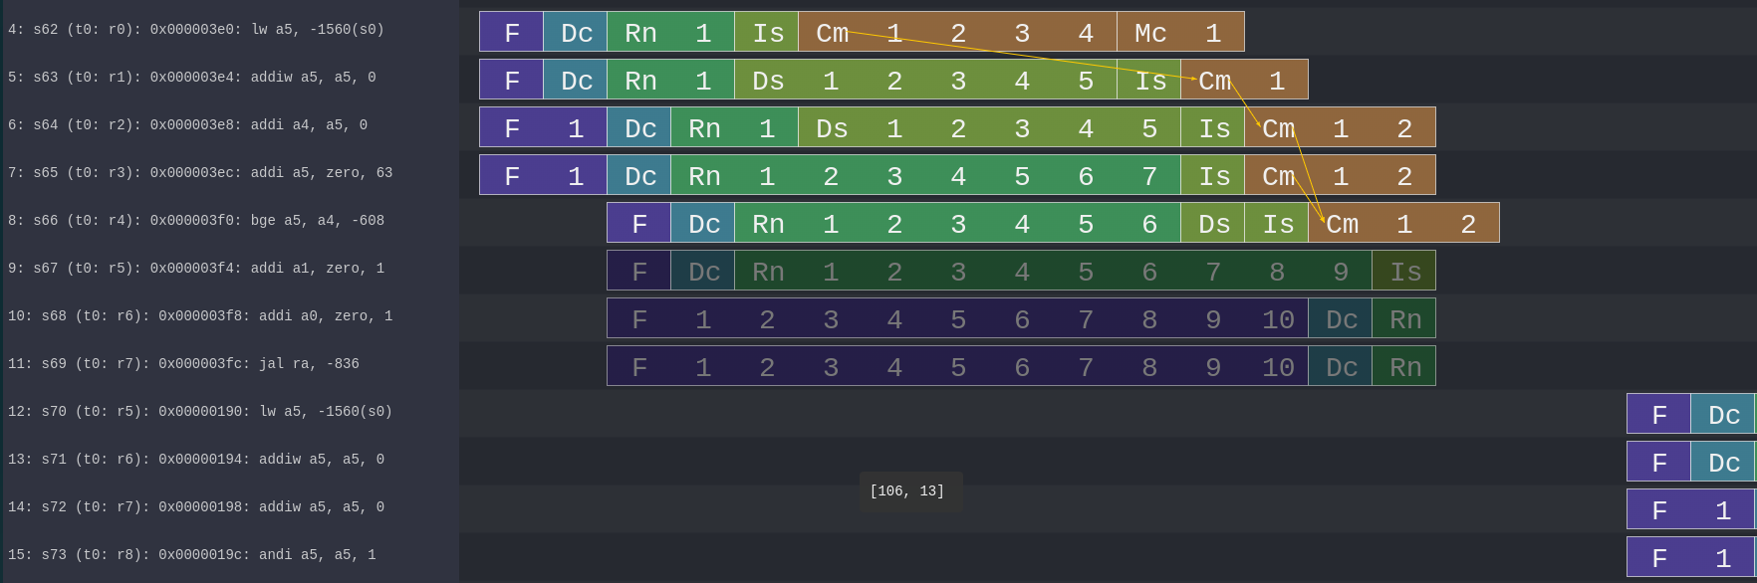
Explain the reason behind the condition | L’istruzione bge effettua un jump if(a5>=a4), i loro valori sono:  - a4 : 0  - a5 : 63  Il branch viene preso e la pipeline delle istruzioni viene flushata

Exercise 2:

Given your benchmark (main.c in my_c_benchmark), optimize the CPU architecture (i.e., modify the riscv_o3_custom.py file) and write down the improvements in terms of CPI and speedup.

- To optimize the CPU architecture, open the configuration file of the CPU (i.e., the riscv_o3_custom.py), and tune specific hardware-related parameters.

You have to change specific values in one or more stages of the pipeline:

  - # - FETCH STAGE
    - Tune parameters such as the fetchWidht, fetchBuffersize and so on, and see the effects on your system.
  - # - DECODE STAGE
  - # - RENAME STAGE
    - Try changing some values, but don’t touch the “Phys” ones.
  - # - DISPATCH/ISSUE STAGE
  - # - EXECUTE STAGE
    - Here you can optimize the Functional units of your CPU like the INT ALU, the FP ALU, the FP Multiplier/Divider and so on.
    - Tune the number of units (count) that you have in the system, as well as their latency (opLat) to see how this affects the execution of your program.

  - You can create a different branch predictor. They are defined in create_predictor.py)

  - You can also try to change the parameters of the L1 Cache. Look for the “class L1Cache” in the riscv_o3_custom.py file. The L1 cache, also referred to as the primary cache, is the smallest and fastest level of memory. It is located directly on the processor, and it is used to store frequently accessed data by the CPU. In this way, the CPU saves time with respect to the normal access to the main memory.
HINT: To implement the best hardware optimization, and understand how to change the parameters, the best option consists in analysing the stats.txt file (in ase_riscv_gem5_sim/results/my_c_benchmark).
Find information regarding the workload profiling. In other words, look for lines such as “system.cpu.commitStats0.committedInstType::IntAlu”, and the following ones to understand which kind of instructions are executed the most. In this way, you can target a specific functional unit and modify its specifications.

Fill the following Tables with the CPI that you obtain with the old and the new architectures. Compute also the equivalent speedup that you obtain.
HINT: You can get the CPI and other useful information from the stats.txt file.

Parameters | Configuration 1 | Configuration 2 | Configuration 4 | Configuration 5
First changed paramenter | FetchWidth=8 | numIQEntries=4 | FetchWidth=8 | FetchWidth=8
Second changed paramenter | DecodeWidth=8 | renameWidth=4 | FetchBufferSize=32 | FetchBufferSize=32
… |  | numRobs=4 | DecodeWidth=8 | DecodeWidth=8
 |  |  | numIQEntries=8 | NumIQEntries=8
 |  |  | renameWidth=8 | RenameWidth=8
 |  |  | numRobs=8 | issueWidth=8
 |  |  |  | DispatchWidth=8
 |  |  |  | WbWidth=4

Original CPI (no hardware optimization): 2.083105

 | Configuration 1 | Configuration 2 | Configuration 4 | Configuration 5
CPI | 1.983529 | 1.770152 | 1.236586 | 1.086349
Speedup (wrt Original CPI) | 1.05 | 1.18 | 1.68 | 1.92

Which is the best optimization in terms of CPI and speedup, why?

Your answer:
La maggiore ottimizzazione si ottiene aumentanto le capacità di parallellismo delle varie stage grazie all’analisi del codice. Tali miglioramenti sono il risultato della riduzione di svariati stalli causati semplicemente da unità occupate ad elaborare le istruzioni precedenti.
Nonostante il codice presenti diverse dipendenze di dati non tutte le operazioni lo sono per cui anche un minimo miglioramento applicato ad un loop che iterato per 64 produce un grande miglioramento del codice complessivo.
Ovviamente la soluzione migliore sarebbe mettere ogni parametro di ogni fase al suo valore massimo, ma considerando un caso reale bisogna tenere conto dei tradeoff che tale scelta potrebbe comportare, non solo in termini di costi ma anche fisici.

