Architetture dei Sistemi di Elaborazione 02GOLOV | Delivery date:  9th November 2023
Laboratory  3 | Expected delivery of lab_03.zip must include:  - program_1_a.s, program_1_b.s and program_1_c.s  - this file compiled and if possible in pdf format.

Please, configure the winMIPS64 simulator with the Base Configuration provided in the following:
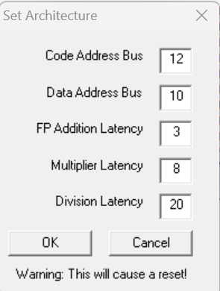
- Code address bus: 12
- Data address bus: 12
- Pipelined FP arithmetic unit (latency): 3 stages
- Pipelined multiplier unit (latency): 8 stages
- divider unit (latency): not pipelined unit,
20 clock cycles
- Forwarding is enabled
- Branch prediction is disabled
- Branch delay slot is disabled
- Integer ALU: 1 clock cycle
- Data memory: 1 clock cycle
- Branch delay slot: 1 clock cycle.

- Enhance the assembly program you created in the previous lab called program_1.s:

int m=1 /* 64 bit */
double k,p
for (i = 0; i < 64; i++){
if (i is even) {
p= v1[i] * ((double)( m<< i)) /*logic shift */
m = (int)p
} else {
/* i is odd */
p= v1[i] / ((double)m* i))
k = ((float)((int)v4[i]/ 2^i)
}

v5[i] = ((p * v2[i]) + v3[i])+v4[i];

v6[i] = v5[i]/(k+v1[i]);

v7[i] = v6[i]*(v2[i]+v3[i]);

}

    - Detect manually the different data, structural and control hazards that provoke a pipeline stall

    - Optimize the program by re-scheduling the program instructions in order to eliminate as many hazards as possible. Compute manually the number of clock cycles the new program (program_1_a.s) requires to execute, and compare the obtained results with the ones obtained by the simulator.

    - Starting from program_1_a.s, enable the branch delay slot and re-schedule some instructions in order to improve the previous program execution time. Compute manually the number of clock cycles the new program (program_1_b.s) requires to execute, and compare the obtained results with the ones obtained by the simulator.

    - Unroll 2 times the program (program_1_b.s), if necessary re-schedule some instructions and increase the number of used registers. Compute manually the number of clock cycles the new program (program_1_c.s) requires to execute, and compare the obtained results with the ones obtained by the simulator.

Complete the following table with the obtained results:

Program  Clock cycle computation | program_1.s | program_1_a.s | program_1_b.s | program_1_c.s
By hand
By simulation

Collect the IPC (from the simulator) for different programs.
 | program_1.s | program_1_a.s | program_1_b.s | program_1_c.s
IPC

Compare the results obtained in point 1, and provide some explanation in the case the results are different.
Eventual explanation:

