Architetture dei Sistemi di Elaborazione  O2GOLOV | Delivery date:  23 November 2023
Laboratory  5 | Expected delivery of lab_5.zip must include:  This file in pdf format.

Exercise 1:

Software Optimizations

Starting from Exercise 2 of Lab 4, you are required to further speedup the benchmark (my_c_benchmark) 😈.

For readability, provide the previously used configurations (Cut & Paste).

Parameters | Configuration 1 | Configuration 2 | Configuration 4 | Configuration 5
First changed paramenter | FetchWidth=8 | numIQEntries=4 | FetchWidth=8 | FetchWidth=8
Second changed paramenter | DecodeWidth=8 | renameWidth=4 | FetchBufferSize=32 | FetchBufferSize=32
… |  | numRobs=4 | DecodeWidth=8 | DecodeWidth=8
... |  |  | numIQEntries=8 | NumIQEntries=8
... |  |  | renameWidth=8 | RenameWidth=8
... |  |  | numRobs=8 | issueWidth=8
... |  |  |  | DispatchWidth=8
... |  |  |  | WbWidth=4

Original CPI (no hardware optimization): 2.083105

 | Configuration 1 | Configuration 2 | Configuration 4 | Configuration 5
CPI | 1.983529 | 1.770152 | 1.236586 | 1.086349
Speedup (w.r.t. the Original CPI) | 1.05 | 1.18 | 1.68 | 1.92

Despite the hardware enhancements for increasing the CPU performance, remember that optimizing compilers for programs in high-level code also exist. The aim of optimizing compilers is to minimize or maximize some attributes of an executable computer program (code size, performance, etc.). They are also aware of hardware enhancements to perform very accurate optimizations.

Compilers can be your best friend (or worst enemy!). The more information you provide in your program, the better the optimized program will be.

You can compile your programs with different SW optimization strategies and/or additional features.
In the setup_default file:

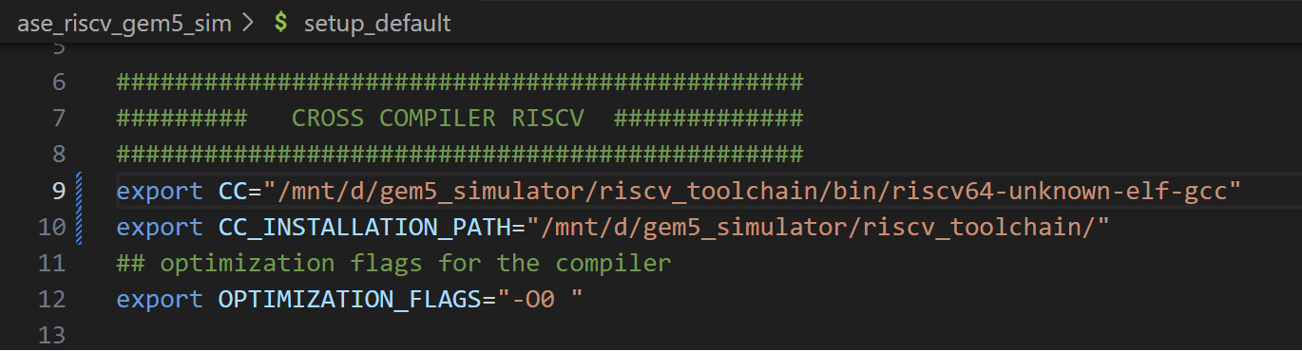

You can change the line 12.

Simulate the program for different optimization levels and collect statistics. You are required to change the OPTIMIZATION_FLAGS variable in the setup_default. O0 is the default value, you need to change the optimization value accordingly to the values in parenthesis in the following Table.

DO NOT CONFUSE -O3 WITH O3 PROCESSOR.

TABLE1: IPC for different compiler optimization levels and configurations
Optimization  Configuration | Opt lvl 0 (-O0) | Opt lvl 1 (-O1) | Opt lvl 2 (-O2) | Opt size (-Os) | Opt lvl 3  (-O3) | Opt lvl 2  (-O2 --fast-math)
Original Configuration | 0.480053 | 0.396446 | 0.443626 | 0.415027 | 0.443626 | 0.458622
Configuration 1 | 0.497950 | 0.419123 | 0.447254 | 0.417030 | 0.447254 | 0.460553
Configuration 2 | 0.480053 | 0.480053 | 0.443626 | 0.415027 | 0.443626 | 0.458622
Configuration 4 | 0.808433 | 0.749522 | 0.771857 | 0.730470 | 0.771857 | 0.785777
Configuration 5 | 0.920515 | 0.807653 | 0.840891 | 0.793778 | 0.840891 | 0.840232
Program Size [Bytes] | 3228 | 3044 | 3032 | 3016 | 3032 | 3032

Regarding the Program Size (Code and Data!!), you can retrieve the size from:

~/ase_riscv_gem5_sim$ /opt/riscv-2023.10.18/bin/riscv64-unknown-elf-size –format=gnu –radix=10 ./programs/my_c_benchmark/my_c_benchmark.elf

For brave and curious guys:
For visualize the enabled optimizations from the compiler perspective, you can run:

~/my_gem5Dir$ /opt/riscv-2023.10.18/bin/riscv64-unknown-elf-gcc -Q -O2 --help=optimizers

By changing the “-O2” parameter with the desired one, you will find the enabled/disabled optimizations.
Here are some possible types of optimizations:
- https://en.wikipedia.org/wiki/Optimizing_compiler
- https://gcc.gnu.org/onlinedocs/gcc/Optimize-Options.html

Exercise 2:

Given your benchmark (my_c_benchmark.c), select the best optimization to obtain your best angle of optimization, compared to the baseline configuration (riscv_o3_custom.py; -O0).

- Based on Table 1 (from Exercise 1), select the best optimization (for example, the green box corresponding to Configuration 1 with -O2).

Optimization  Configuration | Opt lvl 0 (-O0) | Opt lvl 1 (-O1) | Opt lvl 2 (-O2) | Opt size (-Os) | Opt lvl 3  (-O3) | Opt lvl 2  (-O2 --fast-math)
Original Configuration | 0.480053 | 0.396446 | 0.443626 | 0.415027 | 0.443626 | 0.458622
Configuration 1 | 0.497950 | 0.419123 | 0.447254 | 0.417030 | 0.447254 | 0.460553
Configuration 2 | 0.480053 | 0.480053 | 0.443626 | 0.415027 | 0.443626 | 0.458622
Configuration 4 | 0.808433 | 0.749522 | 0.771857 | 0.730470 | 0.771857 | 0.785777
Configuration 5 | 0.920515 | 0.807653 | 0.840891 | 0.793778 | 0.840891 | 0.840232
Program Size [Bytes] | 3228 | 3044 | 3032 | 3016 | 3032 | 3032

- By using Konata, overlap the two pipelines (the original obtained with riscv_o3_custom.py and the optimized corresponding to the best SW-HW combination) to compute your angle of optimization.
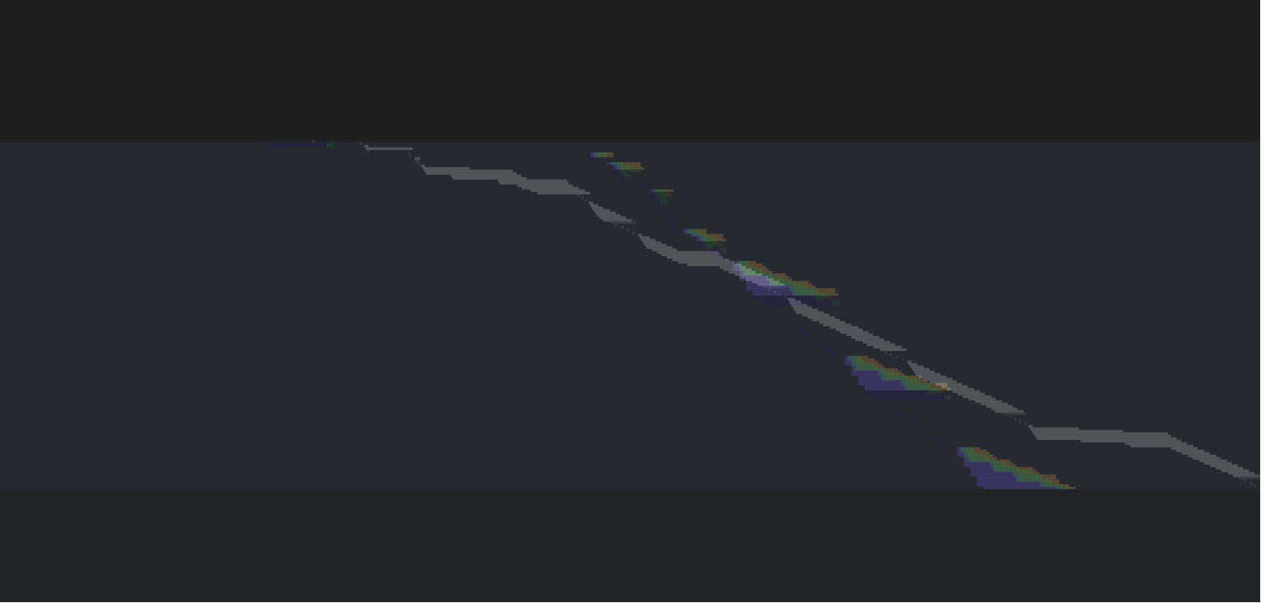
Program 2
Program 1

Compute the angle (named optimization angle) existing between the traces.

Hint: To load different traces in Konata, load them separately. Afterward, righ-click in the pipeline visualizer and select “transparent mode”. You need to adjust the scale!

- To compute the angle of optimization :

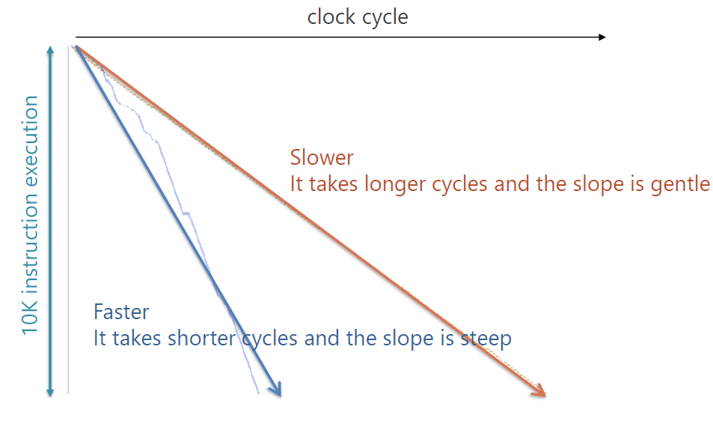
-

The angle of optimization is equal to:
arctan(0,480053) – arctan(0,920515) = -0,296471384 rad = -16,986559 deg

- Do you see any visual improvements (for example, a less discontinued pipeline)? Yes, why? No, why? What is happening? How they could be improved?

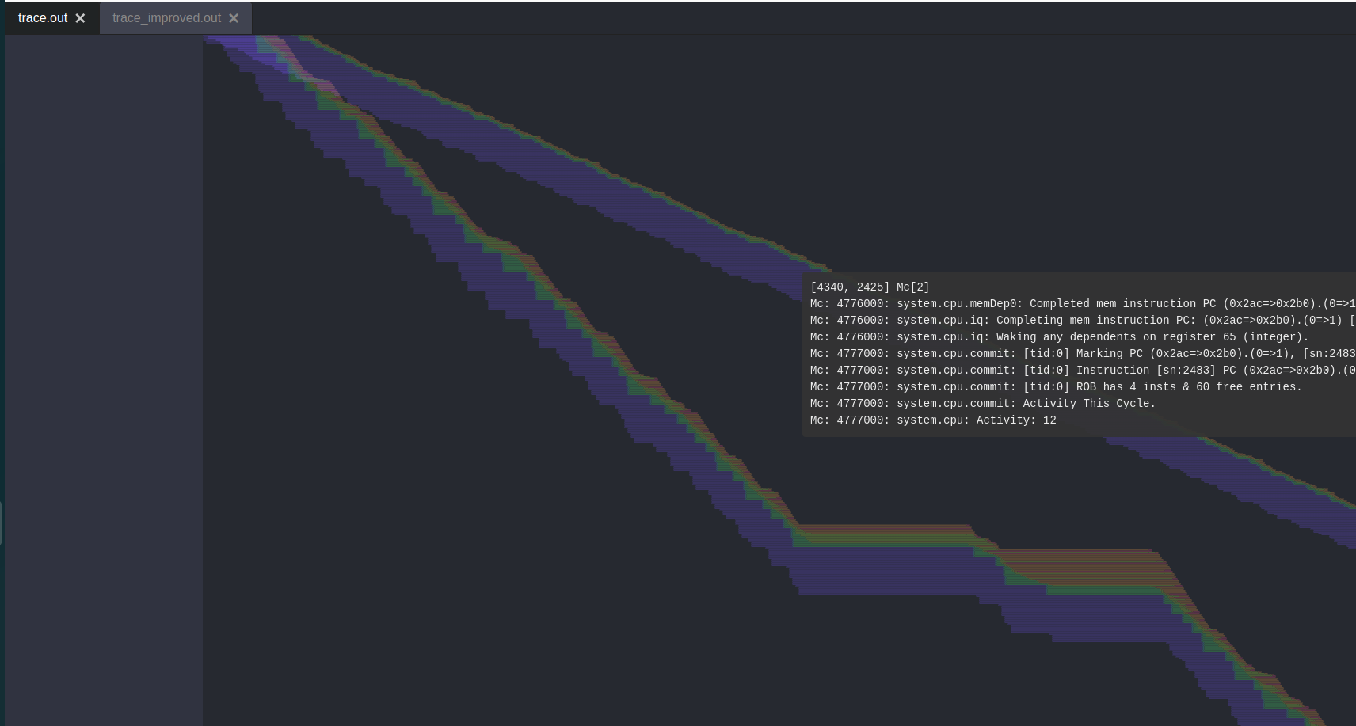
Comment box
la discontinuità visiva nella pipeline viene generata quando un branch è misstaken e la “grandezza” della discontinuià dipende da due fattori:
- numero di istruzioni flushate (aumentano la discontinuià verticale)
- tempo in attesa di risoluzioni di stalli prima di impiegato prima di riconoscere che il branch sia misstaken (aumenta la discontinuià orizzontale).
Il programma migliorato presenta sicuramente delle riduzioni di stalli per cui la discontinuità orizzontale si riduce, però, avendo aumentato il numero di fetch per singolo colpo di clock, ogni branch misstaken comporta una grande perdita, non solo in efficienza, ma anche in compattezza visiva.

