|  |  |
| --- | --- |
| **Architetture dei Sistemi di Elaborazione** | Delivery date:  October 25th 2023 |
| **Laboratory**  **2** | Expected delivery of lab_02.zip must include:   * **program_1.s** and **program_2.s** * This file, filled with information and possibly compiled in a pdf format. |

Please, configure the winMIPS64 simulator with the *Base Configuration* provided in the following (*in italics not user controllable configuration*):

* Immagine che contiene testo, schermata, Carattere, numero

  Description automatically generatedCode address bus: 12
* Data address bus: 10
* Pipelined FP arithmetic unit (latency): 3 stages
* Pipelined multiplier unit (latency): 8 stages
* divider unit (latency): not pipelined unit,

20 clock cycles

* Forwarding is enabled
* Branch prediction is disabled
* Branch delay slot is disabled
* *Integer ALU: 1 clock cycle*
* *Data memory: 1 clock cycle*
* *Branch delay slot: 1 clock cycle*.

1. Write an assembly program (**program_1.s**) for the *winMIPS64* architecture described before able to implement the following piece of code described at high-level:

for (i = 0; i < 64; i++) {

v5[i] = ((v1[i]* v2[i]) + v3[i]) + v4[i];

v6[i] = v5[i]/(v4[i]+v1[i]);

v7[i] = v6[i]*(v2[i]+v3[i]);

}

Assume that the vectors v1[], v2[], v3[], and v4[] are allocated previously in memory and contain 64 double precision **floating point** values; assume also that v1[] and v4[] do not contain 0 values. Additionally, the vectors v5[], v6[], v7[] are empty vectors also allocated in memory.

**Calculate** the data memory footprint of your program:

|  |  |
| --- | --- |
| Data | Number of Bytes |
| V1 |  |
| V2 |  |
| V3 |  |
| V4 |  |
| V5 |  |
| V6 |  |
| V7 |  |
| Total |  |

Are there any issues? Yes, where and why? No ? Do you need to change something?

|  |
| --- |
| Your answer: |

ATTENTION: winMIPS64 has a limitation due to the underlying software.

There is a limitation in the string length when declaring a vector. Split the vectors elements in multiple lines (it also increases the readability) .

Example: my_fancy_vector: .byte 4, 5 ,7, 8

.byte 5,77, 8

.byte ……

* + 1. Compute the CPU performance equation (CPU time) of the previous program following the next directions, assume a clock frequency of 1MHz:
 $$\text{CPU time}=(\sum_{i=1}^{n}{\text{CP}{\text{I}}_{i}×\text{I}{\text{C}}_{i})×\text{Clock cycle} \text{period}}$$

      - Count manually, the number of the different instructions (*ICi*) executed in the program
       - Assume that the *CPIi* for every type of instructions equals the number of clock cycles in the instruction EXE stage, for example:
         * integer instructions CPI = 1
         * LD/SD instructions CPI = 1
         * FP MUL instructions CPI = 8
         * FP DIV instructions CPI = 20
         * …
    2. Compute by hand again the CPU performance equation assuming that you can improve the FP Multiplier or the FP Divider by speeding up by 2 only one of the units at a time:
       - Pipelined FP multiplier unit (latency): 8 🡪 4 stages

Or

* + - * FP Divider unit (latency): not pipelined unit, 20 🡪 10 clock cycles

Table 1: CPU time by hand

|  |  |  |  |
| --- | --- | --- | --- |
|  | CPU Time initial (a) | CPU Time  (b – MUL speed up) | CPU Time  (b – DIV speed up) |
| program_1.S |  |  |  |

* + 1. Using the simulator calculate again the CPU time and complete the following table:

Table 2: CPU time using the simulator

|  |  |  |  |
| --- | --- | --- | --- |
|  | CPU Time initial (a) | CPU Time  (b – MUL speed up) | CPU Time  (b – DIV speed up) |
| program_1.S |  |  |  |

Are there any difference? If yes, where and why? If Not, provide some comments in the following:

|  |
| --- |
| Your answer: |

* + 1. Using the simulator and the *Base Configuration*, disable the Forwarding option and compute how many clock cycles the program takes to execute.

Table 3: forwarding disabled

|  |  |  |
| --- | --- | --- |
|  | Number of clock cycles | IPC (Instructions Per Clock) |
| program_1.S |  |  |

Enable one at a time the **optimization features** that were initially disabled and collect statistics to fill the following table (fill all required data in the table before exporting this file to pdf format to be delivered).

Table 4: **Program performance for different processor configurations**

|  |  |  |  |  |  |  |  |  |
| --- | --- | --- | --- | --- | --- | --- | --- | --- |
| Program | Forwarding | | Branch Target Buffer | | Delay Slot | | Forwarding + Branch Target Buffer | |
|  | IPC | CC | IPC | CC | IPC | CC | IPC | CC |
| Program_1.S |  |  |  | |  | |  | |

1. Using the WinMIPS64 simulator, validate experimentally the Amdahl’s law, defined as follows:



1. Using the program developed before: **program_1.s**
2. Modify the processor architectural parameters related with multicycle instructions (Menu🡪Configure🡪Architecture) in the following way:
   * + - 1. Configuration 1

Starting from the *Base Configuration*, change only the FP addition latency to 6

* + - * 1. Configuration 2

Starting from the *Base Configuration*, change only the Multiplier latency to 4

* + - * 1. Configuration 3

Starting from the *Base Configuration*, change only the division latency to 10

Compute by hand (using the Amdahl’s Law) and using the simulator the speed-up for any one of the previous processor configurations. Compare the obtained results and complete the following table.

Table 5: **program_1.s speed-up computed by hand and by simulation**

|  |  |  |  |  |
| --- | --- | --- | --- | --- |
| **Proc. Config.**    **Speed-up comp.** | Base config.  [c.c.] | Config. 1 | Config. 2 | Config. 3 |
| **By hand** |  |  |  |  |
| **By simulation** |  |  |  |  |

1. Write an assembly program (**program_2.s**) for the winMIPS64 architecture able to compute the output (y) of a **neural computation** (see the Fig. below):

*x = $\sum_{j=0}^{K-1}{i_{j}*w_{j}+b}$*

*y = f(x)*

where, to prevent the propagation of NaN (Not a Number), the activation function *f* is defined as:

$$f\left(x\right)=\left\{\begin{aligned}0, &if the exponent part of x is equal to 0x7ff \\ x, &otherwise\end{aligned}\right.$$

Assume the vectors *i* and *w* respectively store the inputs entering the neuron and the weights of the connections. They contain *K=30* double precision **floating point** elements. Assume that *b* is a double precision **floating point** constant and is equal to *0xab*, and *y* is a double precision **floating point** value stored in memory.

Compute *y*.

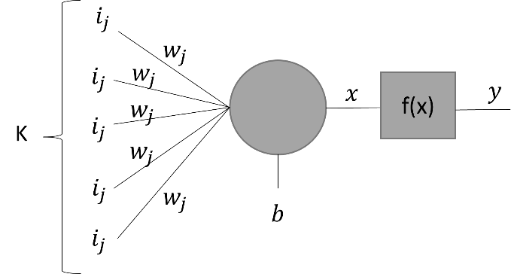

Below is reported the encoding of IEEE 754 double-precision binary floating-point format:

Given the *Base Configuration*, run your program and extract the following information.

|  |  |  |  |
| --- | --- | --- | --- |
|  | Number of clock cycles | IPC (Instructions Per Clock) | CPI (Clock per Instructions) |
| program_2.S |  |  |  |