PROJECT SYNOPSIS
Smt. Maherbanu College of Science & Commerce, Akola
Department of Computer Application (BCA)

Title: CampusConnect
Team:
- Leader:
  - Name: Sushant Gangaprasad Ukande
  - Phone: +91 9552965834
  - Email: sushantukande37@gmail.com

- Member 1:
  - Name : Shekhar Bhagwan Mahajan
  - Phone: +91 9028159448
  - Email: shekharmahajan1505@gmail.com

- Member 2:
  - Name : Kumar Keshav Thakare
  - Phone : +91 70838 58443
  - Email : kumarthakare00@gmail.com

- Member 3:
  - Name : Aniket Surendra Palhade
  - Phone: +91 89564 05658
  - Email: aniketpalhade99@gmail.com

Project Guide: Prof. Pravin Dhande
Course: Bachelor of Computer Applications
Class: Semester V Final Year
Academic Year: 2026–27

INDEX

Sr. No. | Description | Page No.
1 | Abstract | 3
2 | Introduction | 3
3 | Motivation | 4
4 | Aims & Objectives | 5
5 | Literature Review | 6
6 | Methodology | 7
6.1 | - Requirement Analysis | 7
6.2 | - System Design (Module Breakdown) | 8
6.3 | - Database Design | 8
6.4 | - Development & Tech Stack | 8
6.5 | - Testing Strategy | 8
7 | Proposed System / Model | 9
8 | Applications | 10
9 | References | 10

ABSTRACT
CampusConnect is a web-based social learning platform designed for college students and faculty to integrate academic resource sharing, communication, and collaboration into a unified hub. Students can share notes, posts, short educational videos, and PDFs, interact via a social-style feed, create study groups, and chat. Teachers hold additional privileges to moderate content, oversee groups, and organize academic activities like coding challenges and quizzes. Featuring role-based access control, file sharing, messaging, and search, CampusConnect provides a secure, organized environment that streamlines student-teacher interaction without relying on multiple disjointed tools.

INTRODUCTION
The rapid growth of digital platforms in education has led students to use multiple applications for communication, resource sharing, quizzes, and coding competitions, often resulting in fragmented academic interactions.
CampusConnect addresses this by providing a centralized social learning platform tailored to the college community. Students can access a personalized academic feed, share educational content (notes, PDFs, posts), form study or project groups, and participate in No index entries found.competitions. Teachers hold elevated permissions to publish materials, organize quizzes and coding challenges, and moderate content.
By unifying social networking with academic collaboration, CampusConnect establishes a secure, organized digital environment for seamless student-teacher interaction.

MOTIVATION
The main motivation behind CampusConnect is the need for a centralized platform where students can communicate, collaborate, and share academic resources within their college community.

Currently, students may use different applications for classroom communication, document sharing, messaging, social interaction, quizzes, and coding competitions. This can result in scattered information and difficulty in finding useful academic resources.

The proposed system attempts to solve this problem by providing multiple academic and social features in one platform.

The major motivations are:

1. To provide a centralized platform for college students.
2. To make academic resource sharing easier.
3. To encourage students to help and learn from each other.
4. To provide communication between students and teachers.
5. To create college-specific groups and communities.
6. To organize coding competitions and MCQ quizzes.
7. To provide teachers with moderation and management capabilities.
8. To make educational content easier to discover and organize.
9. To reduce dependency on multiple unrelated platforms.
10. To create a collaborative digital college environment.

AIMS & OBJECTIVE

Aim:

The main aim of the project is to develop a college-oriented social learning and collaboration website that allows students and teachers to share educational resources, communicate, collaborate, and participate in academic activities through a centralized platform.

Objectives:

The major objectives of CampusConnect are:

1. To provide secure student and teacher registration and login.
2. To provide role-based access for students and teachers.
3. To allow students to create and manage their profiles.
4. To allow students to upload educational notes and resources.
5. To support text, images, PDFs, and potentially short educational videos.
6. To provide a social-media-style academic feed.
7. To allow students to interact with shared content.
8. To allow users to create and join academic groups.
9. To provide one-to-one and group communication.
10. To allow students to search for useful academic resources.
11. To provide teachers with additional administrative privileges.
12. To allow teachers to moderate inappropriate or irrelevant content.
13. To allow teachers to organize coding competitions.
14. To provide MCQ-based quizzes and assessments.
15. To provide notifications for important academic activities.
16. To maintain organized records of posts, users, groups, and competitions.

LITRETURE REVIEW

1. Social Media Platforms (e.g., Instagram, LinkedIn)
• Strengths : Engaging media feeds, instant messaging, high user activity.
• Limitations : Lacks academic focus; study material easily gets lost among non-educational content.

2. Learning Management Systems (e.g., Google Classroom, Canvas)
• Strengths : Efficient assignment submission, grading, and notices.
• Limitations : Highly formal; lacks informal peer collaboration and interactive social feeds.

3. Instant Messaging Apps (e.g., WhatsApp, Telegram)
• Strengths : Fast group chats and quick file sharing.
• Limitations : Important notes and PDFs quickly get buried under long chat histories, making retrieval difficult.

4. Coding & Assessment Platforms
• Strengths : Great for technical problem-solving and quizzes.
• Limitations : Operates as standalone tools disconnected from daily campus communication.

CampusConnect bridges these gaps by consolidating four distinct domains into a single, college-centric platform:

[ Social Feed ] + [ Resource Sharing ] + [ Study Groups & Chat ] + [ Quizzes & Coding Challenges ] + [ Faculty Control ]

This unified approach eliminates the need to switch between multiple apps, creating a secure, structured, and engaging environment for both students and teachers.
METHODOLOGY

SOFTWARE DEVELOPMENT

The development of CampusConnect follows a systematic Software Development Life Cycle (SDLC) consisting of five core phases: Requirement Analysis, System Design, Database Design, Development, and Testing.

REQUIREMENT ANALYSIS

Identifies specific needs and functional access levels for all platform users:

• Student Requirements: -
Account registration, login, and profile management - Social feed interactions (posts, images, text, and short videos) - Educational resource sharing (notes, PDFs, documents) - Group creation, direct messaging, and real-time notifications - Search functionality, participation in quizzes, and coding challenges

• Teacher Requirements: -
Faculty login with elevated privileges - Content creation and moderation (approving/removing posts) - Group management and student activity oversight - Creation and evaluation of interactive quizzes and coding competitions

• Administrator Requirements: -
User and role-based access management - Platform-wide moderation and user report handling - System monitoring and configuration control

SYSTEM DESIGN (MODULE BREAKDOWN)
The platform is divided into 13 core functional modules:
1. Authentication Module 8. Teacher Management Module
2. User Profile Module 9. Quiz Module
3. Social Feed Module 10. Coding Competition Module
4. Notes & File Sharing Module 11. Search Module
5. Group Module 12. Moderation Module
6. Chat Module 13. Administration Module
7. Notification Module

DATABASE DESIGN
A structured schema manages platform entities and their relational mappings:
• User Data : Student profiles, Teacher profiles, Roles, and Auth logs
• Content Data : Posts, Comments, Likes/Reactions, Notes, and Files
• Social Data : Groups, Group Memberships, and Direct Messages
• Assessment Data : Quizzes, Questions, Results
• System Data : Notifications, Moderation Logs, and User Reports

DEVELOPMENT & PROPOSED TECH STACK
• Frontend Interface : HTML, CSS, JavaScript / React.js
• Backend API : Python (Flask, FlaskSockeIO)
• Database System : MySQL / MongoDB
• Real-time Messaging: WebSockets / Socket.io
• File Storage : Local Server / Cloud-based Storage
• Development Tools : Visual Studio Code, Git, GitHub

TESTING STRATEGY
System security, integrity, and performance:
• Functional & Unit Testing : Verifies individual functions
• Integration & Database Testing : Ensures smooth API and database
• Security & Auth Testing : Validates access control
• UI & Performance Testing : Guarantees responsive layout and speed

PROPOSED SYSTEM / MODEL

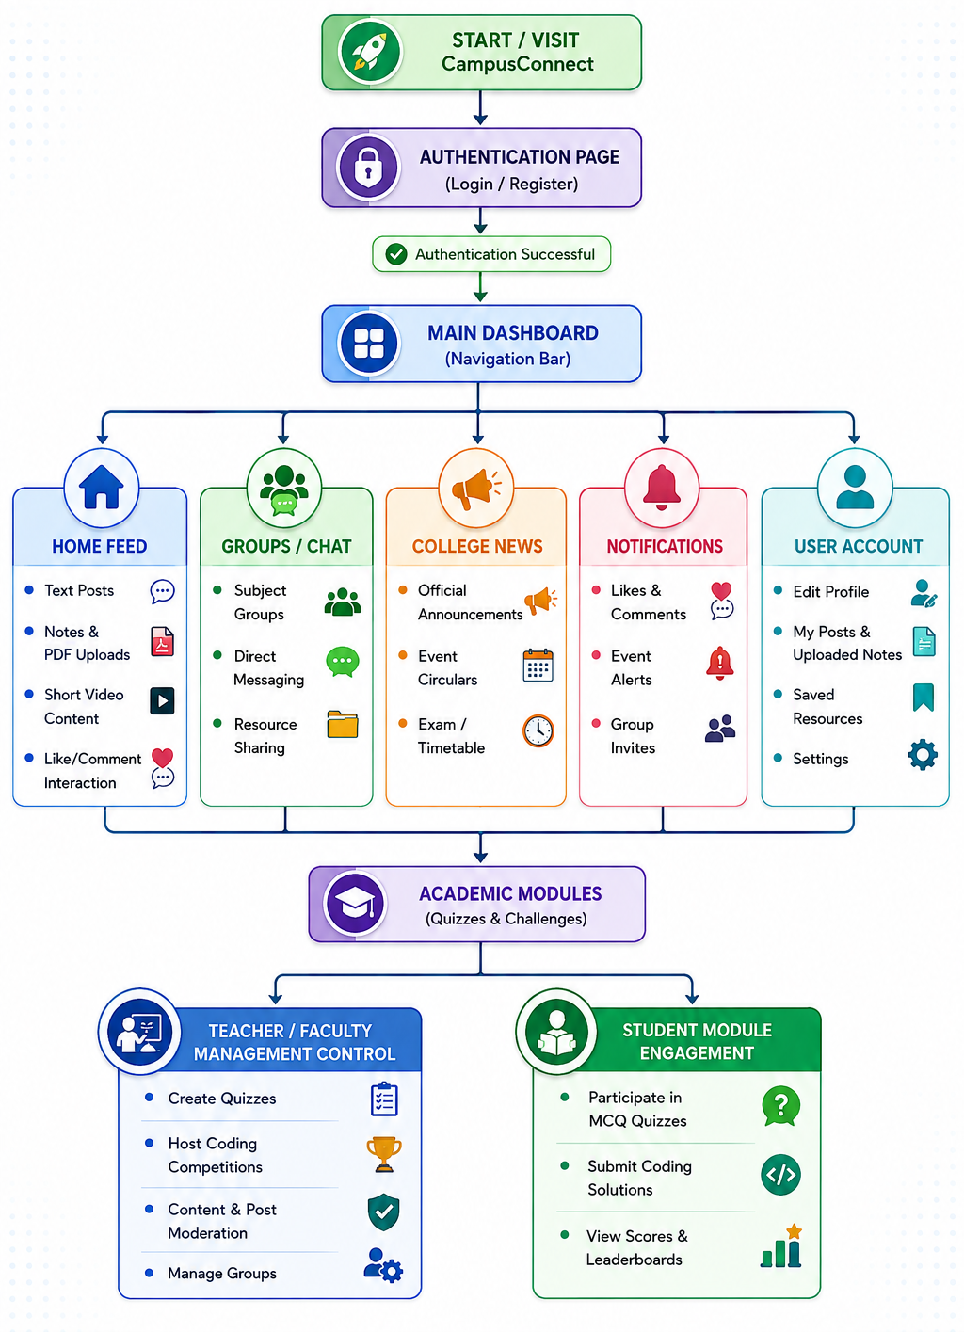

APPLICATIONS
The proposed platform, CampusConnect, has several practical applications within an educational environment:
- Centralized Campus Communication:
• Acts as an official channel for colleges to broadcast circulars, exam timetables, and event news without depending on public social media.
- Peer-to-Peer Academic Learning:
• Enables students to easily share and discover study materials, lecture notes, PDFs, and educational video resources in an organized manner.
- Collaborative Group Study & Messaging:
• Allows students to form subject-wise, project-wise, or interest-based groups for active discussions and seamless resource exchange.
- Faculty-Guided Assessment & Skill Building:
• Provides a dedicated platform for teachers to conduct online MCQ quizzes and host coding competitions to evaluate technical knowledge.
- Moderated & Distraction-Free Environment:
• Serves as a secure, academic-focused alternative to general social networking apps, ensuring content is filtered and monitored by college faculty.

REFERENCES

1. React Documentation: https://react.dev/
2. Flask (Python) Documentation: https://flask.palletsprojects.com/ 3. Web Docs: https://developer.mozilla.org/
4. MySQL Reference Manual: https://dev.mysql.com/doc/

