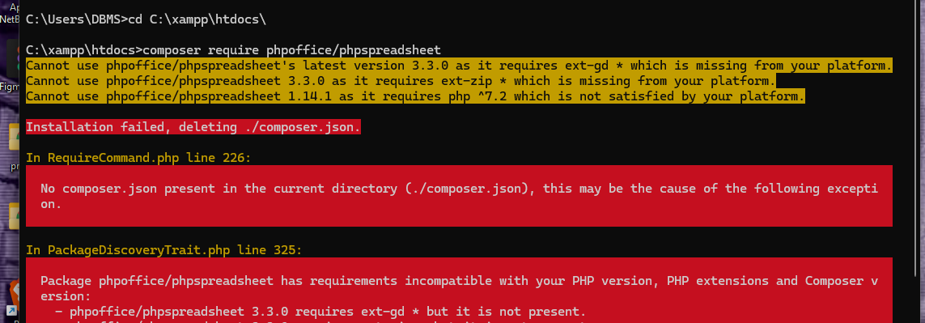

The error you're seeing is because the PhpSpreadsheet package requires some PHP extensions (`ext-gd` and `ext-zip`) that are missing from your XAMPP installation, or the PHP version you are using doesn't meet the package's requirements.

Here's what you can do to resolve the issue:

### 1. **Enable the Required Extensions in XAMPP**

You need to enable the `gd` and `zip` extensions in your XAMPP configuration.

1. **Open the PHP configuration file**:

- Go to your XAMPP installation directory (`C:\xampp\php\php.ini`).

2. **Enable the `gd` and `zip` extensions**:

- Search for the following lines in the `php.ini` file:

```

;extension=gd

;extension=zip

```

- Remove the semicolon (`;`) at the beginning of both lines to enable the extensions:

```

extension=gd

extension=zip

```

3. **Restart Apache**:

- Go back to the XAMPP Control Panel and restart Apache for the changes to take effect.

### 2. **Check PHP Version**

The version of PHP in XAMPP may also need to be upgraded because PhpSpreadsheet requires PHP 7.2 or higher.

1. **Check your current PHP version**:

- In the XAMPP Control Panel, click on "Apache" and then "Admin". This will open the XAMPP dashboard. On this page, you can see your current PHP version.

2. **Upgrade PHP in XAMPP** (if needed):

- If you're using PHP 7.1 or below, you'll need to upgrade to a later version (7.2 or higher). Follow the [XAMPP guide](https://www.apachefriends.org/faq_windows.html) to upgrade PHP in XAMPP.

### 3. **Re-run the Composer Command**

After enabling the extensions and ensuring you're using the correct PHP version, you can retry the installation:

```bash

composer require phpoffice/phpspreadsheet

```

If you've successfully enabled the required extensions and have a compatible PHP version, the package should install without issues. Let me know if you need further assistance!