Set up Microsoft Authenticator app authentication
Use the Microsoft Authenticator app to receive notifications on your smartphone or tablet to verify your identity when prompted for Multifactor Authentication.

Step 1. Download and install the Microsoft Authenticator app
Visit the Apple app store or Google play store on your device and install the Microsoft Authenticator app. Alternatively, visit aka.ms/authapp and download the Microsoft Authenticator app.
YOU MUST enable notifications when prompted to do so. The application will not work if you do not.
DO NOT attempt to sign in in the app. Proceed to step two without taking ANY action in the app after it is installed.
If you already have the app installed, you do not need to download it again.

Step 2. Add your account to the app
- On your computer, visit https://mysignins.microsoft.com/security-info
- Select Add Method > Authenticator app from the list, and then select Add

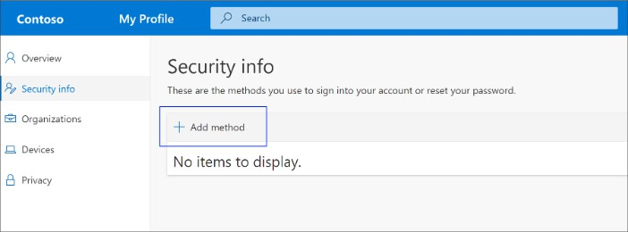

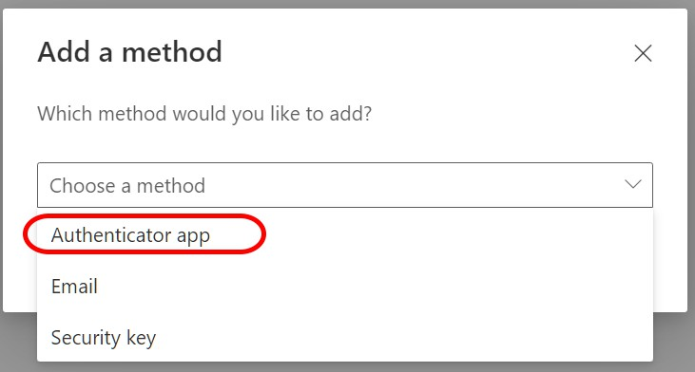

- If you’ve already installed the Authenticator App in Step 1 click Next. Otherwise, on the Start by getting the app page, select Download now to download and install the Microsoft Authenticator app on your mobile device. When the app is installed,
select Next.

Be sure you’re installing the correct authenticator app, the Microsoft Authenticator app will have
the following icon associated to it.
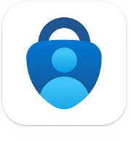
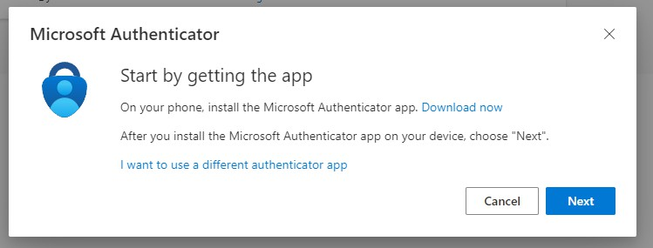

- Remain on the Set up your account page while you set up the Microsoft Authenticator app on your mobile device.

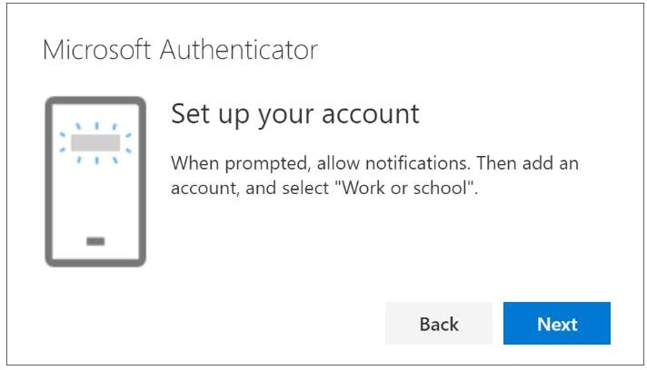

- Open the Microsoft Authenticator app, select to allow notifications (if prompted), select Add account from the Customize and control icon on the upper-right (A Plus “+” symbol), and then select Work or school account.

NOTE: The first time you set up the Microsoft Authenticator app, you might receive a prompt asking whether to allow the app to access your camera (iOS) or to allow the app to take pictures and record video (Android). You must select Allow so the authenticator app can access your camera to take a picture of the QR code in the next step. If you don't allow the camera, you can still set up the authenticator app, but you'll need to add the code information manually.

- Return to the Set up your account page on your computer, and then select Next. The “Scan the QR code” page appears.
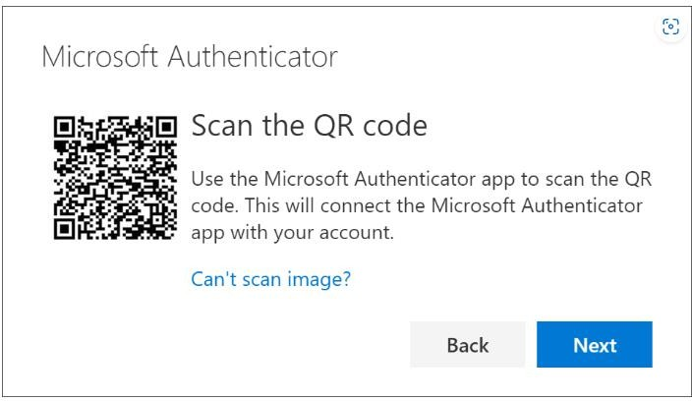
- Scan the provided code with the Microsoft Authenticator app QR code reader, which appeared on your mobile device after you created your work or school account in step five.

- The authenticator app should successfully add your work or school account without requiring any additional information from you. However, if the QR code reader can't read the code, you can select “Can't scan image?” and manually enter the code and URL into the Microsoft Authenticator app.
- Select Next on the Scan the QR code page on your computer. A notification is sent to the Microsoft Authenticator app on your mobile device, to test your account.
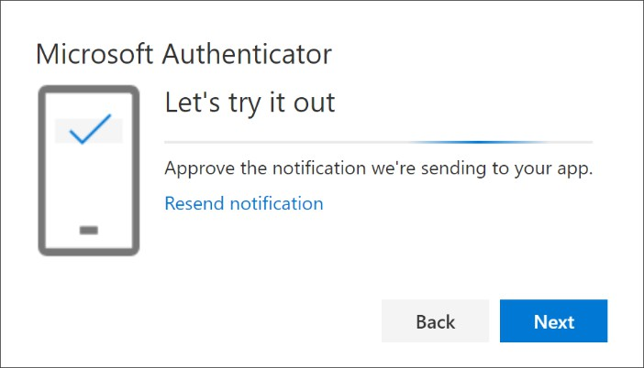

- Approve the notification in the Microsoft Authenticator app, and then select Next. Your security info is updated to use the Microsoft Authenticator app by default to verify your identity when using two-step verification or password reset.

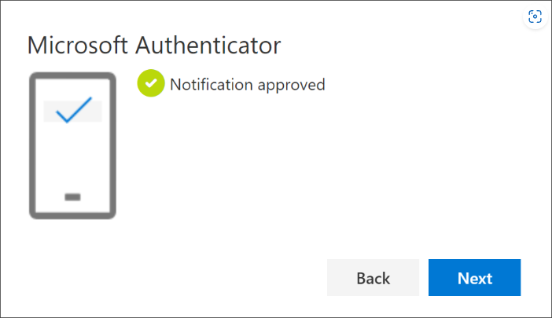

Step 3. Set up External Email for Self-Service Password Recovery.
This is a non-New Balance Email; this is to help with recovery should you lose service in the future. If you do

not want to provide your personal email it is suggested to create a different personal email address, on any free mail service, and just keep this in your personal records. Administrators do not have access to the stored email address.
- Visit https://mysignins.microsoft.com/security-info

Select Add Sign-in Method > Email > Add.
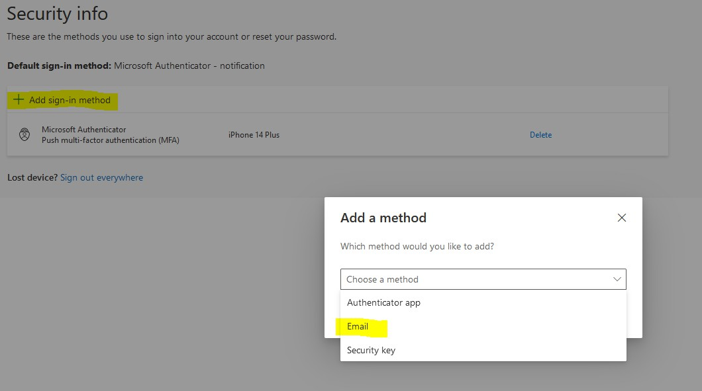

- Put in a personal EXTERNAL email address and click Next.

  - This requires an external, non New Balance email address to assist in the self services password Recovery process if the service is needed in the future.
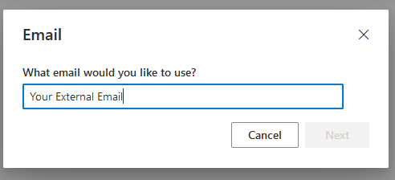

- You will be sent a 6 digit code to the external email address provided. Enter that code here and click Next.

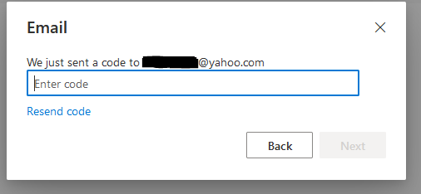

Congratulations! You are now set up with Azure MFA!

