Experiment 8 — LIME
Explainability of a Pre-trained Image Classification Model
Raj Kalpesh Mathuria | UID: 2023300139 | Batch: PE - C
Code Repository: https://github.com/CodeCraftsmanRaj/xAI/tree/main/Experiment_8_LIME

1. Introduction
LIME (Local Interpretable Model-agnostic Explanations) is a post-hoc explainability technique that approximates a complex model locally with an interpretable surrogate model. For image classification, LIME divides an image into superpixels, creates perturbed versions by hiding selected regions, observes the model's predictions, and assigns importance weights to regions associated with a selected class.
This experiment applies LIME to a pretrained ResNet-50 ImageNet classifier. Three dog images with different backgrounds were evaluated. The experiment then varied SLIC segmentation resolution to create two reasonable but substantially disagreeing explanations for one study image. Finally, deletion and insertion tests used only the model's prediction probabilities to compare the competing explanations.

2. Aim
To explain prediction of a pre-trained model using LIME.

3. Objectives
- Apply LIME to three images and visualize important regions.
- Compare explanations under different SLIC superpixel counts.
- Identify two reasonable but disagreeing explanations.
- Define the decision criterion before testing.
- Use only model predictions through deletion and insertion tests.
- Determine whether the evidence supports A, B, or neither.

4. Experimental Setup
Component | Configuration
Model | ResNet-50
Pretraining | ImageNet
Device | CUDA / GPU
LIME samples | 1200
LIME features | 12
Segmentation | SLIC
Base segments | 80
Candidate segments | 40, 80, 120
Study image | dog1.jpg
Target class | golden retriever
Test fractions | 10%, 20%, 30%, 40%, 50%
Baseline | Blur
Decision margin | 0.05

5. Methodology

5.1 Model prediction
Each image was passed through pretrained ResNet-50 and the top ImageNet predictions and probabilities were recorded.

5.2 LIME attribution
LIME generated superpixel-level explanations using 1200 perturbed samples. Positive regions were used to represent regions supporting the target prediction; local surrogate R² was recorded as fidelity.

5.3 Disagreement experiment
For dog1.jpg, SLIC segmentation was varied while the other major settings were kept fixed. Candidate segment counts were 40, 80, and 120. The selected pair was 40 vs 120 segments.

5.4 Pre-registered decision criterion
A would be supported if its positive regions caused a larger target-probability decrease during deletion and/or retained a larger target probability during insertion than B, with the combined difference exceeding 0.05. B would be supported by the reverse pattern. Otherwise the result would be neither/inconclusive.

5.5 Prediction-only validation
Positive regions were progressively deleted from the image and progressively inserted into a blurred baseline. Only the model's target-class probability was used; no ground-truth segmentation was used.

6. Predictions and LIME Results
Image | Class | Probability | LIME R² | Segments | Samples
dog1.jpg | golden retriever | 0.5142 | 0.6093 | 80 | 1200
dog2.jpg | golden retriever | 0.4172 | 0.4979 | 80 | 1200
dog3.jpg | golden retriever | 0.3979 | 0.6798 | 80 | 1200
All three images were classified as golden retriever. Probabilities were 0.5142, 0.4172, and 0.3979.
dog1.jpg — LIME attribution
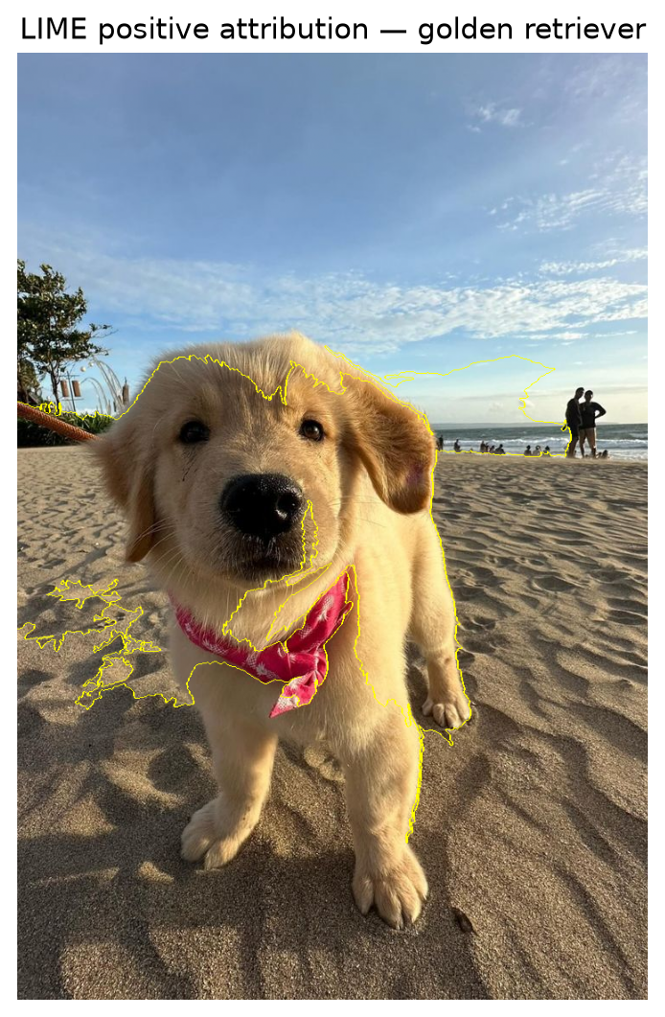
dog2.jpg — LIME attribution
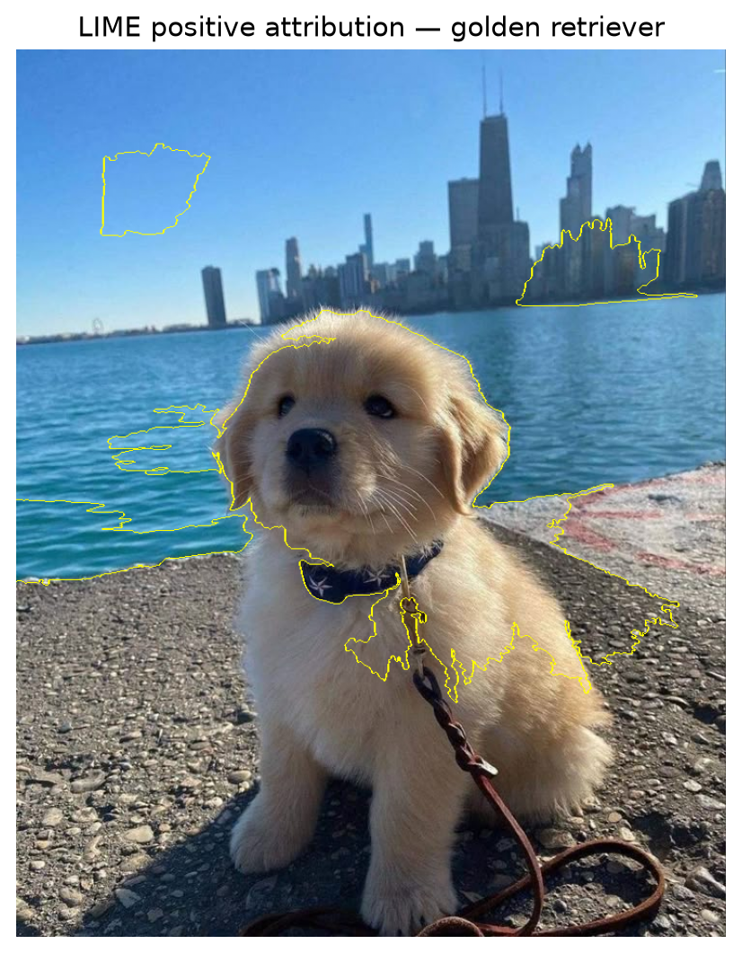
dog3.jpg — LIME attribution
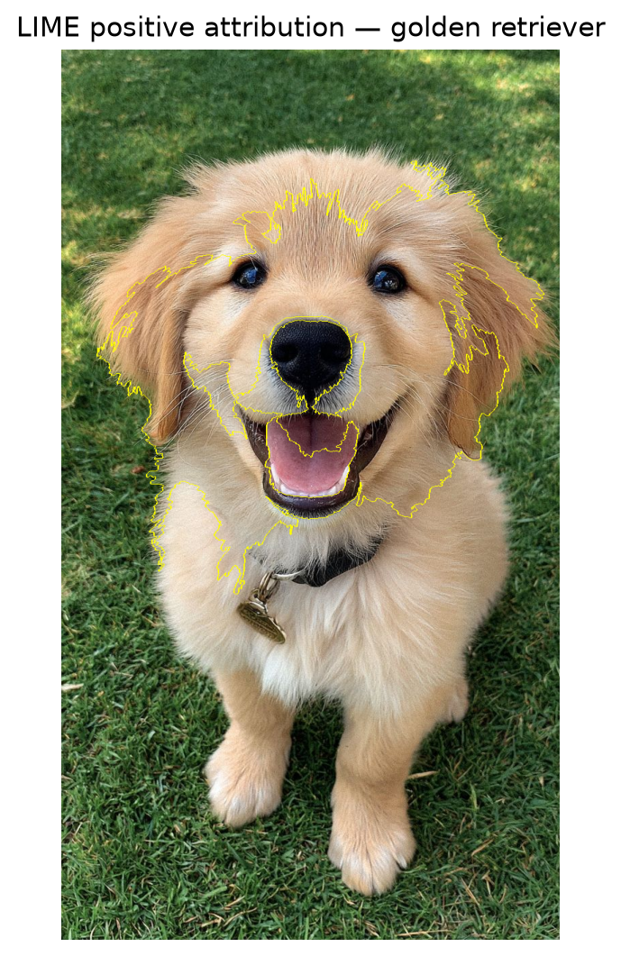

7. Disagreement Analysis
A seg. | B seg. | A R² | B R² | Jaccard | Disagreement | Reasonable
40 | 80 | 0.8242 | 0.6093 | 0.2659 | 73.41% | Yes
40 | 120 | 0.8242 | 0.5374 | 0.2519 | 74.81% | Yes
80 | 120 | 0.6093 | 0.5374 | 0.4903 | 50.97% | Yes
Selected pair: A = 40 segments, B = 120 segments. Pixel-mask disagreement = 74.81%; Jaccard overlap = 0.2519.
Explanation A — 40 segments
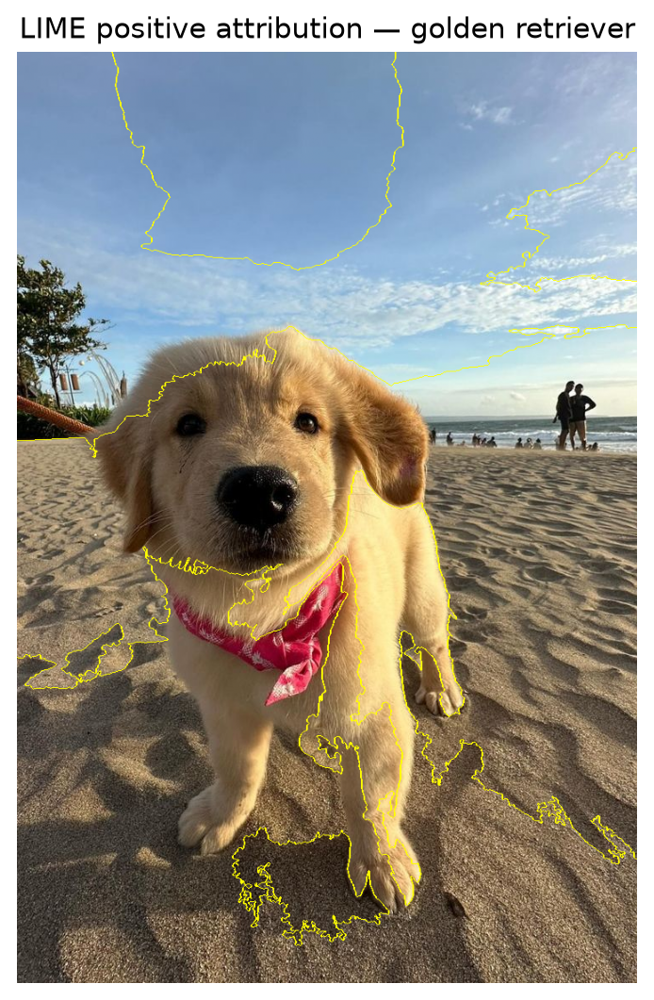
Explanation B — 120 segments
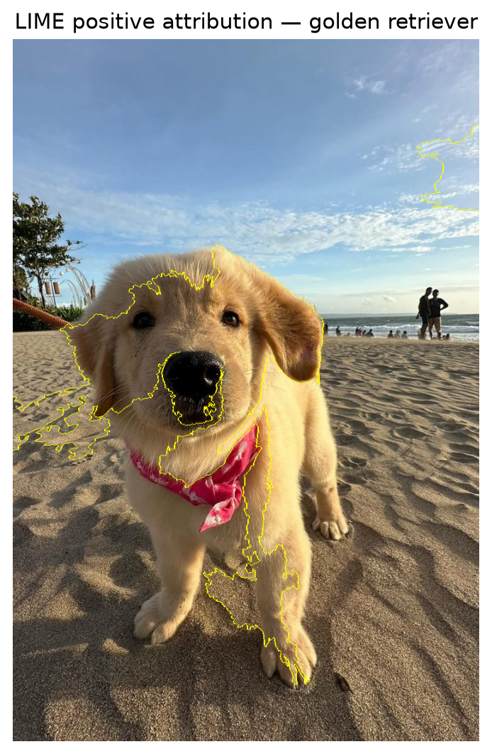
Direct comparison of A and B
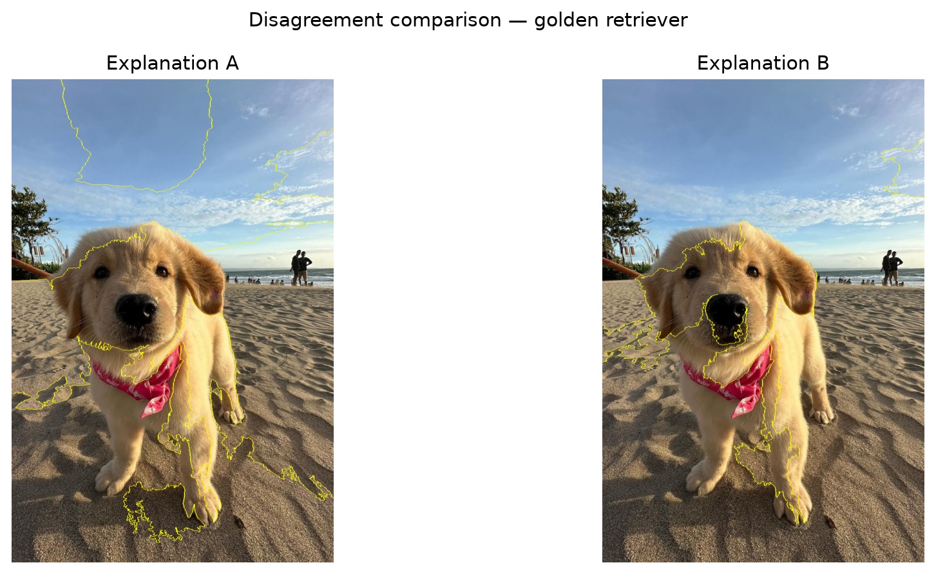

8. Prediction-Only Validation
Metric | A | B
Deletion AUC (probability drop) | 0.033839 | 0.058156
Insertion AUC | 0.190840 | 0.169268
Combined A − B support | -0.002746 | —
Decision margin | 0.050000 | —
Final decision | Neither / inconclusive
Deletion test
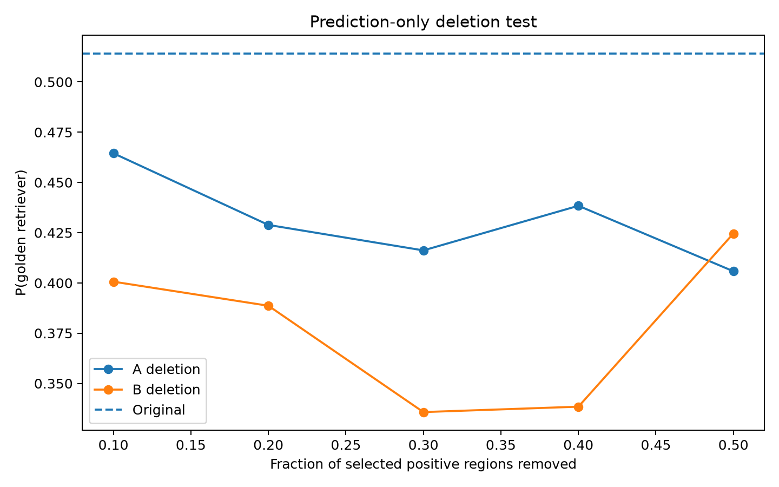
Insertion test
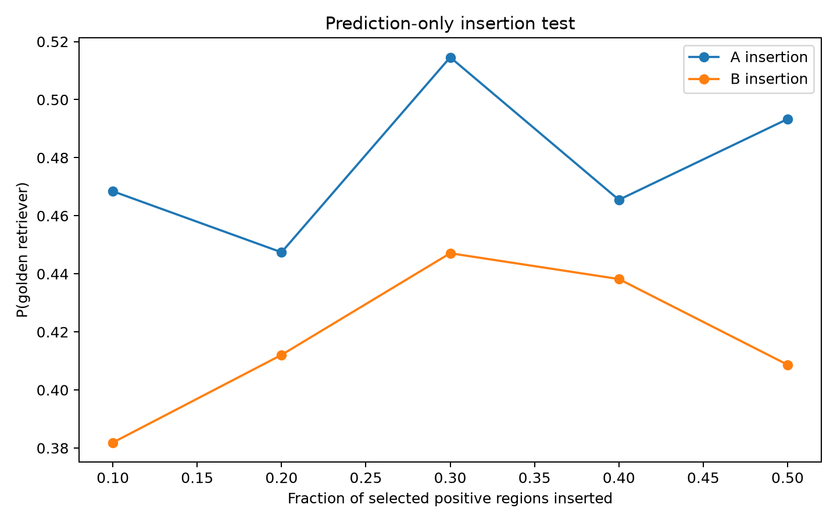

9. Detailed Prediction-Test Results
Fraction | A deletion P | B deletion P | A insertion P | B insertion P
10% | 0.4645 | 0.4006 | 0.4684 | 0.3819
20% | 0.4288 | 0.3886 | 0.4474 | 0.4121
30% | 0.4162 | 0.3357 | 0.5146 | 0.4471
40% | 0.4384 | 0.3384 | 0.4655 | 0.4382
50% | 0.4058 | 0.4246 | 0.4933 | 0.4087

10. What Is Understood from the Results

Consistent classification
All three dog images received the same predicted class, golden retriever, although confidence varied from 39.79% to 51.42%.

Sensitivity to segmentation
Changing the SLIC segmentation produced substantially different highlighted regions. The selected 40-vs-120 pair disagreed over 74.81% of the evaluated pixel mask.

Fidelity is not proof
A had higher local surrogate fidelity (R² 0.8242) than B (0.5374), but this alone does not establish that A is the correct explanation.

Prediction-only result
B had the larger deletion probability drop, while A had the larger insertion score. Because the signals conflict and the combined difference is only -0.002746, below the 0.05 margin, neither explanation is supported strongly enough.

XAI lesson
Explanation sensitivity is itself an important result. When reasonable explanations disagree, a validation procedure should be used rather than selecting a visualization by appearance alone.

11. Limitations
- The model is pretrained on ImageNet rather than trained specifically on these images.
- The three predictions have moderate confidence.
- LIME is local and can vary with segmentation, sampling, or random seed.
- Prediction-only validation measures consistency with model behavior, not real-world causal truth.
- Perturbation baselines can affect deletion/insertion measurements.
- The model may use contextual or spurious visual cues.

12. Conclusion
The experiment successfully applied LIME to a pretrained ResNet-50 ImageNet classifier and generated attribution maps for three dog images. All three were classified as golden retriever. For dog1.jpg, changing SLIC segmentation from 40 to 120 segments produced two reasonable but strongly disagreeing explanations, with 74.81% pixel-mask disagreement.
The pre-defined prediction-only validation did not establish a winner. Explanation B produced the larger deletion probability drop, while explanation A produced the larger insertion score. The combined support difference was -0.002746, far below the 0.05 decision margin. Therefore, the experimental conclusion is neither/inconclusive.
The main lesson is that LIME explanations are local approximations and can be sensitive to methodological choices. A visually plausible explanation should not automatically be treated as ground truth; when explanations disagree, explicit validation is valuable.

13. Reproducibility and Repository
Code: https://github.com/CodeCraftsmanRaj/xAI/tree/main/Experiment_8_LIME
Generated outputs include predictions.csv, summary.json, decision.md, decision_criterion.md, three_image_lime.csv, disagreement_pairs.csv, prediction_test.csv, attribution maps, explanation comparisons, and deletion/insertion plots.

14. Key Takeaways
- LIME provides useful local visual explanations for image classifiers.
- Explanations can change substantially with segmentation granularity.
- Local fidelity should not be interpreted as proof of causal correctness.
- Deletion and insertion tests can compare explanations using only model predictions.
- When validation evidence is conflicting or too small, an inconclusive result is scientifically preferable to forcing a winner.

