BHARATIYA VIDYA BHAVAN’S
SARDAR PATEL INSTITUTE OF TECHNOLOGY
Bhavan’s Campus, Munshi Nagar, Andheri (West), Mumbai – 400058
DEPARTMENT OF COMPUTER ENGINEERING

Student Detail | Information
Name | Raj Mathuria
UID No. | 2023300139
Batch | PE - C
Experiment No. | 2
GitHub Repository | https://github.com/CodeCraftsmanRaj/xAI/tree/main/Exp2

EXPERIMENT NO. 2

AIM
To train a Random Forest classifier on a tabular dataset, assess its classification performance using standard metrics, and apply SHAP (SHapley Additive exPlanations) to interpret the model at both dataset-wide and individual-prediction levels.

THEORY

Random Forest Classifier
Random Forest is an ensemble learning method that combines the predictions of multiple decision trees. Each tree is trained using a random sample of the training data and considers subsets of features when splitting nodes. For classification, the forest combines the outputs of its trees to produce a final class prediction. Combining many trees generally reduces the instability of a single decision tree and can provide strong performance on tabular data.

SHAP (SHapley Additive exPlanations)
SHAP is a model-interpretation approach inspired by Shapley values from cooperative game theory. It assigns each input feature a contribution to a model output, treating the features as contributors to the prediction. A SHAP explanation expresses the output as a baseline prediction plus the contributions assigned to the individual features:
f(x) = E[f(x)] + Σᵢ φᵢ
Here, E[f(x)] is the expected or baseline output, φᵢ is the SHAP contribution for feature i, and f(x) is the explained model output. A positive SHAP value moves the explained output upward, while a negative value moves it downward. The precise interpretation depends on the output class being explained.

Global and Local Interpretation
Global interpretation summarizes feature influence across many examples. A SHAP beeswarm plot displays the spread and direction of feature contributions alongside feature values, while a SHAP bar plot ranks features by their mean absolute SHAP values.
Local interpretation focuses on one observation. A waterfall plot shows how individual feature contributions move the prediction away from the baseline. A force plot visualizes the same push-and-pull effect interactively. A SHAP scatter plot can help reveal how the value of a selected feature relates to its SHAP contribution and how that relationship varies with another feature.
For tree-based estimators such as Random Forest, SHAP's TreeExplainer uses the structure of the trees to compute explanations efficiently.

DATASET
The experiment uses scikit-learn's Breast Cancer Wisconsin Diagnostic dataset. It contains 569 observations, 30 numerical features, and two target classes: malignant and benign. The feature set includes measurements such as radius, texture, perimeter, area, smoothness, compactness, concavity, and symmetry.
The data was split into training and testing subsets using an 80:20 split. Stratification preserved the class proportions, and a fixed random seed was used for reproducibility.

PROGRAM
import numpy as np
import pandas as pd
import matplotlib.pyplot as plt
from sklearn.datasets import load_breast_cancer
from sklearn.model_selection import train_test_split
from sklearn.ensemble import RandomForestClassifier
from sklearn.metrics import accuracy_score, classification_report, confusion_matrix
import shap
# Load dataset
data = load_breast_cancer()
X = pd.DataFrame(data.data, columns=data.feature_names)
y = pd.Series(data.target)
print(X.head())
print("Shape:", X.shape)
print("Classes:", data.target_names)
# Train-test split
X_train, X_test, y_train, y_test = train_test_split(
X, y, test_size=0.2, random_state=42, stratify=y
)
# Train Random Forest
rf = RandomForestClassifier(n_estimators=100, random_state=42)
rf.fit(X_train, y_train)
# Evaluate the classifier
y_pred = rf.predict(X_test)
print("Accuracy:", accuracy_score(y_test, y_pred))
print("\\nClassification Report\\n")
print(classification_report(y_test, y_pred))
print("\\nConfusion Matrix\\n")
print(confusion_matrix(y_test, y_pred))
# Create the SHAP explainer and compute values for test data
explainer = shap.TreeExplainer(rf)
shap_values = explainer(X_test)
# Global interpretation: class index 1 (benign)
shap.plots.beeswarm(shap_values[:, :, 1])
shap.plots.bar(shap_values[:, :, 1])
# Local interpretation for one test observation
sample = 15
original_index = X_test.index[sample]
print("Original Dataset Index:", original_index)
print("Feature Values:")
print(X_test.iloc[sample])
actual = y_test.iloc[sample]
predicted = rf.predict(X_test.iloc[[sample]])[0]
prob = rf.predict_proba(X_test.iloc[[sample]])[0]
print("Actual Class:", actual)
print("Predicted Class:", predicted)
print(f"Probability of Malignant (Class 0): {prob[0]:.4f}")
print(f"Probability of Benign (Class 1): {prob[1]:.4f}")
# Local SHAP plots
shap.plots.waterfall(shap_values[sample, :, 1])
shap.initjs()
shap.plots.force(shap_values[sample, :, 0])
# Feature effect / interaction view
shap.plots.scatter(
shap_values[:, "mean concave points", 1],
color=shap_values[:, :, 1]
)

PROCEDURE
- Import the required libraries for data handling, visualization, classification, evaluation, and SHAP explanations.
- Load the Breast Cancer Wisconsin Diagnostic dataset and create a feature table and target vector.
- Split the data into training and testing subsets using an 80:20 ratio with stratification.
- Train a Random Forest classifier with 100 decision trees.
- Predict the classes for the test subset and evaluate the predictions using accuracy, a classification report, and a confusion matrix.
- Create a SHAP TreeExplainer and compute SHAP values for the test data.
- Use a beeswarm plot and a bar plot to inspect global feature importance.
- Select a test observation and examine its actual class, predicted class, and class probabilities.
- Generate waterfall and force plots for local interpretation, and use a SHAP scatter plot to inspect a feature relationship.

RESULTS
The Random Forest model was evaluated on 114 test observations. The recorded accuracy was approximately 95.61%. The classification report and confusion matrix from the provided experiment are reproduced below.
Metric | Class 0 (malignant) | Class 1 (benign)
Precision | 0.95 | 0.96
Recall | 0.93 | 0.97
F1-score | 0.94 | 0.97
Support | 42 | 72

Confusion Matrix | Predicted malignant | Predicted benign
Actual malignant | 39 | 3
Actual benign | 2 | 70

The confusion matrix indicates that 39 malignant observations and 70 benign observations were classified correctly. Three malignant observations were predicted as benign, while two benign observations were predicted as malignant. The weighted-average F1-score was approximately 0.96.

Global SHAP Interpretation
The beeswarm plot ranks features by their overall influence and shows the distribution of SHAP values across test observations. In the supplied result, features such as worst area, worst concave points, worst radius, worst perimeter, and mean concave points appear among the most influential features for the benign-class output. Points to the left of zero lower that output, while points to the right raise it.
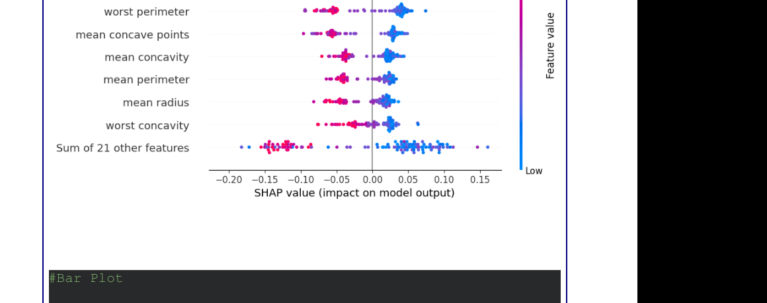
Figure 1. SHAP beeswarm plot from the supplied experiment.
The SHAP bar plot summarizes the average absolute contribution of each feature. The strongest individual features shown include worst area, worst concave points, worst radius, worst perimeter, and mean concave points. The grouped contribution of the remaining features is also substantial, indicating that the classifier relies on a combination of measurements.
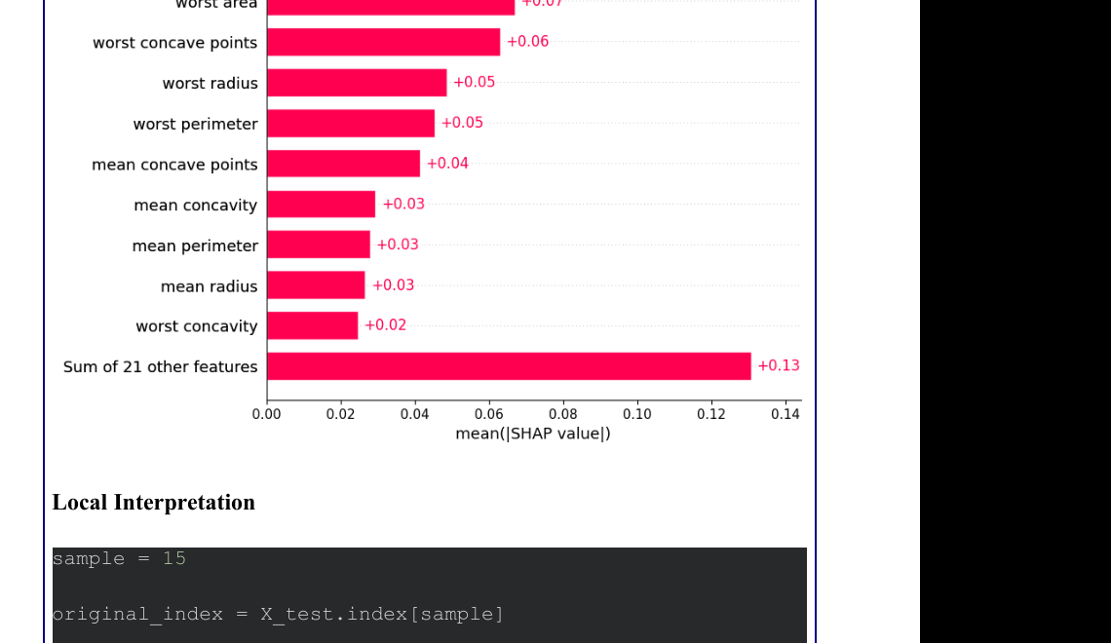
Figure 2. SHAP global feature-importance bar plot from the supplied experiment.

Local SHAP Interpretation
For the selected test observation, the original dataset index was 495. The actual class was 1 and the model also predicted class 1, corresponding to benign in this dataset. The recorded class probabilities were 0.1300 for malignant and 0.8700 for benign.
Local prediction detail | Value
Original dataset index | 495
Actual class | 1 (benign)
Predicted class | 1 (benign)
P(malignant) | 0.1300
P(benign) | 0.8700

The waterfall plot explains how feature contributions move the selected prediction from the baseline to the model output. Features with positive SHAP values increase the explained benign-class output, whereas negative values decrease it.
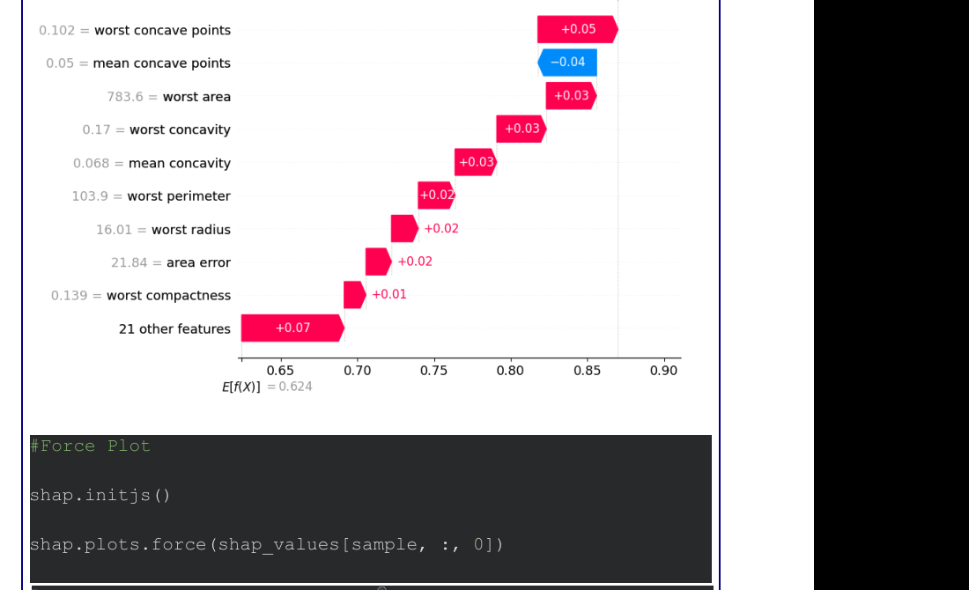
Figure 3. SHAP waterfall plot for the selected observation.
The force plot provides another view of how feature contributions push the output upward or downward from the baseline. The supplied visualization shows the baseline near 0.624 and the final output near 0.87 for the explained benign class.

Figure 4. SHAP force plot included in the supplied results.
The scatter plot examines the relationship between the value of mean concave points and its SHAP contribution for the benign-class output. The pattern suggests that the effect of this feature is not constant across its range; feature values and interactions with other variables are associated with different contributions.
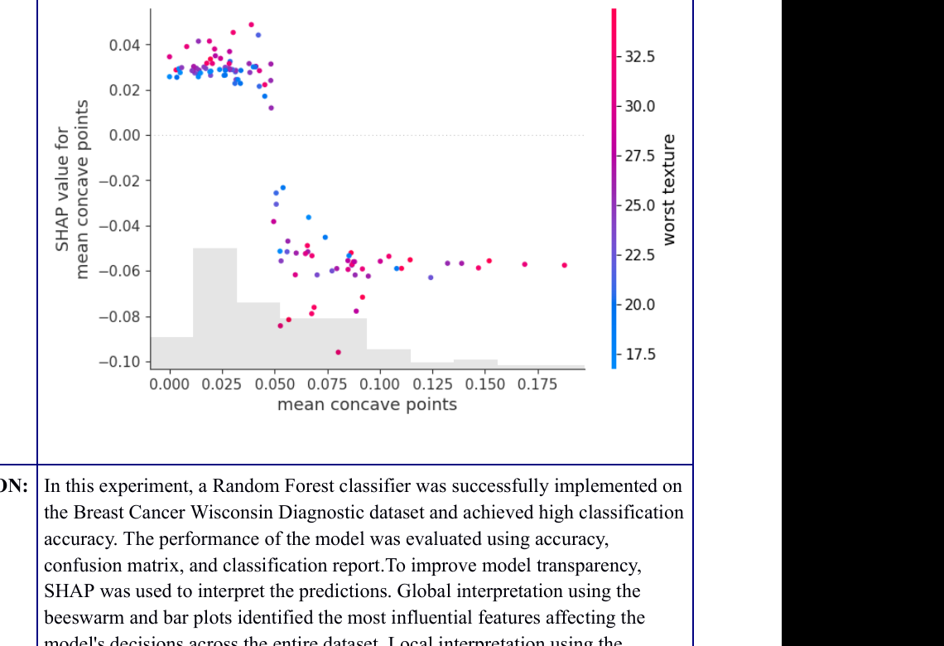
Figure 5. SHAP scatter plot for mean concave points.

CONCLUSION
A Random Forest classifier was trained on the Breast Cancer Wisconsin Diagnostic dataset and achieved approximately 95.61% accuracy on the held-out test set. Its performance was assessed using precision, recall, F1-score, and a confusion matrix. SHAP was then used to improve interpretability: the beeswarm and bar plots summarized global feature influence, while the waterfall and force plots explained an individual prediction relative to a baseline. The selected observation was correctly classified as benign with a predicted probability of 0.87. Overall, the experiment demonstrates how a tree-ensemble classifier can be evaluated quantitatively and examined using both global and local feature-attribution methods.

REPOSITORY
https://github.com/CodeCraftsmanRaj/xAI/tree/main/Exp2

