**CS673S16 Software Engineering** 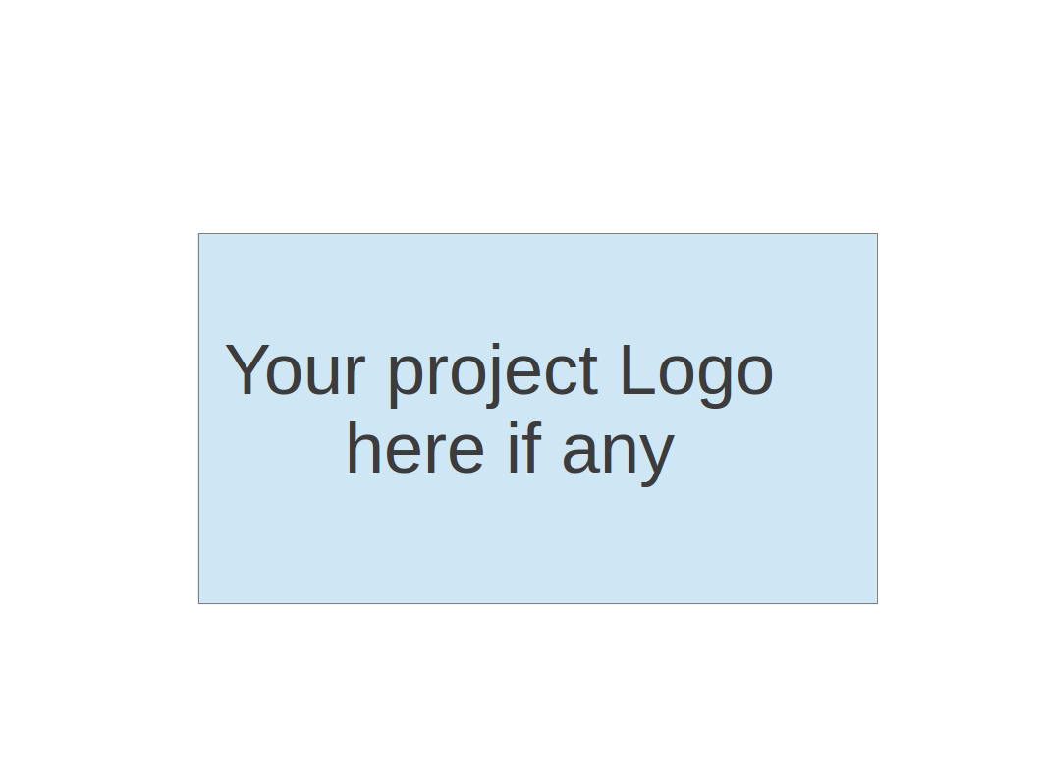

**Team 1 - Project Portal**

**Tests Report**

|  |  |  |  |
| --- | --- | --- | --- |
| Team Member | Role(s) | Signature | Date |
| Kanishka Bagri | QA Leader | *Kanishka Bagri* | 03/22/2018 |

**Revision history**

|  |  |  |  |
| --- | --- | --- | --- |
| **Version** | **Author** | **Date** | **Change** |
| Initial Draft with Metrics | Kanishka Bagri | 03/22/2018 |  |
| Final Version | Kanishka Bagri | **04/30/2018** |  |

Introduction

Test Summary

Tests Reports

Testing Metrics

References

Glossary

# Introduction

This document summarizes the Test activities including Testing strategy, Defect Analysis, Test Reports, etc for the “**Project Portal Application**”.

# Test Summary

### Unit Test

Unit testing is a part of the software development process, where the developers writing the code also develop corresponding Tests to test the individual classes/methods. These tests will be automated and run as a part of each build.

### Acceptance Test

Acceptance Test is a part of the User Story Development Process where the functionality is tested in accordance to the pre-agreed Acceptance Criteria defined in the User Story

### System Tests

System testing is a part of the testing process. In this phase the behavior of the features is tested in conjunction with the overall product. I.e. the “Add a User” story is tested in the browser with real data to ensure it works well with all the other components.

# Testing Strategy

* Setting up a common environment for testing (Dev and QA)
* Understanding and preparation of the Test Plan document for the defined Story
* Adding Test cases for identified scenarios in the Test Case Management Tracker
* API: Add new automation test cases for the new APIs being developed
* Functional Testing: Execution of identified test cases on the latest build
* Regression Testing:
  + Execute P1/P2 test cases.

# Automation Strategy:

**API Automation:**

Mocha and Chai will be used for developing all the API automation tests

All the test cases will be added to the test folder in the code base:

<https://github.com/cs673-team-silver-serpent/project/tree/master/test>

**UI Automation:**

Protractor (webDriver based) tool will be used for running the UI Automation tests

<https://github.com/cs673-team-silver-serpent/project/tree/master/test>

# Tests Reports

The Test Case management and the Defect tracking is being done in a separate sheet for easier management and access. Please refer to the **ProjectPortal_TestingDocument.xls** on the google Drive for further details. Below is a snippet of the Template that will be used for this effort:

### Test Case Management:

* Module
* Test case ID/name
* Test Case Summary
* Test items: (what do you test )
* Test priority (high/medium/low)
* Test steps:
* Expected output:
* Actual output:
* Pass or Fail:
* Bug id/link
* Additional notes:

### Defect Management:

* Defect ID
* Defect Summary
* Description
* Priority
* Severity
* Status
* Dev Owner
* QA Owner
* Test Case ID

# Testing Metrics

This section documents the identified metrics at the end of each Sprint:

# Product Complexity:

|  |  |  |  |  |
| --- | --- | --- | --- | --- |
|  | Iteration 0 | Iteration 1 | Iteration 2 | Iteration 3 |
| Lines of Code (LOC)  The total number of lines of code in the application |  | N/A | N/A | N/A |
| Number of Files  The total number of classes or functions in the entire application |  | N/A | N/A | N/A |
| Number of classes:  The total number of classes or functions in the entire application |  | N/A | N/A | N/A |
| Number of methods  The total number of methods in the application |  | N/A | N/A | N/A |

# Process Metrics:

|  |  |  |  |  |
| --- | --- | --- | --- | --- |
|  | Iteration 0 | Iteration 1 | Iteration 2 | Iteration 3 |
| Team Velocity:  This measures the number of User Stories the team complete in an Iteration |  | 4 | 12 | 11 |
| Open/Close Rates  This measures the number of Defects reported in a sprint |  |  | 12 | 24 |
| Active Days  This is a measure of the time a team member spends contributing to the product development cycle |  | 6 | 10 | 10 |
| Code Churn  Code churnsindicates the number of Lines of code that were modified during an iteration. This would include the lines of code that have been added or deleted. |  |  |  |  |
| Defect per n LOC  This is a ratio of the number of defects reported for every n lines of code |  |  |  |  |
| QA kickback rate  Number of defects that were re-opened by QA in an Iteration |  |  | 3 | 5 |

# Testing:

|  |  |  |  |  |
| --- | --- | --- | --- | --- |
|  | Iteration 0 | Iteration 1 | Iteration 2 | Iteration 3 |
| Unit Test  The percentage of code that is tested by Unit Tests |  |  | 30 | 54 |
| Average Lifetime of Open Defects  Average lifetime of reported defects. This should be less than 3 days |  |  | 3 | 4 |
| Defects reported for each User Story  The number of defects reported for a user story. This number is a direct indication of the quality of the story |  |  | 3 | 3 |
| Automation Coverage  The percentage of identified P1/P2 test cases that are being tested via Automation. |  | 100% | 85% | 92% |

**Product Cost:**

|  |  |  |  |  |
| --- | --- | --- | --- | --- |
|  | Iteration 0 | Iteration 1 | Iteration 2 | Iteration 3 |
| Man hours  The total number of hours spent on the Project, including development, Test, Management |  | 400 | 400 | 500 |

# References

# Glossary