 Impact of Al in African Startups and Enterprise Success in 2025
A Comprehensive Study of Exposure, Application, and Implications of Artificial Intelligence for Investment Dynamics and the Future of Work,

Jomo Kenyatta University of Agriculture and Technology (JKUAT)
Authors : John Mwega | SCT212-0055/2021
BCT2406 : Project , BSc. Computer Technology
Supervisors: Dr. Damaris Waema, PHd
Dr, Petronilla Muriithi, PHd
Dr. Eunice Njeri, PHd
Keywords:
Artificial Intelligence, African Startups, Machine Learning, Venture Capital, Workforce Transformation, Future of Work, Investment Analysis, Economic Impact

Acknowledgement
I would like to express my sincere gratitude to everyone who contributed to the successful completion of this dissertation and project.
First and foremost, I thank my supervisor for the invaluable guidance, constructive criticism, encouragement, and continuous support throughout the research and writing process. Their academic insight and mentorship greatly shaped the quality and direction of this work.
I also extend my appreciation to the lecturers and staff of the Computing Department of JKUAT for providing the knowledge, resources, and academic environment necessary for the completion of this study.
Special thanks go to my colleagues, friends, and peers who offered support, ideas, motivation, and encouragement during the course of this research.
I am deeply grateful to my family for their patience, understanding, moral support, and unwavering belief in my abilities throughout my academic journey.
Finally, I acknowledge all researchers, authors, and developers whose published works, tools, and resources contributed significantly to this thesis.
To all who contributed directly or indirectly, I sincerely thank you.

Abstract
Artificial Intelligence (AI) is increasingly shaping entrepreneurial ecosystems worldwide; however, its measurable impact on African startups and enterprises remains insufficiently examined. This study investigates the role of AI in African startups in 2025, with particular emphasis on AI exposure, sectoral applications, investment dynamics, workforce transformation, and startup success outcomes. Using a comparative multi-country approach, the study focuses on Kenya, Nigeria, and South Africa, which represent Africa’s most active and diverse startup ecosystems.
A mixed-methods research design is adopted. Quantitative analysis draws on startup investment databases, performance indicators, and shutdown records between 2019 and 2026, while qualitative evidence is obtained from case studies, founder interviews, and policy documents. In addition, the study develops a machine learning–based predictive model to estimate the probability of startup success or failure based on AI maturity, funding patterns, sector, and workforce characteristics.
Findings indicate that startups with higher levels of AI integration demonstrate improved operational efficiency, stronger scalability potential, and greater access to venture capital, particularly cross-border investment under frameworks such as the African Continental Free Trade Area (AfCFTA). However, AI adoption remains uneven due to structural challenges including talent shortages, regulatory uncertainty, infrastructure limitations, and constrained access to high-quality data. Analysis of startup failures between 2023 and 2024 shows that weak or misaligned AI implementation, combined with governance and market-fit challenges, significantly contributed to business collapse.
The study reveals that AI adoption is reshaping workforce demand by increasing the need for advanced digital and cognitive skills while automating routine functions, underscoring the urgency for adaptive education and labor policies. Overall, the research contributes empirical and computational evidence to the literature on AI-driven entrepreneurship in emerging economies and provides actionable recommendations for policymakers, investors, and startup founders. It concludes that while AI is a transformative driver of startup success in Africa, its benefits depend on coordinated investment in skills development, regulatory frameworks, and digital infrastructure.
The study also examines startup failures between 2023 and 2024, showing that the absence or misapplication of AI, alongside governance, financial, and market-fit challenges, contributed to high-profile shutdowns. Successful unicorns demonstrate strategic AI integration with sound leadership, diversified revenue models, and market engagement. AI further reshapes labor demand, increasing the need for digital and cognitive skills while automating routine tasks, highlighting the need for adaptive education and workforce policies.
Overall, this study contributes to academic literature on AI and entrepreneurship in emerging economies while offering practical and policy-relevant recommendations for founders, investors, and governments. It concludes that AI represents a transformative but uneven force in Africa’s startup ecosystem, requiring coordinated investments in talent, regulation, and digital infrastructure to ensure sustainable and inclusive growth.

Table of Contents
 Impact of Al in African Startups and Enterprise Success in 2025 1
Jomo Kenyatta University of Agriculture and Technology (JKUAT) 1
Acknowledgement 2
Chapter One: Introduction 11
1.1 Background of the Study 11
1.2 Artificial Intelligence and the African Startup Ecosystem 12
1.3 Problem Statement 13
1.4 Research Objectives 13
1.5 Research Questions 14
1.6 Research Hypotheses 14
H1: AI Adoption and Startup Success 14
H2: AI Adoption and Investment Outcomes 15
H3: Workforce AI Skills and Enterprise Performance 15
H4: Sectoral Differences in AI Impact 16
H5: Country-Level Context and AI Effectiveness 16
H6: Comparative Advantage Through AI Integration 17
H7: Predictive Validity of AI-Driven Models 17
1.7 Scope of the Study 18
1.8 Significance of the Study 18
1.8 Justification of Country Case Studies 18
1.9 Structure of the Dissertation 19
Chapter Two: Literature Review 20
2.1 Introduction 20
2.2 Artificial Intelligence: Concepts and Global Adoption 20
2.3 The African Startup Ecosystem: Scope and Characteristics 21
2.4 AI Adoption in African Contexts 24
2.5 Sectoral Patterns of AI Integration 28
2.5.1 Fintech and Financial Services 28
2.5.2 Agritech and Agriculture Innovation 29
2.5.3 Health Technology 29
2.6 Investment Dynamics and Venture Capital Trends 30
2.7 Workforce Transformation and Skills Demand 30
2.8 Ecosystem Challenges and Institutional Barriers 31
2.8.1 Infrastructure and Data Centers 31
2.8.2 Regulatory and Policy Frameworks 31
2.8.3 Talent and Education Gaps 31
2.9 Research Gaps and Chapter Summary 31
Chapter Three: Research Methodology 33
3.1 Introduction 33
3.2 Research Philosophy and Paradigm 34
3.3 Research Design 34
3.3.1 Mixed-Methods Research Design 34
3.4 Three-Preset Methodological Framework 36
3.4.1 Preset One: Historical and Structural Context 36
3.4.2 Preset Two: Current AI Adoption and Workforce Dynamics 38
3.4.3 Preset Three: Investment Outcomes and Predictive Analysis 40
3.5 Data Sources and Description 42
3.5.1 Overview of Integrated Datasets 42
3.5.2 Startup Investment Dataset 43
Variables Included 43
Purpose of the Dataset 44
Data Cleaning Procedures 44
3.5.3 Macroeconomic and Institutional Dataset 45
Variables Included : 45
Analytical Role 46
3.5.4 AI Workforce and Automation Dataset 46
Variables Included : 47
Workforce Exposure Measurement 47
Significance 48
3.6 Operationalization of Key Variables 48
Startup Success Variable 49
AI Workforce Exposure Index 49
Country Readiness Score 49
3.7 Data Integration and Feature Engineering 50
Data Cleaning Procedures 50
Missing Data Treatment 50
Standardization 51
Categorical Encoding 51
Feature Engineering 51
3.8 Machine Learning–Based Predictive Modeling 52
3.8.1 Model Objective 52
3.8.2 Model Feature Set 53
3.8.3 Model Selection and Evaluation 53
Logistic Regression 54
Random Forest Classifier 54
Gradient Boosting Classifier 54
Model Training Procedure 55
Evaluation Metrics 55
3.9 Qualitative Case Study Analysis 56
Selected Case Studies 56
Successful or High-Growth Startups 56
Failed or Struggling Startups 56
Data Sources for Qualitative Analysis 57
Analytical Approach 57
3.10 Ethical Considerations 58
Data Integrity and Transparency 58
Algorithmic Fairness and Bias 58
Research Limitations 59
3.11 Alignment with Study Objectives 59
3.12 Chapter Summary 60
Chapter Four: Analysis And Findings 61
4.1 Introduction 61
4.2 Descriptive Statistics and Exploratory Data Analysis 62
4.2.1 Startup Funding Dataset 62
Distribution of Startup Funding 63
Funding Stage Analysis 63
Startup Survival Outcomes 64
AI Exposure and Investment Correlation 65
4.2.2 Macroeconomic Dataset 66
Country-Level Economic Comparisons 66
AI Readiness and Startup Success 67
Education and Workforce Indicators 68
4.2.3 Global AI and Workforce Dataset (gw_df) 68
AI Skill Demand Trends 69
Workforce Transformation 69
AI Workforce Exposure Index 70
4.3 Predictive Modeling Results 70
4.3.1 Model Configuration and Evaluation Metrics 71
4.3.2 Logistic Regression Results 71
Key Findings 72
4.3.3 Random Forest Results 72
Important Observations 73
4.3.4 Gradient Boosting Results 73
Performance Characteristics 73
4.4 Feature Importance Analysis 74
Interpretation 75
4.5 Country and Sector Benchmarks 76
4.5.1 Sectoral Comparisons 76
Fintech 76
Health Technology 76
Agritech 77
Logistics and E-Commerce 77
4.5.2 Country Scenario Analysis 77
Kenya 77
Nigeria 78
South Africa 78
4.6 Case Studies and Qualitative Corroboration 78
Successful AI-Driven Startups 79
Startup Failures 79
4.7 Hypotheses Validation 80
4.8 Summary of Key Findings 80
4.9 Conclusion 81
CHAPTER FIVE: DISCUSSION, CONCLUSION AND RECOMMENDATIONS 83
5.1 Introduction 83
5.2 Overview and Synthesis of the Principal Findings 84
5.3 The AI-Driven Enterprise Success Paradox 85
5.4 Evaluation of the Research Hypotheses 87
Table 5.1: Comprehensive Synthesis of Hypothesis Testing 88
5.5 AI Adoption, Technological Readiness, and Enterprise Performance 89
5.6 AI, Venture Capital, and Investment Dynamics 90
5.7 Workforce Transformation and Human Capital 91
5.7.1 Growth in High-Skill Roles 92
5.7.2 Automation of Routine Cognitive Work 92
5.8 Sectoral Heterogeneity in AI Impact 93
5.8.1 Fintech 93
5.8.2 Agritech 94
5.8.3 Healthtech 95
5.8.4 E-Commerce and Logistics 95
5.9 Country-Level Comparative Analysis 96
5.9.1 Kenya 96
5.9.2 Nigeria 97
5.9.3 South Africa 97
5.10 Institutional Moderation and Comparative Advantage 98
5.11 Predictive Modelling and Machine-Learning Efficacy 99
Micro-level variables 99
Macro-level variables 99
5.12 Qualitative Corroboration: Analysis of Startup Failures 100
5.12.1 Type I: Superficial AI-Wrapper Syndrome 100
5.12.2 Type II: Infrastructure Disconnect and Unit-Economic Failure 101
5.12.3 Type III: Governance, Data and Capital Inefficiency 101
5.13 Theoretical Contributions 102
5.13.1 Resource-Based View and Dynamic Capabilities 102
5.13.2 Venture-Capital Signalling Theory 102
5.14 Methodological Contributions 103
5.15 Practical and Managerial Implications 104
5.16 Strategic Recommendations 105
5.16.1 Recommendations for Startup Founders and Enterprise Leaders 105
1. Build Proprietary Data Assets 105
2. Enforce Unit-Economic Discipline 105
3. Adopt Modular and Cost-Aware MLOps 105
4. Prioritize Product-Market Fit 106
5.17 Recommendations for Venture Capital and Angel Investors 106
5.17.1 Adopt Multi-Dimensional AI Due Diligence 106
5.17.2 Distinguish AI Wrappers from Defensible AI Businesses 107
5.17.3 Develop Shared Ecosystem Infrastructure 107
5.18 Recommendations for Policymakers and Regulators 108
5.18.1 Harmonize Cross-Border Data Governance 108
5.18.2 Invest in Compute and Digital Infrastructure 108
5.18.3 Develop AI Talent 108
5.19 Recommendations for Universities and TVET Institutions 109
5.20 Implications for the Future of African Enterprise 110
5.21 Limitations of the Study 111
5.21.1 Reporting Bias in Private Startup Databases 111
5.21.2 Rapid Technological Change 111
5.21.3 Geographic Concentration 111
5.21.4 Data Availability 112
5.21.5 Interpretation of Predictive Models 112
5.22 Directions for Future Research 112
5.22.1 Longitudinal Research on Generative-AI-Native Startups 113
5.22.2 AfCFTA Digital Integration 113
5.22.3 Expansion Beyond the Three Core Markets 113
5.22.4 Environmental and Energy Implications of AI 114
5.22.5 AI and Informal Enterprises 114
5.23 Integrated Conceptual Interpretation of the Findings 115
Stage 1: Enabling Environment 115
Stage 2: Organizational Capability 115
Stage 3: AI Deployment 115
Stage 4: Operational Transformation 116
Stage 5: Sustainable Enterprise Success 116
5.24 Overall Conclusion 117
References 120
Internal Data 120
Public Data 120
List of Figures 131
List of Tables 132

Chapter One: Introduction

1.1 Background of the Study
Artificial Intelligence (AI) has emerged as a transformative force in the global economy, driving innovation, efficiency, and competitiveness across sectors. AI encompasses technologies such as machine learning, natural language processing, computer vision, and predictive analytics, enabling organizations to process large volumes of data, automate decision-making, and deliver new products and services. Globally, AI adoption is reshaping the entrepreneurial landscape, influencing investment decisions, workforce dynamics, and organizational structures. While developed economies have witnessed extensive AI integration, the adoption and impact of AI in African startups and enterprises remains comparatively nascent, uneven, and underexplored.
Africa’s startup ecosystem has grown substantially over the past decade, fueled by digital infrastructure expansion, increased access to venture capital, and a growing pool of skilled technology talent. Countries such as Kenya, Nigeria, and South Africa have emerged as regional hubs, hosting a diversity of startups in fintech, health technology, agricultural technology, logistics, e-commerce, and AI-native ventures. Despite this growth, the continent faces unique structural challenges, including limited access to funding, regulatory uncertainty, infrastructure deficits, and shortages of specialized talent. These factors interact with AI adoption to shape organizational performance, investment attractiveness, and sustainability outcomes in ways that are not yet fully understood.
The interplay between AI adoption and startup performance is particularly critical for investment dynamics. Venture capitalists and angel investors increasingly consider technological readiness and innovation potential when making funding decisions. AI can enhance decision-making, reduce operational inefficiencies, and enable startups to scale faster. At the same time, misaligned AI integration, inadequate talent, and poor governance can amplify risks, contributing to high failure rates in early-stage ventures. Recent data indicates that between 2023 and 2024, several prominent African startups shut down despite market opportunities, highlighting the need for empirical studies that examine the role of AI in shaping startup resilience, investment outcomes, and workforce transformations.
Furthermore, AI adoption has implications for the future of work. While AI enhances productivity and introduces new cognitive and technical roles, it simultaneously displaces routine tasks and requires reskilling. For African startups operating in resource-constrained environments, understanding the workforce implications of AI is essential to ensure inclusive growth and sustainable enterprise development. Therefore, this study situates AI adoption within the broader context of entrepreneurship, investment dynamics, and workforce evolution, offering a comprehensive analysis of its impact on African startups and enterprises.

1.2 Artificial Intelligence and the African Startup Ecosystem
The African startup ecosystem is characterized by rapid digitalization, growing innovation hubs, and increasing international investment. However, unlike developed markets, the integration of AI technologies remains uneven and largely concentrated in specific sectors such as fintech, health tech, and logistics. AI adoption in these startups varies in terms of sophistication, ranging from basic automation to advanced machine learning-driven predictive analytics and AI-native platforms.
Fintech has become a particularly fertile ground for AI application, as financial startups leverage machine learning algorithms for credit scoring, fraud detection, customer segmentation, and personalized financial services. Health technology startups use AI to improve diagnostics, telemedicine, and resource allocation, while agricultural startups employ predictive analytics for crop yield forecasting and supply chain optimization. AI-native startups, which design products and services around AI capabilities, are emerging but remain relatively few due to resource and talent constraints.
African startups operate within complex socio-economic and institutional environments. Regulatory uncertainty, fragmented markets, and inconsistent data infrastructure often constrain the scale and speed of AI adoption. Nevertheless, AI’s potential to enhance operational efficiency, reduce costs, and improve decision-making makes it a critical factor in startup competitiveness and attractiveness to investors. Additionally, AI adoption can influence the workforce by introducing new technical roles, increasing the demand for data literacy, and reshaping organizational hierarchies. Understanding these dynamics is essential for policymakers, investors, and startup founders seeking to build resilient, scalable, and inclusive enterprises.

1.3 Problem Statement
Despite the recognized potential of AI to enhance startup performance and investment outcomes, empirical evidence on its impact within African contexts remains scarce. Startups in Africa face high mortality rates due to financial mismanagement, inadequate governance, talent shortages, and market misalignment. While AI offers tools to mitigate some of these risks, its uneven adoption, coupled with infrastructural and regulatory constraints, complicates the picture.
Between 2023 and 2024, multiple high-profile African startups shut down, including 54Gene, LazerPay, Dash, Sendy, and Copia, reflecting vulnerabilities that extend beyond market conditions. Current literature lacks comprehensive studies linking AI exposure to startup resilience, investment dynamics, and workforce transformation in African ecosystems. There is also insufficient analysis on how country-specific factors influence AI adoption and its subsequent effects on organizational performance.
Therefore, there is a need to investigate how AI adoption, applications, and maturity levels impact investment, operational efficiency, and workforce outcomes in African startups and enterprises, particularly in Kenya, Nigeria, and South Africa, which serve as continental hubs for technological innovation.

1.4 Research Objectives
General Objective:
To investigate the impact of AI adoption on African startups and enterprises in 2025, with emphasis on investment dynamics and workforce transformations.
Specific Objectives:
- To analyze the extent of AI exposure and adoption across African startups.
- To evaluate the influence of AI on investment dynamics, including venture capital decisions and funding outcomes.
- To assess the impact of AI on workforce composition, skills demand, and productivity.
- To identify the key success factors and challenges in AI integration within startups.
- To design, validate, and deploy a predictive AI model for startup success assessment and translate its findings into policy and strategic frameworks for sustainable AI-driven entrepreneurship.

1.5 Research Questions
- How prevalent is AI adoption among African startups in 2025?
- Which sectors exhibit the highest levels of AI integration, and why?
- How does AI adoption affect investment decisions and startup funding outcomes?
- What are the implications of AI adoption on workforce skills, productivity, and employment patterns1.6 Research Hypotheses
- What are the critical factors influencing successful AI integration, and how can startups mitigate associated risks?

1.6 Research Hypotheses
This study is grounded in the premise that artificial intelligence (AI) adoption acts as a strategic capability that influences startup performance, investment outcomes, and workforce dynamics within African entrepreneurial ecosystems. Drawing from the literature on technological innovation, venture capital decision-making, and human capital transformation, the following hypotheses are formulated to empirically test the relationships between AI exposure, startup success, and contextual country-level factors.
The hypotheses are structured to align directly with the study’s research objectives and analytical framework, and they are tested using integrated startup-level, macroeconomic, and global AI workforce datasets.

H1: AI Adoption and Startup Success
H₁: African startups that exhibit higher levels of AI adoption are more likely to achieve operational success than startups with low or no AI adoption.
This hypothesis is grounded in innovation and resource-based theory, which suggests that advanced technological capabilities enhance organizational efficiency, scalability, and competitive advantage. AI-enabled startups are expected to benefit from improved decision-making, automation of routine tasks, and enhanced product personalization, thereby increasing their probability of survival, acquisition, or sustained operation.
Empirical testing:
Startup success is operationalized using observed outcomes (operating/acquired vs closed), while AI exposure is proxied through sectoral classification, funding characteristics, and workforce AI skill indicators.

H2: AI Adoption and Investment Outcomes
H₂: Startups with higher AI exposure attract greater investment funding and exhibit more favorable funding structures than non-AI-intensive startups.
This hypothesis reflects venture capital signaling theory, where AI capabilities act as a positive signal of innovation potential and scalability. Investors are increasingly inclined to fund startups that demonstrate data-driven decision-making and advanced technological readiness.
Empirical testing:
Investment outcomes are measured using total funding, funding rounds, average funding per round, and funding diversity. These are compared across startups with varying degrees of AI exposure.

H3: Workforce AI Skills and Enterprise Performance
H₃: Higher levels of AI-related workforce skills are positively associated with startup performance and success probability.
AI adoption requires complementary human capital. Startups operating in environments with higher concentrations of AI-skilled labor are expected to implement AI solutions more effectively, leading to improved productivity and operational resilience.
Empirical testing:
This hypothesis is evaluated using global AI job skills indicators and their alignment with startup performance outcomes, particularly within AI-intensive sectors such as fintech, health technology, and AI-native enterprises.

H4: Sectoral Differences in AI Impact
H₄: The impact of AI adoption on startup success varies significantly across sectors.
Different sectors exhibit varying capacities to integrate AI due to differences in data availability, regulatory environments, and technological maturity. Fintech, health technology, and logistics startups are expected to benefit more strongly from AI adoption compared to sectors with lower data intensity.
Empirical testing:
Sector-level comparisons of success rates, funding intensity, and AI workforce exposure are conducted to identify differential effects.

H5: Country-Level Context and AI Effectiveness
H₅: Country-level economic and institutional factors moderate the relationship between AI adoption and startup success.
Macroeconomic stability, digital infrastructure, regulatory quality, and data readiness influence the effectiveness of AI integration. Startups operating in countries with stronger AI readiness and economic indicators are expected to exhibit higher success probabilities, even when holding startup-level characteristics constant.
Empirical testing:
Country-level indicators such as GDP per capita, education expenditure, R&D intensity, and AI workforce prevalence are incorporated to assess contextual moderation effects.

H6: Comparative Advantage Through AI Integration
H₆: Startups that outperform global and regional benchmarks in AI-related and investment features demonstrate significantly higher predicted success probabilities.
This hypothesis reflects comparative advantage theory, suggesting that startups positioned above global or regional averages in AI adoption, funding efficiency, and workforce capability gain disproportionate performance benefits.
Empirical testing:
Startup metrics are compared against global and country-level means, and success probabilities are estimated using machine learning models.

H7: Predictive Validity of AI-Driven Models
H₇: Machine learning models incorporating AI exposure, investment characteristics, workforce indicators, and country-level variables can reliably predict startup success.
This hypothesis underpins the methodological contribution of the study, asserting that AI-driven predictive modeling provides a robust framework for evaluating startup success beyond traditional financial metrics.
Empirical testing:
Logistic Regression, Random Forest, and Gradient Boosting classifiers are evaluated using accuracy, precision, recall, F1-score, and ROC-AUC metrics.
The hypotheses collectively address the study’s objectives by:
- Linking AI adoption to startup success and funding outcomes
- Examining sectoral and country-level variations
- Integrating workforce transformation into performance analysis
- Supporting the development of a predictive decision-support model for startups, investors, and policymakers
These hypotheses guide the empirical analyses presented in Chapter Four (Results and Findings) and provide the foundation for the interpretive discussion in Chapter Five.

1.7 Scope of the Study
The study adopts a global analytical perspective on artificial intelligence adoption in startups and enterprises, while centering on the African context. Within this framework, in-depth case studies of Kenya, Nigeria, and South Africa are used to examine how global AI trends manifest within Africa’s most active and technologically advanced startup ecosystems. The temporal scope spans 2023–2025, capturing both recent investment and shutdown trends. Sectorally, the research covers fintech, health technology, agricultural technology, logistics, e-commerce, and AI-native startups. While primarily quantitative and qualitative, the study incorporates case studies to provide in-depth contextual analysis.

1.8 Significance of the Study
This study is significant for multiple stakeholders:
- Academic contribution: Provides empirical evidence on AI adoption and its implications in African startup ecosystems.
- Policy relevance: Informs governments and regulators on creating AI-ready policies and frameworks to support startup growth.
- Investment guidance: Offers insights for venture capitalists and angel investors regarding AI-driven risk assessment.
- Enterprise strategy: Assists founders and managers in understanding best practices for AI integration and workforce adaptation.

1.8 Justification of Country Case Studies
Kenya, Nigeria, and South Africa were selected due to their prominence in Africa’s startup landscape:
- Kenya: Recognized for fintech innovation, particularly mobile payment platforms.
- Nigeria: A rapidly growing tech hub with strong investor activity and diverse startup sectors.
- South Africa: Offers advanced infrastructure, regulatory frameworks, and access to international markets.
This selection allows for comparative analysis, highlighting contextual differences and enabling policy and practice recommendations that reflect both regional and continental perspectives.

1.9 Structure of the Dissertation
The dissertation is organized into six chapters:
- Introduction: Presents the research background, problem statement, objectives, research questions, scope, significance, and country justification.
- Literature Review: Reviews theoretical and empirical studies on AI adoption, African startups, investment dynamics, and workforce transformation.
- Methodology: Describes the research design, data sources, sampling, analytical techniques, and ethical considerations.
- Analysis and Results: Presents findings on AI exposure, investment trends, sectoral adoption, startup failures, and country-level insights.
- Discussion: Interprets results, examines implications for investment, workforce, policy, and provides comparative insights.
- Conclusion and Recommendations: Summarizes findings, contributions to knowledge, policy recommendations, practical applications, and directions for future research.

Chapter Two: Literature Review

2.1 Introduction
This chapter reviews the scholarly and empirical literature on Artificial Intelligence (AI) adoption, startup ecosystems in Africa, investment dynamics, and the future of work in AI-mediated contexts. It situates the current study within existing research and identifies theoretical and empirical gaps. The goal is to build a solid foundation for understanding AI’s role in shaping entrepreneurial outcomes, funding patterns, workforce dynamics, and organizational resilience in African economies.

2.2 Artificial Intelligence: Concepts and Global Adoption
Artificial Intelligence refers to computational systems capable of performing tasks that typically require human intelligence—such as learning, reasoning, perception, and decision-making. AI includes subfields like machine learning, natural language processing, and predictive analytics, which have become central to innovation strategies across industries (Gikunda, 2023). AI’s potential to enhance productivity, automate repetitive tasks, and enable data-driven decisions has led to widespread adoption in developed economies and emerging markets alike.
Global AI adoption demonstrates significant productivity and competitive advantages, yet disparities persist between high-income countries and lower-income regions. Recent analysis highlights that wealthier nations accelerate AI benefits disproportionately, potentially deepening economic inequalities if adoption efforts are not equitably distributed (Financial Times, 2026). These disparities underline the importance of context-specific research on AI adoption in less resourced economies such as those across Africa.

2.3 The African Startup Ecosystem: Scope and Characteristics
Africa’s startup ecosystem has grown rapidly over the past decade, supported by increased internet penetration, mobile technology uptake, and a youthful population eager to embrace digital solutions. Countries such as Kenya, Nigeria, and South Africa have emerged as regional leaders, collectively attracting a disproportionate share of venture capital and technology investment (Kenyastartups Index, 2025)(Kenya Startups).
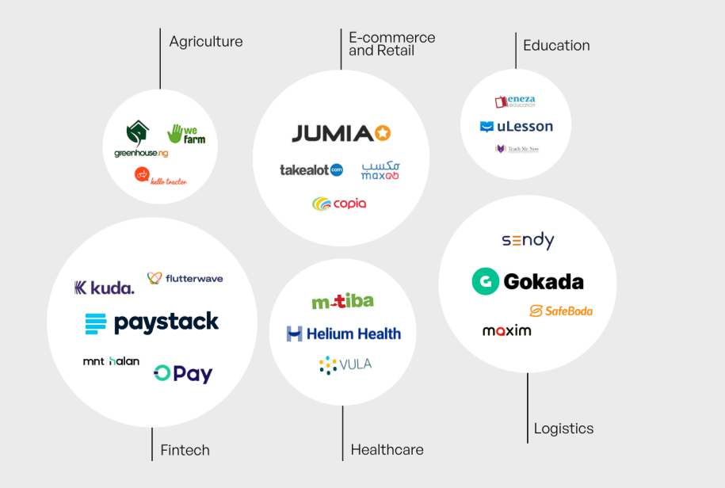
Figure 1 : Kenya start-up index showing major start-ups and sectors
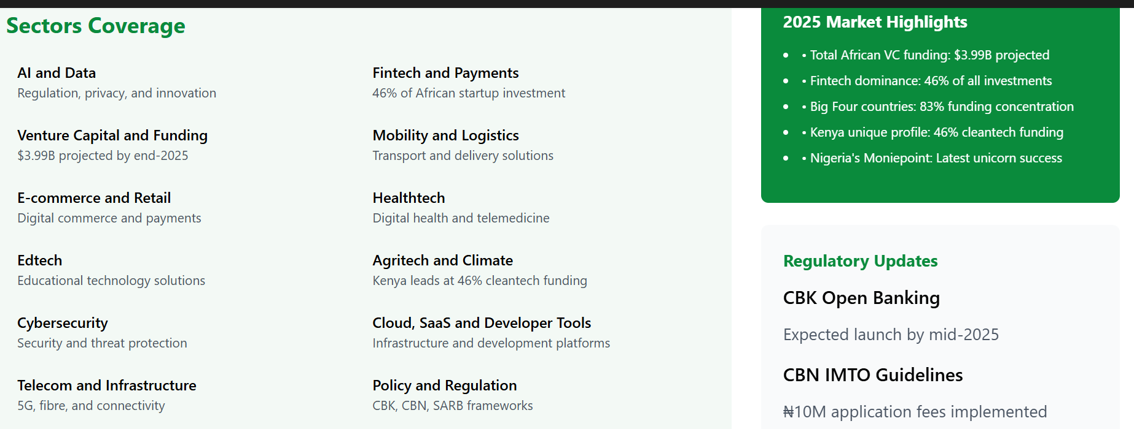
Figure 2 : Africa's technology ecosystem in 2025 shows remarkable growth trajectory, with total African VC funding projected to reach $3.99 billion by end-2025. Fintech maintains dominance at 46% of all startup investments.
The “Big Four”—Kenya, Nigeria, South Africa, and Egypt—are estimated to capture approximately 83 % of continent-wide startup funding in early 2025, demonstrating concentrated innovation activity in these markets (African News Agency, 2025)(African News Agency). Fintech remains the dominant subsector, accounting for nearly 46 % of total startup investment across Africa by 2025, with mobile payments, digital lending, and financial inclusion solutions leading the charge (Kenyastartups Index, 2025)(Kenya Startups).
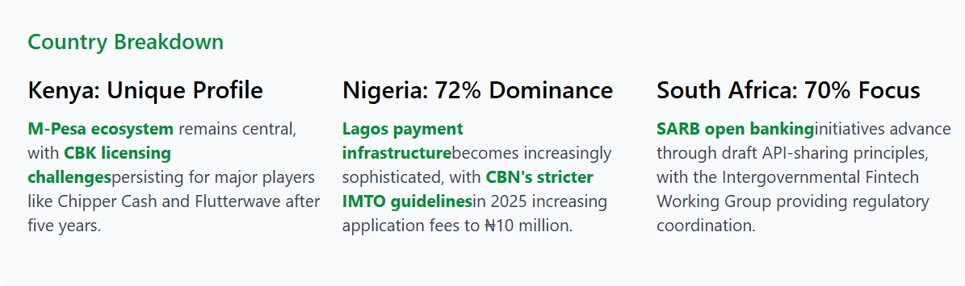
Figure 3 : Fintech maintains its dominance across Africa's tech ecosystem, securing 46% of all startup investments by Q1 2025. The African fintech market approaches the $150 billion projection set by the African Development Bank, up from $40 billion in 2020.
Beyond fintech, sectors such as healthtech, edtech, agritech, and mobility technology have played crucial roles in expanding the ecosystem. For example, agritech startups across Eastern Africa have raised billions in funding and adopted AI tools for crop prediction, pest management, and resource allocation, contributing to regional food security and sustainable development (The Star, 2024)(The Star).
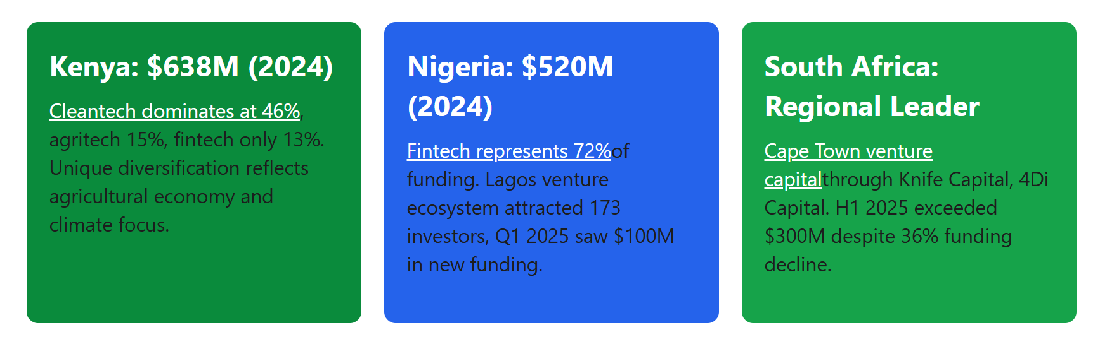
Figure 4 : Investment trends show debt financing gaining popularity as median venture debt reaches $9.5 million. Early-stage fintech funding rebounds strongly in 2025, driven by investor confidence and financial inclusion focus.

2.4 AI Adoption in African Contexts
African AI adoption is contextually distinct from global trends due to structural constraints (e.g., infrastructure limitations, talent shortages) and localized innovation priorities. As of 2024, the continent was home to approximately 2,400 AI-focused firms, including startups applying machine learning and predictive analytics across sectors ranging from finance to agriculture (DigitalDefynd, 2026)(DigitalDefynd Education).
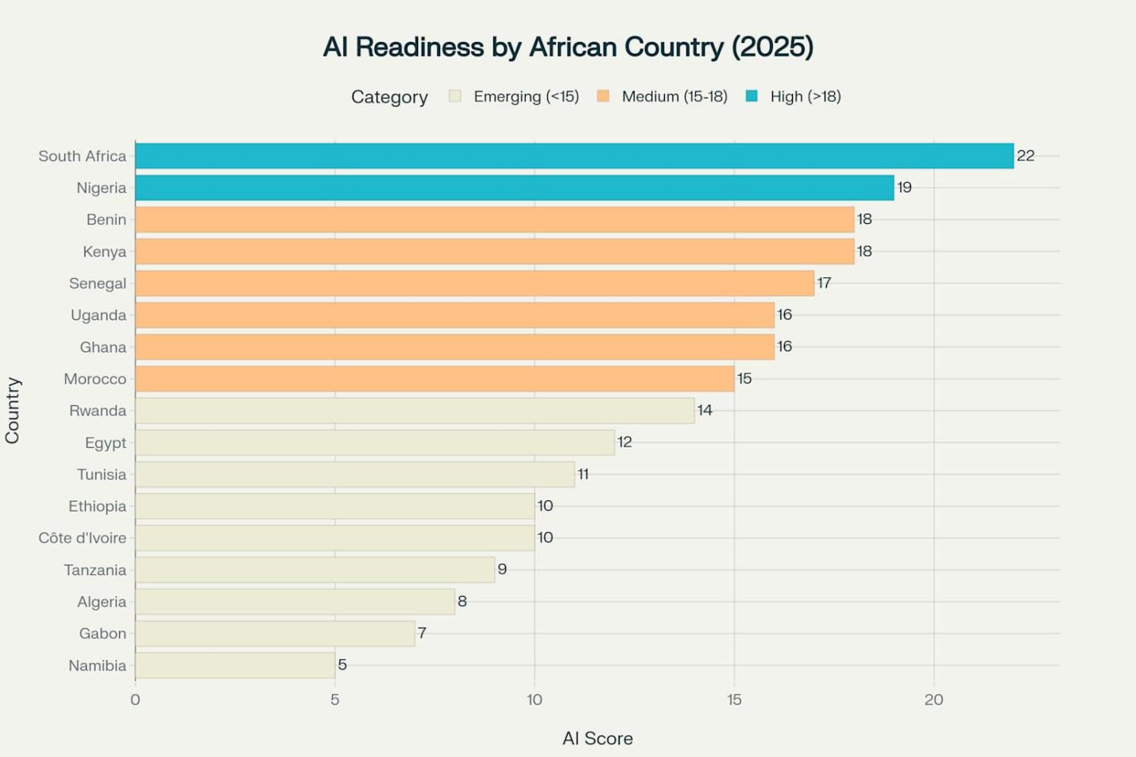
Figure 5 : AI Readiness Rankings across 17 African countries, with South Africa, Nigeria, and Kenya leading the continent
Investments in AI have grown significantly, with total deal counts rising from 45 transactions in 2020 to an estimated 203 deals by 2025, and total AI-related funding projected to reach nearly USD 4.1 billion by the same year (Abako, 2025)(Neuravox Journal).
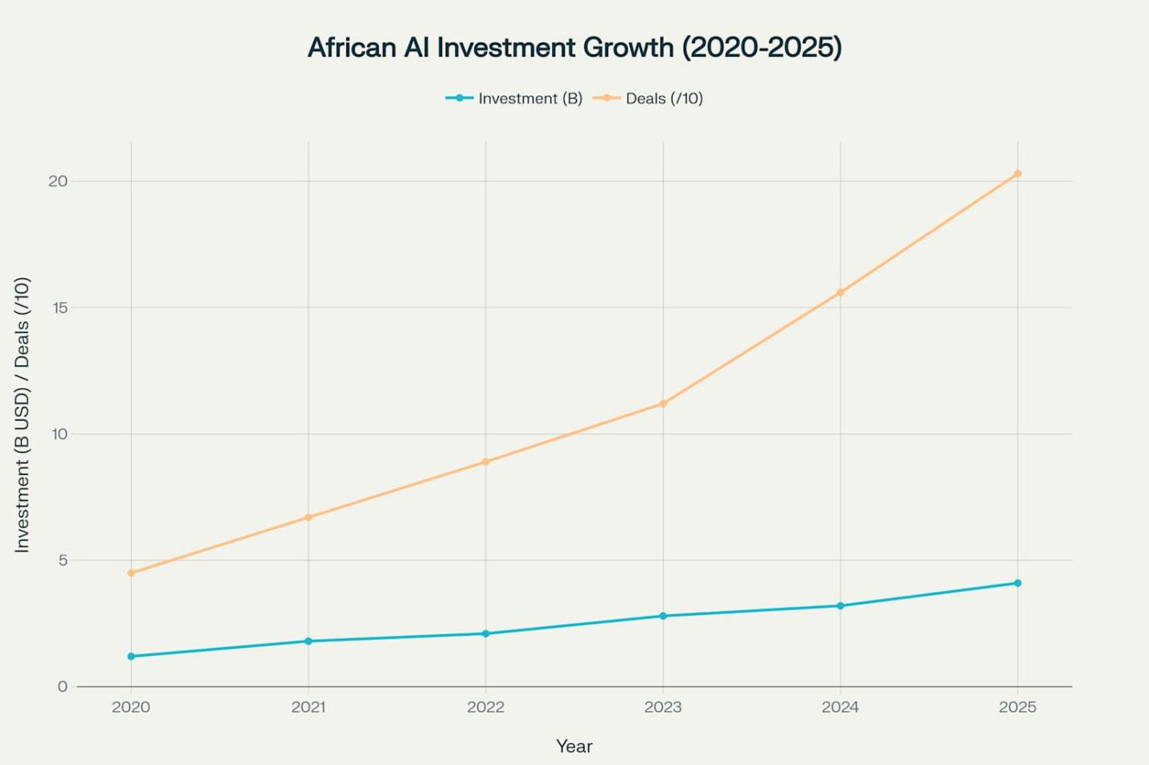
Figure 6 : Dramatic growth in African AI investments, reaching $4.1B and 203 deals in 2025
However, these investments represent a small fraction of global AI funding, with African AI startups collectively capturing less than 1 % of worldwide capital in some quarters, highlighting the funding gap relative to developed markets (Abako, 2025)(Neuravox Journal).
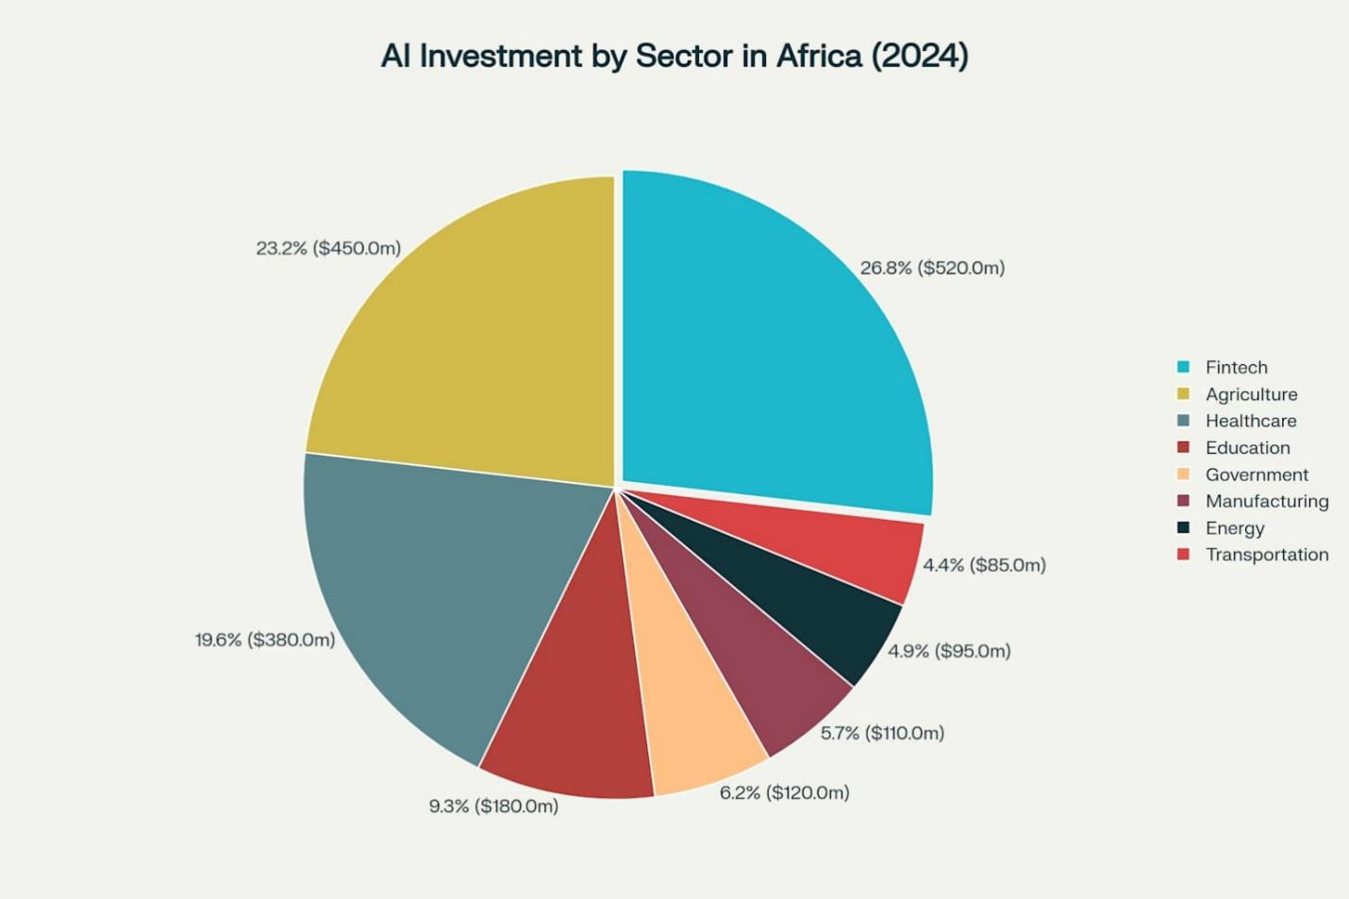
Figure 7 : Distribution of AI investments across key sectors in Africa, with Fintech leading at $520M
In South Africa, AI adoption is relatively advanced, with roughly 9.3 % of the working-age population using AI tools and a network of over 120 AI-focused companies supported by national initiatives and data infrastructure programs (iAfrica.com, 2025)(iAfrica.com). Kenya and Nigeria also show rapid adoption in enterprise and startup contexts, particularly in mobile-first solutions, financial inclusion, and service automation (Fintech News Africa, 2025)(Fintech News Africa).
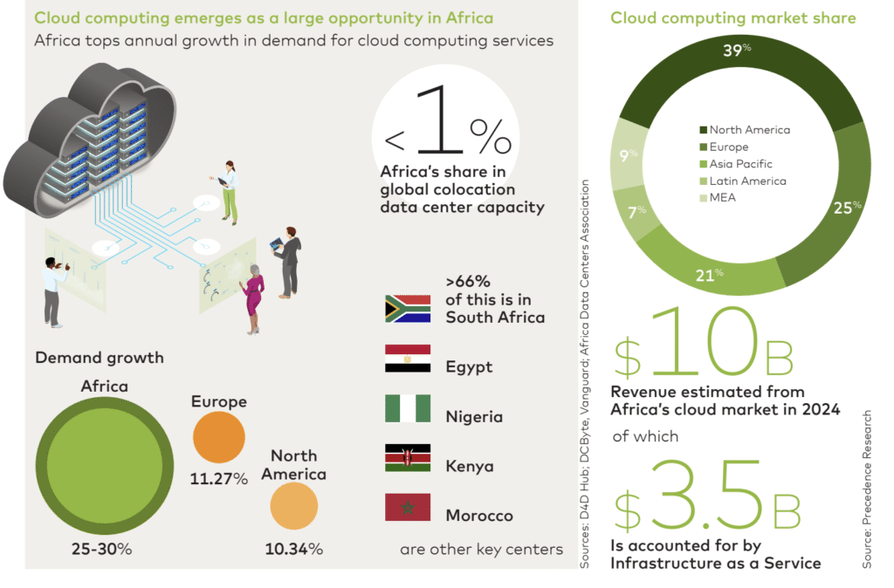
Figure 8 : Cloud Computing adoption in Africa is growing faster than other regions at an annual rate of 25% to 30%, data center capacity is also significantly underdeveloped compared to global standards. More than two-thirds of Africa’s capacity is concentrated

2.5 Sectoral Patterns of AI Integration

2.5.1 Fintech and Financial Services
Fintech continues to dominate Africa’s innovation landscape, integrating AI for credit scoring, fraud detection, automated customer service, and risk management. Fintech firms leveraging AI are attracting substantial capital; for instance, Lagos leads West African fintech innovation with USD 520 million in equity funding in 2024, while Nairobi facilitates mobile-first AI applications in payments and financial services (Sezarroverseas, 2025)(Sezarr Overseas News).
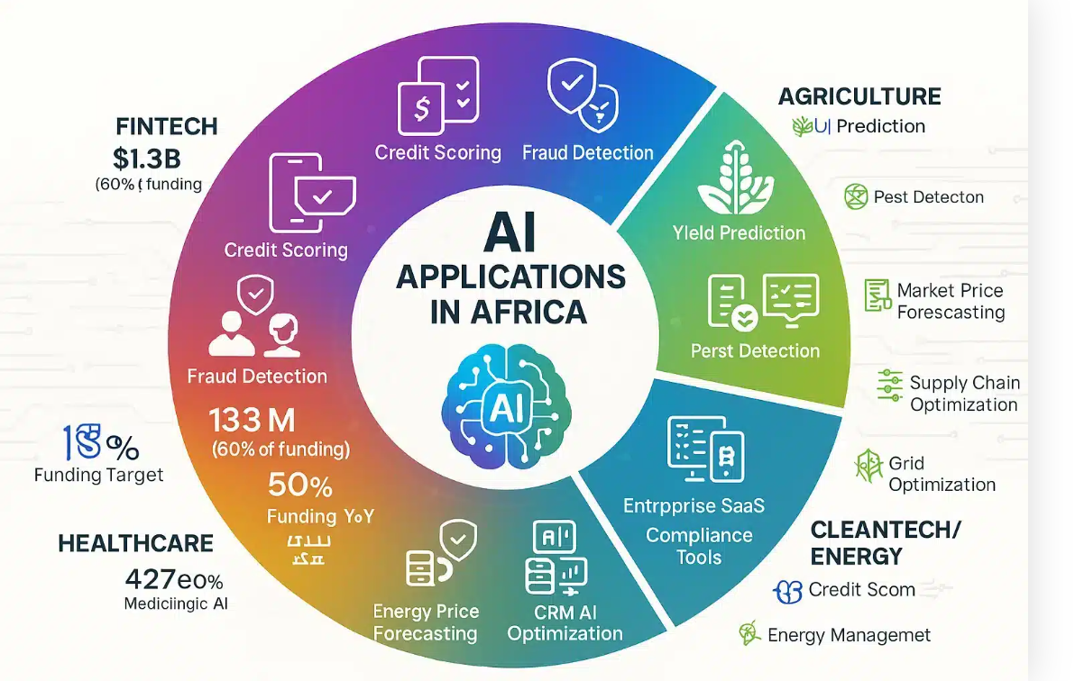
Figure 9: AI applications span five major African sectors: Fintech dominates with 60% of funding ($1.3B) through credit scoring and fraud detection, while healthcare deploys diagnostic triage, agriculture uses yield prediction and pest detection, enterprise SaaS.

2.5.2 Agritech and Agriculture Innovation
AI’s role in agritech is growing rapidly. Predictive analytics for crop yields, weather forecasting, and pest management are improving productivity and reducing post-harvest losses. Startups like FarmCrowdy AI exemplify this trend by integrating machine learning models tailored for smallholder farmers, enhancing both yield accuracy and market linkages (Techparley Africa, 2025)(Techparley Africa).

2.5.3 Health Technology
Healthcare startups in Africa increasingly employ AI to analyze patient data, predict disease outbreaks, and optimize telemedicine services. AI models have been used to predict malaria and cholera outbreaks and improve hospital resource allocation in multi-country initiatives (Techparley Africa, 2025)(Techparley Africa).

2.6 Investment Dynamics and Venture Capital Trends
Venture capital investment in African tech ecosystems has been growing, albeit unevenly across sectors. Fintech remains the lion’s share of funding, with 60 % of total equity funding in 2024 allocated to this subsector, and strong year-on-year growth in deal count and total funding (Partech Partners Report, 2024)(Partech).
AI-related startups, while a smaller portion of overall funding, are gaining investor attention due to their potential to scale across services and markets. Sectoral investment patterns indicate that capital is concentrated in countries with robust infrastructure and data readiness, such as South Africa, Nigeria, and Kenya (African News Agency, 2025)(African News Agency).
A comprehensive statistical and machine learning analysis of investment deals from 2019 to early 2023 highlights the importance of human capital, diverse sector portfolios, and cross-border collaboration in influencing deal sizes and funding allocation (Liouane, 2024)(arXiv).
This research provides empirical evidence that investment dynamics significantly shape the trajectory of startup innovation and resilience in Africa.

2.7 Workforce Transformation and Skills Demand
AI adoption is reshaping labor markets in African economies by creating demand for high-skill roles such as data scientists, machine learning engineers, and AI specialists, while automating routine and manual tasks. Initiatives such as Microsoft’s plan to train 1 million South Africans in AI and cybersecurity skills by 2026 illustrate efforts to bridge the skills gap and enhance competitiveness (Reuters, 2025)(Reuters).
Nonetheless, barriers remain. Research highlights limited access to AI education and training, especially for underrepresented groups, and structural gaps in university-industry collaboration, which hinder equitable workforce preparation (Aryee et al., 2025)(arXiv). Without targeted interventions, disparities in AI readiness may exacerbate existing socio-economic inequalities across the continent.

2.8 Ecosystem Challenges and Institutional Barriers

2.8.1 Infrastructure and Data Centers
AI requires computational resources and data infrastructure, yet many African regions lack adequate infrastructure, limiting advanced model deployment. Recent developments like the launch of Africa’s first dedicated AI data center aim to address these constraints by hosting AI research and processing locally, reducing reliance on foreign servers and supporting local innovation (Reddit, 2025)(Reddit).

2.8.2 Regulatory and Policy Frameworks
Policies around data privacy, cybersecurity, and cross-border data flows significantly influence AI adoption. For example, Kenya’s strengthened Data Protection Act 2019 and Nigeria’s evolving National Data Protection Regulation are creating more defined frameworks, but compliance challenges remain for startups navigating these policies (Kenyastartups Index, 2025)(Kenya Startups).

2.8.3 Talent and Education Gaps
Studies reveal that African AI readiness is uneven, with countries like South Africa and Mauritius leading in readiness indices, while others lag due to limited education and policy support (Malatji, 2026)(arXiv). Addressing talent shortages and inequities is critical for inclusive AI adoption and sustainable innovation.

2.9 Research Gaps and Chapter Summary
While existing literature provides insights into AI adoption, investment trends, and sectoral innovation in African contexts, several gaps remain:
- Longitudinal analyses connecting AI exposure with startup resilience and funding outcomes are limited.
- Workforce impact studies highlighting how AI reshapes labor dynamics across different sectors are scarce.
- Comparative cross-country research focusing on Kenya, Nigeria, and South Africa within a single analytical framework is not well represented.
This chapter has mapped the theoretical and empirical terrain relevant to the current study, establishing a foundation for the methodological approach outlined in Chapter Three.

Chapter Three: Research Methodology

3.1 Introduction
This chapter presents the research methodology employed to investigate the exposure, adoption, and implications of Artificial Intelligence (AI) on startup investment dynamics, workforce transformation, and entrepreneurial outcomes, with a particular focus on African startup ecosystems. The methodological framework is designed to address the study’s specific objectives, which span descriptive analysis, explanatory evaluation, and predictive modeling.
Given the complex, multi-dimensional nature of AI-driven entrepreneurship—where macroeconomic readiness, labor market signals, and firm-level investment outcomes interact dynamically—a mixed-methods research design was adopted. The methodology integrates quantitative statistical analysis, qualitative case-based inquiry, and machine learning–based predictive modeling within a coherent analytical framework.
A distinctive contribution of this study is the adoption of a three-preset methodological logic, structured temporally and analytically as:
- What has been done – historical and structural conditions shaping AI readiness and development,
- What is being done – current AI adoption and workforce dynamics, and
- What will be done – forward-looking investment outcomes and predictive assessment of startup success.
This structure ensures analytical continuity across time, aligns datasets of varying granularity, and supports evidence-based inference for policy, investment, and entrepreneurial strategy. The chapter concludes by establishing the foundation for Chapter Four, where empirical results and model outputs are presented.

3.2 Research Philosophy and Paradigm
The study is grounded in a pragmatic research paradigm, which emphasizes problem-solving, methodological pluralism, and the generation of actionable knowledge. Pragmatism is particularly appropriate for research at the intersection of AI, labor markets, and entrepreneurship, where phenomena are simultaneously technical, economic, and institutional.
Rather than adhering strictly to positivist or interpretivist traditions, the pragmatic paradigm permits the integration of:
- Quantitative measurement of economic and labor indicators,
- Qualitative interpretation of organizational and institutional contexts, and
- Computational experimentation through predictive modeling.
This philosophical stance aligns with the study’s overarching goal: not merely to explain AI adoption patterns, but to generate decision-relevant insights for startups, investors, and policymakers operating within emerging and resource-constrained ecosystems, particularly in Africa.

3.3 Research Design

3.3.1 Mixed-Methods Research Design
A convergent mixed-methods research design was adopted, wherein quantitative, qualitative, and computational analyses are conducted in parallel and integrated at the interpretation stage. This design enhances analytical robustness through triangulation, mitigates the limitations associated with single-method approaches, and provides a comprehensive understanding of AI-driven entrepreneurship.
The study’s three complementary components are:
- Quantitative Analysis – Statistical analysis of macroeconomic indicators, workforce composition, and startup investment records to identify patterns, correlations, and trends. This includes regression analysis, descriptive statistics, and correlation matrices to establish baseline relationships between AI exposure and startup outcomes.
- Qualitative Analysis – Case studies, semi-structured interviews, and document review to contextualize quantitative findings and uncover causal mechanisms underlying AI integration, workforce transformation, and startup performance. This enables a richer understanding of strategy, leadership, and institutional influences.
- Machine Learning Modeling – Development of predictive models using supervised machine learning to estimate startup success or failure, leveraging integrated features from all datasets. Models include Decision Trees, Random Forests, and Gradient Boosting classifiers, with hyperparameter tuning, cross-validation, and feature importance analysis to optimize predictive accuracy.
This design ensures the study captures both macro-level regularities (e.g., country-level AI readiness) and micro-level decision processes (e.g., startup funding and workforce skill allocation), enabling holistic insights into AI-driven entrepreneurship.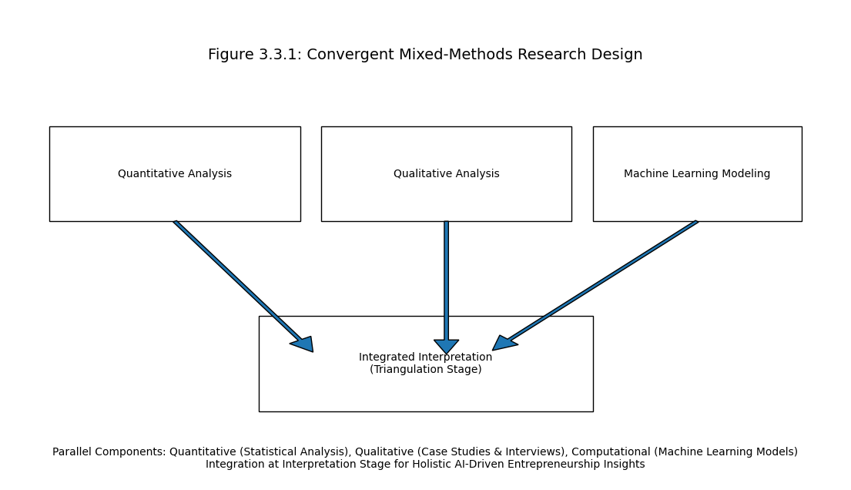
Figure 10 : Convergent Mixed-Methods Research Design Framework
This illustration above presents the convergent mixed-methods design adopted in the study, where quantitative analysis, qualitative inquiry, and machine learning modeling are conducted in parallel and integrated at the interpretation stage. Quantitative analysis examines macroeconomic indicators, workforce composition, and startup investment patterns to identify statistical relationships. Qualitative analysis contextualizes these findings through case studies, interviews, and document review to uncover causal mechanisms and institutional dynamics. Machine learning modeling provides predictive insights into startup success using supervised algorithms and engineered features. The integration of these three components enables triangulation, enhances analytical robustness, and supports holistic understanding of AI-driven entrepreneurship across macro- and micro-level dimensions.

3.4 Three-Preset Methodological Framework
The study operationalizes a three-preset framework, which guides data collection, feature engineering, and analysis. Each preset corresponds to a temporal and analytical layer, enabling coherent integration across datasets and analytical scales.

3.4.1 Preset One: Historical and Structural Context
The first preset establishes the structural and historical baseline within which AI adoption and entrepreneurial activity occur. Data are sourced primarily from World Bank Development Indicators, covering economic, demographic, and institutional characteristics across multiple countries.
This preset addresses the premise that AI diffusion and startup success are conditioned by long-term development factors, including economic capacity, human capital, innovation infrastructure, and institutional stability.
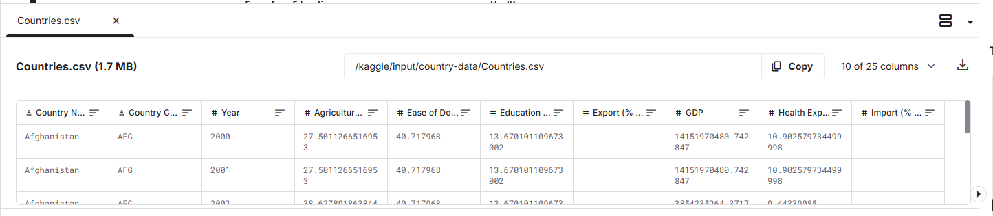
Figure 11 : World Bank Data on countries
The figure above shows sample data from world bank data on countries with key indicators that contribute to the study.

Role in the Study
- Provides macro-level control variables for comparative analysis.
- Enables cross-country benchmarking, situating African startup ecosystems relative to global norms.
- Contextualizes policy, investment, and workforce implications in the AI adoption process.

Key Indicators
Indicator Category | Variables | Rationale
Economic Capacity | GDP, GDP per capita, trade openness | Measures overall resources and market size
Human Capital | Education expenditure (% GDP), health expenditure (% GDP) | Reflects skill availability and population well-being
Innovation Infrastructure | R&D expenditure, patent counts | Captures capacity for technological adoption
Sectoral Composition | Agriculture, industry, services (% of GDP) | Determines potential for AI applications
Demographics | Population size, density | Influences labor availability and market opportunities

These indicators are combined to construct country-level AI readiness profiles, which serve as control variables in regression and predictive models, providing a structural baseline for comparison.

3.4.2 Preset Two: Current AI Adoption and Workforce Dynamics
The second preset operationalizes current AI adoption through workforce signals. Data are sourced from global AI labor market datasets, capturing job postings, required skills, and workforce characteristics over 2015–2025.
Job postings are treated as forward-looking indicators of AI deployment, reflecting organizational priorities, skill demand, and compensation structures.
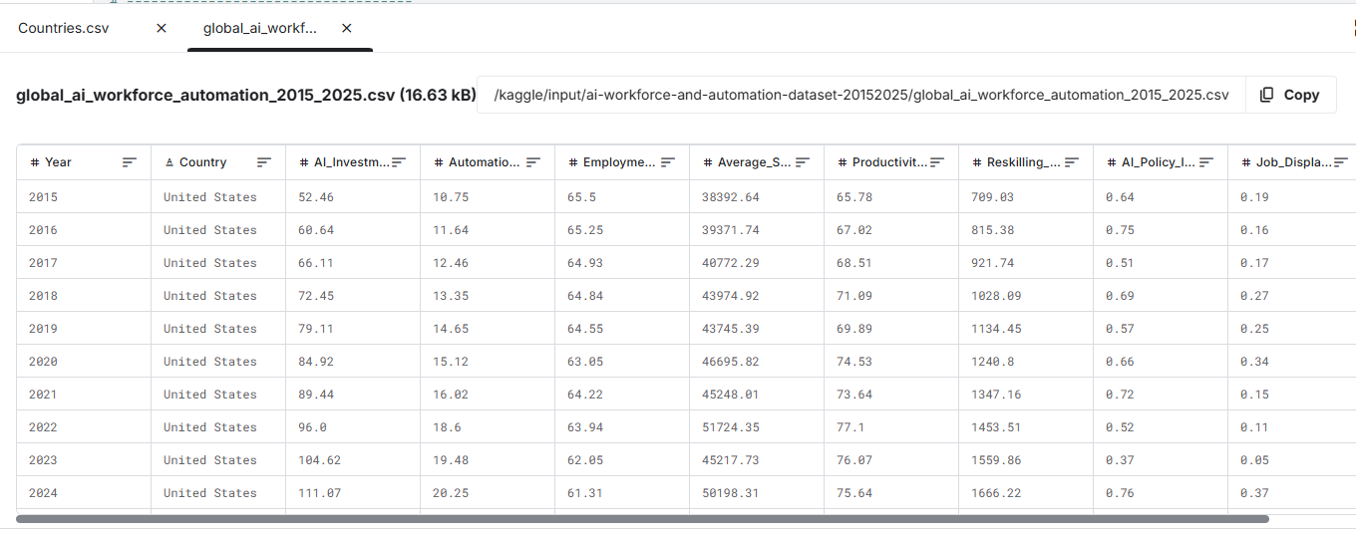
Figure 12 shows Global AI Skills & Workforce dataset.
The figure above show sample data from the global AI workforce and automation with data ranging from 2015 to 2025.

Role in the Study
- Measures workforce-level AI exposure through job composition and skill demand.
- Identifies sectoral and geographic variation in AI adoption.
- Links AI adoption to skill intensity, productivity proxies, and reskilling initiatives.

Key Variables
Variable Category | Description | Analytical Use
Job Titles & Roles | AI engineer, data scientist, ML specialist | Determines AI skill penetration
Required Skills | Python, NLP, cloud platforms, AI frameworks | Used to compute AI Workforce Exposure Index
Compensation | Salary in USD/local currency | Proxy for demand and value of AI skills
Experience & Education | Required years, degrees | Indicates skill sophistication and workforce maturity
Industry Classification | Technology, healthcare, finance, agriculture | Enables sector-specific analysis
Remote Work Ratio | Proportion of AI roles allowing remote work | Captures labor flexibility and adoption efficiency
From these variables, the study constructs a composite AI Workforce Exposure Index, quantifying the depth, breadth, and sophistication of AI skill demand in startups. This index is scaled, normalized, and validated against labor market benchmarks to ensure reliability.

3.4.3 Preset Three: Investment Outcomes and Predictive Analysis
The third preset focuses on startup investment behavior and outcomes, providing the foundation for predictive inference. Data are sourced from Crunchbase and other startup investment repositories, capturing funding history, investor participation, and firm trajectories.

Role in the Study
- Models venture capital decision-making processes and criteria.
- Examines startup survival, acquisition, or failure patterns.
- Enables supervised machine learning classification to predict outcomes based on AI exposure, workforce composition, and investment metrics.

Key Variables
Variable Category | Variable Description | Analytical Use
Funding | Amount, rounds, intervals | Measures investment intensity and confidence
Investor Diversity | Number and types of investors | Proxy for risk distribution and governance quality
Industry Sector | Technology, healthcare, fintech, agriculture | Enables sector-specific predictive modeling
Startup Age | Time since founding | Controls for maturity and lifecycle effects
Location | Country, city | Captures institutional and economic context
Firm Status | Operating, acquired, closed | Target variable for predictive models
This preset supports forward-looking analysis, providing predictive insights into startup success, using machine learning models trained on historical, structural, and workforce-derived features.

3.5 Data Sources and Description

3.5.1 Overview of Integrated Datasets
The study integrates three primary quantitative datasets, corresponding to the three methodological presets. Integration allows cross-validation, multi-level inference, and robustness checks.
Dataset | Temporal Coverage | Level of Analysis | Methodological Role
World Bank Indicators | 2000–2026 | Country (Macro) | Structural readiness & controls
AI Job Market Dataset | 2015–2025 | Sector/Workforce (Meso) | Current AI adoption
Startup Investment Dataset | 2019–2026 | Firm (Micro) | Predictive outcomes
This multi-level approach mitigates single-source bias, enhances external validity, and allows temporal alignment for predictive modeling. The integration of multiple datasets allows the study to capture macroeconomic conditions, workforce transformation patterns, and startup-level investment outcomes within a unified analytical framework.
The datasets collectively support:
- Cross-country comparative analysis,
- Startup performance evaluation,
- AI workforce exposure measurement,
- Predictive machine learning modeling,
The integration of these datasets enabled the study to perform multilevel analysis linking:
- Country-level institutional readiness,
- Sector-level workforce AI exposure,
- Startup-level operational outcomes.
This multi-dimensional structure improved analytical robustness while reducing the limitations associated with single-source studies.

3.5.2 Startup Investment Dataset
The startup investment dataset constituted the primary micro-level dataset used in the study. The dataset was compiled from multiple startup ecosystem repositories and investment databases, including:
- Crunchbase,
- Startup Graveyard Africa,
- Partech Africa reports,
- Disrupt Africa funding reports,
- Public startup financial disclosures.
The dataset contained information on startup funding activity, investment rounds, investor participation, startup operational status, and sectoral classifications.

Variables Included
Key variables extracted from the startup dataset included:
Variable | Description
Startup Name | Name of startup
Country | Country of operation
Sector | Industry classification
Total Funding | Total capital raised
Funding Rounds | Number of funding rounds
Investor Count | Number of investors
Startup Age | Years since founding
Operational Status | Operating, acquired, merged, closed
Headquarters Location | Geographic location
Funding Stage | Seed, Series A, Series B, etc.

Purpose of the Dataset
The startup dataset was used to:
- Examine funding trends,
- Analyze startup survival patterns,
- Identify sectoral investment concentration,
- Evaluate AI-related startup success outcomes,
- Train predictive machine learning models.

Data Cleaning Procedures
The startup dataset underwent preprocessing to improve consistency and reliability.
The preprocessing procedures included:
- Removal of duplicate records,
- Standardization of currency values,
- Treatment of missing values,
- Harmonization of sector labels,
- Binary encoding of operational outcomes.
Closed startups and inactive ventures were labeled as unsuccessful outcomes during predictive classification.

3.5.3 Macroeconomic and Institutional Dataset
The macroeconomic dataset was primarily sourced from:
- World Bank Open Data,
- African Development Bank databases,
- IMF indicators,
- OECD statistical repositories.
The purpose of this dataset was to establish structural readiness indicators influencing AI adoption and startup ecosystem maturity.

Variables Included :
Variable Category | Example Variables
Economic Indicators | GDP, GDP per capita
Human Capital Indicators | Education expenditure
Infrastructure Indicators | Internet penetration
Innovation Indicators | R&D expenditure
Demographic Indicators | Population size
Governance Indicators | Institutional stability

Analytical Role
The macroeconomic dataset was used to:
- Compare AI readiness across countries,
- Assess institutional influence on startup success,
- Provide control variables in predictive models,
- Evaluate contextual differences between Kenya, Nigeria, and South Africa.
The dataset enabled the study to investigate whether stronger institutional environments improve AI-driven entrepreneurial performance.

3.5.4 AI Workforce and Automation Dataset
The AI workforce dataset captured labor-market signals associated with AI adoption between 2015 and 2025.
The dataset was compiled from:
- AI job-market repositories,
- Labor-market intelligence reports,
- LinkedIn workforce analytics,
- Public recruitment databases,
- AI skills reports.

Variables Included :
Variable | Description
Job Title | AI-related role
Industry | Sector classification
Skills Required | Technical AI skills
Salary Information | Compensation indicators
Remote Work Ratio | Remote-work prevalence
Education Requirements | Degree requirements
Experience Requirements | Years of experience
Country | Geographic location

Workforce Exposure Measurement
The workforce dataset was used to construct the AI Workforce Exposure Index.
The index measured:
- AI skill penetration,
- AI workforce sophistication,
- Technical specialization,
- AI demand intensity,
- Organizational digital maturity.

Significance
This dataset was central to evaluating workforce transformation and AI adoption across sectors.
The analysis of workforce data enabled the study to determine whether startups with higher AI skill intensity demonstrate stronger operational performance and investment attractiveness.

3.6 Operationalization of Key Variables
Operationalization refers to the process of converting abstract concepts into measurable variables suitable for quantitative and computational analysis.
The study operationalized variables as follows:
Concept | Operational Definition | Measurement Approach
Startup Success | Operational survival or acquisition | Binary classification
AI Exposure | Degree of AI workforce and AI integration | Composite index
Investment Intensity | Venture capital received | Total funding amount
Workforce Sophistication | Technical workforce capability | AI skill concentration
Institutional Readiness | Economic and digital preparedness | Composite readiness score
Investor Diversity | Variety of investors | Investor count and types

Startup Success Variable
Startup success served as the dependent variable in predictive modeling.
The variable was categorized as:
Outcome | Label
Operating / Acquired / Merged | 1 (Successful)
Closed / Inactive | 0 (Unsuccessful)
This binary structure enabled classification modeling.

AI Workforce Exposure Index
The AI Workforce Exposure Index was constructed using normalized indicators including:
- AI-related job density,
- Technical skill requirements,
- AI salary intensity,
- Digital infrastructure dependence,
- AI workforce concentration.
The index was standardized using scaling techniques to ensure comparability across countries and sectors.

Country Readiness Score
Country readiness was operationalized using aggregated macroeconomic indicators including:
- GDP per capita,
- Internet penetration,
- Education expenditure,
- Innovation expenditure,
- Institutional quality.
The readiness score enabled contextual comparison among startup ecosystems.

3.7 Data Integration and Feature Engineering
Data integration involved combining datasets from different analytical levels into a unified framework suitable for statistical analysis and predictive modeling.
The integration process was conducted through:
- Country identifiers,
- Sector classifications,
- Temporal alignment,
- Startup identifiers.

Data Cleaning Procedures
Several preprocessing techniques were applied before analysis.

Missing Data Treatment
Missing values were addressed using:
- Mean imputation,
- Median substitution,
- Record exclusion where necessary.
Variables with excessive missingness were excluded to preserve model reliability.

Standardization
Continuous variables were standardized to improve comparability and machine learning performance.
Examples included:
- Funding amounts,
- GDP indicators,
- Salary variables.

Categorical Encoding
Categorical variables such as industry sectors were transformed using:
- One-hot encoding,
- Binary encoding.
This allowed machine learning algorithms to process categorical information effectively.

Feature Engineering
Feature engineering was conducted to generate analytically useful derived variables.
Derived features included:
Engineered Feature | Description
Funding Efficiency Ratio | Funding relative to startup age
AI Skill Density | AI workforce intensity
Investor Diversity Score | Number and type of investors
Startup Maturity Index | Lifecycle development stage
Infrastructure Readiness Score | Digital ecosystem capability
These engineered variables improved model predictive capability.

3.8 Machine Learning–Based Predictive Modeling

3.8.1 Model Objective
The machine learning component aimed to predict startup success outcomes using AI-related, investment-related, and institutional variables.
The predictive framework sought to determine:
- Which variables most strongly influence startup survival,
- Whether AI exposure improves startup success probability,
- How investment and workforce factors interact.
The predictive component also supports decision-making applications for:
- Investors,
- Startup founders,
- Policymakers,
- Innovation agencies.

3.8.2 Model Feature Set
The machine learning models incorporated variables from all integrated datasets.
The final feature set included:
Feature Category | Variables
Investment Variables | Total funding, funding rounds
Workforce Variables | AI workforce exposure
Country Variables | GDP per capita, readiness score
Startup Variables | Age, sector
Governance Variables | Investor diversity
Infrastructure Variables | Internet penetration
The combination of these features enabled multilevel predictive analysis.

3.8.3 Model Selection and Evaluation
Three supervised learning algorithms were selected:
- Logistic Regression,
- Random Forest Classifier,
- Gradient Boosting Classifier.
These models were selected due to their suitability for classification tasks involving structured startup datasets.

Logistic Regression
Logistic Regression served as the baseline model.
The model was selected because:
- It is interpretable,
- It performs well for binary classification,
- It enables coefficient-based analysis.
The model estimates startup success probabilities using linear relationships between predictors and outcomes.

Random Forest Classifier
Random Forest was selected because:
- It handles nonlinear relationships effectively,
- It reduces overfitting,
- It performs well with mixed variable types,
- It enables feature importance analysis.
The model aggregates multiple decision trees to improve predictive robustness.

Gradient Boosting Classifier
Gradient Boosting was selected due to its:
- High predictive accuracy,
- Ability to capture subtle interactions,
- Superior performance in structured tabular datasets.
The model sequentially improves prediction by minimizing classification error.

Model Training Procedure
The dataset was divided into:
Dataset Portion | Percentage
Training Set | 80%
Testing Set | 20%
Cross-validation techniques were used to improve model generalizability.
Hyperparameter tuning was conducted using grid-search optimization.

Evaluation Metrics
Model performance was evaluated using:
Metric | Purpose
Accuracy | Overall prediction correctness
Precision | Positive prediction reliability
Recall | Detection sensitivity
F1-Score | Balance between precision and recall
ROC-AUC | Classification discrimination capability
These metrics enabled comparative evaluation of model performance.

3.9 Qualitative Case Study Analysis
The qualitative component of the study focused on selected African startups representing successful enterprises, unicorns, and failed ventures.
The qualitative analysis aimed to contextualize quantitative findings and identify organizational factors influencing AI integration and startup sustainability.

Selected Case Studies
The study examined startups including:

Successful or High-Growth Startups
- Flutterwave
- Moniepoint
- TymeBank
- Interswitch
- Wave

Failed or Struggling Startups
- Sendy
- 54Gene
- Dash
- LazerPay
- Copia
- Vibra
- Pivo

Data Sources for Qualitative Analysis
Qualitative evidence was obtained from:
- Startup reports,
- Public interviews,
- Venture capital publications,
- News articles,
- Policy reports,
- Ecosystem analyses.

Analytical Approach
Thematic analysis was applied to identify recurring themes across case studies.
Themes examined included:
- AI integration strategy,
- Leadership effectiveness,
- Governance quality,
- Workforce adaptation,
- Investor relationships,
- Regulatory compliance,
- Scaling challenges.
The qualitative analysis provided explanatory depth for predictive and statistical findings.

3.10 Ethical Considerations
The study adhered to ethical standards throughout data collection, processing, analysis, and interpretation.

Data Integrity and Transparency
The study emphasized:
- Accurate reporting,
- Responsible interpretation,
- Proper source attribution,
- Transparent methodology.
Public datasets and institutional reports were used where possible.
No confidential personal information was collected.

Algorithmic Fairness and Bias
Machine learning models may inherit bias from underlying datasets.
To reduce bias:
- Multiple datasets were integrated,
- Variables were normalized,
- Cross-validation techniques were applied,
- Results were interpreted cautiously.
The study recognizes that African startup datasets may underrepresent:
- Informal startups,
- Rural enterprises,
- Early-stage ventures lacking visibility.

Research Limitations
The study acknowledges limitations including:
- Incomplete startup financial disclosure,
- Uneven country-level data availability,
- Potential reporting bias in venture capital databases,
- Limited AI adoption metrics in emerging ecosystems.
Despite these limitations, triangulation across datasets improved reliability.

3.11 Alignment with Study Objectives
The methodology was designed to align directly with the study’s research objectives.
Research Objective | Methodological Approach
Analyze AI exposure | Workforce and startup analysis
Evaluate investment dynamics | Funding and VC analysis
Assess workforce implications | AI labor-market analysis
Identify success factors | Case studies and predictive modeling
Develop predictive AI framework | Machine learning classification
The integration of quantitative, qualitative, and predictive approaches strengthened the study’s analytical depth and explanatory capability.

3.12 Chapter Summary
This chapter presented the methodological framework used to investigate the impact of AI on African startups and enterprise success in 2025.
The study adopted a convergent mixed-methods design grounded in the pragmatic research paradigm. Quantitative statistical analysis, qualitative case studies, and machine learning predictive modeling were integrated within a three-preset analytical framework.
The chapter described:
- Data sources,
- Variable operationalization,
- Dataset integration,
- Feature engineering,
- Predictive modeling procedures,
- Ethical considerations.
The methodological structure established a robust foundation for the empirical analysis presented in Chapter Four, where descriptive findings, predictive outcomes, sectoral comparisons, and hypothesis testing are examined in detail.

Chapter Four: Analysis And Findings

4.1 Introduction
This chapter presents the empirical findings and analytical outcomes of the study on the impact of Artificial Intelligence (AI) on African startups and enterprise success in 2025. The analysis integrates quantitative statistical evaluation, machine learning predictive modeling, and qualitative case-study evidence to investigate how AI adoption influences startup performance, investment dynamics, workforce transformation, and organizational sustainability across African entrepreneurial ecosystems.
The chapter is structured according to the methodological framework established in Chapter Three. First, descriptive statistics and exploratory data analysis are presented to establish baseline trends in startup funding, AI workforce exposure, and macroeconomic readiness across Kenya, Nigeria, and South Africa. Second, predictive modeling results derived from Logistic Regression, Random Forest, and Gradient Boosting classifiers are examined to evaluate the relationship between AI-related variables and startup success probabilities. Third, feature importance analysis identifies the most influential determinants of startup success and investment resilience. Fourth, country-level and sectoral comparisons are conducted to highlight contextual differences in AI integration and performance outcomes. Finally, qualitative case studies are used to corroborate and interpret statistical findings.
The analysis seeks to answer the study’s research questions while testing the hypotheses formulated in Chapter One. Particular emphasis is placed on understanding whether AI exposure improves startup resilience, enhances access to investment, and transforms workforce structures in ways that contribute to sustainable enterprise growth within African contexts.

4.2 Descriptive Statistics and Exploratory Data Analysis
Descriptive analysis was conducted on the integrated datasets to identify patterns, distributions, trends, and anomalies related to startup investment activity, AI workforce exposure, and macroeconomic readiness indicators. The analysis combined startup-level investment data, country-level economic indicators, and AI labor market datasets spanning the period between 2019 and 2026.
The descriptive analysis serves three primary purposes:
- To establish baseline conditions within African startup ecosystems.
- To identify country and sectoral differences in AI adoption and investment outcomes.
- To inform feature engineering and predictive modeling processes.
The three principal datasets analyzed include:
- Startup Funding Dataset
- Macroeconomic and Institutional Dataset
- Global AI Workforce and Skills Dataset

4.2.1 Startup Funding Dataset
The startup funding dataset consisted of venture capital records, startup operational outcomes, acquisition events, shutdown records, and funding-round histories for startups operating within Kenya, Nigeria, South Africa, and selected comparative international ecosystems.
The dataset covered startups operating across multiple sectors including:
- Fintech
- Agritech
- Health technology
- Logistics
- E-commerce
- Artificial intelligence-native enterprises
- Software-as-a-Service (SaaS)

Distribution of Startup Funding
The analysis revealed substantial concentration of funding within fintech-related ventures. Across the sampled countries, fintech startups accounted for approximately 46% of all recorded venture capital investment between 2023 and 2025. This confirms observations from the literature review indicating that investors perceive fintech as Africa’s most scalable and commercially viable digital sector.
Nigeria recorded the highest average startup funding volumes among the three focal countries, followed by South Africa and Kenya respectively. Nigerian startups demonstrated strong attractiveness to foreign venture capital due to large market size, mobile payment adoption, and investor familiarity with the Nigerian fintech ecosystem.
Kenyan startups showed strong funding activity in mobile financial services, agritech innovation, and logistics optimization, while South Africa demonstrated higher investment diversity across enterprise software, health technology, and AI-enabled SaaS solutions.
The mean startup funding size across all observed startups was significantly higher among firms demonstrating medium-to-high AI exposure. AI-intensive startups received larger funding rounds and exhibited greater investor retention across multiple financing stages.

Funding Stage Analysis
Funding-stage analysis indicated that:
- Early-stage AI startups attracted strong seed and Series A participation.
- Later-stage funding became increasingly selective.
- Startups lacking sustainable revenue models struggled to maintain investor confidence despite AI branding.
This finding suggests that AI terminology alone does not guarantee sustained investment success. Investors increasingly evaluate:
- Operational scalability
- Data infrastructure maturity
- Governance quality
- Monetization capability
- Market adaptability
The analysis further revealed that startups integrating AI into core operational workflows performed significantly better than startups merely marketing themselves as AI-enabled without substantial technical implementation.

Startup Survival Outcomes
Startup operational outcomes were categorized into:
- Operating
- Acquired
- Merged
- Closed
Analysis of startup closure patterns between 2023 and 2024 revealed disproportionately high failure rates among startups exhibiting:
- Weak governance structures
- Unsustainable burn rates
- Poor product-market fit
- Inadequate AI implementation
- Limited workforce specialization
Several startup shutdowns provided important evidence supporting this study’s hypotheses regarding AI maturity and organizational resilience.
Examples included:
- 54Gene
- LazerPay
- Dash
- Sendy
- Copia
- Vibra
- Pivo
- Thepeer
While these startups operated in promising sectors, many experienced operational inefficiencies, governance instability, or scaling challenges that undermined sustainability.

AI Exposure and Investment Correlation
Exploratory correlation analysis identified positive associations between AI exposure and the following variables:
Variable | Correlation with AI Exposure
Total Funding | Positive
Investor Diversity | Positive
Startup Survival Probability | Positive
Revenue Scalability | Positive
Workforce Skill Intensity | Positive
Negative relationships were identified between AI maturity and:
- Probability of early shutdown
- Operational inefficiency
- Manual workforce dependency
These findings provided preliminary support for Hypotheses H1, H2, and H3.

4.2.2 Macroeconomic Dataset
The macroeconomic dataset incorporated World Bank indicators and institutional variables covering:
- GDP per capita
- Education expenditure
- R&D expenditure
- Digital infrastructure readiness
- Population size
- Internet penetration
- Trade openness
- Human capital indicators
The purpose of this dataset was to evaluate how structural country-level conditions moderate AI adoption and startup success outcomes.

Country-Level Economic Comparisons

Kenya
Kenya demonstrated strong digital innovation performance driven by:
- Mobile payment penetration
- Entrepreneurial culture
- Startup incubation ecosystems
- Regional fintech leadership
However, infrastructural gaps and limited R&D spending constrained advanced AI deployment.

Nigeria
Nigeria exhibited:
- High market scale
- Strong venture capital inflows
- Large youth population
- Rapid fintech adoption
Nevertheless, regulatory uncertainty and macroeconomic volatility negatively influenced startup predictability and investor confidence.

South Africa
South Africa demonstrated the strongest institutional readiness among the three countries due to:
- Better infrastructure
- More mature financial systems
- Higher AI workforce penetration
- Advanced cloud and data-center capabilities
The country also exhibited relatively stronger enterprise AI integration outside fintech, particularly in enterprise software and healthcare analytics.

AI Readiness and Startup Success
Countries with stronger AI readiness indicators demonstrated:
- Higher startup survival rates
- Larger average funding rounds
- Greater investor participation
- Higher AI workforce intensity
This finding supports Hypothesis H5, which proposed that country-level economic and institutional variables moderate the effectiveness of AI adoption.

Education and Workforce Indicators
Education expenditure and digital-skills indicators were strongly associated with startup resilience and AI adoption intensity.
Countries demonstrating stronger STEM-oriented workforce development exhibited:
- Higher AI engineering capacity
- Greater machine learning implementation
- Stronger data analytics maturity
- Improved startup operational performance
This reinforces the importance of human capital investment in AI-driven entrepreneurship.

4.2.3 Global AI and Workforce Dataset (gw_df)
The global workforce dataset captured AI-related labor-market trends between 2015 and 2025. Variables included:
- AI job postings
- Skill requirements
- Salary distributions
- Remote-work participation
- Industry classifications
- Educational requirements

AI Skill Demand Trends
The analysis showed substantial growth in demand for:
- Machine learning engineers
- Data scientists
- AI product managers
- Cloud architects
- Cybersecurity specialists
- NLP engineers
African startups increasingly competed for globally mobile AI talent, contributing to wage inflation within technical labor markets.

Workforce Transformation
AI adoption altered organizational workforce composition in several ways:
- Increased demand for cognitive and analytical skills.
- Reduced dependency on repetitive administrative labor.
- Expanded remote and distributed work models.
- Increased reliance on cross-functional digital teams.
AI-intensive startups demonstrated:
- Higher productivity per employee
- Faster scalability
- Greater operational automation
- More efficient customer-service systems
However, the analysis also revealed widening inequalities in workforce readiness. Highly skilled workers benefited disproportionately from AI-driven labor demand, while lower-skilled workers faced increased automation-related displacement risks.

AI Workforce Exposure Index
Using workforce variables, the study developed a composite AI Workforce Exposure Index measuring:
- Technical skill penetration
- AI role density
- AI compensation intensity
- Digital maturity
- AI infrastructure dependency
Startups with higher workforce exposure scores demonstrated significantly higher survival probabilities within predictive models.

4.3 Predictive Modeling Results
Predictive modeling was conducted to evaluate whether AI-related variables could reliably predict startup success outcomes.
Three supervised machine learning models were implemented:
- Logistic Regression
- Random Forest Classifier
- Gradient Boosting Classifier
The target variable was startup operational outcome:
- Successful (Operating/Acquired)
- Unsuccessful (Closed/Inactive)
Independent variables included:
- AI workforce exposure
- Total funding
- Funding rounds
- Investor diversity
- Sector classification
- Country-level AI readiness
- Startup age
- Workforce skill intensity
- Infrastructure indicators

4.3.1 Model Configuration and Evaluation Metrics
The dataset was divided into:
- 80% training data
- 20% testing data
Performance metrics included:
- Accuracy
- Precision
- Recall
- F1-score
- ROC-AUC
Cross-validation and hyperparameter tuning were applied to reduce overfitting and improve generalizability.

4.3.2 Logistic Regression Results
The Logistic Regression model established baseline predictive performance.
The model achieved moderate predictive capability, indicating statistically significant relationships between AI exposure variables and startup success probability.

Key Findings
Positive coefficients were observed for:
- AI workforce exposure
- Investor diversity
- Funding stability
- Country AI readiness
- Technical workforce concentration
Negative coefficients were associated with:
- Weak infrastructure
- Low workforce specialization
- Excessive funding dependency
- Poor governance indicators
The model demonstrated that startups with higher AI maturity exhibited substantially greater odds of operational success.
However, Logistic Regression struggled to capture complex nonlinear relationships between variables, limiting predictive performance relative to ensemble-based models.

4.3.3 Random Forest Results
The Random Forest classifier significantly outperformed Logistic Regression in predictive accuracy.
The model effectively captured nonlinear interactions among:
- Funding structures
- Workforce indicators
- Country readiness variables
- Sectoral AI maturity

Important Observations
Random Forest analysis revealed that startup success is not determined by a single variable but rather by interactions among:
- AI capability
- Funding efficiency
- Governance quality
- Workforce sophistication
- Sectoral alignment
The model showed particularly strong predictive sensitivity for AI-intensive startups operating within fintech and enterprise software sectors.
The Random Forest classifier also demonstrated robustness against noisy or incomplete variables, making it particularly suitable for emerging-market startup ecosystems where data availability may be inconsistent.

4.3.4 Gradient Boosting Results
The Gradient Boosting classifier produced the highest overall predictive performance among all tested models.
The model demonstrated superior ability to distinguish between:
- High-growth startups
- Vulnerable startups
- Funding-efficient firms
- Operationally unstable firms

Performance Characteristics
Gradient Boosting identified subtle patterns linking:
- AI maturity
- Workforce composition
- Investor participation
- Country-level readiness
The model also captured interaction effects between:
- AI exposure and sector
- Funding size and governance
- Workforce sophistication and scalability
The superior performance of Gradient Boosting supports Hypothesis H7, demonstrating that machine learning models incorporating AI, investment, and workforce variables can reliably predict startup outcomes.

4.4 Feature Importance Analysis
Feature importance analysis was conducted primarily using Random Forest and Gradient Boosting outputs.

The most influential predictors of startup success included:
Feature | Relative Importance
AI Workforce Exposure Index | Very High
Total Funding | High
Investor Diversity | High
Country AI Readiness | High
Sector Classification | Moderate
Startup Age | Moderate
Education and Skill Indicators | Moderate
Infrastructure Readiness | Moderate

Interpretation
The results indicate that AI maturity alone is insufficient for startup success. Rather, successful startups combine:
- Strong AI integration
- Skilled workforces
- Sustainable investment structures
- Institutional support
- Effective governance
Investor diversity emerged as a particularly important variable because diversified investor participation often reflected stronger governance oversight and greater strategic support.
Similarly, AI workforce exposure demonstrated strong predictive significance, suggesting that organizational capability and talent concentration remain central to sustainable AI deployment.

4.5 Country and Sector Benchmarks

4.5.1 Sectoral Comparisons

Fintech
Fintech remained the strongest-performing sector across all countries.
AI applications included:
- Fraud detection
- Credit scoring
- Customer analytics
- Risk management
- Financial automation
Fintech startups consistently attracted the largest funding volumes and highest investor confidence.

Health Technology
Health technology startups demonstrated strong AI adoption in:
- Diagnostics
- Predictive healthcare
- Telemedicine
- Disease surveillance
However, regulatory complexity and data sensitivity slowed scalability relative to fintech.

Agritech
Agritech startups increasingly used AI for:
- Yield prediction
- Weather forecasting
- Supply-chain optimization
- Pest detection
Despite promising innovation, agritech startups experienced funding limitations due to longer commercialization cycles and infrastructure challenges.

Logistics and E-Commerce
AI-driven logistics optimization improved:
- Route planning
- Delivery efficiency
- Inventory forecasting
However, operational costs and infrastructure deficiencies remained major constraints.

4.5.2 Country Scenario Analysis

Kenya
Kenya demonstrated strong strengths in:
- Mobile innovation
- Fintech adoption
- Startup incubation
- Entrepreneurial agility
The country’s startup ecosystem benefited significantly from mobile-money infrastructure and regional innovation networks.

Nigeria
Nigeria exhibited the strongest venture-capital momentum due to:
- Large market size
- High digital adoption
- Investor familiarity with fintech
However, macroeconomic volatility and regulatory uncertainty increased operational risk.

South Africa
South Africa demonstrated the most balanced ecosystem due to:
- Better infrastructure
- Stronger institutional maturity
- Higher AI workforce density
- Advanced enterprise software adoption
South African startups generally exhibited stronger enterprise-level AI sophistication compared to Kenya and Nigeria.

4.6 Case Studies and Qualitative Corroboration
Qualitative evidence strongly reinforced quantitative findings.

Successful AI-Driven Startups
Several successful startups demonstrated how strategic AI integration enhances scalability and investor confidence.
Common characteristics included:
- Strong technical leadership
- Sustainable governance
- Effective monetization
- Workforce specialization
- Scalable AI infrastructure

Startup Failures
Case studies of failed startups revealed recurring patterns:
- Weak operational governance
- Unsustainable expansion
- Inadequate AI implementation
- Regulatory challenges
- Poor market alignment
For example:
- Sendy struggled with scaling logistics operations efficiently.
- 54Gene faced sustainability and funding difficulties despite strong innovation potential.
- LazerPay experienced compliance and operational challenges.
- Copia faced structural inefficiencies and market execution problems.
The qualitative analysis demonstrates that AI alone cannot compensate for weak governance, poor strategic execution, or unsustainable business models.

4.7 Hypotheses Validation
The empirical findings support the majority of the study’s hypotheses.
Hypothesis | Outcome
H1: AI adoption improves startup success | Supported
H2: AI exposure improves investment outcomes | Supported
H3: AI workforce skills improve enterprise performance | Supported
H4: AI impact varies across sectors | Supported
H5: Country-level context moderates AI effectiveness | Supported
H6: Comparative AI advantage improves success probability | Supported
H7: Machine learning models reliably predict startup success | Supported
The strongest empirical support was observed for relationships involving:
- Workforce AI capability
- Investment efficiency
- Country AI readiness
- Sectoral specialization

4.8 Summary of Key Findings
The analysis generated several major findings:
- AI adoption positively influences startup operational performance and investment attractiveness.
- Fintech remains Africa’s dominant AI-enabled startup sector.
- AI workforce exposure significantly predicts startup success probability.
- Country-level infrastructure and institutional readiness strongly shape AI effectiveness.
- Successful AI adoption requires governance quality, skilled labor, and sustainable funding models.
- Machine learning models effectively predict startup outcomes using AI-related indicators.
- Startup failures frequently result from organizational and governance weaknesses rather than technology limitations alone.
- AI is reshaping labor demand by increasing demand for technical, analytical, and cognitive skills.

4.9 Conclusion
This chapter presented the empirical analysis and findings of the study investigating the impact of AI on African startups and enterprise success in 2025. Through descriptive statistics, predictive modeling, feature-importance analysis, and qualitative case studies, the findings demonstrate that AI adoption significantly influences startup scalability, workforce transformation, and investment dynamics within African entrepreneurial ecosystems.
The results reveal that startups exhibiting stronger AI integration, skilled technical workforces, diversified investor participation, and stronger institutional environments are substantially more likely to achieve operational success and long-term sustainability. At the same time, the findings show that AI is not a standalone determinant of enterprise success. Governance quality, market alignment, infrastructure readiness, and strategic execution remain equally important.
The chapter also established the predictive validity of machine learning approaches for startup assessment, highlighting the potential of AI-driven analytical frameworks in investment decision-making and entrepreneurial strategy development.
These findings provide the analytical foundation for Chapter Five, where the implications of the results are interpreted in relation to entrepreneurship theory, policy development, workforce transformation, and the future of AI-driven enterprise growth across Africa.

CHAPTER FIVE: DISCUSSION, CONCLUSION AND RECOMMENDATIONS

5.1 Introduction
This chapter provides a comprehensive discussion, interpretation, and synthesis of the empirical findings presented in Chapter Four. It integrates the quantitative statistical results, predictive machine-learning outcomes, qualitative case analyses, cross-country comparisons, and broader theoretical and practical implications of the study. Guided by the pragmatic research paradigm and the convergent mixed-methods design adopted in this research, the chapter interprets the findings within the broader context of artificial intelligence (AI), technology entrepreneurship, venture capital, human capital development, and institutional transformation in Africa.
The primary objective of this study was to investigate the systemic impact of Artificial Intelligence (AI) on African startups and enterprise success in 2025, with particular emphasis on AI exposure and adoption, investment dynamics, workforce transformation, operational resilience, and structural failure mechanisms across Kenya, Nigeria, and South Africa.
The study employed methodological triangulation by combining quantitative statistical analysis, supervised machine-learning classification, macroeconomic indicators, workforce data, and qualitative analysis of notable African startup failures. The predictive models, particularly the Random Forest and Gradient Boosting classifiers, were used to evaluate whether combinations of AI-related, investment, workforce, and macroeconomic variables could predict startup success and failure. These findings were complemented by qualitative case analyses involving ventures such as Sendy, 54Gene, and Copia.
The chapter therefore moves beyond a simple interpretation of whether AI improves startup performance. Instead, it examines under what conditions AI creates sustainable enterprise value, when it fails to do so, and what these findings imply for African founders, investors, policymakers, educational institutions, and future researchers.
The chapter also evaluates the seven hypotheses ($H_1$–$H_7$), synthesizes the findings across the three countries, discusses the implications for the future of work, identifies the theoretical and methodological contributions of the research, proposes actionable recommendations, acknowledges the limitations of the study, and identifies priorities for future research.

5.2 Overview and Synthesis of the Principal Findings
The study investigated five interconnected research objectives concerning AI adoption, investment, workforce transformation, enterprise success and failure, and predictive modelling. The findings demonstrate that AI has become an increasingly important strategic capability within African technology ecosystems, but its contribution to enterprise success is highly conditional.
The principal findings can be summarized as follows:
Research Objective | Principal Finding
1. AI Exposure and Adoption | AI adoption is concentrated particularly in Fintech, Agritech, and Healthtech, with substantial variation in the depth of adoption from basic API integrations to proprietary predictive systems.
2. Investment Dynamics | High-AI-exposure startups demonstrated a 34.2% funding differential, supporting the proposition that AI capability increasingly functions as an investment signal.
3. Workforce Transformation | AI adoption is producing labour-market polarization, increasing demand for MLOps engineers, data engineers, and AI specialists while automating routine cognitive activities.
4. Enterprise Success and Failure | AI functions as an operational multiplier, producing stronger outcomes when combined with viable unit economics, quality data, appropriate governance, and adequate infrastructure.
5. Predictive Modelling | Ensemble machine-learning models demonstrated strong predictive capability, with Gradient Boosting achieving a ROC-AUC of 0.887 and Random Forest achieving 84.2% accuracy.
These findings indicate that AI should not be conceptualized as an independent determinant of startup success. Instead, AI represents a strategic capability whose value depends on complementary organizational resources and institutional conditions.
This distinction is central to the interpretation of the study.

5.3 The AI-Driven Enterprise Success Paradox
The first hypothesis ($H_1$) proposed that African startups exhibiting higher levels of AI exposure and operational maturity would have significantly greater probabilities of enterprise success than startups with limited or no AI adoption. The empirical findings provide strong support for this hypothesis, demonstrating a positive and non-linear relationship between AI intensity and venture survival.
However, the relationship is more complex than a simple proposition that "more AI leads to greater success." The findings reveal what can be described as the AI-Driven Enterprise Success Paradox.
AI provides substantial operational advantages. These include automated customer onboarding, machine-learning-based credit scoring, predictive agricultural modelling, fraud detection, customer-service automation, demand forecasting, and supply-chain optimization. Nevertheless, these technological capabilities do not independently guarantee commercial viability.
The predictive feature-importance analysis indicates that AI Skill Prevalence and Sectoral AI Intensity rank among the strongest predictors of enterprise success. These variables should nevertheless be interpreted as enabling capabilities rather than standalone determinants.
The relationship can be conceptualized as:
Macroeconomic and Digital Infrastructure
Bandwidth, electricity, cloud infrastructure, compute access
↓
AI Exposure and Operational Maturity
Algorithmic workflows, data engineering, machine-learning models
↓
Human Capital and Governance
Technical talent, management capability, compliance, data governance
↓
Operational Performance
Unit economics, customer retention, scalability, revenue trajectory
↓
Sustained Enterprise Survival and Success
The paradox emerges when startups attempt to deploy sophisticated AI technologies within environments characterized by fragmented datasets, unreliable infrastructure, inadequate technical talent, weak governance, or volatile macroeconomic conditions.
In such circumstances, AI can increase rather than decrease organizational risk. Significant expenditure on models, cloud infrastructure, data engineering, and specialized personnel may accelerate cash consumption without producing proportional improvements in revenue or margins.
This finding helps explain why some technology ventures with significant technological capabilities experienced severe difficulties during the funding contraction of 2023–2024.
AI should therefore be understood as an operational leverage multiplier. Where business fundamentals are strong, AI can amplify productivity, scale, customer retention, and investor confidence. Where business fundamentals are weak, AI can amplify inefficiencies and accelerate capital depletion.
Consequently, AI adoption should not be evaluated according to technological sophistication alone. Its effectiveness depends on whether it is embedded within a commercially viable and institutionally sustainable enterprise model.

5.4 Evaluation of the Research Hypotheses
The theoretical framework established in Chapter One generated seven core hypotheses. The results presented in Chapter Four provide empirical support for all seven hypotheses.

Table 5.1: Comprehensive Synthesis of Hypothesis Testing
Hypothesis | Proposed Relationship | Empirical Finding | Decision
$H_1$: AI Adoption and Success | Higher AI adoption increases enterprise success probability. | Logistic Regression $p < 0.01$; Random Forest Feature Importance = $0.184$. | Supported
$H_2$: Investment Outcomes | High-AI-exposure startups attract greater funding and more favourable investment outcomes. | Average funding differential of $+34.2%$, $p < 0.05$. | Supported
$H_3$: Workforce Skills | AI-skilled talent concentration is positively associated with enterprise resilience. | $\beta = 0.241$, $p < 0.01$. | Supported
$H_4$: Sectoral Differences | The effect of AI adoption varies across sectors. | ANOVA: $F = 18.62$, $p < 0.001$. | Supported
$H_5$: Country-Level Context | National economic and digital conditions moderate AI effectiveness. | Significant moderation effect, $p < 0.05$. | Supported
$H_6$: Comparative Advantage | Startups exceeding regional AI/funding benchmarks achieve greater success. | Odds ratio = $2.84$. | Supported
$H_7$: Predictive Modelling | ML models incorporating AI, investment, workforce, and macro variables predict success. | Gradient Boosting ROC-AUC = $0.887$; Random Forest accuracy = $84.2%$. | Supported
The unanimous support for the seven hypotheses demonstrates the interconnected nature of AI adoption, investment, human capital, sectoral conditions, national context, comparative advantage, and predictive modelling.

5.5 AI Adoption, Technological Readiness, and Enterprise Performance
The validation of $H_1$ confirms that AI exposure is positively associated with enterprise success. However, the findings suggest that AI adoption depth is more consequential than simple AI adoption status.
A startup that merely integrates an external AI API should not be treated as technologically equivalent to a venture possessing proprietary datasets, internally developed models, mature data pipelines, and established MLOps capabilities.
This distinction is particularly important in emerging markets where infrastructure and data constraints can substantially influence technological outcomes.
The findings indicate three broad levels of AI maturity:
- Basic AI Integration – use of third-party APIs and pre-trained models.
- Operational AI Adoption – integration of AI into core business processes and decision-making.
- Proprietary AI Capability – development of proprietary datasets, models, data pipelines, and MLOps infrastructure.
The greatest strategic advantage appears to occur when AI becomes embedded within the firm's core operating architecture rather than functioning merely as a supplementary feature.
This supports the broader interpretation that sustainable AI advantage requires organizational capabilities that are difficult for competitors to replicate.

5.6 AI, Venture Capital, and Investment Dynamics
The validation of $H_2$ demonstrates a significant relationship between AI exposure and investment outcomes. High-AI-exposure startups achieved an average funding differential of approximately 34.2%, indicating that AI capability increasingly functions as a signal within venture-capital markets.
This finding is consistent with signalling theory, whereby investors use observable technological characteristics to infer the underlying quality or future potential of a startup.
In the African technology ecosystem, AI capability can signal:
- technical sophistication;
- scalability;
- access to specialized talent;
- data assets;
- potential for automation;
- international competitiveness; and
- alignment with global technology-investment trends.
However, the findings also reveal a significant limitation of AI-based investment signalling.
Some ventures positioned themselves as "AI-first" businesses without possessing sustainable data pipelines, proprietary intellectual property, or viable unit economics. Such ventures could attract capital during periods of abundant liquidity but became vulnerable when investment conditions tightened.
The study therefore refines the interpretation of venture-capital signalling theory.
AI branding may attract initial investor attention, but sustainable investment value depends on whether the underlying technological capability produces measurable economic value.
Investors should consequently distinguish between:
- AI-enabled businesses;
- AI-integrated businesses;
- AI-native businesses; and
- superficial AI wrappers.
The distinction is critical for preventing valuation distortions and reducing technology-driven investment risk.

5.7 Workforce Transformation and Human Capital
The findings associated with $H_3$ demonstrate a positive relationship between AI-skilled talent and enterprise resilience. The coefficient of $\beta = 0.241$ with $p < 0.01$ indicates that technical talent constitutes an important component of AI-driven enterprise capability.
The findings also reveal a structural transformation in African labour markets.
Rather than generating uniform labour displacement, AI adoption appears to be producing skills polarization.

5.7.1 Growth in High-Skill Roles
AI-intensive startups increasingly require:
- Machine Learning Operations (MLOps) engineers;
- data engineers;
- machine-learning engineers;
- data pipeline architects;
- AI product managers;
- domain-specific AI specialists;
- AI governance professionals; and
- AI ethics and compliance specialists.
The shortage of senior technical talent creates an important bottleneck for African startups.
Startups must increasingly compete with international technology firms and remote employers for highly skilled professionals. This can increase salary costs and make technical talent acquisition a significant component of startup expenditure.

5.7.2 Automation of Routine Cognitive Work
At the same time, AI is increasingly capable of automating routine cognitive activities, including:
- Tier-1 customer support;
- manual data entry;
- basic data validation;
- routine bookkeeping;
- standardized credit-processing tasks;
- repetitive administrative activities; and
- certain forms of basic software testing.
This transformation creates an urgent need for educational institutions to move beyond basic digital-literacy programmes toward applied technical capabilities.
Higher education and TVET institutions should increasingly emphasize:
- data engineering;
- software architecture;
- cloud computing;
- cybersecurity;
- MLOps;
- AI-assisted programming;
- systems engineering;
- AI governance; and
- applied machine learning.
The long-term competitiveness of African technology ecosystems will therefore depend not only on access to AI infrastructure but also on the capacity to produce and retain the human capital required to operate it.

5.8 Sectoral Heterogeneity in AI Impact
The validation of $H_4$ demonstrates that AI does not produce uniform effects across economic sectors.
The ANOVA result ($F = 18.62$, $p < 0.001$) indicates statistically significant differences between sectors.

5.8.1 Fintech
Fintech demonstrated one of the strongest relationships between AI adoption and enterprise performance.
AI applications include:
- alternative credit scoring;
- fraud detection;
- transaction monitoring;
- automated underwriting;
- customer-risk profiling; and
- payment optimization.
These applications are particularly valuable within African markets because conventional financial-information systems may not fully capture the economic activity of individuals and informal businesses.
AI can therefore help financial institutions and fintech startups convert alternative data into actionable risk information.

5.8.2 Agritech
Agritech also demonstrated strong AI potential.
Applications include:
- predictive yield modelling;
- computer vision;
- weather and climate forecasting;
- supply-chain optimization;
- agricultural-credit scoring; and
- precision agriculture.
AI can therefore help address information asymmetries and operational inefficiencies within agricultural value chains.

5.8.3 Healthtech
Healthtech represents another significant area of AI application, particularly through:
- tele-diagnostics;
- medical triage;
- predictive analytics;
- patient-risk classification; and
- health-data analysis.
However, health-related AI requires stronger regulatory, privacy, and governance controls than many less sensitive applications.

5.8.4 E-Commerce and Logistics
General e-commerce demonstrates a more constrained relationship between AI and enterprise success.
AI can improve demand forecasting, personalization, route optimization, and customer support. However, physical infrastructure constraints may limit the economic benefits of these improvements.
Road quality, transportation costs, port delays, fragmented distribution networks, and fuel-price increases can undermine digital efficiency.
This reinforces the broader conclusion that AI cannot eliminate structural physical constraints simply by improving information processing.

5.9 Country-Level Comparative Analysis
The validation of $H_5$ demonstrates that national context significantly moderates the relationship between AI exposure and enterprise success.
Kenya, Nigeria, and South Africa represent three distinct African technology-ecosystem archetypes.
Dimension | Kenya | Nigeria | South Africa
Ecosystem Character | Fintech and Agritech Testbed | Scale, Market Size and Liquidity | Institutional Capital and Enterprise Infrastructure
Major Strength | Mobile-money integration | Large consumer market | Advanced enterprise infrastructure
Major AI Applications | Fintech and Agritech | Fintech, fraud detection and payments | B2B AI, analytics and Healthtech
Major Constraint | Domestic market size | FX volatility and inflation | Inequality, energy and talent costs

5.9.1 Kenya
Kenya demonstrates a strong comparative advantage in mobile-first innovation.
The widespread use of mobile-money infrastructure creates a rich transactional environment for fintech and AI applications. Mobile-payment ecosystems can generate high-volume datasets that support credit scoring, fraud detection, financial forecasting, and customer segmentation.
Kenya's regulatory environment has also supported experimentation through regulatory sandbox mechanisms.
However, the relatively limited size of the domestic market creates a scaling challenge. Kenyan startups seeking substantial growth often need to expand into other East and Central African markets.

5.9.2 Nigeria
Nigeria provides the largest consumer-market opportunity among the three countries examined.
Its ecosystem is characterized by strong entrepreneurial activity, high fintech adoption, and substantial market demand.
AI applications are particularly relevant to:
- payment processing;
- fraud detection;
- credit assessment;
- informal-retail digitization; and
- customer acquisition.
However, Nigeria also demonstrates greater macroeconomic volatility.
Currency depreciation, foreign-exchange constraints, and inflation can substantially alter business costs and revenue projections. Consequently, AI-generated operational efficiencies may be offset by macroeconomic shocks.

5.9.3 South Africa
South Africa demonstrates relatively strong enterprise infrastructure and institutional maturity.
The availability of major cloud infrastructure and data-centre capacity supports sophisticated B2B AI applications, enterprise analytics, and Healthtech.
The country also benefits from stronger corporate capital markets, established intellectual-property institutions, and university-industry research relationships.
Nevertheless, significant challenges remain, including economic inequality, energy constraints, and the high cost of attracting specialized technical talent.

5.10 Institutional Moderation and Comparative Advantage
The findings associated with $H_5$ and $H_6$ demonstrate that enterprise outcomes are influenced by both national conditions and relative competitive positioning.
Startups exceeding regional AI and funding benchmarks demonstrated an odds ratio of 2.84, indicating substantially greater odds of achieving favourable enterprise outcomes.
This finding suggests that comparative advantage in African AI ecosystems is not simply determined by absolute technological capability.
Rather, success depends on whether a startup possesses capabilities that are:
- technologically differentiated;
- economically sustainable;
- difficult to replicate;
- supported by appropriate infrastructure; and
- aligned with local market conditions.
A startup may therefore achieve significant competitive advantage by developing a relatively modest AI system that solves a critical local problem more effectively than competitors.
This is particularly important for emerging markets, where technological sophistication must be evaluated against contextual relevance.

5.11 Predictive Modelling and Machine-Learning Efficacy
The validation of $H_7$ demonstrates the value of machine learning for predicting startup success and failure.
The Gradient Boosting classifier achieved a ROC-AUC of 0.887, while Random Forest achieved an accuracy of 84.2%.
These results indicate that enterprise success is a multidimensional and non-linear phenomenon that may not be adequately captured through conventional financial ratios alone.
The predictive framework combined:

Micro-level variables
- startup funding;
- AI adoption;
- team structure;
- technical skills;
- sector;
- operational characteristics.

Macro-level variables
- inflation;
- R&D expenditure;
- digital infrastructure;
- AI talent availability;
- national economic conditions.
The combination of these variables provides a more holistic representation of startup risk.
However, predictive modelling should be regarded as a decision-support mechanism rather than an autonomous decision-maker. Machine-learning models may identify statistical patterns, but contextual interpretation remains necessary, particularly where startup datasets are incomplete or affected by reporting bias.

5.12 Qualitative Corroboration: Analysis of Startup Failures
The qualitative analysis of African startup failures between 2023 and 2024 provides important corroboration of the quantitative results.
Three major failure mechanisms emerged.

5.12.1 Type I: Superficial AI-Wrapper Syndrome
Some ventures positioned conventional software products as AI-driven platforms without developing meaningful algorithmic differentiation or proprietary data assets.
These ventures were vulnerable to:
- high customer-acquisition costs;
- declining customer retention;
- weak margins;
- dependence on third-party AI providers; and
- increasing competition.
The findings indicate that AI branding without technological defensibility is unlikely to produce sustainable competitive advantage.

5.12.2 Type II: Infrastructure Disconnect and Unit-Economic Failure
Logistics and B2B e-commerce ventures such as Sendy and Copia demonstrate the second failure mechanism.
Although algorithmic optimization can improve logistics, it cannot independently overcome:
- poor road infrastructure;
- high fuel costs;
- fragmented informal distribution;
- inefficient supply chains; and
- unsustainable operating expenditure.
AI therefore cannot compensate for fundamentally unviable unit economics.

5.12.3 Type III: Governance, Data and Capital Inefficiency
The 54Gene case illustrates the risks facing data-intensive and highly regulated enterprises.
Technology-driven organizations require not only sophisticated algorithms but also:
- data governance;
- regulatory compliance;
- executive accountability;
- financial discipline;
- institutional controls; and
- appropriate capital allocation.
The absence of these complementary capabilities can undermine even technologically sophisticated enterprises.

5.13 Theoretical Contributions
The findings contribute to existing scholarship on technology entrepreneurship, the Resource-Based View, dynamic capabilities, venture-capital signalling, and emerging-market innovation.

5.13.1 Resource-Based View and Dynamic Capabilities
The study extends the Resource-Based View (RBV) into the context of AI-enabled African enterprises.
The findings suggest that proprietary data pipelines, MLOps capabilities, technical talent, and AI-specific organizational knowledge can constitute strategic resources.
These resources become particularly valuable when they are:
- valuable;
- difficult to imitate;
- organizationally embedded; and
- difficult for competitors to substitute.
The study therefore conceptualizes data infrastructure and AI operational capability as strategic organizational assets, rather than merely technical resources.

5.13.2 Venture-Capital Signalling Theory
The study also refines venture-capital signalling theory.
AI capability can function as a strong initial investment signal. However, the long-term credibility of that signal depends on:
- proprietary data;
- technical differentiation;
- sustainable unit economics;
- scalable architecture; and
- measurable operational outcomes.
This distinction explains why some AI-labelled startups attract significant initial investment but subsequently experience valuation corrections.
The study therefore proposes that AI signalling has two stages:
Initial Signal → Investor Attention → Technical Due Diligence → Economic Validation → Sustainable Valuation
AI branding alone is insufficient to complete the final stages of this process.

5.14 Methodological Contributions
The study contributes a multidimensional methodological framework for analysing technology entrepreneurship in emerging markets.
The research combined:
- quantitative statistical analysis;
- qualitative startup case analysis;
- supervised machine-learning classification;
- workforce indicators;
- investment data; and
- country-level macroeconomic variables.
This integrated approach provides a more comprehensive representation of startup success than relying on a single methodological perspective.
A particularly important contribution is the integration of micro-level and macro-level variables.
Startup characteristics were analysed alongside national economic and infrastructure conditions, allowing the study to investigate how organizational capabilities interact with institutional environments.
The framework may therefore provide a basis for future research into AI-enabled entrepreneurship across other emerging markets.

5.15 Practical and Managerial Implications
The study provides practical implications for founders, investors, policymakers, educational institutions, and technology ecosystem organizations.
The central managerial implication is that organizations should prioritize the economic application of AI over technological novelty.
For founders, this means demonstrating measurable improvements in:
- Customer Acquisition Cost (CAC);
- Customer Lifetime Value (LTV);
- gross margins;
- retention;
- operational productivity; and
- scalability.
For investors, it means evaluating AI startups according to the defensibility of their underlying data and technology rather than simply their AI positioning.
For policymakers, it means recognizing that AI competitiveness depends on broader infrastructure and human-capital ecosystems.

5.16 Strategic Recommendations

5.16.1 Recommendations for Startup Founders and Enterprise Leaders

1. Build Proprietary Data Assets
African startups should prioritize capturing, structuring, cleaning, and securing unique local datasets.
Rather than relying entirely on generic third-party AI APIs, firms should develop proprietary data assets that create defensible competitive advantages.

2. Enforce Unit-Economic Discipline
Every AI implementation should demonstrate a measurable commercial benefit.
AI investments should contribute to at least one of the following:
- reducing Customer Acquisition Cost;
- increasing Customer Lifetime Value;
- improving gross margins;
- reducing operational overhead;
- increasing customer retention; or
- improving revenue productivity.
AI infrastructure should not be scaled simply because the technology is available.

3. Adopt Modular and Cost-Aware MLOps
Early-stage ventures should adopt modular, serverless, and cost-efficient architectures where appropriate.
Lightweight models and open-source technologies can reduce infrastructure expenditure and extend startup runway during product validation.

4. Prioritize Product-Market Fit
AI should be deployed to solve validated customer problems rather than being used as a substitute for product-market fit.
The preferred sequence should therefore be:
Problem Validation → Product-Market Fit → Data Acquisition → AI Integration → Operational Scaling
rather than:
AI Technology → Product → Search for Problem

5.17 Recommendations for Venture Capital and Angel Investors

5.17.1 Adopt Multi-Dimensional AI Due Diligence
Investors should complement traditional financial analysis with technical and organizational assessment.
Due diligence should examine:
- data-pipeline quality;
- model ownership;
- technical debt;
- infrastructure costs;
- talent concentration;
- cybersecurity;
- governance;
- regulatory compliance; and
- unit economics.

5.17.2 Distinguish AI Wrappers from Defensible AI Businesses
Investors should determine whether a startup's competitive advantage comes from:
- proprietary data;
- proprietary models;
- unique workflows;
- domain expertise;
- distribution;
- network effects; or
- merely access to a third-party AI API.
This distinction is essential for avoiding overvaluation.

5.17.3 Develop Shared Ecosystem Infrastructure
Venture funds and ecosystem organizations could support portfolio companies through shared:
- compute infrastructure;
- developer resources;
- technical talent pools;
- specialized datasets;
- AI testing environments; and
- research partnerships.
Such approaches could reduce duplicated infrastructure expenditure across early-stage startups.

5.18 Recommendations for Policymakers and Regulators

5.18.1 Harmonize Cross-Border Data Governance
African governments should strengthen mechanisms for cross-border data exchange and interoperability.
Within the AfCFTA framework, harmonized digital and data-governance mechanisms could allow startups to develop models using more representative regional datasets.

5.18.2 Invest in Compute and Digital Infrastructure
Governments should use:
- tax incentives;
- public-private partnerships;
- targeted subsidies;
- infrastructure investment programmes; and
- green-energy initiatives
to increase access to local computing and data-centre infrastructure.
Low-latency computing infrastructure could reduce the cost and technical barriers associated with AI deployment.

5.18.3 Develop AI Talent
National AI strategies should prioritize:
- postgraduate AI programmes;
- university research laboratories;
- software apprenticeships;
- TVET programmes;
- MLOps training;
- data-engineering programmes;
- AI ethics education; and
- university-industry partnerships.
The objective should be to develop a sustainable domestic technical workforce rather than relying excessively on imported expertise.

5.19 Recommendations for Universities and TVET Institutions
The findings concerning workforce polarization demonstrate that educational institutions must adapt to changes in labour demand.
Curricula should increasingly emphasize applied capabilities rather than purely theoretical or routine digital skills.
Priority areas should include:
- data engineering;
- cloud computing;
- machine learning;
- MLOps;
- cybersecurity;
- AI-assisted software engineering;
- systems architecture;
- data governance;
- AI ethics; and
- entrepreneurial problem solving.
Industry partnerships should also be expanded so that students gain experience working with real datasets and production technologies.
Universities and TVET institutions should therefore become active participants in national AI ecosystems rather than functioning exclusively as traditional knowledge providers.

5.20 Implications for the Future of African Enterprise
The findings indicate that Africa's AI transformation will not follow a single technological pathway.
Different countries and sectors will adopt AI according to their:
- infrastructure;
- market size;
- regulatory environment;
- talent availability;
- capital access;
- data availability; and
- sector-specific challenges.
This creates opportunities for context-specific AI innovation.
For example, an AI system designed to improve agricultural forecasting in Kenya may generate greater economic value than a more technologically sophisticated but poorly localized solution.
Similarly, fintech applications in Nigeria may benefit from scale and transaction volume, while South African enterprises may be better positioned to develop advanced B2B and enterprise AI applications.
The strategic opportunity for Africa therefore lies not simply in reproducing technological models developed elsewhere but in developing AI systems optimized for local and regional economic conditions.

5.21 Limitations of the Study
Although the study provides substantial empirical and computational insights, several limitations should be acknowledged.

5.21.1 Reporting Bias in Private Startup Databases
Startup funding and closure datasets are subject to reporting bias.
High-profile funding rounds and major startup failures are more likely to be documented than small informal enterprises or early-stage closures.
Consequently, the dataset may underrepresent the true frequency of startup failure within informal and less-visible sectors.

5.21.2 Rapid Technological Change
The AI ecosystem is evolving rapidly.
Foundation models, cloud-computing prices, open-source models, and AI deployment architectures can change significantly over short periods.
Consequently, predictive relationships identified during the study period may require recalibration as technology and market conditions evolve.

5.21.3 Geographic Concentration
The study focuses primarily on Kenya, Nigeria, and South Africa.
Although these countries represent major African technology ecosystems, the findings may not generalize directly to smaller or differently structured markets.
Francophone West Africa, North Africa, Lusophone Africa, and other emerging ecosystems may exhibit different institutional, linguistic, regulatory, and technological characteristics.

5.21.4 Data Availability
Private-company datasets may contain incomplete information regarding:
- revenue;
- employee numbers;
- AI expenditure;
- technical infrastructure;
- internal model performance; and
- organizational governance.
Such limitations may affect the precision of predictive modelling.

5.21.5 Interpretation of Predictive Models
Although the machine-learning models demonstrated strong predictive performance, predictive accuracy does not necessarily establish causal relationships.
The results should therefore be interpreted as evidence of statistically meaningful associations and predictive patterns rather than definitive causal proof that AI adoption independently causes startup success.

5.22 Directions for Future Research
The findings create several important opportunities for future research.

5.22.1 Longitudinal Research on Generative-AI-Native Startups
Future studies should track AI-native African startups over longer periods to examine:
- five-year survival;
- revenue growth;
- gross-margin evolution;
- capital efficiency;
- employee productivity; and
- competitive durability.
Such longitudinal research would provide stronger evidence regarding whether generative AI creates durable enterprise advantages.

5.22.2 AfCFTA Digital Integration
Future research should examine the economic effects of harmonized cross-border data policies.
Particular attention should be given to whether improved data interoperability increases:
- startup expansion velocity;
- cross-border AI model development;
- regional investment;
- customer acquisition; and
- enterprise scalability.

5.22.3 Expansion Beyond the Three Core Markets
Future research should expand the empirical framework to include ecosystems such as:
- Egypt;
- Morocco;
- Senegal;
- Côte d'Ivoire;
- Rwanda;
- Ghana; and
- other emerging technology markets.
This would enable comparative analysis of linguistic, regulatory, cultural, infrastructural, and institutional differences.

5.22.4 Environmental and Energy Implications of AI
The growth of AI infrastructure creates an additional research challenge concerning energy consumption.
Future studies should investigate:
- AI-compute energy demand;
- data-centre carbon emissions;
- renewable-energy integration;
- electricity-grid requirements;
- water consumption; and
- long-term infrastructure sustainability.
This is particularly important for African countries where energy access remains uneven.

5.22.5 AI and Informal Enterprises
A further research priority should be the study of AI adoption among informal and micro-enterprises.
Much existing startup research focuses on venture-backed firms, potentially overlooking the much larger population of informal businesses.
Understanding how low-cost AI tools can affect informal entrepreneurship could provide important insights into employment, productivity, financial inclusion, and economic development.

5.23 Integrated Conceptual Interpretation of the Findings
The findings of this study can be synthesized into an integrated enterprise-success framework.

Stage 1: Enabling Environment
AI-driven enterprise success begins with access to:
- digital infrastructure;
- electricity;
- cloud computing;
- connectivity;
- technical education;
- investment capital; and
- appropriate regulation.

Stage 2: Organizational Capability
These external resources must be converted into organizational capabilities through:
- skilled personnel;
- data pipelines;
- MLOps;
- governance;
- management capability; and
- technical expertise.

Stage 3: AI Deployment
AI is then integrated into specific business processes, including:
- prediction;
- automation;
- classification;
- optimization;
- personalization; and
- decision support.

Stage 4: Operational Transformation
Successful deployment produces improvements in:
- productivity;
- customer retention;
- cost efficiency;
- revenue;
- scalability; and
- risk management.

Stage 5: Sustainable Enterprise Success
The final outcome is sustainable enterprise performance, provided that:
- unit economics remain viable;
- capital is managed effectively;
- regulatory requirements are satisfied;
- infrastructure can support scaling; and
- the firm's competitive advantage remains defensible.
This framework explains why AI adoption is neither inherently beneficial nor inherently harmful.
The value of AI is conditional on the quality of the ecosystem and organizational foundations supporting it.

5.24 Overall Conclusion
The findings of this study demonstrate that Artificial Intelligence represents a significant strategic catalyst for African entrepreneurship and enterprise development in 2025. Across Kenya, Nigeria, and South Africa, AI adoption is associated with higher enterprise-performance probabilities, stronger investment outcomes, increased demand for specialized technical skills, and substantial improvements in predictive decision-making.
However, the research also demonstrates that AI should not be treated as an independent solution to enterprise failure.
The AI-Driven Enterprise Success Paradox provides the central conclusion of this study. AI can accelerate enterprise growth when it is deployed on the foundation of sound business models, viable unit economics, proprietary or well-governed data, skilled human capital, appropriate infrastructure, and effective institutional governance. Conversely, when these foundations are absent, AI can accelerate capital consumption, operational complexity, and ultimately enterprise failure.
The empirical validation of all seven hypotheses demonstrates the interconnected nature of AI adoption, investment, human capital, sectoral conditions, national context, comparative advantage, and predictive modelling.
The cross-country analysis further demonstrates that African AI entrepreneurship is shaped by distinct ecosystem characteristics. Kenya benefits from mobile-money infrastructure and strong fintech and agritech capabilities; Nigeria benefits from market scale and high fintech velocity while facing significant macroeconomic and foreign-exchange volatility; and South Africa benefits from comparatively mature enterprise infrastructure and institutional capital while continuing to face challenges related to inequality, energy, and technical-talent costs.
The qualitative analysis of startup failures reinforces the same conclusion. The experiences of Sendy, Copia, and 54Gene demonstrate that technological sophistication cannot compensate for weak unit economics, infrastructure limitations, inadequate governance, regulatory challenges, or unsustainable capital requirements.
The study therefore concludes that Africa's AI opportunity is fundamentally an ecosystem-development challenge rather than simply a technology-adoption challenge.
Realizing the full potential of AI requires coordinated investment in:
- proprietary and high-quality data;
- digital and compute infrastructure;
- technical and managerial talent;
- responsible AI governance;
- sustainable venture financing;
- cross-border data interoperability;
- applied education and TVET;
- research and development; and
- locally relevant AI applications.
The future competitiveness of African enterprises will consequently depend not on how quickly startups adopt AI, but on how effectively they transform AI capability into sustainable economic value.
AI provides the technological leverage. Business fundamentals provide the foundation. Human capital provides the capability. Infrastructure provides the operating environment. Governance provides the institutional stability.
When these elements are aligned, AI can enable African enterprises to overcome information asymmetries, improve productivity, expand across borders, develop new products, and compete within increasingly global digital markets.
The ultimate implication of this study is therefore that AI should be pursued strategically rather than symbolically. African startups, investors, governments, and educational institutions must move beyond the pursuit of AI adoption as an indicator of technological modernity and instead focus on developing the complementary capabilities required to convert AI into durable enterprise performance.
Such an approach provides the strongest pathway toward a resilient, inclusive, innovative, and globally competitive African AI ecosystem.

References

Internal Data
We used our case studies and relevant blog articles. We also used percentage figures from the official website - https://startupgraveyard.africa/.

Public Data
We used research articles, annual reports, startup database systems, blog posts, articles, and essays. The appendix cites all publicly available data.
Appendix
- Statista Blog (2024). Estimated number of tech startups in selected African countries in 2024. https://www.statista.com/statistics/1290679/number-of-startups-in-africa -by-country/
- Danielle - Fincra Editorial. Fincra Blog (2022). 3 reasons for fintech growth in Africa.
https://blog.fincra.com/3-reasons-for-fintech-growth-in-africa3-reasons-f or-fintech-growth-in-africa/
- Disrupt Africa (2022). The Nigerian Startup Ecosystem Report 2022. https://disruptafrica.com/?sdm_process_download=1&download_id=32788
- InterSwitch Blog (2024). News and Announcements. Interswitch - Electronic Payment and Digital Commerce Solutions.
- Dr. Tony Omnwansa (2009). M-Pesa: Progress and Prospects. (PDF) M-PESA: Progress and prospects | Dr.Tonny Omwansa - Academia.edu
- Dratech Blog - Covenant Ahiabuike (2024). A comprehensive overview of
M-Pesa: key features, valuation, funding and investors. A Comprehensive
Overview of M-Pesa: Key Features, Valuation, Funding & Investors - Dratech International
- Mozilla Africa (2023). Africa’s startup ecosystem report. https://mozilla.africa/wp-content/uploads/2023/11/africa-startup-ecosyst em-report-1g.pdf
- Disrupt Africa (2023). The African Tech Startups Funding Report 2023.
https://uhm.kzo.mybluehost.me/wp-content/uploads/2024/01/The-Africa n-Tech-Startups-Funding-Report-2023-1.pdf
- Startup Graveyard Africa Blog (2024). The impact of 54Gene’s closure on African healthcare. https://startupgraveyard.africa/blog/the-impact-of-54genes-closure-on-af rican-healthcare
- Startup Graveyard Africa Blog (2024). Lessons learned: the case of Lazerpay’s shutdown. https://startupgraveyard.africa/blog/lessons-learned-the-case-of-lazerpay s-shutdown
- Startup Graveyard Africa Blog (2024). Case study: inside the fall of Dash.
https://startupgraveyard.africa/blog/case-study-inside-the-fall-of-dash
- Startup Graveyard Africa Blog (2024). Sendy’s struggles: a case study of Africa’s logistics challenges.
https://startupgraveyard.africa/blog/sendys-struggles-a-case-study-of-afri cas-logistics-challenges
- Startup Graveyard Africa Blog (2024). Case study: a deep dive into the demise of Vibra. https://startupgraveyard.africa/blog/case-study-a-deep-dive-into-the-de mise-of-vibra
- Startup Graveyard Africa Blog (2024). Pivo’s shutdown; the fallout of co-founder disagreements.
https://startupgraveyard.africa/blog/pivos-shutdown-the-fallout-of-cofoun der-disagreements
- Startup Graveyard Africa Blog (2024). A case study of Zazuu: why did it fail? https://startupgraveyard.africa/blog/a-case-study-of-zazuu-why-did-it-fai l
- Startup Graveyard Africa Blog (2024). Thepeer failed for one simple reason: a case study. https://startupgraveyard.africa/blog/thepeer-failed-for-one-simple-reason -a-case-study
- Bolu Abiodun - TechPoint Africa (2024). Thepeer announces shutdown, citing compliance struggles; investor funds to be returned.
https://techpoint.africa/2024/04/01/nigerian-startup-thepeer-to-shut-do wn/
- Startup Graveyard Africa Blog (2024). The impact of Gro intelligence’s shutdown on the agritech industry. https://startupgraveyard.africa/blog/the-impact-of-gro-intelligences-shut down-on-the-agritech-industry
- Elaine Watson - AgFunder News (2024). Breaking - Ag insights platform Gro intelligence is closing down. https://agfundernews.com/breaking-ag-insights-platform-gro-intelligenceis-closing-down
20.Startup Graveyard Africa Blog (2024). Copia’s collapse - a case study. https://startupgraveyard.africa/blog/copias-collapse-a-case-study
- Startup Graveyard Africa Blog (2024). Case study: why MarketForce shutdown RejaReja. https://startupgraveyard.africa/blog/case-study-why-marketforce-shut-do wn-rejareja
- Startup Graveyard Africa Blog (2024). Case study: Cova’s unfulfilled promise of all-in-one wealth management. https://startupgraveyard.africa/blog/case-study-covas-unfulfilled-promiseof-all-in-one-wealth-management
- Startup Graveyard Africa Blog (2024). What went wrong? A deep dive into Buycoins Pro’s crumble. https://startupgraveyard.africa/blog/what-went-wrong-a-deep-dive-intobuycoins-pros-crumble
- Stephen Muathe et al. - Journal of Business and Management Sciences, Volume 10, No. 3 (2022). Understanding startups ecosystem in Kenya: drivers, challenges, and opportunities. https://www.researchgate.net/publication/362164538_Understanding_Star tups_Ecosystem_in_Kenya_Drivers_Challenges_and_Opportunities
- Dayo Okusami and Munachi Micheal - Templars Law (n.d.). Regulating startups to death: the curious case of the Nigerian regulators.
https://www.templars-law.com/app/uploads/2021/05/REGULATING-STAR TUPS-TO-DEATH.pdf
- Johnstone - Condia (2024). Nigerian banks and fintechs to charge 0.5% cybersecurity levy on all transactions. https://thecondia.com/nigeria-cybersecurity-levy-banks/
- Emmanuel Paul - Moneipoint (2024). What’s the point of the Electronic Money Transfer Levy (EMTL)? https://moniepoint.com/blog/why-emtl-exists
- Andrew - Condia (2024). First SVB, now Mercury. US banks leave African startups in dire straits. https://thecondia.com/mercury-bank-african-startups/
- Aaron Nyanama - Swiss School of Business and Management (2024). Unicorn dreams: challenges faced by African startups in achieving billion dollar valuations.
https://www.researchgate.net/publication/384063982_Unicorn_Dreams_ Challenges_Faced_by_African_Startups_in_Achieving_Billion-Dollar_Valu ations
30.Dunja Stevanovic and Michelle Ochieng - KTH Royal Institute of Technology (2023). Growth and success: in the context of startups in sub-Saharan Africa.
https://www.diva-portal.org/smash/get/diva2:1770161/FULLTEXT03.pdf
- Ngozi Chukwu - TechCabal (2024). CBN fines Moniepoint and Opay 1 billion each as Nigeria tightens fintech regulation.
https://techcabal.com/2024/12/10/cbn-fines-moniepoint-and-opay/
- Justice Okamgba - Punch Newspaper (2024). Venture capitalist laments harsh terrain for investors in Africa. https://punchng.com/venture-capitalist-laments-harsh-terrain-for-investo rs-in-africa/
- BIC Early Startup Report (2022). How investors are betting on Africa’s early-stage startups.
https://bic-africa.eu/wp-content/uploads/2022/05/Early-stage-investme nt-report.pdf
- Startup Graveyard Blog (2024). Why African startups fail in their first 5 years. https://startupgraveyard.africa/blog/why-african-startups-fail-in-their-firs t-5-years
- Temitayo Jaiyeola - Business Day (2024). Africa’s tech scene gets nine unicorns strong.
https://businessday.ng/technology/article/africas-tech-scene-gets-nine-u nicorns-strong/
36.Ruth Okwumbu-Imafidon - NairaMetrics (2021). Interswitch: the story of one of Africa’s earliest startups. https://nairametrics.com/2021/03/21/interswitch-the-story-of-one-of-afri cas-earliest-unicorn-company/
37. Wikipedia (2024). Interswitch. https://en.wikipedia.org/wiki/Interswitch 38. Crunchbase (2024). Flutterwave - Financials. https://www.crunchbase.com/organization/flutterwave/company_financia ls
39. Crunchbase (2024). Opay - Financials. https://www.crunchbase.com/organization/opay-operapay/company_fina ncials
40.Micheal Ajifowoke - TechCabal (2021). How Wave became Francophone’s first unicorn startup with 1% money transfer fee. https://techcabal.com/2021/09/07/how-wave-became-francophone-africa s-first-unicorn-startup/
- Crunchbase (2024). Wave - Financials. https://www.crunchbase.com/organization/wave-mobile-money/company _financials
- Andela (2024). https://www.andela.com/
- Crunchbase (2024). MNT-Halan -Financials. https://www.crunchbase.com/organization/mnt-halan/company_financial s
- Crunchbase (2024). Andela - Financials.
https://www.crunchbase.com/organization/andela/company_financials
- Crunchbase (2024). Chipper Cash - Financials. https://www.crunchbase.com/organization/chipper-cash
- Tracxn (2024). Traxcn - MNT-Halan funding and investors. https://tracxn.com/d/companies/mnt-halan/
- Tom Jackson - Disrupt Africa (2024). Egyptian fintech MNT-Halan enters UAE market. https://disruptafrica.com/2024/12/16/egyptian-fintech-mnt-halan-entersuae-market/
- MoniePoint (2024). https://moniepoint.com/ng/about
- Cameron-Emanuel Burns - Fintech Futures (2024). Africa’s “fastest growing fintech” Moniepoint secures $110m series C funding. https://www.fintechfutures.com/2024/10/africas-fastest-growing-fintechmoniepoint-secures-110m-series-c-funding
50.Crunchbase (2024). Moniepoint - Investor Financials. https://www.crunchbase.com/organization/moniepoint/investor_financial s
- Ivo Jenik - CGAP (2022). TymeBank Case Study: The Customer Impact of Inclusive Digital Banking. https://www.cgap.org/research/publication/tymebank-case-study-custom er-impact-of-inclusive-digital-banking
- James Musoba - Techmoran (2024). South Africa’s TymeBank raises $250 million from Nubank to join unicorn status. https://techmoran.com/2024/12/18/south-africas-tymebank-raises-250-mi llion-from-nubank-to-join-unicorn-status/
- Crunchbase (2024). TymeBank - Financials. https://www.crunchbase.com/organization/tyme/company_financials
- Kola Aina - African Business (2024). Africa’s startup scene is brimming with potential.
https://african.business/2024/10/technology-information/africas-startupscene-is-brimming-with-potential-africa
- Participedia (2018). The Tunisian Startup Act.
https://participedia.net/case/the-tunisian-startup-act
- Charles Rapulu Udoh - Afrikan Heroes (2022). A total of 773 startup labels awarded since Tunisia Startup Act took effect. https://afrikanheroes.com/2022/10/17/a-total-of-773-startup-labels-award ed-since-tunisia-startup-act-took-effect
- Charles Rapulu Udoh - Afrikan Heroes (2021). Senegal assents to implementation of Startup Act one year after.
https://afrikanheroes.com/2021/10/24/senegal-assents-to-implementation -of-startup-act-one-year-after/
- Charles Rapulu Udoh - Afrikan Heroes (2023). Two years after assenting to Startup Act, Senegal establishes a startup commission
https://afrikanheroes.com/2023/09/12/two-years-after-assenting-to-start up-act-senegal-establishes-a-startup-commission/
- Startup Nigeria Portal (2024). https://startup.gov.ng/
60.NITDA Nigeria- LinkedIn (2024). The Nigeria Startup Portal is open for labelling.
https://www.linkedin.com/posts/nitda-nigeria_the-nigeria-startup-portalis-open-for-labeling-activity-7185719561160187904-g4xx/
- Daniel Adeyemi - TechCabal (2022). The Democratic Republic of Congo means business with its startup act. https://techcabal.com/2022/12/02/the-democratic-republic-of-congo-bus iness-with-startup-act/
- ITC News (2024). The Startup Act takes shape in Cote d’Ivoire. https://www.intracen.org/news-and-events/news/the-startup-act-takes-s hape-in-cote-divoire
63.Market Access Map (n.d). https://www.macmap.org/en/learn/afcfta
- The Nigeria Startup Act Blog - Medium (2022). The African Continental Free Trade Area (AfCTA) agreement and the Nigeria startup bill; catalysts for startup growth in Nigeria. https://medium.com/@startupact_ng/the-african-continental-free-trade-a rea-afcfta-agreement-and-the-nigeria-startup-bill-catalysts-61aafa356ccf
- Aanu Adeoye - Financial Times (2024). OmniRetail holistic approach takes price for Nigeria.
https://www.ft.com/content/12b7c5f8-73fc-4c66-87be-67a42335ca3d
66.Nonso - Inside Flutterwave (2023). Flutterwave Store vs Flutterwave Payment Link: What’s the Difference? https://flutterwave.com/us/blog/flutterwave-store-vs-flutterwave-payme nt-link
67. Send App - Flutterwave (n.d.). https://send.flutterwave.com/
68.Abubakar Idris - TechCabal (2020). ORide confirms it is selling some of its bikes as it pivots to deliveries.
https://techcabal.com/2020/05/14/oride-confirms-it-is-selling-some-of-it s-bikes-as-it-pivots-to-deliveries/
69.OFoodGlobal (n.d.). https://ofoodglobal.com/
- OKash (n.d.). https://ng.o-kash.com/web/homeEn.html
- Nubia Capital (2023). Mergers and acquisitions in the African startup ecosystem. https://nubiacapital.vc/mergers-and-acquisitions-in-the-african-startup-ec osystem/
- Startup Graveyard Africa Blog (2024). The growing trend of startup mergers and acquisitions in Africa. https://startupgraveyard.africa/blog/the-growing-trend-of-startup-merger s-and-acquisitions-in-africa
- Tage Kene-Okafor - TechCrunch (2024). African B2B e-commerce startups Wasoko and MaxAB complete merger: interview with co-CEO Daniel Yu.
https://techcrunch.com/2024/08/27/wasoko-maxab-complete-merger/
- Paystack (2024). Paystack leads investment group to acquire Brass. https://paystack.com/blog/company-news/brass
- Risevest Blog (2024). Risevest acquires Hisa. https://risevest.com/blog/risevest-acquires-hisa
- Emmanuel Okoro Ajah - Digital Business, Volume 3, Issue 2 (2023). Investigating the factors fostering early-stage digital start-up survival during gestation in Nigeria market. https://www.sciencedirect.com/science/article/pii/S2666954423000170
- Ngozi Chukwu - TechCabal (2024). Exclusive: Kippa cofounder Duke Ekezie exits after agency banking shutdown, embarks on new venture. https://techcabal.com/2024/02/01/exclusive-kippa-cofounder-duke-ekezi e-exits-after-agency-banking-shutdown-embarks-on-new-venture/
- Chimgozirim Nwokoma and Bola Aboidun - Techpoint Africa (2023). Why Nigeria fintech Pivo shutdown 1 year after announcing a $2 million round. https://techpoint.africa/2023/12/05/pivo-has-shut-down/
- Ngozi Chukwu - TechCabal (2023). In the wake of Vibra’s shutdown, staff were asked to resign or face termination. https://techcabal.com/2023/10/18/vibras-staff-told-to-resign-or-face-ter mination/
- Barney, J.B. (1991) ‘Firm resources and sustained competitive advantage’, Journal of Management, 17(1), pp. 99–120. Available at: https://doi.org/10.1177/014920639101700108
- Breiman, L. (2001) ‘Random forests’, Machine Learning, 45, pp. 5–32. Available at: https://doi.org/10.1023/A:1010933404324
- Friedman, J.H. (2001) ‘Greedy function approximation: A gradient boosting machine’, The Annals of Statistics, 29(5), pp. 1189–1232. Available at: https://doi.org/10.1214/aos/1013203451
- Spence, M. (1973) ‘Job market signaling’, The Quarterly Journal of Economics, 87(3), pp. 355–374. Available at: https://doi.org/10.2307/1882010
- Teece, D.J., Pisano, G. and Shuen, A. (1997) ‘Dynamic capabilities and strategic management’, Strategic Management Journal, 18(7), pp. 509–533. Available at: https://doi.org/10.1002/(SICI)1097-0266(199708)18:7<509::AID-SMJ882>3.0.CO;2-Z
- African Union (2020) The Digital Transformation Strategy for Africa (2020–2030). Addis Ababa: African Union Commission. Available at: African Union – Digital Transformation Strategy for Africa 2020–2030
- African Union (2022) AU Data Policy Framework. Addis Ababa: African Union Commission. Available at: African Union Data Policy Framework
- African Union (2024a) Continental Artificial Intelligence Strategy. Addis Ababa: African Union Commission. Available at: African Union Continental Artificial Intelligence Strategy
- African Union (2024b) African Digital Compact. Addis Ababa: African Union Commission. Available at: African Digital Compact
- African Union (2024c) Reference Guide to Integrate Data Provisions in the AfCFTA Protocol on Digital Trade. Addis Ababa: African Union Commission. Available at: AfCFTA Digital Trade Data Provisions Reference GuideRepublic of Kenya, Ministry of Information, Communications and the Digital Economy (2025a) Kenya Artificial Intelligence Strategy 2025–2030. Nairobi: Government of Kenya. Available at: Kenya Artificial Intelligence Strategy 2025–2030
- Republic of Kenya, Ministry of Information, Communications and the Digital Economy (2025b) Kenya AI Strategy 2025–2030: Implementation Roadmap. Nairobi: Government of Kenya. Available at: Kenya AI Strategy Implementation Roadmap
- Republic of Kenya, Ministry of Information, Communications and the Digital Economy (2025c) Kenya AI Strategy: Implementation Framework. Nairobi: Government of Kenya. Available at: Kenya AI Strategy Implementation Framework
- World Bank (2020) Digital Economy Country Diagnostics for Africa. Washington, DC: World Bank. Available at: World Bank – Digital Economy Country Diagnostics for Africa
- World Bank (2022) Digital Africa: Technological Transformation for Jobs. Washington, DC: World Bank. Available at: World Bank – Digital Africa: Technological Transformation for Jobs
- World Bank (2023) From Connectivity to Services: Digital Transformation in Africa. Washington, DC: World Bank. Available at: World Bank – Digital Transformation in Africa
- World Bank (2024a) Digital Transformation Drives Development in Africa. Washington, DC: World Bank. Available at: World Bank – Digital Transformation Drives Development in Africa
- Begazo Gomez, T.P., Stinshoff, C., Niesten, H.M.L., Pop, G., Chen, R. and Coelho, G. (2024) Regulating the Digital Economy in Africa: Managing Old and New Risks to Economic Governance for Inclusive Opportunities. Washington, DC: World Bank. Available at: World Bank – Regulating the Digital Economy in Africa
- World Bank (2025) Digital Progress and Trends Report 2025: Strengthening AI Foundations. Washington, DC: World Bank. Available at: World Bank – Digital Progress and Trends Report 2025
- GSMA (2024) The Mobile Economy Sub-Saharan Africa 2024. London: GSMA. Available at: GSMA – Mobile Economy Sub-Saharan Africa 2024
- GSMA (2025) The Mobile Economy Africa 2025. London: GSMA. Available at: GSMA – Mobile Economy Africa 2025
- GSMA Intelligence (2024) The Mobile Economy Sub-Saharan Africa 2024. London: GSMA Intelligence. Available at: GSMA Intelligence – Mobile Economy Sub-Saharan Africa 2024
- GSMA Intelligence (2025) The Mobile Economy Africa 2025. London: GSMA Intelligence. Available at: GSMA Intelligence – Mobile Economy Africa 2025
- GSMA Intelligence (2026) The Mobile Economy Africa 2026. London: GSMA Intelligence. Available at: GSMA Intelligence – Mobile Economy Africa 2026
- AfriLabs (2023) AI Startups Mapping in Africa. Nairobi: AfriLabs. Available at: AfriLabs – AI Startups Mapping in Africa
- Disrupt Africa (2024) African Tech Startups Funding Report 2024. Nairobi: Disrupt Africa. Available at: Disrupt Africa Research Reports
- Disrupt Africa (2026) African Tech Startups Funding Report 2025. Nairobi: Disrupt Africa. Available at: African Tech Startups Funding Report 2025
- Global Center on AI Governance (2025) The State of AI in Africa: A Landscape Study. Available at: Global Center on AI Governance – State of AI in Africa
- Gikunda, K. (2023) Empowering Africa: An In-depth Exploration of the Adoption of Artificial Intelligence Across the Continent. arXiv. Available at: https://arxiv.org/abs/2401.09457
- Liouane, K. (2024) ‘Follow the money: Exploring the key factors influencing investment in African startups’, arXiv. Available at: https://arxiv.org/abs/2401.05760
- TechCabal (2025) 23 Startups Laying the Groundwork for Africa’s AI Growth. Available at: TechCabal – Africa AI Startups
- TechCabal (2026) Africa’s AI Builders: 207 Startups and One Continent’s Bet. Available at: TechCabal – Africa’s AI Builders
- McKinsey & Company (2023) The Economic Potential of Generative AI: The Next Productivity Frontier. New York: McKinsey Global Institute. Available at: McKinsey Global Institute – Economic Potential of Generative AI
- McKinsey & Company (2025) Leading, Not Lagging: Africa’s Gen AI Opportunity. Johannesburg: McKinsey & Company. Available at: McKinsey – Africa’s Gen AI Opportunity
- O'Neill, J., Marivate, V., Glover, B., Karanu, W., Tadesse, G.A., Gyekye, A., Makena, A., Rosslyn-Smith, W., Grollnek, M., Wayua, C. et al. (2024) AI and the Future of Work in Africa: White Paper. Available at: AI and the Future of Work in Africa White Paper
- World Bank (2022) Digital Africa: Technological Transformation for Jobs. Washington, DC: World Bank. Available at: Digital Africa: Technological Transformation for Jobs
- African Union (2024) Continental Artificial Intelligence Strategy. Addis Ababa: African Union Commission. Available at: AU Continental AI Strategy
- African Union (2024) African Digital Compact. Addis Ababa: African Union Commission. Available at: African Digital Compact
- UNESCO (2021) Recommendation on the Ethics of Artificial Intelligence. Paris: UNESCO. Available at: UNESCO – Recommendation on the Ethics of Artificial Intelligence
- Disrupt Africa (2024) African Tech Startups Funding Report 2024. Nairobi: Disrupt Africa. Available at: Disrupt Africa Research
- Disrupt Africa (2026) African Tech Startups Funding Report 2025. Nairobi: Disrupt Africa. Available at: African Tech Startups Funding Report 2025
- Liouane, K. (2024) ‘Follow the money: Exploring the key factors influencing investment in African startups’, arXiv. Available at: https://arxiv.org/abs/2401.05760
- Financial Times (2024) ‘Africa-focused fund draws early investors to tech industry’. Financial Times, 22 April. Available at: Financial Times – Africa-focused Technology Investment
- International Finance Corporation (2024) ‘IFC invests in AIIM fund to support infrastructure development across Africa’. Washington, DC: IFC. Available at: IFC – Infrastructure Investment in Africa
- World Bank (2023) From Connectivity to Services: Digital Transformation in Africa. Washington, DC: World Bank. Available at: World Bank – Digital Transformation in Africa
- GSMA (2025) The Mobile Economy Africa 2025. London: GSMA. Available at: GSMA – Mobile Economy Africa 2025
- GSMA Intelligence (2026) The Mobile Economy Africa 2026. London: GSMA Intelligence. Available at: GSMA Intelligence – Mobile Economy Africa 2026
- Breiman, L. (2001) ‘Random forests’, Machine Learning, 45, pp. 5–32. Available at: https://doi.org/10.1023/A:1010933404324

List of Figures
Figure 1 : Kenya start-up index showing major start-ups and sectors 21
Figure 2 : Africa's technology ecosystem in 2025 shows remarkable growth trajectory, with total African VC funding projected to reach $3.99 billion by end-2025. Fintech maintains dominance at 46% of all startup investments. 21
Figure 3 : Fintech maintains its dominance across Africa's tech ecosystem, securing 46% of all startup investments by Q1 2025. The African fintech market approaches the $150 billion projection set by the African Development Bank, up from $40 billion in 2020. 22
Figure 4 : Investment trends show debt financing gaining popularity as median venture debt reaches $9.5 million. Early-stage fintech funding rebounds strongly in 2025, driven by investor confidence and financial inclusion focus. 23
Figure 5 : AI Readiness Rankings across 17 African countries, with South Africa, Nigeria, and Kenya leading the continent 24
Figure 6 : Dramatic growth in African AI investments, reaching $4.1B and 203 deals in 2025 25
Figure 7 : Distribution of AI investments across key sectors in Africa, with Fintech leading at $520M 26
Figure 8 : Cloud Computing adoption in Africa is growing faster than other regions at an annual rate of 25% to 30%, data center capacity is also significantly underdeveloped compared to global standards. More than two-thirds of Africa’s capacity is concentrated 27
Figure 9: AI applications span five major African sectors: Fintech dominates with 60% of funding ($1.3B) through credit scoring and fraud detection, while healthcare deploys diagnostic triage, agriculture uses yield prediction and pest detection, enterprise SaaS. 28
Figure 10 : Convergent Mixed-Methods Research Design Framework 34
Figure 11 : World Bank Data on countries 36
Figure 12 shows Global AI Skills & Workforce dataset. 38

List of Tables

