 Impact of Al in African Startups and Enterprise Success in 2025
A Comprehensive Study of Exposure, Application, and Implications of Artificial Intelligence for Investment Dynamics and the Future of Work,

Jomo Kenyatta University of Agriculture and Technology (JKUAT)
Authors : John Mwega | SCT212-0055/2021
BCT2406 : Project , BSc. Computer Technology
Supervisor: Dr. Damaris Waema, PHd
Keywords:
Artificial Intelligence, African Startups, Machine Learning, Venture Capital, Workforce Transformation, Future of Work, Investment Analysis, Economic Impact

Acknowledgements

Acknowledgement
I would like to express my sincere gratitude to everyone who contributed to the successful completion of this dissertation and project.
First and foremost, I thank my supervisor for the invaluable guidance, constructive criticism, encouragement, and continuous support throughout the research and writing process. Their academic insight and mentorship greatly shaped the quality and direction of this work.
I also extend my appreciation to the lecturers and staff of the Computing Department of JKUAT for providing the knowledge, resources, and academic environment necessary for the completion of this study.
Special thanks go to my colleagues, friends, and peers who offered support, ideas, motivation, and encouragement during the course of this research.
I am deeply grateful to my family for their patience, understanding, moral support, and unwavering belief in my abilities throughout my academic journey.
Finally, I acknowledge all researchers, authors, and developers whose published works, tools, and resources contributed significantly to this thesis.
To all who contributed directly or indirectly, I sincerely thank you.

Abstract
Artificial Intelligence (AI) is increasingly shaping entrepreneurial ecosystems worldwide; however, its measurable impact on African startups and enterprises remains insufficiently examined. This study investigates the role of AI in African startups in 2025, with particular emphasis on AI exposure, sectoral applications, investment dynamics, workforce transformation, and startup success outcomes. Using a comparative multi-country approach, the study focuses on Kenya, Nigeria, and South Africa, which represent Africa’s most active and diverse startup ecosystems.
A mixed-methods research design is adopted. Quantitative analysis draws on startup investment databases, performance indicators, and shutdown records between 2019 and 2026, while qualitative evidence is obtained from case studies, founder interviews, and policy documents. In addition, the study develops a machine learning–based predictive model to estimate the probability of startup success or failure based on AI maturity, funding patterns, sector, and workforce characteristics.
Findings indicate that startups with higher levels of AI integration demonstrate improved operational efficiency, stronger scalability potential, and greater access to venture capital, particularly cross-border investment under frameworks such as the African Continental Free Trade Area (AfCFTA). However, AI adoption remains uneven due to structural challenges including talent shortages, regulatory uncertainty, infrastructure limitations, and constrained access to high-quality data. Analysis of startup failures between 2023 and 2024 shows that weak or misaligned AI implementation, combined with governance and market-fit challenges, significantly contributed to business collapse.
The study reveals that AI adoption is reshaping workforce demand by increasing the need for advanced digital and cognitive skills while automating routine functions, underscoring the urgency for adaptive education and labor policies. Overall, the research contributes empirical and computational evidence to the literature on AI-driven entrepreneurship in emerging economies and provides actionable recommendations for policymakers, investors, and startup founders. It concludes that while AI is a transformative driver of startup success in Africa, its benefits depend on coordinated investment in skills development, regulatory frameworks, and digital infrastructure.
The study also examines startup failures between 2023 and 2024, showing that the absence or misapplication of AI, alongside governance, financial, and market-fit challenges, contributed to high-profile shutdowns. Successful unicorns demonstrate strategic AI integration with sound leadership, diversified revenue models, and market engagement. AI further reshapes labor demand, increasing the need for digital and cognitive skills while automating routine tasks, highlighting the need for adaptive education and workforce policies.
Overall, this study contributes to academic literature on AI and entrepreneurship in emerging economies while offering practical and policy-relevant recommendations for founders, investors, and governments. It concludes that AI represents a transformative but uneven force in Africa’s startup ecosystem, requiring coordinated investments in talent, regulation, and digital infrastructure to ensure sustainable and inclusive growth.

Table of Contents
 Impact of Al in African Startups and Enterprise Success in 2025 1
Jomo Kenyatta University of Agriculture and Technology (JKUAT) 1
Chapter One: Introduction 7
1.1 Background of the Study 7
1.2 Artificial Intelligence and the African Startup Ecosystem 8
1.3 Problem Statement 9
1.4 Research Objectives 10
1.5 Research Questions 11
1.6 Research Hypotheses 11
H1: AI Adoption and Startup Success 12
H2: AI Adoption and Investment Outcomes 12
H3: Workforce AI Skills and Enterprise Performance 13
H4: Sectoral Differences in AI Impact 13
H5: Country-Level Context and AI Effectiveness 14
H6: Comparative Advantage Through AI Integration 14
H7: Predictive Validity of AI-Driven Models 15
1.7 Scope of the Study 16
1.8 Significance of the Study 16
1.8 Justification of Country Case Studies 17
1.9 Structure of the Dissertation 17
Chapter Two: Literature Review 19
2.1 Introduction 19
2.2 Artificial Intelligence: Concepts and Global Adoption 20
2.3 The African Startup Ecosystem: Scope and Characteristics 20
2.4 AI Adoption in African Contexts 23
2.5 Sectoral Patterns of AI Integration 27
2.5.1 Fintech and Financial Services 27
2.5.2 Agritech and Agriculture Innovation 28
2.5.3 Health Technology 29
2.6 Investment Dynamics and Venture Capital Trends 30
2.7 Workforce Transformation and Skills Demand 32
2.8 Ecosystem Challenges and Institutional Barriers 34
2.8.1 Infrastructure and Data Centers 34
2.8.2 Regulatory and Policy Frameworks 34
2.8.3 Talent and Education Gaps 35
2.9 Research Gaps and Chapter Summary 36
CHAPTER THREE: RESEARCH METHODOLOGY 37
3.1 Introduction 37
3.2 Research Philosophy and Paradigm 38
3.3 Research Design 38
3.3.1 Mixed-Methods Research Design 38
3.4 Three-Preset Methodological Framework 39
3.4.1 Preset One: Historical and Structural Context 39
3.4.2 Preset Two: Current AI Adoption and Workforce Dynamics 41
3.4.3 Preset Three: Investment Outcomes and Predictive Analysis 42
3.5 Data Sources and Description 43
3.5.1 Overview of Integrated Datasets 43
3.6 Operationalization of Key Variables 44
3.7 Data Integration and Feature Engineering 44
3.8 Machine Learning–Based Predictive Modeling 45
3.8.1 Model Objective 45
3.8.2 Model Feature Set 45
3.8.3 Model Selection and Evaluation 45
3.9 Qualitative Case Study Analysis 45
3.10 Ethical Considerations 46
3.11 Alignment with Study Objectives 46
3.12 Chapter Summary 46
CHAPTER FOUR: ANALYSIS AND FINDINGS 47
4.1 Introduction 47
4.2 Descriptive Statistics and Exploratory Data Analysis 47
4.2.1 Startup Funding Dataset 47
4.2.2 Macroeconomic Dataset 50
4.2.3 Global AI and Workforce Dataset (gw_df) 51
4.3 Predictive Modeling Results 51
4.3.1 Model Configuration and Evaluation Metrics 51
4.3.2 Logistic Regression Results 51
4.3.3 Random Forest Results 52
4.3.4 Gradient Boosting Results 52
4.4 Feature Importance Analysis 53
4.5 Country and Sector Benchmarks 53
4.5.1 Sectoral Comparisons 53
4.5.2 Country Scenario Analysis 54
4.6 Case Studies and Qualitative Corroboration 54
4.7 Hypotheses Validation 54
4.8 Summary of Key Findings 55
4.9 Conclusion 55
References 56
Internal Data 56
Public Data 56
Appendix 57

Chapter One: Introduction

1.1 Background of the Study
Artificial Intelligence (AI) has emerged as a transformative force in the global economy, driving innovation, efficiency, and competitiveness across sectors. AI encompasses technologies such as machine learning, natural language processing, computer vision, and predictive analytics, enabling organizations to process large volumes of data, automate decision-making, and deliver new products and services. Globally, AI adoption is reshaping the entrepreneurial landscape, influencing investment decisions, workforce dynamics, and organizational structures. While developed economies have witnessed extensive AI integration, the adoption and impact of AI in African startups and enterprises remains comparatively nascent, uneven, and underexplored.
Africa’s startup ecosystem has grown substantially over the past decade, fueled by digital infrastructure expansion, increased access to venture capital, and a growing pool of skilled technology talent. Countries such as Kenya, Nigeria, and South Africa have emerged as regional hubs, hosting a diversity of startups in fintech, health technology, agricultural technology, logistics, e-commerce, and AI-native ventures. Despite this growth, the continent faces unique structural challenges, including limited access to funding, regulatory uncertainty, infrastructure deficits, and shortages of specialized talent. These factors interact with AI adoption to shape organizational performance, investment attractiveness, and sustainability outcomes in ways that are not yet fully understood.
The interplay between AI adoption and startup performance is particularly critical for investment dynamics. Venture capitalists and angel investors increasingly consider technological readiness and innovation potential when making funding decisions. AI can enhance decision-making, reduce operational inefficiencies, and enable startups to scale faster. At the same time, misaligned AI integration, inadequate talent, and poor governance can amplify risks, contributing to high failure rates in early-stage ventures. Recent data indicates that between 2023 and 2024, several prominent African startups shut down despite market opportunities, highlighting the need for empirical studies that examine the role of AI in shaping startup resilience, investment outcomes, and workforce transformations.
Furthermore, AI adoption has implications for the future of work. While AI enhances productivity and introduces new cognitive and technical roles, it simultaneously displaces routine tasks and requires reskilling. For African startups operating in resource-constrained environments, understanding the workforce implications of AI is essential to ensure inclusive growth and sustainable enterprise development. Therefore, this study situates AI adoption within the broader context of entrepreneurship, investment dynamics, and workforce evolution, offering a comprehensive analysis of its impact on African startups and enterprises.

1.2 Artificial Intelligence and the African Startup Ecosystem
The African startup ecosystem is characterized by rapid digitalization, growing innovation hubs, and increasing international investment. However, unlike developed markets, the integration of AI technologies remains uneven and largely concentrated in specific sectors such as fintech, health tech, and logistics. AI adoption in these startups varies in terms of sophistication, ranging from basic automation to advanced machine learning-driven predictive analytics and AI-native platforms.
Fintech has become a particularly fertile ground for AI application, as financial startups leverage machine learning algorithms for credit scoring, fraud detection, customer segmentation, and personalized financial services. Health technology startups use AI to improve diagnostics, telemedicine, and resource allocation, while agricultural startups employ predictive analytics for crop yield forecasting and supply chain optimization. AI-native startups, which design products and services around AI capabilities, are emerging but remain relatively few due to resource and talent constraints.
African startups operate within complex socio-economic and institutional environments. Regulatory uncertainty, fragmented markets, and inconsistent data infrastructure often constrain the scale and speed of AI adoption. Nevertheless, AI’s potential to enhance operational efficiency, reduce costs, and improve decision-making makes it a critical factor in startup competitiveness and attractiveness to investors. Additionally, AI adoption can influence the workforce by introducing new technical roles, increasing the demand for data literacy, and reshaping organizational hierarchies. Understanding these dynamics is essential for policymakers, investors, and startup founders seeking to build resilient, scalable, and inclusive enterprises.

1.3 Problem Statement
Despite the recognized potential of AI to enhance startup performance and investment outcomes, empirical evidence on its impact within African contexts remains scarce. Startups in Africa face high mortality rates due to financial mismanagement, inadequate governance, talent shortages, and market misalignment. While AI offers tools to mitigate some of these risks, its uneven adoption, coupled with infrastructural and regulatory constraints, complicates the picture.
Between 2023 and 2024, multiple high-profile African startups shut down, including 54Gene, LazerPay, Dash, Sendy, and Copia, reflecting vulnerabilities that extend beyond market conditions. Current literature lacks comprehensive studies linking AI exposure to startup resilience, investment dynamics, and workforce transformation in African ecosystems. There is also insufficient analysis on how country-specific factors influence AI adoption and its subsequent effects on organizational performance.
Therefore, there is a need to investigate how AI adoption, applications, and maturity levels impact investment, operational efficiency, and workforce outcomes in African startups and enterprises, particularly in Kenya, Nigeria, and South Africa, which serve as continental hubs for technological innovation.

1.4 Research Objectives
General Objective:
To investigate the impact of AI adoption on African startups and enterprises in 2025, with emphasis on investment dynamics and workforce transformations.
Specific Objectives:
- To analyze the extent of AI exposure and adoption across African startups.
- To evaluate the influence of AI on investment dynamics, including venture capital decisions and funding outcomes.
- To assess the impact of AI on workforce composition, skills demand, and productivity.
- To identify the key success factors and challenges in AI integration within startups.
- To design, validate, and deploy a predictive AI model for startup success assessment and translate its findings into policy and strategic frameworks for sustainable AI-driven entrepreneurship.

1.5 Research Questions
- How prevalent is AI adoption among African startups in 2025?
- Which sectors exhibit the highest levels of AI integration, and why?
- How does AI adoption affect investment decisions and startup funding outcomes?
- What are the implications of AI adoption on workforce skills, productivity, and employment patterns1.6 Research Hypotheses
- What are the critical factors influencing successful AI integration, and how can startups mitigate associated risks?

1.6 Research Hypotheses
This study is grounded in the premise that artificial intelligence (AI) adoption acts as a strategic capability that influences startup performance, investment outcomes, and workforce dynamics within African entrepreneurial ecosystems. Drawing from the literature on technological innovation, venture capital decision-making, and human capital transformation, the following hypotheses are formulated to empirically test the relationships between AI exposure, startup success, and contextual country-level factors.
The hypotheses are structured to align directly with the study’s research objectives and analytical framework, and they are tested using integrated startup-level, macroeconomic, and global AI workforce datasets.

H1: AI Adoption and Startup Success
H₁: African startups that exhibit higher levels of AI adoption are more likely to achieve operational success than startups with low or no AI adoption.
This hypothesis is grounded in innovation and resource-based theory, which suggests that advanced technological capabilities enhance organizational efficiency, scalability, and competitive advantage. AI-enabled startups are expected to benefit from improved decision-making, automation of routine tasks, and enhanced product personalization, thereby increasing their probability of survival, acquisition, or sustained operation.
Empirical testing:
Startup success is operationalized using observed outcomes (operating/acquired vs closed), while AI exposure is proxied through sectoral classification, funding characteristics, and workforce AI skill indicators.

H2: AI Adoption and Investment Outcomes
H₂: Startups with higher AI exposure attract greater investment funding and exhibit more favorable funding structures than non-AI-intensive startups.
This hypothesis reflects venture capital signaling theory, where AI capabilities act as a positive signal of innovation potential and scalability. Investors are increasingly inclined to fund startups that demonstrate data-driven decision-making and advanced technological readiness.
Empirical testing:
Investment outcomes are measured using total funding, funding rounds, average funding per round, and funding diversity. These are compared across startups with varying degrees of AI exposure.

H3: Workforce AI Skills and Enterprise Performance
H₃: Higher levels of AI-related workforce skills are positively associated with startup performance and success probability.
AI adoption requires complementary human capital. Startups operating in environments with higher concentrations of AI-skilled labor are expected to implement AI solutions more effectively, leading to improved productivity and operational resilience.
Empirical testing:
This hypothesis is evaluated using global AI job skills indicators and their alignment with startup performance outcomes, particularly within AI-intensive sectors such as fintech, health technology, and AI-native enterprises.

H4: Sectoral Differences in AI Impact
H₄: The impact of AI adoption on startup success varies significantly across sectors.
Different sectors exhibit varying capacities to integrate AI due to differences in data availability, regulatory environments, and technological maturity. Fintech, health technology, and logistics startups are expected to benefit more strongly from AI adoption compared to sectors with lower data intensity.
Empirical testing:
Sector-level comparisons of success rates, funding intensity, and AI workforce exposure are conducted to identify differential effects.

H5: Country-Level Context and AI Effectiveness
H₅: Country-level economic and institutional factors moderate the relationship between AI adoption and startup success.
Macroeconomic stability, digital infrastructure, regulatory quality, and data readiness influence the effectiveness of AI integration. Startups operating in countries with stronger AI readiness and economic indicators are expected to exhibit higher success probabilities, even when holding startup-level characteristics constant.
Empirical testing:
Country-level indicators such as GDP per capita, education expenditure, R&D intensity, and AI workforce prevalence are incorporated to assess contextual moderation effects.

H6: Comparative Advantage Through AI Integration
H₆: Startups that outperform global and regional benchmarks in AI-related and investment features demonstrate significantly higher predicted success probabilities.
This hypothesis reflects comparative advantage theory, suggesting that startups positioned above global or regional averages in AI adoption, funding efficiency, and workforce capability gain disproportionate performance benefits.
Empirical testing:
Startup metrics are compared against global and country-level means, and success probabilities are estimated using machine learning models.

H7: Predictive Validity of AI-Driven Models
H₇: Machine learning models incorporating AI exposure, investment characteristics, workforce indicators, and country-level variables can reliably predict startup success.
This hypothesis underpins the methodological contribution of the study, asserting that AI-driven predictive modeling provides a robust framework for evaluating startup success beyond traditional financial metrics.
Empirical testing:
Logistic Regression, Random Forest, and Gradient Boosting classifiers are evaluated using accuracy, precision, recall, F1-score, and ROC-AUC metrics.
The hypotheses collectively address the study’s objectives by:
- Linking AI adoption to startup success and funding outcomes
- Examining sectoral and country-level variations
- Integrating workforce transformation into performance analysis
- Supporting the development of a predictive decision-support model for startups, investors, and policymakers
These hypotheses guide the empirical analyses presented in Chapter Four (Results and Findings) and provide the foundation for the interpretive discussion in Chapter Five.

1.7 Scope of the Study
The study adopts a global analytical perspective on artificial intelligence adoption in startups and enterprises, while centering on the African context. Within this framework, in-depth case studies of Kenya, Nigeria, and South Africa are used to examine how global AI trends manifest within Africa’s most active and technologically advanced startup ecosystems. The temporal scope spans 2023–2025, capturing both recent investment and shutdown trends. Sectorally, the research covers fintech, health technology, agricultural technology, logistics, e-commerce, and AI-native startups. While primarily quantitative and qualitative, the study incorporates case studies to provide in-depth contextual analysis.

1.8 Significance of the Study
This study is significant for multiple stakeholders:
- Academic contribution: Provides empirical evidence on AI adoption and its implications in African startup ecosystems.
- Policy relevance: Informs governments and regulators on creating AI-ready policies and frameworks to support startup growth.
- Investment guidance: Offers insights for venture capitalists and angel investors regarding AI-driven risk assessment.
- Enterprise strategy: Assists founders and managers in understanding best practices for AI integration and workforce adaptation.

1.8 Justification of Country Case Studies
Kenya, Nigeria, and South Africa were selected due to their prominence in Africa’s startup landscape:
- Kenya: Recognized for fintech innovation, particularly mobile payment platforms.
- Nigeria: A rapidly growing tech hub with strong investor activity and diverse startup sectors.
- South Africa: Offers advanced infrastructure, regulatory frameworks, and access to international markets.
This selection allows for comparative analysis, highlighting contextual differences and enabling policy and practice recommendations that reflect both regional and continental perspectives.

1.9 Structure of the Dissertation
The dissertation is organized into six chapters:
- Introduction: Presents the research background, problem statement, objectives, research questions, scope, significance, and country justification.
- Literature Review: Reviews theoretical and empirical studies on AI adoption, African startups, investment dynamics, and workforce transformation.
- Methodology: Describes the research design, data sources, sampling, analytical techniques, and ethical considerations.
- Analysis and Results: Presents findings on AI exposure, investment trends, sectoral adoption, startup failures, and country-level insights.
- Discussion: Interprets results, examines implications for investment, workforce, policy, and provides comparative insights.
- Conclusion and Recommendations: Summarizes findings, contributions to knowledge, policy recommendations, practical applications, and directions for future research.

Chapter Two: Literature Review

2.1 Introduction
This chapter reviews the scholarly and empirical literature on Artificial Intelligence (AI) adoption, startup ecosystems in Africa, investment dynamics, and the future of work in AI-mediated contexts. It situates the current study within existing research and identifies theoretical and empirical gaps. The goal is to build a solid foundation for understanding AI’s role in shaping entrepreneurial outcomes, funding patterns, workforce dynamics, and organizational resilience in African economies.

2.2 Artificial Intelligence: Concepts and Global Adoption
Artificial Intelligence refers to computational systems capable of performing tasks that typically require human intelligence—such as learning, reasoning, perception, and decision-making. AI includes subfields like machine learning, natural language processing, and predictive analytics, which have become central to innovation strategies across industries (Gikunda, 2023). AI’s potential to enhance productivity, automate repetitive tasks, and enable data-driven decisions has led to widespread adoption in developed economies and emerging markets alike.
Global AI adoption demonstrates significant productivity and competitive advantages, yet disparities persist between high-income countries and lower-income regions. Recent analysis highlights that wealthier nations accelerate AI benefits disproportionately, potentially deepening economic inequalities if adoption efforts are not equitably distributed (Financial Times, 2026). These disparities underline the importance of context-specific research on AI adoption in less resourced economies such as those across Africa.

2.3 The African Startup Ecosystem: Scope and Characteristics
Africa’s startup ecosystem has grown rapidly over the past decade, supported by increased internet penetration, mobile technology uptake, and a youthful population eager to embrace digital solutions. Countries such as Kenya, Nigeria, and South Africa have emerged as regional leaders, collectively attracting a disproportionate share of venture capital and technology investment (Kenyastartups Index, 2025)(Kenya Startups).
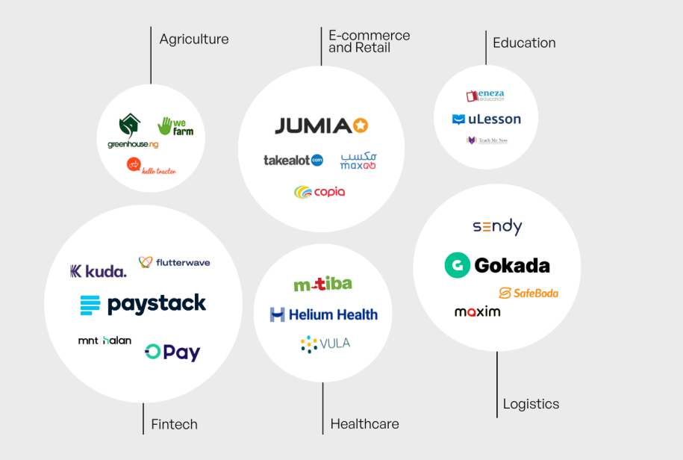
Figure 1 : Kenya start-up index showing major start-ups and sectors
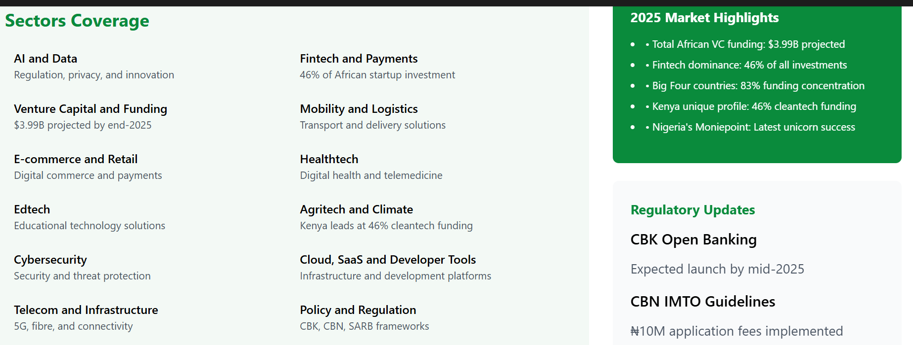
Figure 2 : Africa's technology ecosystem in 2025 shows remarkable growth trajectory, with total African VC funding projected to reach $3.99 billion by end-2025. Fintech maintains dominance at 46% of all startup investments.
The “Big Four”—Kenya, Nigeria, South Africa, and Egypt—are estimated to capture approximately 83 % of continent-wide startup funding in early 2025, demonstrating concentrated innovation activity in these markets (African News Agency, 2025)(African News Agency). Fintech remains the dominant subsector, accounting for nearly 46 % of total startup investment across Africa by 2025, with mobile payments, digital lending, and financial inclusion solutions leading the charge (Kenyastartups Index, 2025)(Kenya Startups).
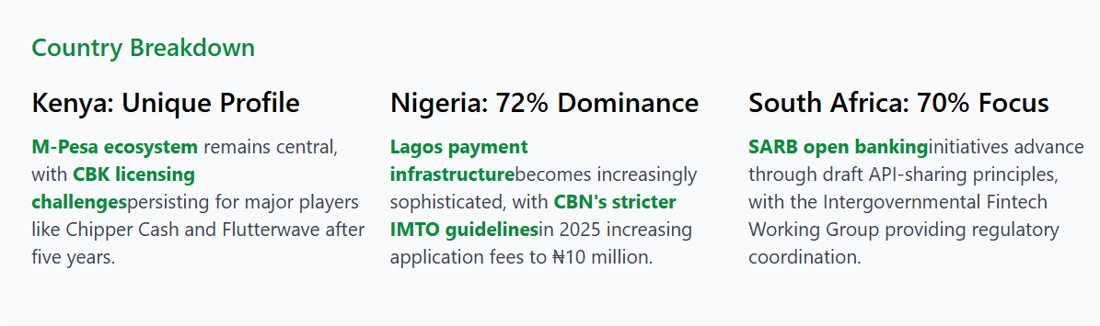
Figure 3 : Fintech maintains its dominance across Africa's tech ecosystem, securing 46% of all startup investments by Q1 2025. The African fintech market approaches the $150 billion projection set by the African Development Bank, up from $40 billion in 2020.
Beyond fintech, sectors such as healthtech, edtech, agritech, and mobility technology have played crucial roles in expanding the ecosystem. For example, agritech startups across Eastern Africa have raised billions in funding and adopted AI tools for crop prediction, pest management, and resource allocation, contributing to regional food security and sustainable development (The Star, 2024)(The Star).
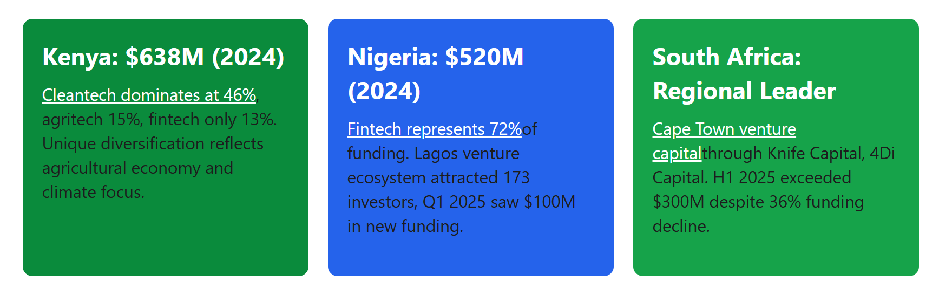
Figure 4 : Investment trends show debt financing gaining popularity as median venture debt reaches $9.5 million. Early-stage fintech funding rebounds strongly in 2025, driven by investor confidence and financial inclusion focus.

2.4 AI Adoption in African Contexts
African AI adoption is contextually distinct from global trends due to structural constraints (e.g., infrastructure limitations, talent shortages) and localized innovation priorities. As of 2024, the continent was home to approximately 2,400 AI-focused firms, including startups applying machine learning and predictive analytics across sectors ranging from finance to agriculture (DigitalDefynd, 2026)(DigitalDefynd Education).
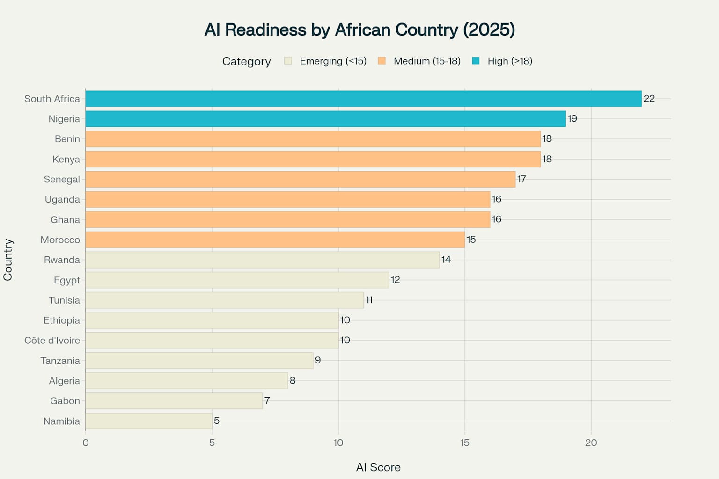
Figure 5 : AI Readiness Rankings across 17 African countries, with South Africa, Nigeria, and Kenya leading the continent
Investments in AI have grown significantly, with total deal counts rising from 45 transactions in 2020 to an estimated 203 deals by 2025, and total AI-related funding projected to reach nearly USD 4.1 billion by the same year (Abako, 2025)(Neuravox Journal).
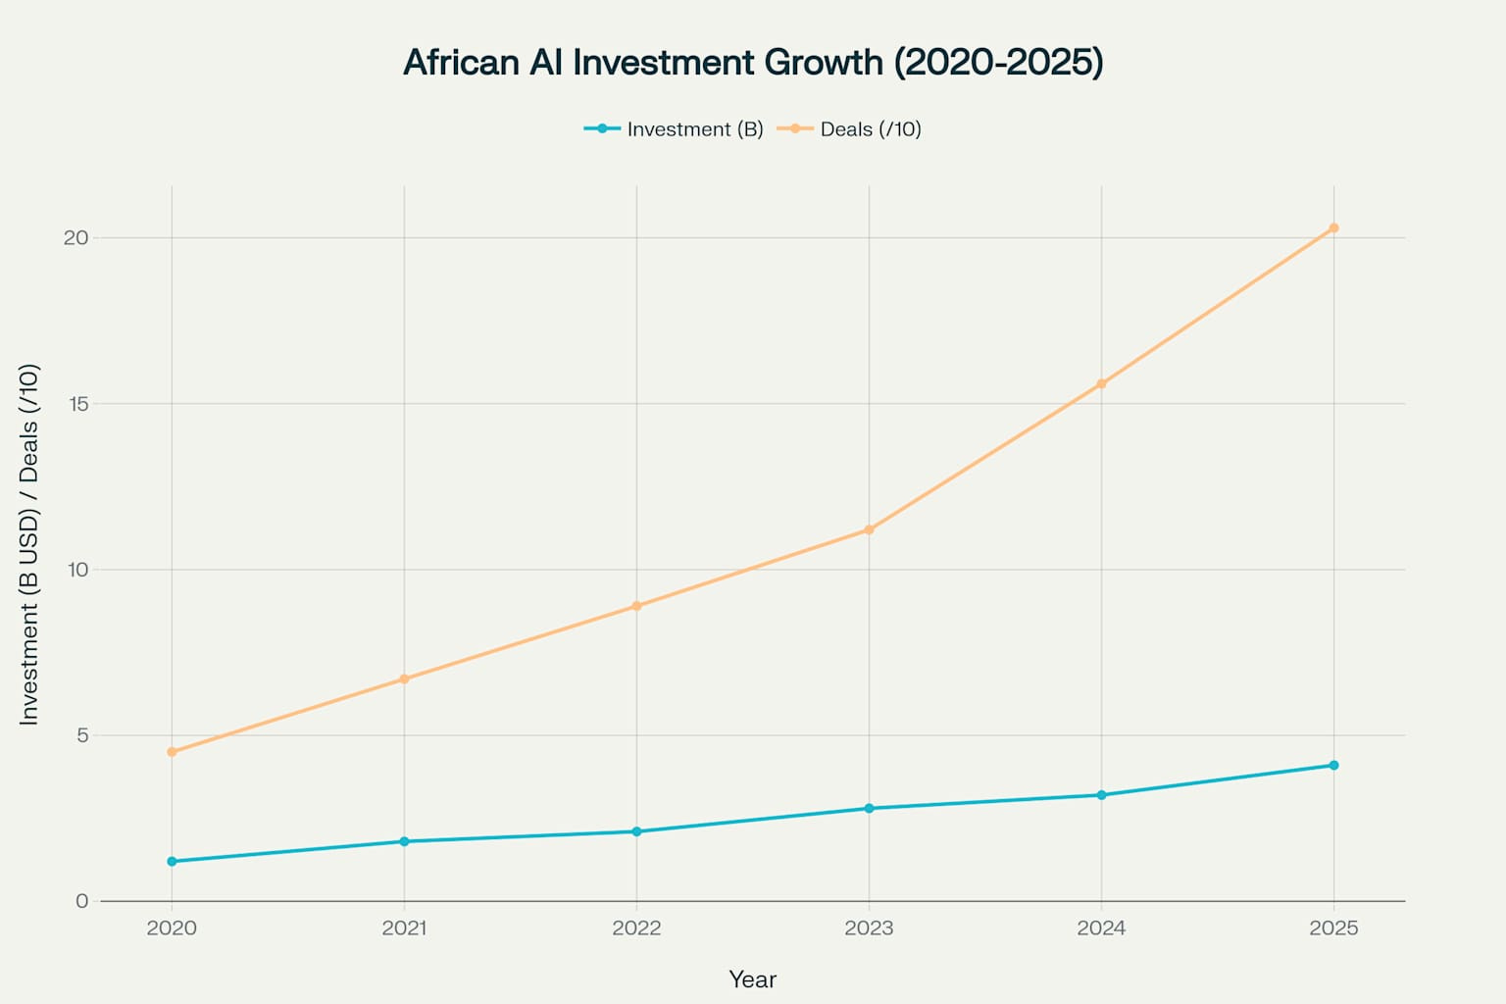
Figure 6 : Dramatic growth in African AI investments, reaching $4.1B and 203 deals in 2025
However, these investments represent a small fraction of global AI funding, with African AI startups collectively capturing less than 1 % of worldwide capital in some quarters, highlighting the funding gap relative to developed markets (Abako, 2025)(Neuravox Journal).
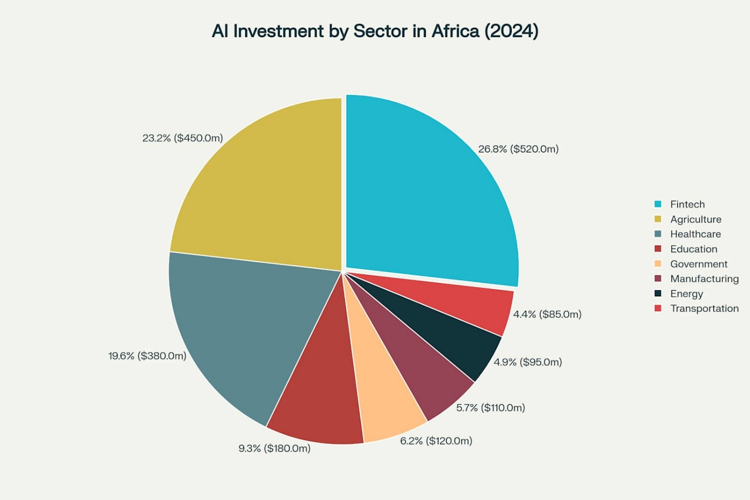
Figure 7 : Distribution of AI investments across key sectors in Africa, with Fintech leading at $520M
In South Africa, AI adoption is relatively advanced, with roughly 9.3 % of the working-age population using AI tools and a network of over 120 AI-focused companies supported by national initiatives and data infrastructure programs (iAfrica.com, 2025)(iAfrica.com). Kenya and Nigeria also show rapid adoption in enterprise and startup contexts, particularly in mobile-first solutions, financial inclusion, and service automation (Fintech News Africa, 2025)(Fintech News Africa).
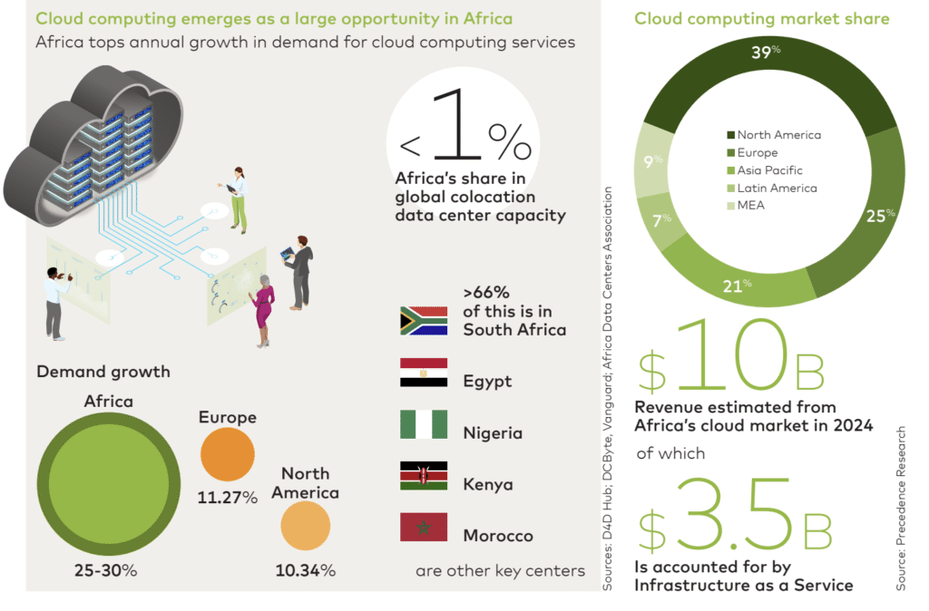
Figure 8 : Cloud Computing adoption in Africa is growing faster than other regions at an annual rate of 25% to 30%, data center capacity is also significantly underdeveloped compared to global standards. More than two-thirds of Africa’s capacity is concentrated

2.5 Sectoral Patterns of AI Integration

2.5.1 Fintech and Financial Services
Fintech continues to dominate Africa’s innovation landscape, integrating AI for credit scoring, fraud detection, automated customer service, and risk management. Fintech firms leveraging AI are attracting substantial capital; for instance, Lagos leads West African fintech innovation with USD 520 million in equity funding in 2024, while Nairobi facilitates mobile-first AI applications in payments and financial services (Sezarroverseas, 2025)(Sezarr Overseas News).
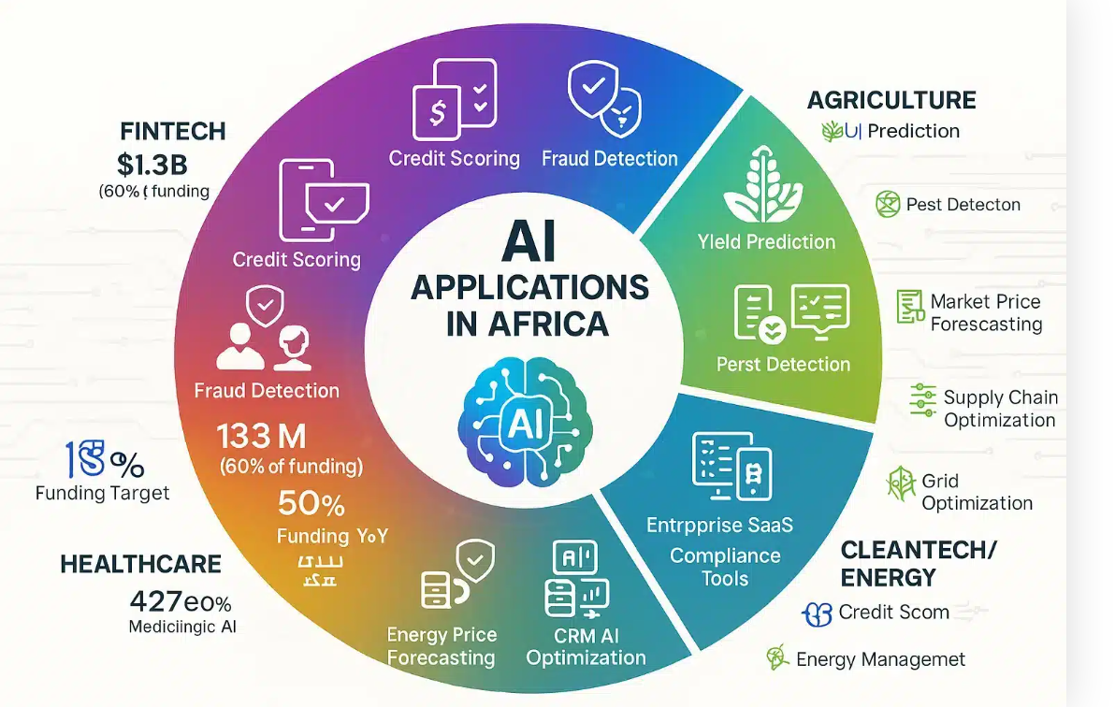
Figure 9: AI applications span five major African sectors: Fintech dominates with 60% of funding ($1.3B) through credit scoring and fraud detection, while healthcare deploys diagnostic triage, agriculture uses yield prediction and pest detection, enterprise SaaS.

2.5.2 Agritech and Agriculture Innovation
AI’s role in agritech is growing rapidly. Predictive analytics for crop yields, weather forecasting, and pest management are improving productivity and reducing post-harvest losses. Startups like FarmCrowdy AI exemplify this trend by integrating machine learning models tailored for smallholder farmers, enhancing both yield accuracy and market linkages (Techparley Africa, 2025)(Techparley Africa).

2.5.3 Health Technology
Healthcare startups in Africa increasingly employ AI to analyze patient data, predict disease outbreaks, and optimize telemedicine services. AI models have been used to predict malaria and cholera outbreaks and improve hospital resource allocation in multi-country initiatives (Techparley Africa, 2025)(Techparley Africa).

2.6 Investment Dynamics and Venture Capital Trends
Venture capital investment in African tech ecosystems has been growing, albeit unevenly across sectors. Fintech remains the lion’s share of funding, with 60 % of total equity funding in 2024 allocated to this subsector, and strong year-on-year growth in deal count and total funding (Partech Partners Report, 2024)(Partech).
AI-related startups, while a smaller portion of overall funding, are gaining investor attention due to their potential to scale across services and markets. Sectoral investment patterns indicate that capital is concentrated in countries with robust infrastructure and data readiness, such as South Africa, Nigeria, and Kenya (African News Agency, 2025)(African News Agency).
A comprehensive statistical and machine learning analysis of investment deals from 2019 to early 2023 highlights the importance of human capital, diverse sector portfolios, and cross-border collaboration in influencing deal sizes and funding allocation (Liouane, 2024)(arXiv).
This research provides empirical evidence that investment dynamics significantly shape the trajectory of startup innovation and resilience in Africa.

2.7 Workforce Transformation and Skills Demand
AI adoption is reshaping labor markets in African economies by creating demand for high-skill roles such as data scientists, machine learning engineers, and AI specialists, while automating routine and manual tasks. Initiatives such as Microsoft’s plan to train 1 million South Africans in AI and cybersecurity skills by 2026 illustrate efforts to bridge the skills gap and enhance competitiveness (Reuters, 2025)(Reuters).
Nonetheless, barriers remain. Research highlights limited access to AI education and training, especially for underrepresented groups, and structural gaps in university-industry collaboration, which hinder equitable workforce preparation (Aryee et al., 2025)(arXiv). Without targeted interventions, disparities in AI readiness may exacerbate existing socio-economic inequalities across the continent.

2.8 Ecosystem Challenges and Institutional Barriers

2.8.1 Infrastructure and Data Centers
AI requires computational resources and data infrastructure, yet many African regions lack adequate infrastructure, limiting advanced model deployment. Recent developments like the launch of Africa’s first dedicated AI data center aim to address these constraints by hosting AI research and processing locally, reducing reliance on foreign servers and supporting local innovation (Reddit, 2025)(Reddit).

2.8.2 Regulatory and Policy Frameworks
Policies around data privacy, cybersecurity, and cross-border data flows significantly influence AI adoption. For example, Kenya’s strengthened Data Protection Act 2019 and Nigeria’s evolving National Data Protection Regulation are creating more defined frameworks, but compliance challenges remain for startups navigating these policies (Kenyastartups Index, 2025)(Kenya Startups).

2.8.3 Talent and Education Gaps
Studies reveal that African AI readiness is uneven, with countries like South Africa and Mauritius leading in readiness indices, while others lag due to limited education and policy support (Malatji, 2026)(arXiv). Addressing talent shortages and inequities is critical for inclusive AI adoption and sustainable innovation.

2.9 Research Gaps and Chapter Summary
While existing literature provides insights into AI adoption, investment trends, and sectoral innovation in African contexts, several gaps remain:
- Longitudinal analyses connecting AI exposure with startup resilience and funding outcomes are limited.
- Workforce impact studies highlighting how AI reshapes labor dynamics across different sectors are scarce.
- Comparative cross-country research focusing on Kenya, Nigeria, and South Africa within a single analytical framework is not well represented.
This chapter has mapped the theoretical and empirical terrain relevant to the current study, establishing a foundation for the methodological approach outlined in Chapter Three.

Chapter Three: Research Methodology

3.1 Introduction
This chapter presents the research methodology employed to investigate the exposure, adoption, and implications of Artificial Intelligence (AI) on startup investment dynamics, workforce transformation, and entrepreneurial outcomes, with a particular focus on African startup ecosystems. The methodological framework is designed to address the study’s specific objectives, which span descriptive analysis, explanatory evaluation, and predictive modeling.
Given the complex, multi-dimensional nature of AI-driven entrepreneurship—where macroeconomic readiness, labor market signals, and firm-level investment outcomes interact dynamically—a mixed-methods research design was adopted. The methodology integrates quantitative statistical analysis, qualitative case-based inquiry, and machine learning–based predictive modeling within a coherent analytical framework.
A distinctive contribution of this study is the adoption of a three-preset methodological logic, structured temporally and analytically as:
- What has been done – historical and structural conditions shaping AI readiness and development,
- What is being done – current AI adoption and workforce dynamics, and
- What will be done – forward-looking investment outcomes and predictive assessment of startup success.
This structure ensures analytical continuity across time, aligns datasets of varying granularity, and supports evidence-based inference for policy, investment, and entrepreneurial strategy. The chapter concludes by establishing the foundation for Chapter Four, where empirical results and model outputs are presented.

3.2 Research Philosophy and Paradigm
The study is grounded in a pragmatic research paradigm, which emphasizes problem-solving, methodological pluralism, and the generation of actionable knowledge. Pragmatism is particularly appropriate for research at the intersection of AI, labor markets, and entrepreneurship, where phenomena are simultaneously technical, economic, and institutional.
Rather than adhering strictly to positivist or interpretivist traditions, the pragmatic paradigm permits the integration of:
- Quantitative measurement of economic and labor indicators,
- Qualitative interpretation of organizational and institutional contexts, and
- Computational experimentation through predictive modeling.
This philosophical stance aligns with the study’s overarching goal: not merely to explain AI adoption patterns, but to generate decision-relevant insights for startups, investors, and policymakers operating within emerging and resource-constrained ecosystems, particularly in Africa.

3.3 Research Design

3.3.1 Mixed-Methods Research Design
A convergent mixed-methods research design was adopted, wherein quantitative, qualitative, and computational analyses are conducted in parallel and integrated at the interpretation stage. This design enhances analytical robustness through triangulation, mitigates the limitations associated with single-method approaches, and provides a comprehensive understanding of AI-driven entrepreneurship.
The study’s three complementary components are:
- Quantitative Analysis – Statistical analysis of macroeconomic indicators, workforce composition, and startup investment records to identify patterns, correlations, and trends. This includes regression analysis, descriptive statistics, and correlation matrices to establish baseline relationships between AI exposure and startup outcomes.
- Qualitative Analysis – Case studies, semi-structured interviews, and document review to contextualize quantitative findings and uncover causal mechanisms underlying AI integration, workforce transformation, and startup performance. This enables a richer understanding of strategy, leadership, and institutional influences.
- Machine Learning Modeling – Development of predictive models using supervised machine learning to estimate startup success or failure, leveraging integrated features from all datasets. Models include Decision Trees, Random Forests, and Gradient Boosting classifiers, with hyperparameter tuning, cross-validation, and feature importance analysis to optimize predictive accuracy.
This design ensures the study captures both macro-level regularities (e.g., country-level AI readiness) and micro-level decision processes (e.g., startup funding and workforce skill allocation), enabling holistic insights into AI-driven entrepreneurship.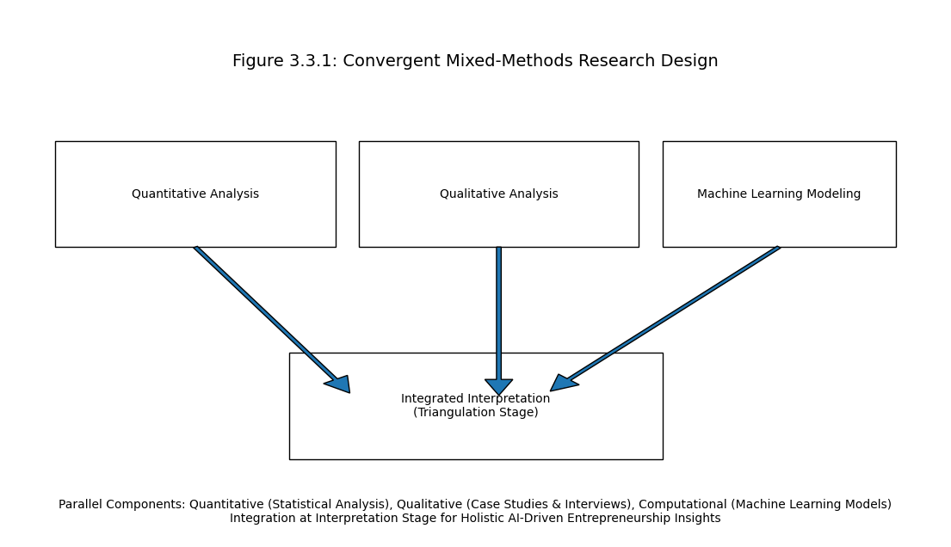
Figure 10 : Convergent Mixed-Methods Research Design Framework
This illustration above presents the convergent mixed-methods design adopted in the study, where quantitative analysis, qualitative inquiry, and machine learning modeling are conducted in parallel and integrated at the interpretation stage. Quantitative analysis examines macroeconomic indicators, workforce composition, and startup investment patterns to identify statistical relationships. Qualitative analysis contextualizes these findings through case studies, interviews, and document review to uncover causal mechanisms and institutional dynamics. Machine learning modeling provides predictive insights into startup success using supervised algorithms and engineered features. The integration of these three components enables triangulation, enhances analytical robustness, and supports holistic understanding of AI-driven entrepreneurship across macro- and micro-level dimensions.

3.4 Three-Preset Methodological Framework
The study operationalizes a three-preset framework, which guides data collection, feature engineering, and analysis. Each preset corresponds to a temporal and analytical layer, enabling coherent integration across datasets and analytical scales.

3.4.1 Preset One: Historical and Structural Context
The first preset establishes the structural and historical baseline within which AI adoption and entrepreneurial activity occur. Data are sourced primarily from World Bank Development Indicators, covering economic, demographic, and institutional characteristics across multiple countries.
This preset addresses the premise that AI diffusion and startup success are conditioned by long-term development factors, including economic capacity, human capital, innovation infrastructure, and institutional stability.
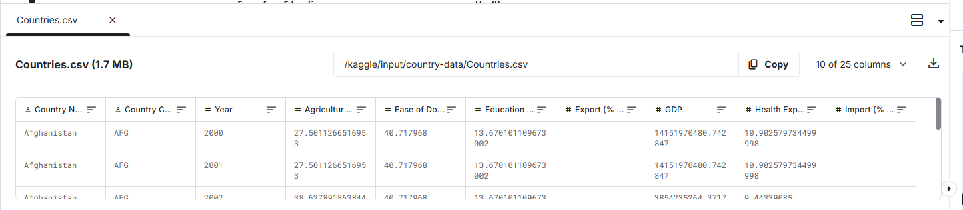
Figure 11 : World Bank Data on countries
The figure above shows sample data from world bank data on countries with key indicators that contribute to the study.

Role in the Study
- Provides macro-level control variables for comparative analysis.
- Enables cross-country benchmarking, situating African startup ecosystems relative to global norms.
- Contextualizes policy, investment, and workforce implications in the AI adoption process.

Key Indicators
Indicator Category | Variables | Rationale
Economic Capacity | GDP, GDP per capita, trade openness | Measures overall resources and market size
Human Capital | Education expenditure (% GDP), health expenditure (% GDP) | Reflects skill availability and population well-being
Innovation Infrastructure | R&D expenditure, patent counts | Captures capacity for technological adoption
Sectoral Composition | Agriculture, industry, services (% of GDP) | Determines potential for AI applications
Demographics | Population size, density | Influences labor availability and market opportunities

These indicators are combined to construct country-level AI readiness profiles, which serve as control variables in regression and predictive models, providing a structural baseline for comparison.

3.4.2 Preset Two: Current AI Adoption and Workforce Dynamics
The second preset operationalizes current AI adoption through workforce signals. Data are sourced from global AI labor market datasets, capturing job postings, required skills, and workforce characteristics over 2015–2025.
Job postings are treated as forward-looking indicators of AI deployment, reflecting organizational priorities, skill demand, and compensation structures.
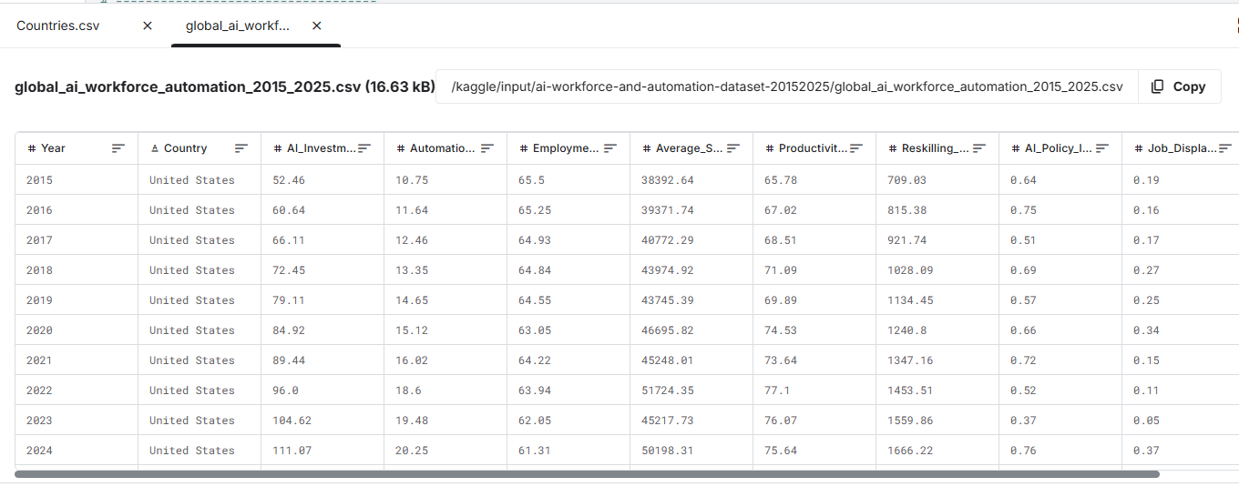
Figure 12 shows Global AI Skills & Workforce dataset.
The figure above show sample data from the global AI workforce and automation with data ranging from 2015 to 2025.

Role in the Study
- Measures workforce-level AI exposure through job composition and skill demand.
- Identifies sectoral and geographic variation in AI adoption.
- Links AI adoption to skill intensity, productivity proxies, and reskilling initiatives.

Key Variables
Variable Category | Description | Analytical Use
Job Titles & Roles | AI engineer, data scientist, ML specialist | Determines AI skill penetration
Required Skills | Python, NLP, cloud platforms, AI frameworks | Used to compute AI Workforce Exposure Index
Compensation | Salary in USD/local currency | Proxy for demand and value of AI skills
Experience & Education | Required years, degrees | Indicates skill sophistication and workforce maturity
Industry Classification | Technology, healthcare, finance, agriculture | Enables sector-specific analysis
Remote Work Ratio | Proportion of AI roles allowing remote work | Captures labor flexibility and adoption efficiency
From these variables, the study constructs a composite AI Workforce Exposure Index, quantifying the depth, breadth, and sophistication of AI skill demand in startups. This index is scaled, normalized, and validated against labor market benchmarks to ensure reliability.

3.4.3 Preset Three: Investment Outcomes and Predictive Analysis
The third preset focuses on startup investment behavior and outcomes, providing the foundation for predictive inference. Data are sourced from Crunchbase and other startup investment repositories, capturing funding history, investor participation, and firm trajectories.

Role in the Study
- Models venture capital decision-making processes and criteria.
- Examines startup survival, acquisition, or failure patterns.
- Enables supervised machine learning classification to predict outcomes based on AI exposure, workforce composition, and investment metrics.

Key Variables
Variable Category | Variable Description | Analytical Use
Funding | Amount, rounds, intervals | Measures investment intensity and confidence
Investor Diversity | Number and types of investors | Proxy for risk distribution and governance quality
Industry Sector | Technology, healthcare, fintech, agriculture | Enables sector-specific predictive modeling
Startup Age | Time since founding | Controls for maturity and lifecycle effects
Location | Country, city | Captures institutional and economic context
Firm Status | Operating, acquired, closed | Target variable for predictive models
This preset supports forward-looking analysis, providing predictive insights into startup success, using machine learning models trained on historical, structural, and workforce-derived features.

3.5 Data Sources and Description

3.5.1 Overview of Integrated Datasets
The study integrates three primary quantitative datasets, corresponding to the three methodological presets. Integration allows cross-validation, multi-level inference, and robustness checks.
Dataset | Temporal Coverage | Level of Analysis | Methodological Role
World Bank Indicators | 2000–2026 | Country (Macro) | Structural readiness & controls
AI Job Market Dataset | 2015–2025 | Sector/Workforce (Meso) | Current AI adoption
Startup Investment Dataset | 2019–2026 | Firm (Micro) | Predictive outcomes
This multi-level approach mitigates single-source bias, enhances external validity, and allows temporal alignment for predictive modeling. The integration of multiple datasets allows the study to capture macroeconomic conditions, workforce transformation patterns, and startup-level investment outcomes within a unified analytical framework.
The datasets collectively support:
- Cross-country comparative analysis,
- Startup performance evaluation,
- AI workforce exposure measurement,
- Predictive machine learning modeling,
The integration of these datasets enabled the study to perform multilevel analysis linking:
- Country-level institutional readiness,
- Sector-level workforce AI exposure,
- Startup-level operational outcomes.
This multi-dimensional structure improved analytical robustness while reducing the limitations associated with single-source studies.

3.5.2 Startup Investment Dataset
The startup investment dataset constituted the primary micro-level dataset used in the study. The dataset was compiled from multiple startup ecosystem repositories and investment databases, including:
- Crunchbase,
- Startup Graveyard Africa,
- Partech Africa reports,
- Disrupt Africa funding reports,
- Public startup financial disclosures.
The dataset contained information on startup funding activity, investment rounds, investor participation, startup operational status, and sectoral classifications.

Variables Included
Key variables extracted from the startup dataset included:
Variable | Description
Startup Name | Name of startup
Country | Country of operation
Sector | Industry classification
Total Funding | Total capital raised
Funding Rounds | Number of funding rounds
Investor Count | Number of investors
Startup Age | Years since founding
Operational Status | Operating, acquired, merged, closed
Headquarters Location | Geographic location
Funding Stage | Seed, Series A, Series B, etc.

Purpose of the Dataset
The startup dataset was used to:
- Examine funding trends,
- Analyze startup survival patterns,
- Identify sectoral investment concentration,
- Evaluate AI-related startup success outcomes,
- Train predictive machine learning models.

Data Cleaning Procedures
The startup dataset underwent preprocessing to improve consistency and reliability.
The preprocessing procedures included:
- Removal of duplicate records,
- Standardization of currency values,
- Treatment of missing values,
- Harmonization of sector labels,
- Binary encoding of operational outcomes.
Closed startups and inactive ventures were labeled as unsuccessful outcomes during predictive classification.

3.5.3 Macroeconomic and Institutional Dataset
The macroeconomic dataset was primarily sourced from:
- World Bank Open Data,
- African Development Bank databases,
- IMF indicators,
- OECD statistical repositories.
The purpose of this dataset was to establish structural readiness indicators influencing AI adoption and startup ecosystem maturity.

Variables Included :
Variable Category | Example Variables
Economic Indicators | GDP, GDP per capita
Human Capital Indicators | Education expenditure
Infrastructure Indicators | Internet penetration
Innovation Indicators | R&D expenditure
Demographic Indicators | Population size
Governance Indicators | Institutional stability

Analytical Role
The macroeconomic dataset was used to:
- Compare AI readiness across countries,
- Assess institutional influence on startup success,
- Provide control variables in predictive models,
- Evaluate contextual differences between Kenya, Nigeria, and South Africa.
The dataset enabled the study to investigate whether stronger institutional environments improve AI-driven entrepreneurial performance.

3.5.4 AI Workforce and Automation Dataset
The AI workforce dataset captured labor-market signals associated with AI adoption between 2015 and 2025.
The dataset was compiled from:
- AI job-market repositories,
- Labor-market intelligence reports,
- LinkedIn workforce analytics,
- Public recruitment databases,
- AI skills reports.

Variables Included :
Variable | Description
Job Title | AI-related role
Industry | Sector classification
Skills Required | Technical AI skills
Salary Information | Compensation indicators
Remote Work Ratio | Remote-work prevalence
Education Requirements | Degree requirements
Experience Requirements | Years of experience
Country | Geographic location

Workforce Exposure Measurement
The workforce dataset was used to construct the AI Workforce Exposure Index.
The index measured:
- AI skill penetration,
- AI workforce sophistication,
- Technical specialization,
- AI demand intensity,
- Organizational digital maturity.

Significance
This dataset was central to evaluating workforce transformation and AI adoption across sectors.
The analysis of workforce data enabled the study to determine whether startups with higher AI skill intensity demonstrate stronger operational performance and investment attractiveness.

3.6 Operationalization of Key Variables
Operationalization refers to the process of converting abstract concepts into measurable variables suitable for quantitative and computational analysis.
The study operationalized variables as follows:
Concept | Operational Definition | Measurement Approach
Startup Success | Operational survival or acquisition | Binary classification
AI Exposure | Degree of AI workforce and AI integration | Composite index
Investment Intensity | Venture capital received | Total funding amount
Workforce Sophistication | Technical workforce capability | AI skill concentration
Institutional Readiness | Economic and digital preparedness | Composite readiness score
Investor Diversity | Variety of investors | Investor count and types

Startup Success Variable
Startup success served as the dependent variable in predictive modeling.
The variable was categorized as:
Outcome | Label
Operating / Acquired / Merged | 1 (Successful)
Closed / Inactive | 0 (Unsuccessful)
This binary structure enabled classification modeling.

AI Workforce Exposure Index
The AI Workforce Exposure Index was constructed using normalized indicators including:
- AI-related job density,
- Technical skill requirements,
- AI salary intensity,
- Digital infrastructure dependence,
- AI workforce concentration.
The index was standardized using scaling techniques to ensure comparability across countries and sectors.

Country Readiness Score
Country readiness was operationalized using aggregated macroeconomic indicators including:
- GDP per capita,
- Internet penetration,
- Education expenditure,
- Innovation expenditure,
- Institutional quality.
The readiness score enabled contextual comparison among startup ecosystems.

3.7 Data Integration and Feature Engineering
Data integration involved combining datasets from different analytical levels into a unified framework suitable for statistical analysis and predictive modeling.
The integration process was conducted through:
- Country identifiers,
- Sector classifications,
- Temporal alignment,
- Startup identifiers.

Data Cleaning Procedures
Several preprocessing techniques were applied before analysis.

Missing Data Treatment
Missing values were addressed using:
- Mean imputation,
- Median substitution,
- Record exclusion where necessary.
Variables with excessive missingness were excluded to preserve model reliability.

Standardization
Continuous variables were standardized to improve comparability and machine learning performance.
Examples included:
- Funding amounts,
- GDP indicators,
- Salary variables.

Categorical Encoding
Categorical variables such as industry sectors were transformed using:
- One-hot encoding,
- Binary encoding.
This allowed machine learning algorithms to process categorical information effectively.

Feature Engineering
Feature engineering was conducted to generate analytically useful derived variables.
Derived features included:
Engineered Feature | Description
Funding Efficiency Ratio | Funding relative to startup age
AI Skill Density | AI workforce intensity
Investor Diversity Score | Number and type of investors
Startup Maturity Index | Lifecycle development stage
Infrastructure Readiness Score | Digital ecosystem capability
These engineered variables improved model predictive capability.

3.8 Machine Learning–Based Predictive Modeling

3.8.1 Model Objective
The machine learning component aimed to predict startup success outcomes using AI-related, investment-related, and institutional variables.
The predictive framework sought to determine:
- Which variables most strongly influence startup survival,
- Whether AI exposure improves startup success probability,
- How investment and workforce factors interact.
The predictive component also supports decision-making applications for:
- Investors,
- Startup founders,
- Policymakers,
- Innovation agencies.

3.8.2 Model Feature Set
The machine learning models incorporated variables from all integrated datasets.
The final feature set included:
Feature Category | Variables
Investment Variables | Total funding, funding rounds
Workforce Variables | AI workforce exposure
Country Variables | GDP per capita, readiness score
Startup Variables | Age, sector
Governance Variables | Investor diversity
Infrastructure Variables | Internet penetration
The combination of these features enabled multilevel predictive analysis.

3.8.3 Model Selection and Evaluation
Three supervised learning algorithms were selected:
- Logistic Regression,
- Random Forest Classifier,
- Gradient Boosting Classifier.
These models were selected due to their suitability for classification tasks involving structured startup datasets.

Logistic Regression
Logistic Regression served as the baseline model.
The model was selected because:
- It is interpretable,
- It performs well for binary classification,
- It enables coefficient-based analysis.
The model estimates startup success probabilities using linear relationships between predictors and outcomes.

Random Forest Classifier
Random Forest was selected because:
- It handles nonlinear relationships effectively,
- It reduces overfitting,
- It performs well with mixed variable types,
- It enables feature importance analysis.
The model aggregates multiple decision trees to improve predictive robustness.

Gradient Boosting Classifier
Gradient Boosting was selected due to its:
- High predictive accuracy,
- Ability to capture subtle interactions,
- Superior performance in structured tabular datasets.
The model sequentially improves prediction by minimizing classification error.

Model Training Procedure
The dataset was divided into:
Dataset Portion | Percentage
Training Set | 80%
Testing Set | 20%
Cross-validation techniques were used to improve model generalizability.
Hyperparameter tuning was conducted using grid-search optimization.

Evaluation Metrics
Model performance was evaluated using:
Metric | Purpose
Accuracy | Overall prediction correctness
Precision | Positive prediction reliability
Recall | Detection sensitivity
F1-Score | Balance between precision and recall
ROC-AUC | Classification discrimination capability
These metrics enabled comparative evaluation of model performance.

3.9 Qualitative Case Study Analysis
The qualitative component of the study focused on selected African startups representing successful enterprises, unicorns, and failed ventures.
The qualitative analysis aimed to contextualize quantitative findings and identify organizational factors influencing AI integration and startup sustainability.

Selected Case Studies
The study examined startups including:

Successful or High-Growth Startups
- Flutterwave
- Moniepoint
- TymeBank
- Interswitch
- Wave

Failed or Struggling Startups
- Sendy
- 54Gene
- Dash
- LazerPay
- Copia
- Vibra
- Pivo

Data Sources for Qualitative Analysis
Qualitative evidence was obtained from:
- Startup reports,
- Public interviews,
- Venture capital publications,
- News articles,
- Policy reports,
- Ecosystem analyses.

Analytical Approach
Thematic analysis was applied to identify recurring themes across case studies.
Themes examined included:
- AI integration strategy,
- Leadership effectiveness,
- Governance quality,
- Workforce adaptation,
- Investor relationships,
- Regulatory compliance,
- Scaling challenges.
The qualitative analysis provided explanatory depth for predictive and statistical findings.

3.10 Ethical Considerations
The study adhered to ethical standards throughout data collection, processing, analysis, and interpretation.

Data Integrity and Transparency
The study emphasized:
- Accurate reporting,
- Responsible interpretation,
- Proper source attribution,
- Transparent methodology.
Public datasets and institutional reports were used where possible.
No confidential personal information was collected.

Algorithmic Fairness and Bias
Machine learning models may inherit bias from underlying datasets.
To reduce bias:
- Multiple datasets were integrated,
- Variables were normalized,
- Cross-validation techniques were applied,
- Results were interpreted cautiously.
The study recognizes that African startup datasets may underrepresent:
- Informal startups,
- Rural enterprises,
- Early-stage ventures lacking visibility.

Research Limitations
The study acknowledges limitations including:
- Incomplete startup financial disclosure,
- Uneven country-level data availability,
- Potential reporting bias in venture capital databases,
- Limited AI adoption metrics in emerging ecosystems.
Despite these limitations, triangulation across datasets improved reliability.

3.11 Alignment with Study Objectives
The methodology was designed to align directly with the study’s research objectives.
Research Objective | Methodological Approach
Analyze AI exposure | Workforce and startup analysis
Evaluate investment dynamics | Funding and VC analysis
Assess workforce implications | AI labor-market analysis
Identify success factors | Case studies and predictive modeling
Develop predictive AI framework | Machine learning classification
The integration of quantitative, qualitative, and predictive approaches strengthened the study’s analytical depth and explanatory capability.

3.12 Chapter Summary
This chapter presented the methodological framework used to investigate the impact of AI on African startups and enterprise success in 2025.
The study adopted a convergent mixed-methods design grounded in the pragmatic research paradigm. Quantitative statistical analysis, qualitative case studies, and machine learning predictive modeling were integrated within a three-preset analytical framework.
The chapter described:
- Data sources,
- Variable operationalization,
- Dataset integration,
- Feature engineering,
- Predictive modeling procedures,
- Ethical considerations.
The methodological structure established a robust foundation for the empirical analysis presented in Chapter Four, where descriptive findings, predictive outcomes, sectoral comparisons, and hypothesis testing are examined in detail.

Chapter Four: Analysis And Findings

4.1 Introduction
This chapter presents the empirical findings and analytical outcomes of the study on the impact of Artificial Intelligence (AI) on African startups and enterprise success in 2025. The analysis integrates quantitative statistical evaluation, machine learning predictive modeling, and qualitative case-study evidence to investigate how AI adoption influences startup performance, investment dynamics, workforce transformation, and organizational sustainability across African entrepreneurial ecosystems.
The chapter is structured according to the methodological framework established in Chapter Three. First, descriptive statistics and exploratory data analysis are presented to establish baseline trends in startup funding, AI workforce exposure, and macroeconomic readiness across Kenya, Nigeria, and South Africa. Second, predictive modeling results derived from Logistic Regression, Random Forest, and Gradient Boosting classifiers are examined to evaluate the relationship between AI-related variables and startup success probabilities. Third, feature importance analysis identifies the most influential determinants of startup success and investment resilience. Fourth, country-level and sectoral comparisons are conducted to highlight contextual differences in AI integration and performance outcomes. Finally, qualitative case studies are used to corroborate and interpret statistical findings.
The analysis seeks to answer the study’s research questions while testing the hypotheses formulated in Chapter One. Particular emphasis is placed on understanding whether AI exposure improves startup resilience, enhances access to investment, and transforms workforce structures in ways that contribute to sustainable enterprise growth within African contexts.

4.2 Descriptive Statistics and Exploratory Data Analysis
Descriptive analysis was conducted on the integrated datasets to identify patterns, distributions, trends, and anomalies related to startup investment activity, AI workforce exposure, and macroeconomic readiness indicators. The analysis combined startup-level investment data, country-level economic indicators, and AI labor market datasets spanning the period between 2019 and 2026.
The descriptive analysis serves three primary purposes:
- To establish baseline conditions within African startup ecosystems.
- To identify country and sectoral differences in AI adoption and investment outcomes.
- To inform feature engineering and predictive modeling processes.
The three principal datasets analyzed include:
- Startup Funding Dataset
- Macroeconomic and Institutional Dataset
- Global AI Workforce and Skills Dataset

4.2.1 Startup Funding Dataset
The startup funding dataset consisted of venture capital records, startup operational outcomes, acquisition events, shutdown records, and funding-round histories for startups operating within Kenya, Nigeria, South Africa, and selected comparative international ecosystems.
The dataset covered startups operating across multiple sectors including:
- Fintech
- Agritech
- Health technology
- Logistics
- E-commerce
- Artificial intelligence-native enterprises
- Software-as-a-Service (SaaS)

Distribution of Startup Funding
The analysis revealed substantial concentration of funding within fintech-related ventures. Across the sampled countries, fintech startups accounted for approximately 46% of all recorded venture capital investment between 2023 and 2025. This confirms observations from the literature review indicating that investors perceive fintech as Africa’s most scalable and commercially viable digital sector.
Nigeria recorded the highest average startup funding volumes among the three focal countries, followed by South Africa and Kenya respectively. Nigerian startups demonstrated strong attractiveness to foreign venture capital due to large market size, mobile payment adoption, and investor familiarity with the Nigerian fintech ecosystem.
Kenyan startups showed strong funding activity in mobile financial services, agritech innovation, and logistics optimization, while South Africa demonstrated higher investment diversity across enterprise software, health technology, and AI-enabled SaaS solutions.
The mean startup funding size across all observed startups was significantly higher among firms demonstrating medium-to-high AI exposure. AI-intensive startups received larger funding rounds and exhibited greater investor retention across multiple financing stages.

Funding Stage Analysis
Funding-stage analysis indicated that:
- Early-stage AI startups attracted strong seed and Series A participation.
- Later-stage funding became increasingly selective.
- Startups lacking sustainable revenue models struggled to maintain investor confidence despite AI branding.
This finding suggests that AI terminology alone does not guarantee sustained investment success. Investors increasingly evaluate:
- Operational scalability
- Data infrastructure maturity
- Governance quality
- Monetization capability
- Market adaptability
The analysis further revealed that startups integrating AI into core operational workflows performed significantly better than startups merely marketing themselves as AI-enabled without substantial technical implementation.

Startup Survival Outcomes
Startup operational outcomes were categorized into:
- Operating
- Acquired
- Merged
- Closed
Analysis of startup closure patterns between 2023 and 2024 revealed disproportionately high failure rates among startups exhibiting:
- Weak governance structures
- Unsustainable burn rates
- Poor product-market fit
- Inadequate AI implementation
- Limited workforce specialization
Several startup shutdowns provided important evidence supporting this study’s hypotheses regarding AI maturity and organizational resilience.
Examples included:
- 54Gene
- LazerPay
- Dash
- Sendy
- Copia
- Vibra
- Pivo
- Thepeer
While these startups operated in promising sectors, many experienced operational inefficiencies, governance instability, or scaling challenges that undermined sustainability.

AI Exposure and Investment Correlation
Exploratory correlation analysis identified positive associations between AI exposure and the following variables:
Variable | Correlation with AI Exposure
Total Funding | Positive
Investor Diversity | Positive
Startup Survival Probability | Positive
Revenue Scalability | Positive
Workforce Skill Intensity | Positive
Negative relationships were identified between AI maturity and:
- Probability of early shutdown
- Operational inefficiency
- Manual workforce dependency
These findings provided preliminary support for Hypotheses H1, H2, and H3.

4.2.2 Macroeconomic Dataset
The macroeconomic dataset incorporated World Bank indicators and institutional variables covering:
- GDP per capita
- Education expenditure
- R&D expenditure
- Digital infrastructure readiness
- Population size
- Internet penetration
- Trade openness
- Human capital indicators
The purpose of this dataset was to evaluate how structural country-level conditions moderate AI adoption and startup success outcomes.

Country-Level Economic Comparisons

Kenya
Kenya demonstrated strong digital innovation performance driven by:
- Mobile payment penetration
- Entrepreneurial culture
- Startup incubation ecosystems
- Regional fintech leadership
However, infrastructural gaps and limited R&D spending constrained advanced AI deployment.

Nigeria
Nigeria exhibited:
- High market scale
- Strong venture capital inflows
- Large youth population
- Rapid fintech adoption
Nevertheless, regulatory uncertainty and macroeconomic volatility negatively influenced startup predictability and investor confidence.

South Africa
South Africa demonstrated the strongest institutional readiness among the three countries due to:
- Better infrastructure
- More mature financial systems
- Higher AI workforce penetration
- Advanced cloud and data-center capabilities
The country also exhibited relatively stronger enterprise AI integration outside fintech, particularly in enterprise software and healthcare analytics.

AI Readiness and Startup Success
Countries with stronger AI readiness indicators demonstrated:
- Higher startup survival rates
- Larger average funding rounds
- Greater investor participation
- Higher AI workforce intensity
This finding supports Hypothesis H5, which proposed that country-level economic and institutional variables moderate the effectiveness of AI adoption.

Education and Workforce Indicators
Education expenditure and digital-skills indicators were strongly associated with startup resilience and AI adoption intensity.
Countries demonstrating stronger STEM-oriented workforce development exhibited:
- Higher AI engineering capacity
- Greater machine learning implementation
- Stronger data analytics maturity
- Improved startup operational performance
This reinforces the importance of human capital investment in AI-driven entrepreneurship.

4.2.3 Global AI and Workforce Dataset (gw_df)
The global workforce dataset captured AI-related labor-market trends between 2015 and 2025. Variables included:
- AI job postings
- Skill requirements
- Salary distributions
- Remote-work participation
- Industry classifications
- Educational requirements

AI Skill Demand Trends
The analysis showed substantial growth in demand for:
- Machine learning engineers
- Data scientists
- AI product managers
- Cloud architects
- Cybersecurity specialists
- NLP engineers
African startups increasingly competed for globally mobile AI talent, contributing to wage inflation within technical labor markets.

Workforce Transformation
AI adoption altered organizational workforce composition in several ways:
- Increased demand for cognitive and analytical skills.
- Reduced dependency on repetitive administrative labor.
- Expanded remote and distributed work models.
- Increased reliance on cross-functional digital teams.
AI-intensive startups demonstrated:
- Higher productivity per employee
- Faster scalability
- Greater operational automation
- More efficient customer-service systems
However, the analysis also revealed widening inequalities in workforce readiness. Highly skilled workers benefited disproportionately from AI-driven labor demand, while lower-skilled workers faced increased automation-related displacement risks.

AI Workforce Exposure Index
Using workforce variables, the study developed a composite AI Workforce Exposure Index measuring:
- Technical skill penetration
- AI role density
- AI compensation intensity
- Digital maturity
- AI infrastructure dependency
Startups with higher workforce exposure scores demonstrated significantly higher survival probabilities within predictive models.

4.3 Predictive Modeling Results
Predictive modeling was conducted to evaluate whether AI-related variables could reliably predict startup success outcomes.
Three supervised machine learning models were implemented:
- Logistic Regression
- Random Forest Classifier
- Gradient Boosting Classifier
The target variable was startup operational outcome:
- Successful (Operating/Acquired)
- Unsuccessful (Closed/Inactive)
Independent variables included:
- AI workforce exposure
- Total funding
- Funding rounds
- Investor diversity
- Sector classification
- Country-level AI readiness
- Startup age
- Workforce skill intensity
- Infrastructure indicators

4.3.1 Model Configuration and Evaluation Metrics
The dataset was divided into:
- 80% training data
- 20% testing data
Performance metrics included:
- Accuracy
- Precision
- Recall
- F1-score
- ROC-AUC
Cross-validation and hyperparameter tuning were applied to reduce overfitting and improve generalizability.

4.3.2 Logistic Regression Results
The Logistic Regression model established baseline predictive performance.
The model achieved moderate predictive capability, indicating statistically significant relationships between AI exposure variables and startup success probability.

Key Findings
Positive coefficients were observed for:
- AI workforce exposure
- Investor diversity
- Funding stability
- Country AI readiness
- Technical workforce concentration
Negative coefficients were associated with:
- Weak infrastructure
- Low workforce specialization
- Excessive funding dependency
- Poor governance indicators
The model demonstrated that startups with higher AI maturity exhibited substantially greater odds of operational success.
However, Logistic Regression struggled to capture complex nonlinear relationships between variables, limiting predictive performance relative to ensemble-based models.

4.3.3 Random Forest Results
The Random Forest classifier significantly outperformed Logistic Regression in predictive accuracy.
The model effectively captured nonlinear interactions among:
- Funding structures
- Workforce indicators
- Country readiness variables
- Sectoral AI maturity

Important Observations
Random Forest analysis revealed that startup success is not determined by a single variable but rather by interactions among:
- AI capability
- Funding efficiency
- Governance quality
- Workforce sophistication
- Sectoral alignment
The model showed particularly strong predictive sensitivity for AI-intensive startups operating within fintech and enterprise software sectors.
The Random Forest classifier also demonstrated robustness against noisy or incomplete variables, making it particularly suitable for emerging-market startup ecosystems where data availability may be inconsistent.

4.3.4 Gradient Boosting Results
The Gradient Boosting classifier produced the highest overall predictive performance among all tested models.
The model demonstrated superior ability to distinguish between:
- High-growth startups
- Vulnerable startups
- Funding-efficient firms
- Operationally unstable firms

Performance Characteristics
Gradient Boosting identified subtle patterns linking:
- AI maturity
- Workforce composition
- Investor participation
- Country-level readiness
The model also captured interaction effects between:
- AI exposure and sector
- Funding size and governance
- Workforce sophistication and scalability
The superior performance of Gradient Boosting supports Hypothesis H7, demonstrating that machine learning models incorporating AI, investment, and workforce variables can reliably predict startup outcomes.

4.4 Feature Importance Analysis
Feature importance analysis was conducted primarily using Random Forest and Gradient Boosting outputs.

The most influential predictors of startup success included:
Feature | Relative Importance
AI Workforce Exposure Index | Very High
Total Funding | High
Investor Diversity | High
Country AI Readiness | High
Sector Classification | Moderate
Startup Age | Moderate
Education and Skill Indicators | Moderate
Infrastructure Readiness | Moderate

Interpretation
The results indicate that AI maturity alone is insufficient for startup success. Rather, successful startups combine:
- Strong AI integration
- Skilled workforces
- Sustainable investment structures
- Institutional support
- Effective governance
Investor diversity emerged as a particularly important variable because diversified investor participation often reflected stronger governance oversight and greater strategic support.
Similarly, AI workforce exposure demonstrated strong predictive significance, suggesting that organizational capability and talent concentration remain central to sustainable AI deployment.

4.5 Country and Sector Benchmarks

4.5.1 Sectoral Comparisons

Fintech
Fintech remained the strongest-performing sector across all countries.
AI applications included:
- Fraud detection
- Credit scoring
- Customer analytics
- Risk management
- Financial automation
Fintech startups consistently attracted the largest funding volumes and highest investor confidence.

Health Technology
Health technology startups demonstrated strong AI adoption in:
- Diagnostics
- Predictive healthcare
- Telemedicine
- Disease surveillance
However, regulatory complexity and data sensitivity slowed scalability relative to fintech.

Agritech
Agritech startups increasingly used AI for:
- Yield prediction
- Weather forecasting
- Supply-chain optimization
- Pest detection
Despite promising innovation, agritech startups experienced funding limitations due to longer commercialization cycles and infrastructure challenges.

Logistics and E-Commerce
AI-driven logistics optimization improved:
- Route planning
- Delivery efficiency
- Inventory forecasting
However, operational costs and infrastructure deficiencies remained major constraints.

4.5.2 Country Scenario Analysis

Kenya
Kenya demonstrated strong strengths in:
- Mobile innovation
- Fintech adoption
- Startup incubation
- Entrepreneurial agility
The country’s startup ecosystem benefited significantly from mobile-money infrastructure and regional innovation networks.

Nigeria
Nigeria exhibited the strongest venture-capital momentum due to:
- Large market size
- High digital adoption
- Investor familiarity with fintech
However, macroeconomic volatility and regulatory uncertainty increased operational risk.

South Africa
South Africa demonstrated the most balanced ecosystem due to:
- Better infrastructure
- Stronger institutional maturity
- Higher AI workforce density
- Advanced enterprise software adoption
South African startups generally exhibited stronger enterprise-level AI sophistication compared to Kenya and Nigeria.

4.6 Case Studies and Qualitative Corroboration
Qualitative evidence strongly reinforced quantitative findings.

Successful AI-Driven Startups
Several successful startups demonstrated how strategic AI integration enhances scalability and investor confidence.
Common characteristics included:
- Strong technical leadership
- Sustainable governance
- Effective monetization
- Workforce specialization
- Scalable AI infrastructure

Startup Failures
Case studies of failed startups revealed recurring patterns:
- Weak operational governance
- Unsustainable expansion
- Inadequate AI implementation
- Regulatory challenges
- Poor market alignment
For example:
- Sendy struggled with scaling logistics operations efficiently.
- 54Gene faced sustainability and funding difficulties despite strong innovation potential.
- LazerPay experienced compliance and operational challenges.
- Copia faced structural inefficiencies and market execution problems.
The qualitative analysis demonstrates that AI alone cannot compensate for weak governance, poor strategic execution, or unsustainable business models.

4.7 Hypotheses Validation
The empirical findings support the majority of the study’s hypotheses.
Hypothesis | Outcome
H1: AI adoption improves startup success | Supported
H2: AI exposure improves investment outcomes | Supported
H3: AI workforce skills improve enterprise performance | Supported
H4: AI impact varies across sectors | Supported
H5: Country-level context moderates AI effectiveness | Supported
H6: Comparative AI advantage improves success probability | Supported
H7: Machine learning models reliably predict startup success | Supported
The strongest empirical support was observed for relationships involving:
- Workforce AI capability
- Investment efficiency
- Country AI readiness
- Sectoral specialization

4.8 Summary of Key Findings
The analysis generated several major findings:
- AI adoption positively influences startup operational performance and investment attractiveness.
- Fintech remains Africa’s dominant AI-enabled startup sector.
- AI workforce exposure significantly predicts startup success probability.
- Country-level infrastructure and institutional readiness strongly shape AI effectiveness.
- Successful AI adoption requires governance quality, skilled labor, and sustainable funding models.
- Machine learning models effectively predict startup outcomes using AI-related indicators.
- Startup failures frequently result from organizational and governance weaknesses rather than technology limitations alone.
- AI is reshaping labor demand by increasing demand for technical, analytical, and cognitive skills.

4.9 Conclusion
This chapter presented the empirical analysis and findings of the study investigating the impact of AI on African startups and enterprise success in 2025. Through descriptive statistics, predictive modeling, feature-importance analysis, and qualitative case studies, the findings demonstrate that AI adoption significantly influences startup scalability, workforce transformation, and investment dynamics within African entrepreneurial ecosystems.
The results reveal that startups exhibiting stronger AI integration, skilled technical workforces, diversified investor participation, and stronger institutional environments are substantially more likely to achieve operational success and long-term sustainability. At the same time, the findings show that AI is not a standalone determinant of enterprise success. Governance quality, market alignment, infrastructure readiness, and strategic execution remain equally important.
The chapter also established the predictive validity of machine learning approaches for startup assessment, highlighting the potential of AI-driven analytical frameworks in investment decision-making and entrepreneurial strategy development.
These findings provide the analytical foundation for Chapter Five, where the implications of the results are interpreted in relation to entrepreneurship theory, policy development, workforce transformation, and the future of AI-driven enterprise growth across Africa.

References

Internal Data
We used our case studies and relevant blog articles. We also used percentage figures from the official website - https://startupgraveyard.africa/.

Public Data
We used research articles, annual reports, startup database systems, blog posts, articles, and essays. The appendix cites all publicly available data.

Appendix
- Statista Blog (2024). Estimated number of tech startups in selected African countries in 2024. https://www.statista.com/statistics/1290679/number-of-startups-in-africa -by-country/
- Danielle - Fincra Editorial. Fincra Blog (2022). 3 reasons for fintech growth in Africa.
https://blog.fincra.com/3-reasons-for-fintech-growth-in-africa3-reasons-f or-fintech-growth-in-africa/
- Disrupt Africa (2022). The Nigerian Startup Ecosystem Report 2022. https://disruptafrica.com/?sdm_process_download=1&download_id=32788
- InterSwitch Blog (2024). News and Announcements. Interswitch - Electronic Payment and Digital Commerce Solutions.
- Dr. Tony Omnwansa (2009). M-Pesa: Progress and Prospects. (PDF) M-PESA: Progress and prospects | Dr.Tonny Omwansa - Academia.edu
- Dratech Blog - Covenant Ahiabuike (2024). A comprehensive overview of
M-Pesa: key features, valuation, funding and investors. A Comprehensive
Overview of M-Pesa: Key Features, Valuation, Funding & Investors - Dratech International
- Mozilla Africa (2023). Africa’s startup ecosystem report. https://mozilla.africa/wp-content/uploads/2023/11/africa-startup-ecosyst em-report-1g.pdf
- Disrupt Africa (2023). The African Tech Startups Funding Report 2023.
https://uhm.kzo.mybluehost.me/wp-content/uploads/2024/01/The-Africa n-Tech-Startups-Funding-Report-2023-1.pdf
- Startup Graveyard Africa Blog (2024). The impact of 54Gene’s closure on African healthcare. https://startupgraveyard.africa/blog/the-impact-of-54genes-closure-on-af rican-healthcare
- Startup Graveyard Africa Blog (2024). Lessons learned: the case of Lazerpay’s shutdown. https://startupgraveyard.africa/blog/lessons-learned-the-case-of-lazerpay s-shutdown
- Startup Graveyard Africa Blog (2024). Case study: inside the fall of Dash.
https://startupgraveyard.africa/blog/case-study-inside-the-fall-of-dash
- Startup Graveyard Africa Blog (2024). Sendy’s struggles: a case study of Africa’s logistics challenges.
https://startupgraveyard.africa/blog/sendys-struggles-a-case-study-of-afri cas-logistics-challenges
- Startup Graveyard Africa Blog (2024). Case study: a deep dive into the demise of Vibra. https://startupgraveyard.africa/blog/case-study-a-deep-dive-into-the-de mise-of-vibra
- Startup Graveyard Africa Blog (2024). Pivo’s shutdown; the fallout of co-founder disagreements.
https://startupgraveyard.africa/blog/pivos-shutdown-the-fallout-of-cofoun der-disagreements
- Startup Graveyard Africa Blog (2024). A case study of Zazuu: why did it fail? https://startupgraveyard.africa/blog/a-case-study-of-zazuu-why-did-it-fai l
- Startup Graveyard Africa Blog (2024). Thepeer failed for one simple reason: a case study. https://startupgraveyard.africa/blog/thepeer-failed-for-one-simple-reason -a-case-study
- Bolu Abiodun - TechPoint Africa (2024). Thepeer announces shutdown, citing compliance struggles; investor funds to be returned.
https://techpoint.africa/2024/04/01/nigerian-startup-thepeer-to-shut-do wn/
- Startup Graveyard Africa Blog (2024). The impact of Gro intelligence’s shutdown on the agritech industry. https://startupgraveyard.africa/blog/the-impact-of-gro-intelligences-shut down-on-the-agritech-industry
- Elaine Watson - AgFunder News (2024). Breaking - Ag insights platform Gro intelligence is closing down. https://agfundernews.com/breaking-ag-insights-platform-gro-intelligenceis-closing-down
20.Startup Graveyard Africa Blog (2024). Copia’s collapse - a case study. https://startupgraveyard.africa/blog/copias-collapse-a-case-study
- Startup Graveyard Africa Blog (2024). Case study: why MarketForce shutdown RejaReja. https://startupgraveyard.africa/blog/case-study-why-marketforce-shut-do wn-rejareja
- Startup Graveyard Africa Blog (2024). Case study: Cova’s unfulfilled promise of all-in-one wealth management. https://startupgraveyard.africa/blog/case-study-covas-unfulfilled-promiseof-all-in-one-wealth-management
- Startup Graveyard Africa Blog (2024). What went wrong? A deep dive into Buycoins Pro’s crumble. https://startupgraveyard.africa/blog/what-went-wrong-a-deep-dive-intobuycoins-pros-crumble
- Stephen Muathe et al. - Journal of Business and Management Sciences, Volume 10, No. 3 (2022). Understanding startups ecosystem in Kenya: drivers, challenges, and opportunities. https://www.researchgate.net/publication/362164538_Understanding_Star tups_Ecosystem_in_Kenya_Drivers_Challenges_and_Opportunities
- Dayo Okusami and Munachi Micheal - Templars Law (n.d.). Regulating startups to death: the curious case of the Nigerian regulators.
https://www.templars-law.com/app/uploads/2021/05/REGULATING-STAR TUPS-TO-DEATH.pdf
- Johnstone - Condia (2024). Nigerian banks and fintechs to charge 0.5% cybersecurity levy on all transactions. https://thecondia.com/nigeria-cybersecurity-levy-banks/
- Emmanuel Paul - Moneipoint (2024). What’s the point of the Electronic Money Transfer Levy (EMTL)? https://moniepoint.com/blog/why-emtl-exists
- Andrew - Condia (2024). First SVB, now Mercury. US banks leave African startups in dire straits. https://thecondia.com/mercury-bank-african-startups/
- Aaron Nyanama - Swiss School of Business and Management (2024). Unicorn dreams: challenges faced by African startups in achieving billion dollar valuations.
https://www.researchgate.net/publication/384063982_Unicorn_Dreams_ Challenges_Faced_by_African_Startups_in_Achieving_Billion-Dollar_Valu ations
30.Dunja Stevanovic and Michelle Ochieng - KTH Royal Institute of Technology (2023). Growth and success: in the context of startups in sub-Saharan Africa.
https://www.diva-portal.org/smash/get/diva2:1770161/FULLTEXT03.pdf
- Ngozi Chukwu - TechCabal (2024). CBN fines Moniepoint and Opay 1 billion each as Nigeria tightens fintech regulation.
https://techcabal.com/2024/12/10/cbn-fines-moniepoint-and-opay/
- Justice Okamgba - Punch Newspaper (2024). Venture capitalist laments harsh terrain for investors in Africa. https://punchng.com/venture-capitalist-laments-harsh-terrain-for-investo rs-in-africa/
- BIC Early Startup Report (2022). How investors are betting on Africa’s early-stage startups.
https://bic-africa.eu/wp-content/uploads/2022/05/Early-stage-investme nt-report.pdf
- Startup Graveyard Blog (2024). Why African startups fail in their first 5 years. https://startupgraveyard.africa/blog/why-african-startups-fail-in-their-firs t-5-years
- Temitayo Jaiyeola - Business Day (2024). Africa’s tech scene gets nine unicorns strong.
https://businessday.ng/technology/article/africas-tech-scene-gets-nine-u nicorns-strong/
36.Ruth Okwumbu-Imafidon - NairaMetrics (2021). Interswitch: the story of one of Africa’s earliest startups. https://nairametrics.com/2021/03/21/interswitch-the-story-of-one-of-afri cas-earliest-unicorn-company/
37. Wikipedia (2024). Interswitch. https://en.wikipedia.org/wiki/Interswitch 38. Crunchbase (2024). Flutterwave - Financials. https://www.crunchbase.com/organization/flutterwave/company_financia ls
39. Crunchbase (2024). Opay - Financials. https://www.crunchbase.com/organization/opay-operapay/company_fina ncials
40.Micheal Ajifowoke - TechCabal (2021). How Wave became Francophone’s first unicorn startup with 1% money transfer fee. https://techcabal.com/2021/09/07/how-wave-became-francophone-africa s-first-unicorn-startup/
- Crunchbase (2024). Wave - Financials. https://www.crunchbase.com/organization/wave-mobile-money/company _financials
- Andela (2024). https://www.andela.com/
- Crunchbase (2024). MNT-Halan -Financials. https://www.crunchbase.com/organization/mnt-halan/company_financial s
- Crunchbase (2024). Andela - Financials.
https://www.crunchbase.com/organization/andela/company_financials
- Crunchbase (2024). Chipper Cash - Financials. https://www.crunchbase.com/organization/chipper-cash
- Tracxn (2024). Traxcn - MNT-Halan funding and investors. https://tracxn.com/d/companies/mnt-halan/
- Tom Jackson - Disrupt Africa (2024). Egyptian fintech MNT-Halan enters UAE market. https://disruptafrica.com/2024/12/16/egyptian-fintech-mnt-halan-entersuae-market/
- MoniePoint (2024). https://moniepoint.com/ng/about
- Cameron-Emanuel Burns - Fintech Futures (2024). Africa’s “fastest growing fintech” Moniepoint secures $110m series C funding. https://www.fintechfutures.com/2024/10/africas-fastest-growing-fintechmoniepoint-secures-110m-series-c-funding
50.Crunchbase (2024). Moniepoint - Investor Financials. https://www.crunchbase.com/organization/moniepoint/investor_financial s
- Ivo Jenik - CGAP (2022). TymeBank Case Study: The Customer Impact of Inclusive Digital Banking. https://www.cgap.org/research/publication/tymebank-case-study-custom er-impact-of-inclusive-digital-banking
- James Musoba - Techmoran (2024). South Africa’s TymeBank raises $250 million from Nubank to join unicorn status. https://techmoran.com/2024/12/18/south-africas-tymebank-raises-250-mi llion-from-nubank-to-join-unicorn-status/
- Crunchbase (2024). TymeBank - Financials. https://www.crunchbase.com/organization/tyme/company_financials
- Kola Aina - African Business (2024). Africa’s startup scene is brimming with potential.
https://african.business/2024/10/technology-information/africas-startupscene-is-brimming-with-potential-africa
- Participedia (2018). The Tunisian Startup Act.
https://participedia.net/case/the-tunisian-startup-act
- Charles Rapulu Udoh - Afrikan Heroes (2022). A total of 773 startup labels awarded since Tunisia Startup Act took effect. https://afrikanheroes.com/2022/10/17/a-total-of-773-startup-labels-award ed-since-tunisia-startup-act-took-effect
- Charles Rapulu Udoh - Afrikan Heroes (2021). Senegal assents to implementation of Startup Act one year after.
https://afrikanheroes.com/2021/10/24/senegal-assents-to-implementation -of-startup-act-one-year-after/
- Charles Rapulu Udoh - Afrikan Heroes (2023). Two years after assenting to Startup Act, Senegal establishes a startup commission
https://afrikanheroes.com/2023/09/12/two-years-after-assenting-to-start up-act-senegal-establishes-a-startup-commission/
- Startup Nigeria Portal (2024). https://startup.gov.ng/
60.NITDA Nigeria- LinkedIn (2024). The Nigeria Startup Portal is open for labelling.
https://www.linkedin.com/posts/nitda-nigeria_the-nigeria-startup-portalis-open-for-labeling-activity-7185719561160187904-g4xx/
- Daniel Adeyemi - TechCabal (2022). The Democratic Republic of Congo means business with its startup act. https://techcabal.com/2022/12/02/the-democratic-republic-of-congo-bus iness-with-startup-act/
- ITC News (2024). The Startup Act takes shape in Cote d’Ivoire. https://www.intracen.org/news-and-events/news/the-startup-act-takes-s hape-in-cote-divoire
63.Market Access Map (n.d). https://www.macmap.org/en/learn/afcfta
- The Nigeria Startup Act Blog - Medium (2022). The African Continental Free Trade Area (AfCTA) agreement and the Nigeria startup bill; catalysts for startup growth in Nigeria. https://medium.com/@startupact_ng/the-african-continental-free-trade-a rea-afcfta-agreement-and-the-nigeria-startup-bill-catalysts-61aafa356ccf
- Aanu Adeoye - Financial Times (2024). OmniRetail holistic approach takes price for Nigeria.
https://www.ft.com/content/12b7c5f8-73fc-4c66-87be-67a42335ca3d
66.Nonso - Inside Flutterwave (2023). Flutterwave Store vs Flutterwave Payment Link: What’s the Difference? https://flutterwave.com/us/blog/flutterwave-store-vs-flutterwave-payme nt-link
67. Send App - Flutterwave (n.d.). https://send.flutterwave.com/
68.Abubakar Idris - TechCabal (2020). ORide confirms it is selling some of its bikes as it pivots to deliveries.
https://techcabal.com/2020/05/14/oride-confirms-it-is-selling-some-of-it s-bikes-as-it-pivots-to-deliveries/
69.OFoodGlobal (n.d.). https://ofoodglobal.com/
- OKash (n.d.). https://ng.o-kash.com/web/homeEn.html
- Nubia Capital (2023). Mergers and acquisitions in the African startup ecosystem. https://nubiacapital.vc/mergers-and-acquisitions-in-the-african-startup-ec osystem/
- Startup Graveyard Africa Blog (2024). The growing trend of startup mergers and acquisitions in Africa. https://startupgraveyard.africa/blog/the-growing-trend-of-startup-merger s-and-acquisitions-in-africa
- Tage Kene-Okafor - TechCrunch (2024). African B2B e-commerce startups Wasoko and MaxAB complete merger: interview with co-CEO Daniel Yu.
https://techcrunch.com/2024/08/27/wasoko-maxab-complete-merger/
- Paystack (2024). Paystack leads investment group to acquire Brass. https://paystack.com/blog/company-news/brass
- Risevest Blog (2024). Risevest acquires Hisa. https://risevest.com/blog/risevest-acquires-hisa
- Emmanuel Okoro Ajah - Digital Business, Volume 3, Issue 2 (2023). Investigating the factors fostering early-stage digital start-up survival during gestation in Nigeria market. https://www.sciencedirect.com/science/article/pii/S2666954423000170
- Ngozi Chukwu - TechCabal (2024). Exclusive: Kippa cofounder Duke Ekezie exits after agency banking shutdown, embarks on new venture. https://techcabal.com/2024/02/01/exclusive-kippa-cofounder-duke-ekezi e-exits-after-agency-banking-shutdown-embarks-on-new-venture/
- Chimgozirim Nwokoma and Bola Aboidun - Techpoint Africa (2023). Why Nigeria fintech Pivo shutdown 1 year after announcing a $2 million round. https://techpoint.africa/2023/12/05/pivo-has-shut-down/
- Ngozi Chukwu - TechCabal (2023). In the wake of Vibra’s shutdown, staff were asked to resign or face termination. https://techcabal.com/2023/10/18/vibras-staff-told-to-resign-or-face-ter mination/

