Q. Write a datagram socket program that capitalizes a sentence provided by the client. The server receives the sentence, processes it to convert all characters to uppercase, and sends the result back to the client.
-> Server file :
import socket

server_socket = socket.socket(socket.AF_INET, socket.SOCK_DGRAM)

server_address = ('localhost', 12345)
server_socket.bind(server_address)
print("UDP Server is up and listening...")

while True:

data, client_address = server_socket.recvfrom(1024)
print(f"Received from client: {data.decode()}")

capitalized_data = data.decode().upper()

server_socket.sendto(capitalized_data.encode(), client_address)
print(f"Sent back to client: {capitalized_data}")

Client File :
import socket

client_socket = socket.socket(socket.AF_INET, socket.SOCK_DGRAM)

server_address = ('localhost', 12345)

sentence = input("Enter a sentence to capitalize: ")

client_socket.sendto(sentence.encode(), server_address)

data, _ = client_socket.recvfrom(1024)
print("Capitalized sentence from server:", data.decode())

client_socket.close()

Output :
Client Side :
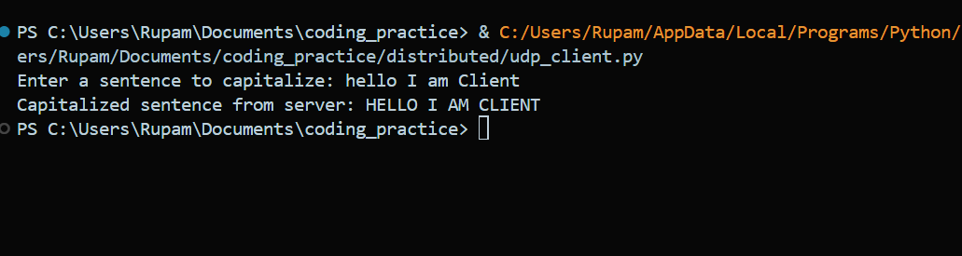
Server Side:
