

Maulana Abul kalam Azad University of
Technology,West Bengal
NH-12(old NH-34),Simhat,Haringhata,Nadia-741249,West Bengal
PCA-1
Subject-Communication Engineering Lab
(PCC-IT494)

NAME-RUPAM BHADRA
ROLL NO.- 10000222057
REG.NO.-221000110083
DEPARTMENT-B.Tech. IT
YEAR-2023-24
SEMESTER-4th Sem

SOCKET PROGRAMMING IN PYTHON
Sockets are the endpoints of a bidirectional communications channel. Sockets may communicate within a process, between processes on the same machine, or between processes on different continents.
A socket is identified by the combination of IP address and the port number. It should be properly configured at both ends to begin communication.
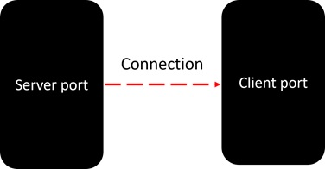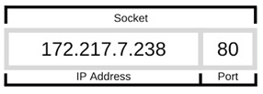
Sockets may be implemented over a number of different channel types: Unix domain sockets, TCP, UDP, and so on. The socket library provides specific classes for handling the common transports as well as a generic interface for handling the rest.
The term socket programming implies programmatically setting up sockets to be able to send and receive data.
Socket programming is a way of connecting two nodes on a network to communicate with each other. One socket(node) listens on a particular port at an IP, while the other socket reaches out to the other to form a connection.
The server forms the listener socket while the client reaches out to the server. They are the real backbones behind web browsing. In simpler terms, there is a server and a client. Socket programming is started by importing the socket library and making a simple socket.
- SERVER:
A server has a bind() method which binds it to a specific IP and port so that it can listen to incoming requests on that IP and port. A server has a listen() method which puts the server into listening mode. This allows the server to listen to incoming connections. And last a server has an accept() and close() method. The accept method initiates a connection with the client and the close method closes the connection with the client.
- PYTHON CODE FOR SERVER:
import socket
s = socket.socket()
print ("Socket successfully created")

port = 12345

s.bind(('', port))
print ("socket binded to %s" %(port))

s.listen(5)
print ("socket is listening")

while True:

c, addr = s.accept()
print ('Got connection from', addr )

c.send('Thank you for connecting'.encode())

c.close()

break

- CLIENT:
Now we need something with which a server can interact. We could telnet to the server like this just to know that our server is working. A client is a computer application, such as a web browser, that runs on a user's local computer, smartphone, or other device, and connects to a server as necessary. Operations may be performed client-side because they require access to information or functionality that is available on the client but not on the server.
- PYTHON CODE FOR CLIENT:
import socket

s = socket.socket()

port = 12345

s.connect(('127.0.0.1', port))

print (s.recv(1024).decode())

s.close()

- OUTPUT:
