**Front-end Project – Documentation**

# Basics

Team name: *Team One*

Team leader: Ece

Project: CodeFactory Contact book (Project C)

Project name: *Contactzzz*

Trello: https://trello.com/b/niiXicA3/cf-contact-book

# Requirements

Must:

* Users must have the possibility to login
* Users must be able to see the contacts previously added to the contact book
* Authenticated users must be able to filter the existing contacts by name and type
* Authenticated users must be able to add new contacts
* New contacts must have first name, last name, phone number, e-mail and type (student, lunch-speaker, company) as required properties.
* Authenticated users must be able to delete existing contacts
* The website must have a responsive design

Should:

* Authenticated users should be able to edit the details of exiting contacts

Could:

* Authenticated users could have the possibility archive existing contacts
* The website design could be enhanced

Won’t:

* Users won’t have the possibility to upload photos for the contacts
* Users won’t be able to filter by properties other than name and type
* Authenticated users won’t have the possibility to create new user accounts

# Use Case Diagram

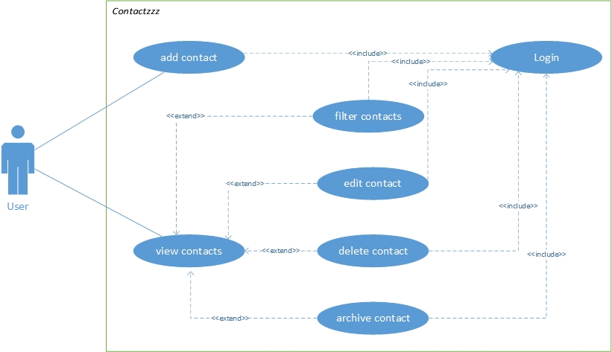

# Stack

* Angular
* Bootstrap
* Firebase
* SCSS

# Rules for Development

1. camelCase should be used for naming all variables and methods
2. the selector name automatically created for Angular components should not be changed (i.e. all selectors will include the prefix “app-“)
3. code should be indented with tabs (1 tab = 4 spaces)
4. all variable/method names, comments and documentation should be written in English only
5. comments should be added to every method/class created
6. only working code should be committed, unless otherwise requested by the rest of the team

# Daily Status Updates

Monday morning:

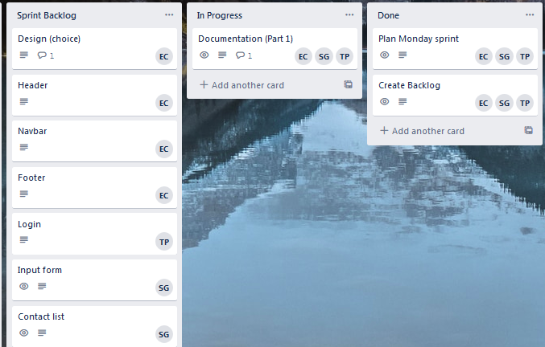

Monday evening:

During the day, we decided to put the header component on hold (as we might not actually use it) and to postpone the content creation for the footer until all other components have been styled.

We managed to finish a few tasks that were not on the backlog (edit/delete/filter functionalities).

As expected, the login is still being worked on. Everything else that was planned was completed today.

Tuesday morning:

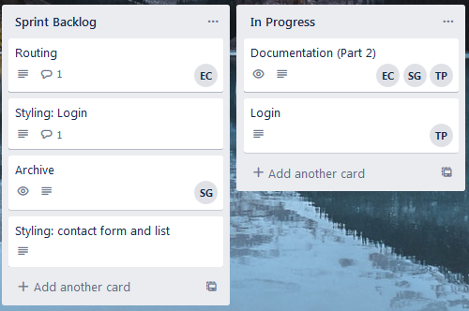

Tuesday evening:

We finished the login component and added the archive. Styling is still ongoing. Routes have been implemented and troubleshooted.