**ABSTRACT**

**CONTENTS**

**Page No.**

|  |  |
| --- | --- |
|  |  |
| **Abstract** | **i** |
| **List of Figures** | **ii** |
| **List of Tables** | **iii** |
| **List of Algorithms** | **iv** |
| **List of Acronyms** | **v** |

|  |  |
| --- | --- |
| **CHAPTER 1 Introduction 1** | |
| * 1. Background |  |
| **CHAPTER 2 Literature Survey** | |
| **CHAPTER 3 Problem Statement** | |
| **CHAPTER 4 Project Planning** | |
| **CHAPTER 5 System Design**  **CHAPTER 6 Software Requirement Specification** | |
| **REFERENCES** | |

**List of Figures**

|  |  |  |
| --- | --- | --- |
| **Figure No.** | **Figure Name** | **Page No.** |
| Figure 1.1 | Mining of Image Process | 3 |

**List of Tables**

|  |  |  |
| --- | --- | --- |
| **Table No.** | **Table Name** | **Page No.** |

**List of Algorithms**

|  |  |  |
| --- | --- | --- |
| **Algorithm No.** | **Algorithm Name** | **Page No.** |

**List of Acronyms**

|  |  |
| --- | --- |
| ANFIS | Adaptive Neuro Fuzzy Classifier |

**CHAPTER 1**

**INTRODUCTION**

* 1. **Background**

Increased amount of data in various domains like medical, agricultural, military, industry, etc., in day to day life in the world is creating lot of opportunities for researchers to explore these data for knowledge discovery.

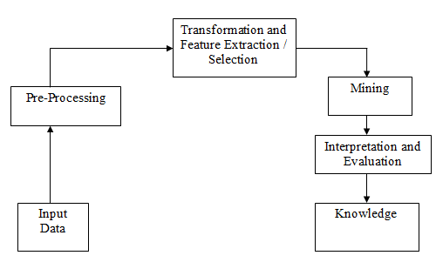

**Figure 1.1:Mining of Image Process**

**Table 1.1: Confusion matrix**

|  |  |  |
| --- | --- | --- |
|  |  | |
|  |  |  |
|  |  |