**Wasfi Momen**

**CSC3320 System Level Programming**

**Program Challenge 9**

Due at 11:59 pm on Saturday, Nov. 19, 2016

**Part I:**

Write a program named as ***reverse.c*** that reads a message, then prints the reversal of the message. The output the program should look like this:

Enter a message: Don ’t get mad, get even.

Reversal is : .neve teg ,dam teg t ’noD

Hint: Read the message one character at a time (using getchar) and store the characters in an array. Stop Reading when the array is full or the character read is ‘\n’.

**Part II:**

Revise the program in Part I to use a pointer instead of an integer to keep track of the current position in the array. Name the new C program as ***reverseP.c .***

**Question:**

1. Put the source code of  ***reverse.c*** and ***reverseP.c***  in your answer sheet.
2. In your answer sheet, please also attach screenshots of the outputs (note: you can type any messages you like).

Reverse.c

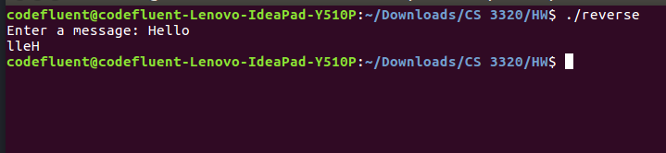

1. Upload your file ***reverse.c*** and ***reverseP.c***  to iCollege.

***Submssion***:

* Upload an electronic copy (MS word or pdf) of your answer sheet to the folder named “**PC9**” of the dropbox in the iCollege system
* Upload files ***reverse.c***  and ***reverseP***.c to the folder named “**PC9**” of the dropbox in the iCollege system. Note: if you do not upload these C files, you would get zero for this assignment.
* Please add the program challenge number and your name at the top of your answer sheet.
* Name your file in the format of PC9_FirstnameLastname (eg. PC9_YuanLong.docx, PC9_YuanLong.pdf)