**CSC3320 System Level Programming**

**Program Challenge 8**

Due at 11:59 pm on Tuesday, Nov. 1, 2016

**Part I:**

Write a C program named ***calcWordAvg.c*** that calculates the average word lenth for a sentence:

Enter a sentence : It was deja vu all over again.

Average word length : 3.4

For simplicity, your program should consider a punctuation mark to be part of the word to which it is attached. Display the average word length to one decimal place.

**Question:**

1. Put the source code of  ***calcWordAvg.c***  in your answer sheet.
2. In your answer sheet, please also attach a screenshot of the output when entering the sentence "I am working on program challenge 8.".
3. Upload your file ***calcWordAvg.c*** to iCollege.

**Part II:**

Write a C program named ***loanCalc.c*** that calculates monthly payment and print a table of payment schedule for a fixed rate loan, which performs a similar task as in the link below:

<http://www.bankrate.com/calculators/mortgages/loan-calculator.aspx>

In this C program, the input and output are defined as following:

* **Input**: amount of loan, interest rate per year and number of payments
* **Output**: a table of amortization schedule (also called payment schedule) containing payment number, monthly payment, principal paid, interest paid and new balance at each row.

The attached screenshot below shows a sample of the output.

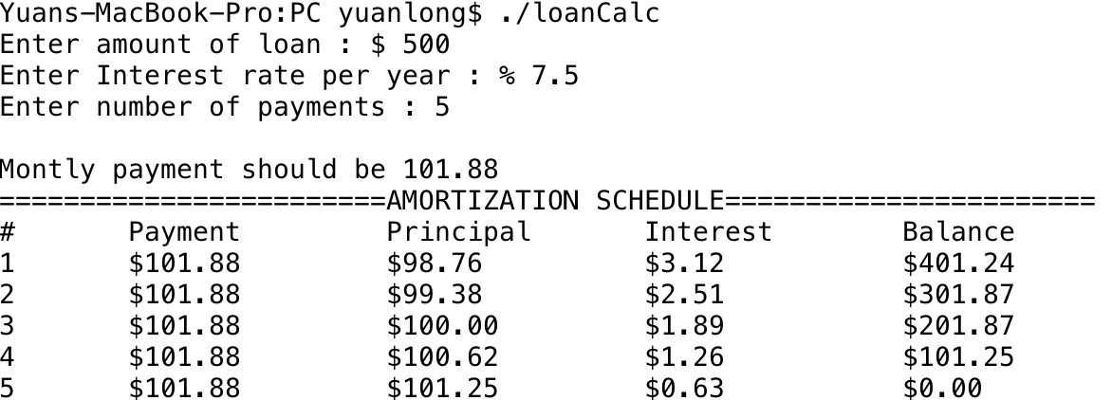

***Note****: monthly payments are equal. The way to calculate monthly payment and other values for each row are provided in Appendix.*

**Hint:** *To print out a percentage %, please use %%.*

**Question:**

1. Put the source code of  ***loanCalc.c***  in your answer sheet.
2. In your answer sheet, please also attach a screenshot of the output when amount of loan is $2000, interest rate per year is %7.5 and number of payment is 6.
3. Upload your file ***loanCalc.c*** to iCollege.

**Appendix:**

**1. Calculating the monthly payment.**

(Note: The following instruction is from

<http://www.vertex42.com/ExcelArticles/amortization-calculation.html> )

The formula for calculating the payment amount is shown below.

$$A=B\frac{r{(1+r)}^{n}}{{(1+r)}^{n}-1}$$

where

* A = payment Amount per period (monthly payment)
* B = initial Balance (loan amount)
* r = interest rate per period
* n = total number of payments or periods

**Example 1**: What would the monthly payment be on a 5-year, $20,000 car loan with a nominal 7.5% annual interest rate?

B = $20,000

r = 7.5% per year / 12 months = 0.625%= 0.00625 per period

n = 5 years * 12 months = 60 total periods

$A=20000* \frac{0.00625 {\left(1+0.00625 \right)}^{60}}{{\left(1+0.00625 \right)}^{60}-1}=400.76$

**2. Calculating the Principal(P), Interest(INT) and Balance(B) for each payment.**

The formula is shown below.

$$INT(n)=B(n-1) *r;$$

$$P(n)=A- INT(n);$$

$$B(n)=B(n-1)- P(n);$$

Where $INT(n)$, $P(n)$ and $B(n)$ are the paid principal, paid interest and new balance for the $nth$ payment. And $B\left(0\right)$ means the loan amount.

**Example 2**: Continue example 1. To calculate the values for the columns on the first payment, we can use the following steps.

Since B(0) = $20,000, then

INT(1) = B(0) * r = 20000 * 0.00625 = 125.00

P(1) = A - INT(1) = 400.76 - 125.00 = 275.76

B(1) = B(0) - P(1) = 20000 - 275.76 = 19724.24

***Submssion***:

* Upload an electronic copy (MS word or pdf) of your answer sheet to the folder named “**PC8**” of the dropbox in the iCollege system
* Upload files ***loanCalc.c***  and ***calcWordAvg***.c to the folder named “**PC8**” of the dropbox in the iCollege system. Note: if you do not upload these C files, you would get zero for this assignment.
* Please add the program challenge number and your name at the top of your answer sheet.
* Name your file in the format of PC8_FirstnameLastname (eg. PC8_YuanLong.docx, PC8_YuanLong.pdf)