CSC 6220: Assignment 3

1. The 8bit checksum is 00100110. At the receiver’s side, all the 8bit chunks of the sender’s message and the checksum value will be added together. The resulting sum should be 11111111. If the receiver computes the sum and gets a 0 for any value, it means there was an error in the transmission, an in-memory error, or even a hardware error.

Rdt 1.0 – Assumes network layer is reliable and there are no errors. Creates two state machines for the sender and receiver.

Rdt 2.0 – Adds error detection and feedback by including ACKs and NAKs. Now, sender waits for ACK or NAK from receiver and the receiver checks the packet for corruption. Cannot handle garbled or duplicate ACKs or NAKs. Still assumes no packet loss.

Rdt 2.1 – Adds a 1bit sequence number. Can now detect garbled NAKs or ACKs and the sequence number indicates whether the packet being sent is a new packet or an old packet retransmission, solving the duplicate problem. Still assumes no packet loss.

Rdt 2.2 – Same as 2.1, but instead of NAKs we ACK the last noncorrupted packet sequence number. Sender now must check sequence number to decide whether to retransmit. Duplicates can now issue retransmission. Still assumes no packet loss.

Rdt 3.0 – Now assumes packet loss. Adds an additional function to each state as a timer. If the timer runs out, the sender will retransmit. ACKs, sequence number can also issue retransmission.

The problem of Go-Back-N was of performance considerations. If one packet is dropped en route, then all packets before must be retransmitted. This can be a significant problem in large amounts of packets where the probability of packet loss is high. If packet 999 out of 1,000 packets is lost, then packets 1-999 will have to be retransmitted (assuming the window size is 1,000).



For opening a connection, the sequence numbers will be 0 until the last ACK in the 3-way handshake is received, then it will be 1. The FIN bit will be set to 0 always. The SYN bit will be 1 until the last ACK, then the SYN bit will be 0.

For closing a connection, the sequence number of both the sender and receiver will be incremented by how many bytes they have transferred. Once the decision is made to terminate the connection, one of the sides will set the FIN bit to 1 with the SYN bit at 0. The other side will ACK with a FIN bit of 1 and SYN bit of 0. The final ACK will have both SYN and FIN set to 0.



An example of duplicate ACK when uploading and downloading a file on <https://pdftoimage.com/>. The duplicate ACK has the same sequence, acknowledgement, and source, destination ports.

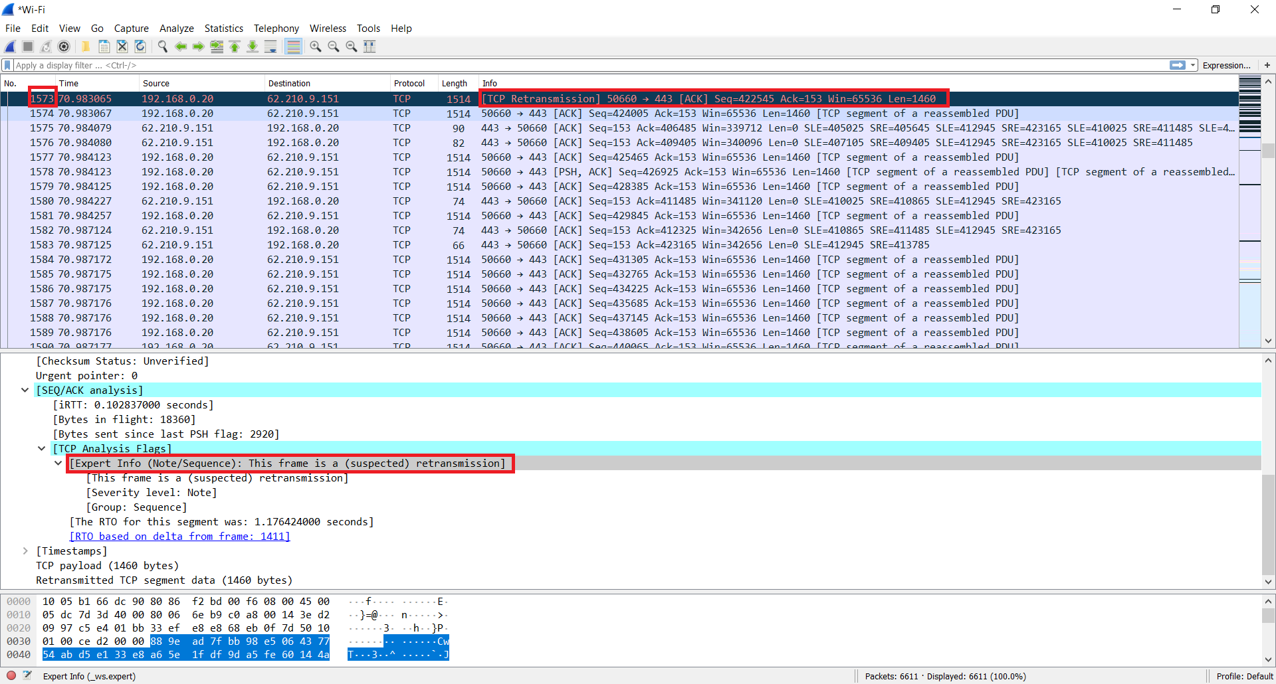



Here, packet 40725 is an ACK retransmission due to keep-alive timeout.

