## Section 1

1.

* 1. A vm is an important tool for a cyber security engineer in order to test, develop, and deploy code that protect systems that the engineer wishes to target.
  2. A vm is important for a hacker in order to have a copy of his/her target that was found out in initial recon. A hacker wil be able to use a vm to explore the best techniques for infiltration.

## Section 2

1. The IP address of the baidu server is 103.235.46.39

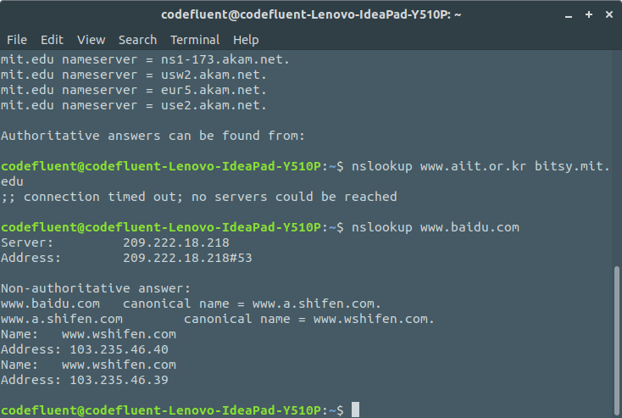

## Section 3

3. My DNS queries were sent to 209.222.18.222, which is indeed my local DNS server. I used “cat /etc/resolve.conf” find my local DNS server with “systemd-resolve –status”.

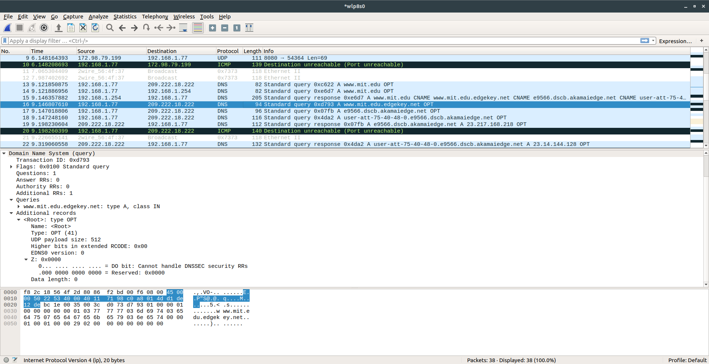

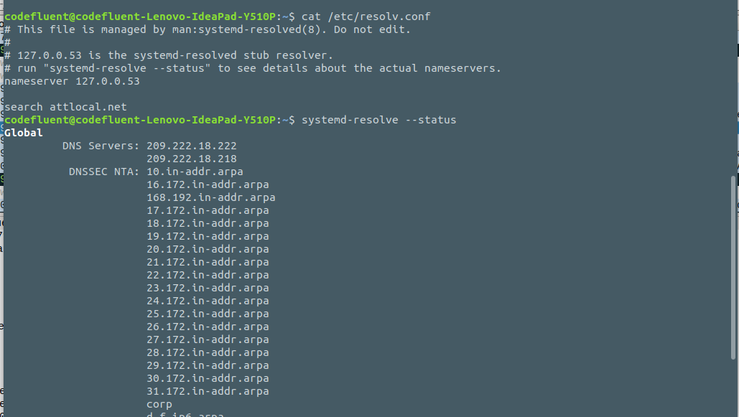

## Section 4

4. The IP address of my computer is 192.168.1.77

5. The upper layer protocol field value is ICMP protocol.

6. 20 bytes in the IP header. There are 520 bytes for the total UDP length, so 520 – 20 = 500 bytes for the payload.

7. Yes the IP datagram has been fragmented since there is a flag set to 0x01, meaning the IP was fragmented.

