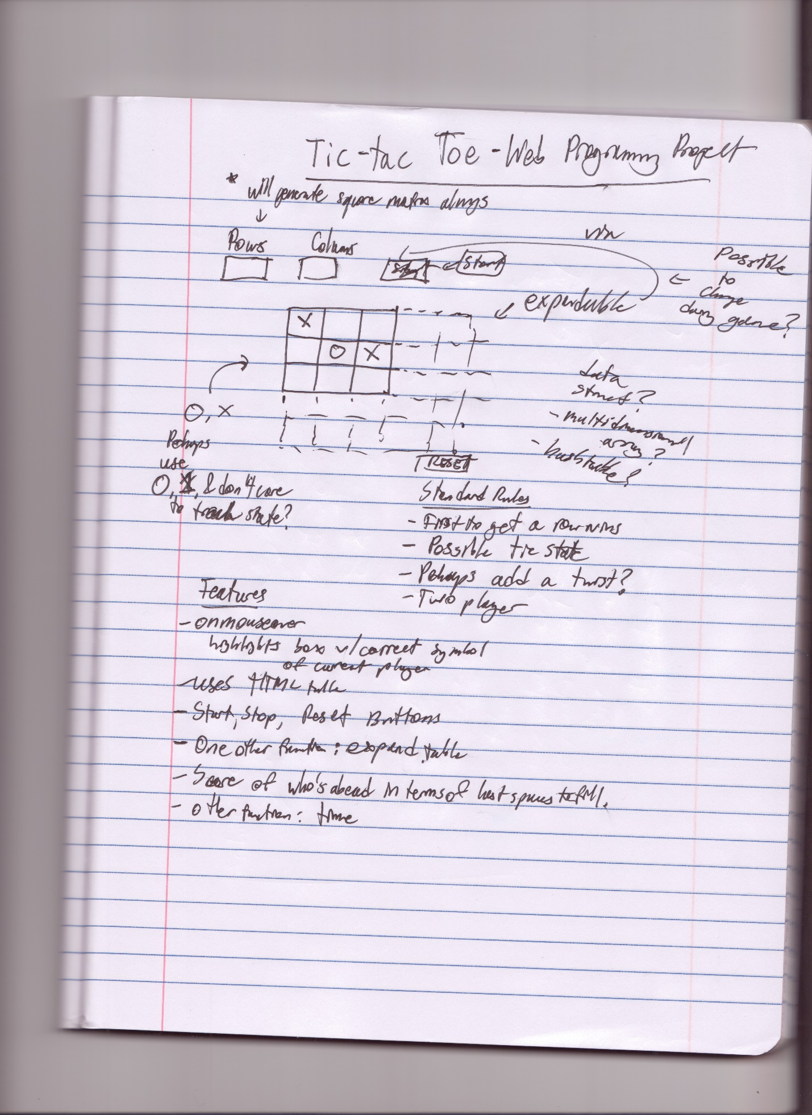

Team Members: Wasfi Momen

Translated:

*My project will create a tic-tac-toe game using HTML tables and Javascript. The following contains the notes written just in case my handwriting is hard to read.*

* Rows and Columns will always provide a square matrix (*in which case I can just specify rows or a matrix size…)*
* Unknown data struct for now, possibly multidimensional array or maybe a hashtable?
* O, X are user inputs
* Maybe use 0,1, and don’t care to track state? (*kind of like in Computer Architecture)*

Standard Rules

* First to get a row wins
* Possible tie state
* Perhaps add a twist?
* Two players

Features

* Onmouseover highlights box w/correct symbol of current player
* Uses HTML table
* Start, stop, reset buttons
* One other function: expand table
* Score of who’s ahead in terms of last spaces to fill
* Other function: time