**CSC4840/6840 Computer Graphics Imaging**

Spring 2017

Homework 1

Due date: February 17, 2017 at 11:59 pm

Requirements:

* Use 3D graphics to recreate the living room scene in the picture. Try to make your rendered picture as close to this picture as possible. Your grade is largely based on how closely you can reproduce the models and lighting effects in this picture.
* Create 3D models for the objects in the scene.
* Try to reproduce the lighting effect in this picture as much as possible.
* You may use a different texture for the wall and floor, but try to find a texture like the ones used in the original picture.
* You are not required to create 3D models for the flowers and plants. You may use pictures for the flowers and plants. But you will get credits if you do create 3D models for them.
* This homework will be evaluated by the following criteria.
  + How many 3D models are created?
  + Is the quality of the 3D models good? Do they look close to the objects in the picture?
  + What is the quality of the lighting effects? Are they close to the lighting effects in the original picture?
  + Are the color close to the original picture?

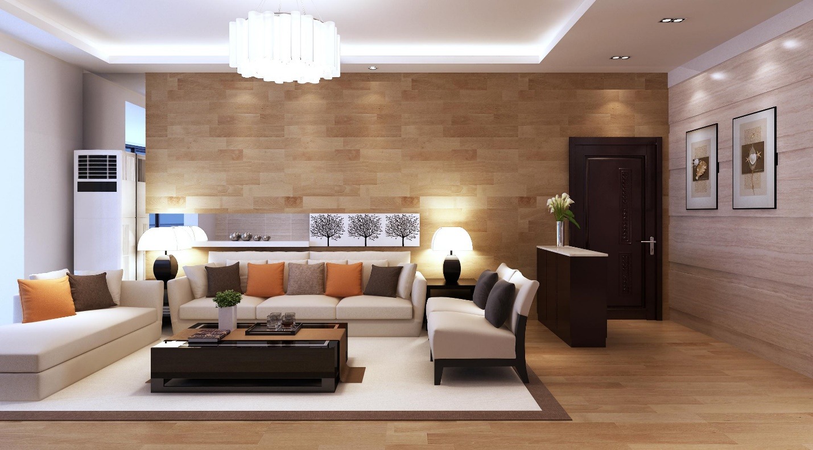

This image is taken from <http://zandart.com/wp-content/uploads/2016/11/decorating-ideas-for-small-office-modern-living-room-design-also-modern-living-room-design-living-room-photo-modern-living-room.jpg>

Submit the following to the “homework 1” drop box on iCollege.

* Your Blender file.
* All the texture image files.
* Rendered image.

Do not submit by email.