**CSC4840/6840 Computer Graphics Imaging**

Spring 2017

Homework 2

Due date: March 14, 2017 (Tuesday) at 11:59 pm

In this homework, you will learn how to use lighting, material, and texture mapping to create photorealistic pictures.

Requirements:

* Choose ONE picture from the three pictures attached below and use 3D graphics to recreate the scene. Try to make your rendered picture as close to this picture as possible. Your grade is largely based on how closely you can reproduce the models and lighting effects in this picture.
  + All three pictures are of hotels at Maldives.
* Create 3D models for the objects in the scene.
* Try to reproduce the lighting effect and material in this picture as much as possible.
* The sky and cloud in the background may be different from the picture’s but should be close.
* The texture for the objects should be close to the picture.
* Cycles rending engine may give better lighting effect but the rendering process are usually quite long, especially on laptops. For most people, I recommend that you use Blender’s default rendering engine.
* This homework will be evaluated by the following criteria.
  + Is the quality of the 3D models good? Do they look close to the objects in the picture?
  + What is the quality of the lighting, material, and texture mapping? Are they close to the lighting effects in the original picture?

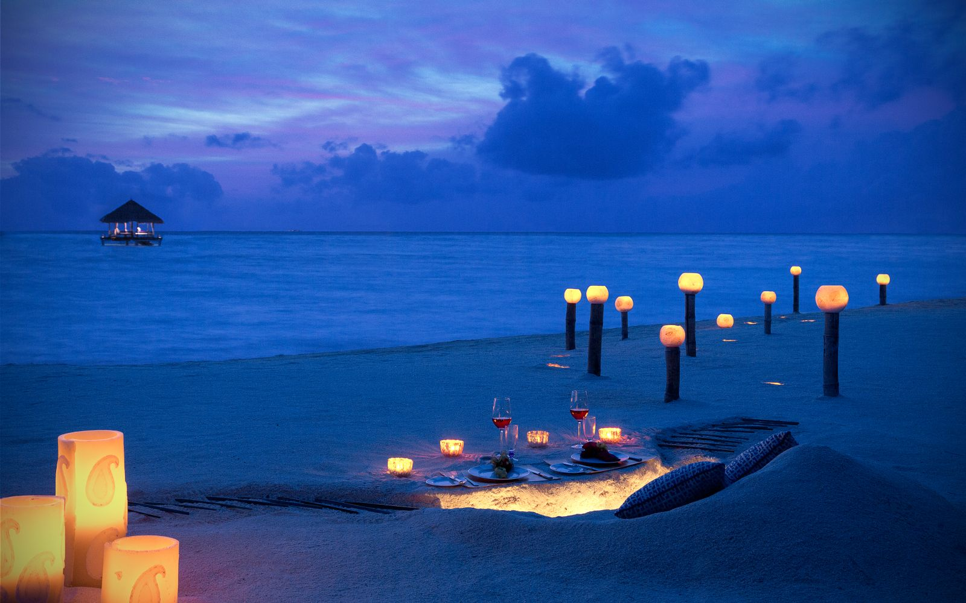

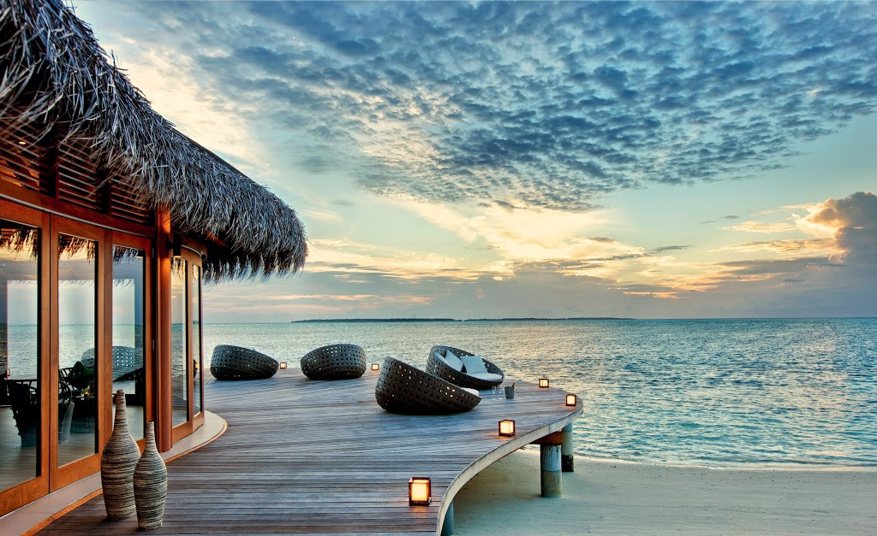

(You don’t have to model the thatched roof in this picture, although it can be done using Blender’s hair model.)

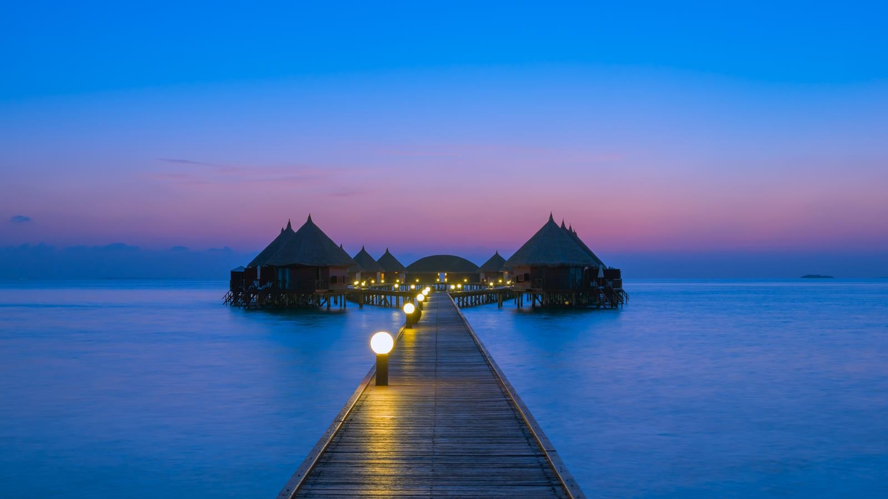

Submit the following to the “homework 2” assignment drop box on iCollege.

* Your Blender file.
* All the texture image files.
* At least one rendered image, preferably multiple pictures from different camera positions.

Do not submit by email.